LeetCode: https://leetcode.com/problems/perfect-number/
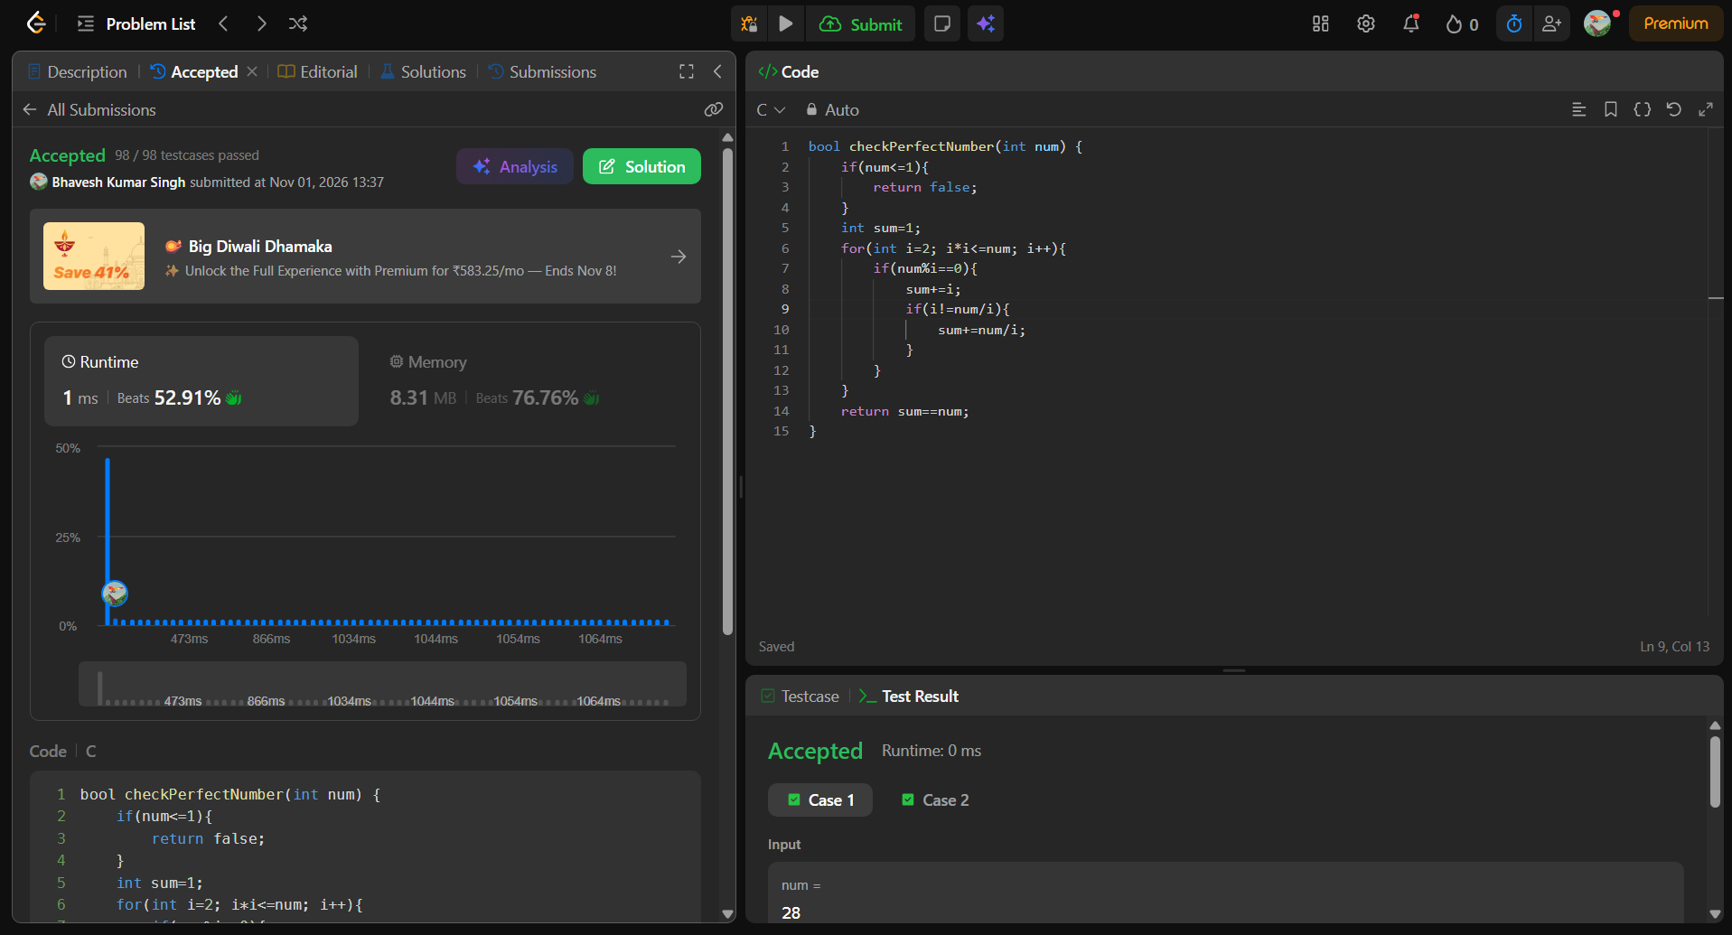
bool checkPerfectNumber(int num) {
if(num<=1){
return false;
}
int sum=1;
for(int i=2; i*i<=num; i++){
if(num%i==0){
sum+=i;
if(i!=num/i){
sum+=num/i;
}
}
}
return sum==num;
}

