LeetCode: https://leetcode.com/problems/reverse-integer/
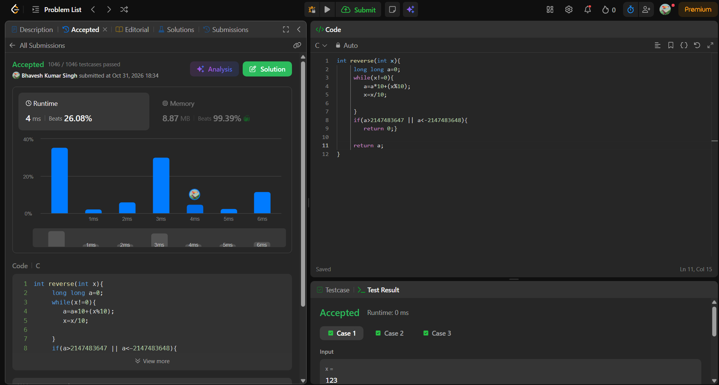
int reverse(int x){
long long a=0;
while(x!=0){
a=a*10+(x%10);
x=x/10;

}
if(a>2147483647 || a<-2147483648){
return 0;}

return a;
}

