UNIT - III

PRODUCTION FUNCTION

Introduction: The production function expresses a functional relationship between physical inputs and physical outputs of a firm at any particular time period. The output is thus a function of inputs. Mathematically production function can be written as

Q= f (A, B, C, D)

Where “Q” stands for the quantity of output and A, B, C, D are various input factors such as land, labour, capital and organization. Here output is the function of inputs. Hence output becomes the dependent variable and inputs are the independent variables.

The above function does not state by how much the output of “Q” changes as a consequence of change of variable inputs. In order to express the quantitative relationship between inputs and output, Production function has been expressed in a precise mathematical equation i.e.

Y= a+b(x)

Which shows that there is a constant relationship between applications of input (the only factor input ‘X’ in this case) and the amount of output (y) produced.

Importance:

- When inputs are specified in physical units, production function helps to estimate the level of production.
- It becomes is equates when different combinations of inputs yield the same level of output.
- It indicates the manner in which the firm can substitute on input for another without altering the total output.
- When price is taken into consideration, the production function helps to select the least combination of inputs for the desired output.
- It considers two types’ input-output relationships namely ‘law of variable proportions’ and ‘law of returns to scale’. Law of variable propositions explains the pattern of output in the short-run as the units of variable inputs are increased to increase the output. On the other hand law of returns to scale explains the pattern of output in the long run as all the units of inputs are increased.
- The production function explains the maximum quantity of output, which can be produced, from any chosen quantities of various inputs or the minimum quantities of various inputs that are required to produce a given quantity of output.

Production function can be fitted the particular firm or industry or for the economy as whole. Production function will change with an improvement in technology.

Assumptions:

Production function has the following assumptions.

- The production function is related to a particular period of time.
- There is no change in technology.
- The producer is using the best techniques available.
- The factors of production are divisible.
- Production function can be fitted to a short run or to long run.

Cobb-Douglas production function:

Production function of the linear homogenous type is invested by Junt wicksell and first tested by C. W. Cobb and P. H. Dougles in 1928. This famous statistical production function is known as Cobb-Douglas production function. Originally the function is applied on the empirical study of the American manufacturing industry. Cabb – Douglas production function takes the following mathematical form.

Y= (AKX L1-x)
Where Y=output K=Capital L=Labour
A, ∞=positive constant

Assumptions:

It has the following assumptions

- The function assumes that output is the function of two factors viz. capital and labour.
- It is a linear homogenous production function of the first degree
- The function assumes that the logarithm of the total output of the economy is a linear function of the logarithms of the labour force and capital stock.
- There are constant returns to scale
- All inputs are homogenous
- There is perfect competition
- There is no change in technology

LEONTIEF PRODUCTION FUNCTION
The Leontief Production Function (LPF), named for the father of Input-Output economics Wassily Leontief, is what is utilized in IMPLAN. It is also known as the Fixed-Proportions Production Function. We still see output (Q) being a function of capital (K) and labor (L). The designation of min refers to the smallest numbers for K and L.
The isoquants in the LPF are right angles. Capital and labor are fixed proportions. They are perfect complements and cannot be substituted for one another. Increasing the inputs will lead to a proportional increase in output (Miller & Blair, 2009). Also, you can’t have too few or too many outputs; the relationship between capital and labor is locked.

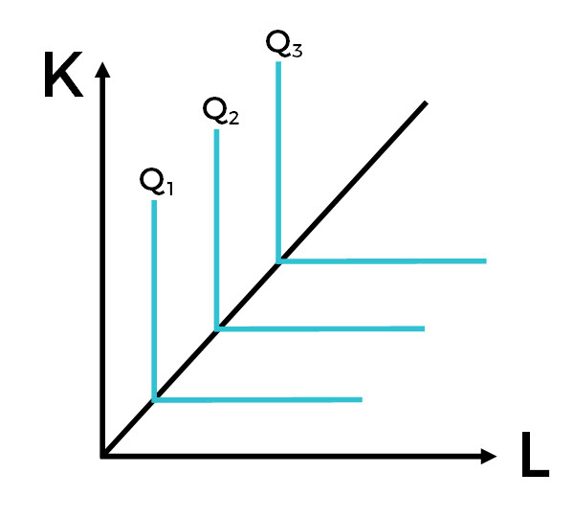

THE LPF IN IMPLAN
So that was a fun economics lesson, but how does this work in IMPLAN? Well, it all comes down to Output, the total annual production value of each Industry. The LPF of an Industry in IMPLAN determines how each Industry will allocate Output. Industries have employees, they pay Labor Income and Proprietor Income. They also pay taxes (Taxes on Production and Imports) and realize profits (Other Property Income). These combine to give us Value Added. In addition to the Value Added, Industries spend money on Intermediate Inputs.
Instead of Output just consisting of capital and labor, we have an equation for Output that includes all of these pieces:
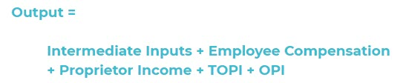

ISOQUANTS:

The term Isoquants is derived from the words ‘iso’ and ‘quant’ – ‘Iso’ means equal and ‘quent’ implies quantity. Isoquant therefore, means equal quantity. A family of iso-product curves or isoquants or production difference curves can represent a production function with two variable inputs, which are substitutable for one another within limits.
Isoquants are the curves, which represent the different combinations of inputs producing a particular quantity of output. Any combination on the isoquant represents the some level of output.

For a given output level firm’s production become,

Q= f (L, K)

Where ‘Q’, the units of output is a function of the quantity of two inputs ‘L’ and ‘K’.

Thus an isoquant shows all possible combinations of two inputs, which are capable of producing equal or a given level of output. Since each combination yields same output, the producer becomes indifferent towards these combinations.

Assumptions:

- There are only two factors of production, viz. labour and capital.
- The two factors can substitute each other up to certain limit
- The shape of the isoquant depends upon the extent of substitutability of the two inputs.
- The technology is given over a period.

An isoquant may be explained with the help of an arithmetical example.

Combinations | Labour (units) | Capital (Units) | Output (quintals)
A | 1 | 10 | 50
B | 2 | 7 | 50
C | 3 | 4 | 50
D | 4 | 4 | 50
E | 5 | 1 | 50

Combination ‘A’ represent 1 unit of labour and 10 units of capital and produces ‘50’ quintals of a product all other combinations in the table are assumed to yield the same given output of a product say ‘50’ quintals by employing any one of the alternative combinations of the two factors labour and capital. If we plot all these combinations on a paper and join them, we will get continues and smooth curve called Iso-product curve as shown below.

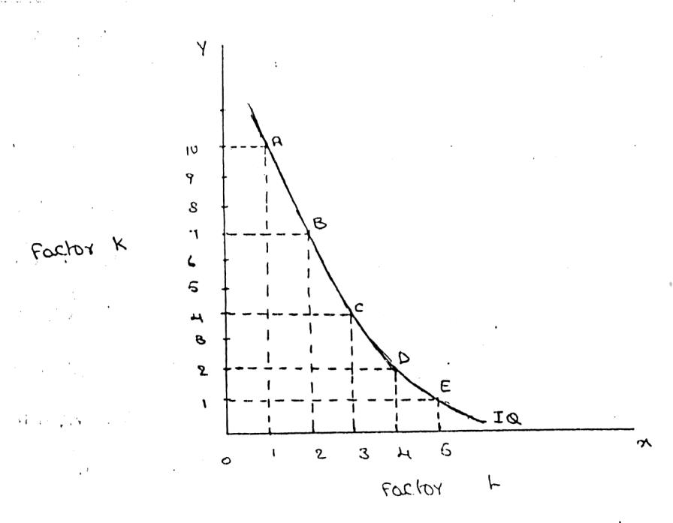
Labour is on the X-axis and capital is on the Y-axis. IQ is the ISO-Product curve which shows all the alternative combinations A, B, C, D, E which can produce 50 quintals of a product.

Iso-Cost lines
Iso-cost lines represent the prices of factors. An iso-cost line graphically represents all the combinations of the inputs which the firm can achieve with a given budget for production or given outlay.
Suppose the firm has 100 Rs. which it can spend on combinations of factor X and factor Y, the former priced at Rs. 10 per unit and the latter priced at Rs. 20. The firm can spend the entire amount on factor X or factor Y.
Further, there will be various combinations of both factors which amount to the outlay. The iso-cost line represents all these combinations. Q1, Q2 and Q3 are three different isocosts. The isocost on the right represents a higher outlay.
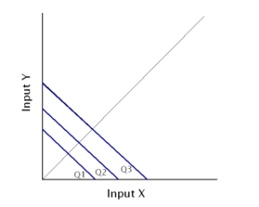

Production Optimisation
Isocosts and Isoquants can together help us to determine the optimum production for a firm. We can achieve production optimisation in two ways. Either we can maximize the production for a given outlay or we can minimize the cost of producing a given level of output.
In case a firm has decided to achieve a given level of production, the next step would be to choose the combination of factors to achieve this target. Definitely, a rational firm would choose the least cost combination. This least cost combination is found out by superimposing the iso-quant on the iso-cost line.
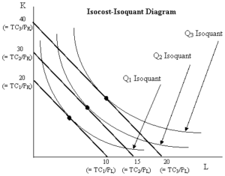
We define the least-cost combinations for three different iso-quants show above at a point where the isocosts are tangential to the isoquants. Evidently, the least cost combination for a given isoquant is at the point of tangency of the isoquant with the isocost line.
Producer’s Equilibrium:

The tem producer’s equilibrium is the counter part of consumer’s equilibrium. Just as the consumer is in equilibrium when be secures maximum satisfaction, in the same manner, the producer is in equilibrium when he secures maximum output, with the least cost combination of factors of production.

The optimum position of the producer can be found with the help of iso-product curve. The Iso-product curve or equal product curve or production indifference curve shows different combinations of two factors of production, which yield the same output. This is illustrated as follows.

Let us suppose. The producer can produces the given output of paddy say 100 quintals by employing any one of the following alternative combinations of the two factors labour and capital computation of least cost combination of two inputs.

L  Units | K  Units | Q  Output | L&LP (3Rs.)  Cost of labour | KXKP(4Rs.)  cost of capital | Total cost
10 | 45 | 100 | 30 | 180 | 210
20 | 28 | 100 | 60 | 112 | 172
30 | 16 | 100 | 90 | 64 | 154
40 | 12 | 100 | 120 | 48 | 168

50 | 8 | 100 | 150 | 32 | 182

It is clear from the above that 10 units of ‘L’ combined with 45 units of ‘K’ would cost the producer Rs. 20/-. But if 17 units reduce ‘K’ and 10 units increase ‘L’, the resulting cost would be Rs. 172/-. Substituting 10 more units of ‘L’ for 12 units of ‘K’ further reduces cost pf Rs. 154/-/ However, it will not be profitable to continue this substitution process further at the existing prices since the rate of substitution is diminishing rapidly. In the above table the least cost combination is 30 units of ‘L’ used with 16 units of ‘K’ when the cost would be minimum at Rs. 154/-. So this is they stage “the producer is in equilibrium”.

LAW OF PRODUCTION:

Production analysis in economics theory considers two types of input-output relationships.

- When quantities of certain inputs, are fixed and others are variable and
- When all inputs are variable.

These two types of relationships have been explained in the form of laws.

  - Law of variable proportions
  - Law of returns to scale

- Law of variable proportions:

The law of variable proportions which is a new name given to old classical concept of “Law of diminishing returns has played a vital role in the modern economics theory. Assume that a firms production function consists of fixed quantities of all inputs (land, equipment, etc.) except labour which is a variable input when the firm expands output by employing more and more labour it alters the proportion between fixed and the variable inputs. The law can be stated as follows:

“When total output or production of a commodity is increased by adding units of a variable input while the quantities of other inputs are held constant, the increase in total production becomes after some point, smaller and smaller”.

“If equal increments of one input are added, the inputs of other production services being held constant, beyond a certain point the resulting increments of product will decrease i.e. the marginal product will diminish”. (G. Stigler)

“As the proportion of one factor in a combination of factors is increased, after a point, first the marginal and then the average product of that factor will diminish”. (F. Benham)

The law of variable proportions refers to the behaviour of output as the quantity of one Factor is increased Keeping the quantity of other factors fixed and further it states that the marginal product and average product will eventually do cline. This law states three types of productivity an input factor – Total, average and marginal physical productivity.

Assumptions of the Law: The law is based upon the following assumptions:

  - The state of technology remains constant. If there is any improvement in technology, the average and marginal out put will not decrease but increase.
  - Only one factor of input is made variable and other factors are kept constant. This law does not apply to those cases where the factors must be used in rigidly fixed proportions.
  - All units of the variable factors are homogenous.

Three stages of law:

The behaviors of the Output when the varying quantity of one factor is combines with a fixed quantity of the other can be divided in to three district stages. The three stages can be better understood by following the table.

Fixed factor | Variable factor  (Labour) | Total product | Average  Product | Marginal  Product
1 | 1 | 100 | 100 | - | Stage I
1 | 2 | 220 | 120 | 120
1 | 3 | 270 | 90 | 50
1 | 4 | 300 | 75 | 30 | Stage II
1 | 5 | 320 | 64 | 20
1 | 6 | 330 | 55 | 10
1 | 7 | 330 | 47 | 0 | Stage  III
1 | 8 | 320 | 40 | -10

Above table reveals that both average product and marginal product increase in the beginning and then decline of the two marginal products drops of faster than average product. Total product is maximum when the farmer employs 6th worker, nothing is produced by the 7th worker and its marginal productivity is zero, whereas marginal product of 8th worker is ‘-10’, by just creating credits 8th worker not only fails to make a positive contribution but leads to a fall in the total output.
Production function with one variable input and the remaining fixed inputs is illustrated as below

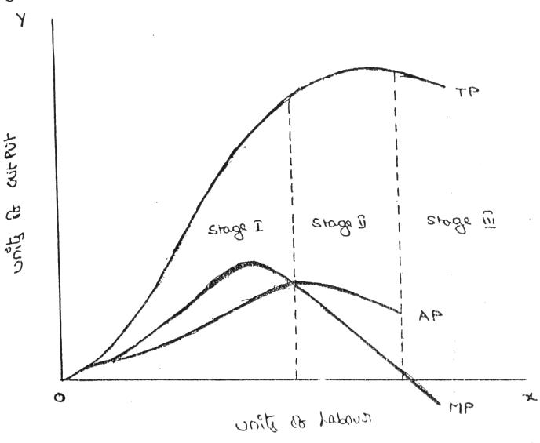

From the above graph the law of variable proportions operates in three stages. In the first stage, total product increases at an increasing rate. The marginal product in this stage increases at an increasing rate resulting in a greater increase in total product. The average product also increases. This stage continues up to the point where average product is equal to marginal product. The law of increasing returns is in operation at this stage. The law of diminishing returns starts operating from the second stage awards. At the second stage total product increases only at a diminishing rate. The average product also declines. The second stage comes to an end where total product becomes maximum and marginal product becomes zero. The marginal product becomes negative in the third stage. So the total product also declines. The average product continues to decline.

We can sum up the above relationship thus when ‘A.P.’ is rising, “M. P.’ rises more than “
A. P; When ‘A. P.” is maximum and constant, ‘M. P.’ becomes equal to ‘A. P.’ when ‘A. P.’ starts falling, ‘M. P.’ falls faster than ‘ A. P.’.

Thus, the total product, marginal product and average product pass through three phases, viz., increasing diminishing and negative returns stage. The law of variable proportion is nothing but the combination of the law of increasing and demising returns.

The law of Return to Scale in Production Functions
Changes in output when all factors change in the same proportion are referred to as the law of return to scale. This law applies only in the long run when no factor is fixed, and all factors are increased in the same proportion to boost production.
There are three stages in all.
- Increasing the scale’s return
- Constant scale returns
- Decrease in Returns on the scale
Unit of Labour | Unit of capital | % increase in labour and capital | Total production | % increase in TP | Stages
1 | 3 | – | 10 | – | increasing
2 | 6 | 100% | 30 | 200%
3 | 9 | 50% | 60 | 100%
4 | 12 | 33% | 80 | 33% | constant
5 | 15 | 25% | 100 | 25%
6 | 18 | 20% | 110 | 10% | diminishing
7 | 21 | 16.6% | 120 | 8.3%

Increasing returns to scale
It describes a condition in which all of the factors of production are raised, resulting in a higher rate of output. For example, if inputs are raised by 10%, the output will be increased by 20%.

Reasons
- Due to the economy of scale
- Specialisation through better division of labour

Constant returns to scale
It describes a condition in which all of the factors of production are increased at the same time, resulting in a steady growth in output. For example, if inputs are raised by 10%, the output is also increased by 10%.

Reasons
As the firm’s production grows, it reaches a point where all of the economy’s resources have been fully utilised, and output equals input.

Diminishing returns to scale
When all of the production factors are increased simultaneously, output grows at a slower rate. For example, if inputs are raised by 10%, the output will be increased by 5%.

Reasons
- The major cause of diminishing returns to scale is large-scale economies, diseconomies of scale occur when a company has grown to such a size that it is difficult to manage
- Lack of coordination
Assumptions of Return to scale
The following are the returns to scale assumptions: Capital and labour are the only two variables of production used by the company. In a fixed proportion, labour and capital are integrated. Factor prices do not fluctuate, and the State of technology remains the same.
Difference between return to scale and return to a factor
- Return to factor has only one variable while the rest of the factors remain constant, whereas return to scale has all of the variables changing
- In return for factor, the factor proportion changes as more and more variable factor units raise production
- In return to scale, the factor proportion remains constant when factors are re-added in the same proportion to increase output
- When you return to a factor, you get a negative return. Returning to scale has the effect of decreasing returns
- Return to scale is a long-term phenomenon, whereas return to a factor is a one-time event

Difference between variable factor and fixed factor
- Variable factors can be modified in the short run, whereas fixed factors cannot be changed in the short run
- Variable factors fluctuate immediately with output, whereas fixed factors do not vary directly with output
- Variable factors include raw materials, casual labour, power, and fuel, whereas fixed factors include expenses related to buildings, plant and machinery, components, etc

ECONOMIES OF SCALE

Production may be carried on a small scale or o a large scale by a firm. When a firm expands its size of production by increasing all the factors, it secures certain advantages known as economies of production. Marshall has classified these economies of large-scale production into internal economies and external economies.

Internal economies are those, which are opened to a single factory or a single firm independently of the action of other firms. They result from an increase in the scale of output of a firm and cannot be achieved unless output increases. Hence internal economies depend solely upon the size of the firm and are different for different firms.

External economies are those benefits, which are shared in by a number of firms or industries when the scale of production in an industry or groups of industries increases. Hence external economies benefit all firms within the industry as the size of the industry expands.

Causes of internal economies:
Internal economies are generally caused by two factors
- Indivisibilities 2. Specialization.

- Indivisibilities
Many fixed factors of production are indivisible in the sense that they must be used in a fixed minimum size. For instance, if a worker works half the time, he may be paid half the salary. But he cannot be chopped into half and asked to produce half the current output. Thus as output increases the indivisible factors which were being used below capacity can be utilized to their full capacity thereby reducing costs. Such indivisibilities arise in the case of labour, machines, marketing, finance and research.

- Specialization.

Division of labour, which leads to specialization, is another cause of internal economies. Specialization refers to the limitation of activities within a particular field of production. Specialization may be in labour, capital, machinery and place. For example, the production process may be split into four departments relation to manufacturing, assembling, packing and marketing under the charge of separate managers who may work under the overall charge of the general

manger and coordinate the activities of the for departments. Thus specialization will lead to greater productive efficiency and to reduction in costs.

Internal Economies:

Internal economies may be of the following types.

- Technical Economies.

Technical economies arise to a firm from the use of better machines and superior techniques of production. As a result, production increases and per unit cost of production falls. A large firm, which employs costly and superior plant and equipment, enjoys a technical superiority over a small firm. Another technical economy lies in the mechanical advantage of using large machines. The
cost of operating large machines is less than that of operating mall machine. More over a larger firm is able to reduce it’s per unit cost of production by linking the various processes of production. Technical economies may also be associated when the large firm is able to utilize all its waste materials for the development of by-products industry. Scope for specialization is also available in a large firm. This increases the productive capacity of the firm and reduces the unit cost of production.

- Managerial Economies:

These economies arise due to better and more elaborate management, which only the large size firms can afford. There may be a separate head for manufacturing, assembling, packing, marketing, general administration etc. Each department is under the charge of an expert. Hence the appointment of experts, division of administration into several departments, functional specialization and scientific co-ordination of various works make the management of the firm most efficient.

- Marketing Economies:

The large firm reaps marketing or commercial economies in buying its requirements and in selling its final products. The large firm generally has a separate marketing department. It can buy and sell on behalf of the firm, when the market trends are more favorable. In the matter of buying they could enjoy advantages like preferential treatment, transport concessions, cheap credit, prompt delivery and fine relation with dealers. Similarly it sells its products more effectively for a higher margin of profit.

- Financial Economies:

The large firm is able to secure the necessary finances either for block capital purposes or for working capital needs more easily and cheaply. It can barrow from the public, banks and other financial institutions at relatively cheaper rates. It is in this way that a large firm reaps financial economies.

- Risk bearing Economies:

The large firm produces many commodities and serves wider areas. It is, therefore, able to absorb any shock for its existence. For example, during business depression, the prices fall for every firm. There is also a possibility for market fluctuations in a particular product of the firm. Under such circumstances the risk-bearing economies or survival economies help the bigger firm to survive business crisis.

- Economies of Research:

A large firm possesses larger resources and can establish it’s own research laboratory and employ trained research workers. The firm may even invent new production techniques for increasing its output and reducing cost.

- Economies of welfare:

A large firm can provide better working conditions in-and out-side the factory. Facilities like subsidized canteens, crèches for the infants, recreation room, cheap houses, educational and medical facilities tend to increase the productive efficiency of the workers, which helps in raising production and reducing costs.

External Economies.

Business firm enjoys a number of external economies, which are discussed below:

- Economies of Concentration:

When an industry is concentrated in a particular area, all the member firms reap some common economies like skilled labour, improved means of transport and communications, banking and financial services, supply of power and benefits from subsidiaries. All these facilities tend to lower the unit cost of production of all the firms in the industry.

- Economies of Information

The industry can set up an information centre which may publish a journal and pass on information regarding the availability of raw materials, modern machines, export potentialities and provide other information needed by the firms. It will benefit all firms and reduction in their costs.

- Economies of Welfare:

An industry is in a better position to provide welfare facilities to the workers. It may get land at concessional rates and procure special facilities from the local bodies for setting up housing colonies for the workers. It may also establish public health care units,

educational institutions both general and technical so that a continuous supply of skilled labour is available to the industry. This will help the efficiency of the workers.

- Economies of Disintegration:

The firms in an industry may also reap the economies of specialization. When an industry expands, it becomes possible to spilt up some of the processes which are taken over by specialist firms. For example, in the cotton textile industry, some firms may specialize in manufacturing thread, others in printing, still others in dyeing, some in long cloth, some in dhotis, some in shirting etc. As a result the efficiency of the firms specializing in different fields increases and the unit cost of production falls.

Thus internal economies depend upon the size of the firm and external economies depend upon the size of the industry.

DISECONOMIES OF LARGE SCALE PRODUCTION

Internal and external diseconomies are the limits to large-scale production. It is possible that expansion of a firm’s output may lead to rise in costs and thus result diseconomies instead of economies. When a firm expands beyond proper limits, it is beyond the capacity of the manager to manage it efficiently. This is an example of an internal diseconomy. In the same manner, the expansion of an industry may result in diseconomies, which may be called external diseconomies. Employment of additional factors of production becomes less efficient and they are obtained at a higher cost. It is in this way that external diseconomies result as an industry expands.

The major diseconomies of large-scale production are discussed below:

Internal Diseconomies:

- Financial Diseconomies:

For expanding business, the entrepreneur needs finance. But finance may not be easily available in the required amount at the appropriate time. Lack of finance retards the production plans thereby increasing costs of the firm.

- Managerial diseconomies:

There are difficulties of large-scale management. Supervision becomes a difficult job. Workers do not work efficiently, wastages arise, decision-making becomes difficult, coordination between workers and management disappears and production costs increase.

- Marketing Diseconomies:

As business is expanded, prices of the factors of production will rise. The cost will therefore rise. Raw materials may not be available in sufficient quantities due to their scarcities. Additional output may depress the price in the market. The demand for the products may fall as a result of changes in tastes and preferences of the people. Hence cost will exceed the revenue.

- Technical Diseconomies:

There is a limit to the division of labour and splitting down of production p0rocesses. The firm may fail to operate its plant to its maximum capacity. As a result cost per unit increases. Internal diseconomies follow.

- Diseconomies of Risk-taking:

As the scale of production of a firm expands risks also increase with it. Wrong decision by the management may adversely affect production. In large firms are affected by any disaster, natural or human, the economy will be put to strains.

External Diseconomies:

When many firm get located at a particular place, the costs of transportation increases due to congestion. The firms have to face considerable delays in getting raw materials and sending finished products to the marketing centers. The localization of industries may lead to scarcity of raw material, shortage of various factors of production like labour and capital, shortage of power, finance and equipments. All such external diseconomies tend to raise cost.

