Unit – 4

INTRODUCTION TO MARKET

MARKET
Market is a place where buyer and seller meet, goods and services are offered for the sale and transfer of ownership occurs. A market may be also defined as the demand made by a certain group of potential buyers for a good or service. The former one is a narrow concept and later one, a broader concept. Economists describe a market as a collection of buyers and sellers who transact over a particular product or product class (the housing market, the clothing market, the grain market etc.).
MARKET STRUCTURES
Market structure describes the competitive environment in the market for any good or service. A market consists of all firms and individuals who are willing and able to buy or sell a particular product. This includes firms and individuals currently engaged in buying and selling a particular product, as well as potential entrants.
The determination of price is affected by the competitive structure of the market. This is because the firm operates in a market and not in isolation. In marking decisions concerning economic variables it is affected, as are all institutions in society by its environment.

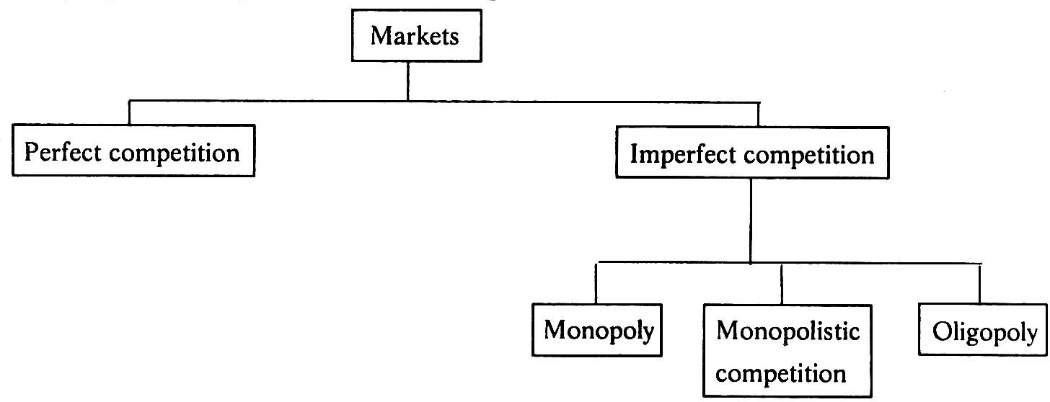

PERFECT COMPETITION
Perfect competition refers to a market structure where competition among the sellers and buyers prevails in its most perfect form. In a perfectly competitive market, a single market price prevails for the commodity, which is determined by the forces of total demand and total supply in the market.
A market structure in which all firms in an industry are price takers and in which there is
freedom of entry into and exit from the industry is called perfect competition. The market with perfect competition conditions is known as perfect market.

Features of perfectly competition

- A large number of buyers and sellers: The number of buyers and sellers is large and the share of each one of them in the market is so small that none has any influence on the market price.
There should be significantly large number of buyers and sellers in the market. The number should be so large that it should not make any difference in terms of price of quantity supplied even if one enters the market or one leaves the market.

- Homogenous products or services: the products and services of each seller should be homogeneous. They cannot be differentiated from that of one another. It makes no difference to the buyer whether he buys from firm X or firm Z. in other words, the buyer does not have any particular preference to buy the goods from a particular trader or supplier. The price is one and the same in every firm. There are no concessions or discounts.
- Freedom to enter or exit the market: there should not be restrictions on the part of the buyers and sellers to enter the market or leave the market. There should not be any barriers. The buyers can enter the market or leave the market whenever they want.
- Prefect information available to the buyers and sellers: each buyer and seller has total knowledge of the prices prevailing in the market at every given point of time, quantity supplied, costs, demand, nature of product, and other relevant information. There is no need for any advertisement expenditure as the buyers and sellers are fully informed.

- Perfect mobility of factors of production: there should not be any restrictions on the utilization of factors of production such as land , labour, capital and so on. In words, the firm or buyer should have free access to the factors of production. Whenever capital or labor is required, it should instantly be made available.
- Each firm is a price taker: an individual firm can alter its rate of production or sales without significantly affecting the market price of the product, a firm in a perfect market cannot influence the market through its own individual actions. It has no alternative other than selling its products at the price prevailing in the market. It cannot sell as much as it wants at its own set price

Monopoly
The word monopoly is made up of two syllables, Mono and poly. Mono means single while poly implies selling. Thus monopoly is a form of market organization in which there is only one seller of the commodity. There are no close substitutes for the commodity sold by the seller. Pure monopoly is a market situation in which a single firm sells a product for which there is no good substitute.
Features of monopoly
- Single person or a firm: A single person or a firm controls the total supply of the commodity. There will be no competition for monopoly firm. The monopolist firm is the only firm in the whole industry.
- No close substitute: The goods sold by the monopolist shall not have closely competition substitutes. Even if price of monopoly product increase people will not go in far substitute. For example: If the price of electric bulb increase slightly, consumer will not go in for kerosene lamp.
- Large number of Buyers: Under monopoly, there may be a large number of buyers in the market who compete among themselves.
- Price Maker: Since the monopolist controls the whole supply of a commodity, he is a price-maker, and then he can alter the price.
- Supply and Price: The monopolist can fix either the supply or the price. He cannot fix both. If he charges a very high price, he can sell a small amount. If he wants to sell more, he has to charge a low price. He cannot sell as much as he wishes for any price he pleases.
- Downward Sloping Demand Curve: The demand curve (average revenue curve) of monopolist slopes downward from left to right. It means that he can sell more only by lowering price.

Monopolistic competition

Monopolistic competition is said to exist when there are many firms and each one produces such goods and services that are close substitutes to each other. They are similar but not identical.
Product differentiation is the essential feature of monopolistic. Products can be differentiated by means of unique facilities, advertising, brand loyalty, packaging, pricing, terms of credit, superior maintenance services, convenient location and so on.

Features of Monopolistic

- Existence of Many firms: Industry consists of a large number of sellers, each one of whom does not feel dependent upon others. Every firm acts independently without bothering about the reactions of its rivals. The size is so large that an individual firm has only a relatively small part in the total market, so that each firm has very limited control over the price of the product. As the number is relatively large it is difficult for these firms to determine its price- output policies without considering the possible reactions of the rival forms. A monopolistically competitive firm follows an independent price policy.

- Product Differentiation: Product differentiation means that products are different in some ways, but not altogether so. The products are not identical but the same time they will not be entirely different from each other. IT really means that there are various monopolist firms competing with each other. An example of monopolistic competition and product differentiation is the toothpaste produced by various firms. The product of each firm is different from that of its rivals in one or more respects. Different toothpastes like Colgate, Close-up, Forehans, Cibaca, etc., provide an example of monopolistic competition. These products are relatively close substitute for each other but not perfect substitutes. Consumers have definite preferences for the particular verities or brands of products offered for sale by various sellers. Advertisement, packing, trademarks, brand names etc. help differentiation of products even if they are physically identical.

- Large Number of Buyers: There are large number buyers in the market. But the buyers have their own brand preferences. So the sellers are able to exercise a certain degree of monopoly over them. Each seller has to plan various incentive schemes to retain the customers who patronize his products.

- Free Entry and Exist of Firms: As in the perfect competition, in the monopolistic competition too, there is freedom of entry and exit. That is, there is no barrier as found under monopoly.

- Selling costs: Since the products are close substitute much effort is needed to retain the existing consumers and to create new demand. So each firm has to spend a lot on selling cost, which includes cost on advertising and other sale promotion activities.

- Imperfect Knowledge: Imperfect knowledge about the product leads to monopolistic competition. If the buyers are fully aware of the quality of the product they cannot be influenced much by advertisement or other sales promotion techniques. But in the business world we can see that thought the quality of certain products is the same, effective advertisement and sales promotion techniques make certain brands monopolistic. For examples, effective dealer service backed by advertisement-helped popularization of some brands through the quality of almost all the cement available in the market remains the same.

- The Group: Under perfect competition the term industry refers to all collection of firms producing a homogenous product. But under monopolistic competition the products of various firms are not identical through they are close substitutes. Prof. Chamberlin called the collection of firms producing close subset

OLIGOPOLY
The term oligopoly is derived from two Greek words: ‘oligi’ means few and ‘polein’ means to sell. Oligopoly is a market structure in which there are only a few sellers (but more than two) of the homogeneous or differentiated products. So, oligopoly lies in between monopolistic competition and monopoly.

Features of Oligopoly:

- Few firms: Under oligopoly, there are few large firms. The exact number of firms is not defined. Each firm produces a significant portion of the total output. There exists severe competition among different firms and each firm try to manipulate both prices and volume of production to outsmart each other. For example, the market for automobiles in India is an oligopolist structure as there are only few producers of automobiles.

- Interdependence: Firms under oligopoly are interdependent. Interdependence means that actions of one firm affect the actions of other firms. A firm considers the action and reaction of the rival firms while determining its price and output levels. A change in output or price by one firm evokes reaction from other firms operating in the market. For example, market for cars in India is dominated by few firms (Maruti, Tata, Hyundai, Ford, Honda, etc.). A change by any one firm (say, Tata) in any of its vehicle (say, Indica) will induce other firms (say, Maruti, Hyundai, etc.) to make changes in their respective vehicles.

- Non-Price Competition: Under oligopoly, firms are in a position to influence the prices. However, they try to avoid price competition for the fear of price war. They follow the policy of price rigidity. Price rigidity refers to a situation in which price tends to stay fixed irrespective of changes in demand and supply conditions. Firms use other methods like advertising, better services to customers, etc. to compete with each other.

- Barriers to Entry of Firms: The main reason for few firms under oligopoly is the barriers, which prevent entry of new firms into the industry. Patents, requirement of large capital, control over crucial raw materials, etc, are some of the reasons, which prevent new firms from entering into industry. Only those firms enter into the industry which is able to cross these barriers. As a result, firms can earn abnormal profits in the long run.

- Role of Selling Costs: Due to severe competition ‘and interdependence of the firms, various sales promotion techniques are used to promote sales of the product. Advertisement is in full swing under oligopoly, and many a times advertisement can become a matter of life-and-death. A firm under oligopoly relies more on non-price competition.

- Group Behaviour: Under oligopoly, there is complete interdependence among different firms. So, price and output decisions of a particular firm directly influence the competing firms. Instead of independent price and output strategy, oligopoly firms prefer group decisions that will protect the interest of all the firms. Group Behaviour means that firms tend to behave as if they were a single firm even though individually they retain their independence.

- Nature of the Product: The firms under oligopoly may produce homogeneous or differentiated product.

Price Determination under Perfect Competition
Under perfect competition, many factors influence the determination of the price of goods. In this article, we will look at the equilibrium of the industry and the equilibrium of a firm as important factors behind price determination under perfect competition.
Equilibrium of the Industry under Perfect Competition
In economic terms, an industry consists of many independent firms. Each firm has a number of factories, farms or mines, as required. Each such firm in industry produces a homogeneous product. Equilibrium of the industry happens when the total output of the industry is equal to the total demand. In such a scenario, the prevailing price of a commodity is its equilibrium price.
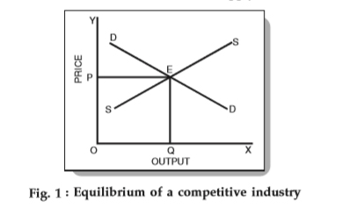
We know that under competitive conditions, the interaction of demand and supply determines the equilibrium price as shown below:

In Fig. 1 above, OP is the equilibrium price. Further, OQ is the equilibrium quantity sold at that price. Now, the equilibrium price is the price at which both the demand and supply are equal. In other words, no buyer, who wanted to buy at that price, goes dissatisfied and no seller, who wanted to sell his goods at that price, goes dissatisfied either.
Note that with the demand remaining the same, if the price is higher or lower than OP, then the market is not in equilibrium. Also, if goods are lesser or higher than the demand, the equilibrium is not attained.

Equilibrium of the Firm under Perfect Competition
A firm is in equilibrium when it maximizes its profits. Hence, the output that offers maximum profit to a firm is the equilibrium output. When a firm is in equilibrium, there is no reason to increase or decrease the output.
In a competitive market, firms are price-takers. The reason being the presence of a large number of firms who produce homogeneous products. Therefore, firms cannot influence the price in their individual capacities. They have to follow the price determined by the industry.
The following figure shows a firm’s demand curve under perfect competition:

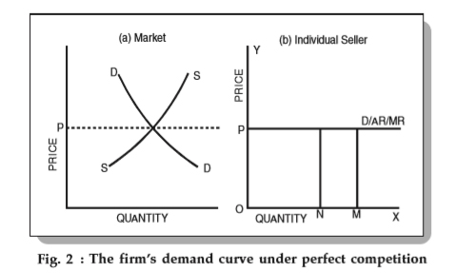
From Fig. 2 above, you can see that the industry price, OP, is fixed throughout the interaction of demand and supply of the industry. Firms have to accept this price. Hence, they are price-takers and not price-makers. Hence, they cannot increase or decrease the price OP.
Therefore, the line P acts as a demand curve for such firms. Hence, in perfect competition, the demand curve of an individual firm is a horizontal line at the level of the industry-set market price. Firms have to choose the level of output that yields maximum profit.

Conditions for the equilibrium of a firm
To attain an equilibrium position, a firm must satisfy the following two conditions:
They must ensure that the marginal revenue is equal to the marginal cost (MR = MC).
- If MR > MC, the firm has an incentive to expand its production and sell additional units.
- If MR < MC, the firm must reduce the output since additional units add more cost than revenue.
- The firm gets maximum profits only when MR = MC.
- The MC curve must have a positive slope and cut the MR curve from below.
- In Fig. 3 above, DD is the demand curve and SS is the supply curve. They equilibrate at point E and set the market price as OP. Under perfect competition, firms adopt OP as the industry price and consider the P-line as the demand curve or AR – average revenue curve (perfectly elastic at P).
- Since all units are equally priced, the MR curve is a horizontal line and is equal to the AR line. Observe that the curve MC cuts the MR curve at two points – T and R. At point T, the MC curve cuts the MR curve from above whereas at point R it cuts the MR curve from below. Therefore, according to the conditions of equilibrium of a firm, point R is the point of equilibrium and OQ₂ is the equilibrium level of output.

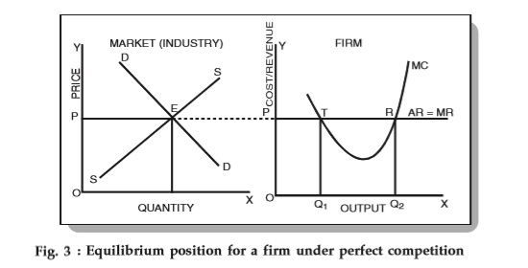

In Fig. 3 above, DD is the demand curve and SS is the supply curve. They equilibrate at point E and set the market price as OP. Under perfect competition, firms adopt OP as the industry price and consider the P-line as the demand curve or AR – average revenue curve (perfectly elastic at P).
Since all units are equally priced, the MR curve is a horizontal line and is equal to the AR line. Observe that the curve MC cuts the MR curve at two points – T and R. At point T, the MC curve cuts the MR curve from above whereas at point R it cuts the MR curve from below. Therefore, according to the conditions of equilibrium of a firm, point R is the point of equilibrium and OQ₂ is the equilibrium level of output.

Price and Output Determination under Monopoly During Short-Run
The monopoly-owned firm achieves price and output determination under monopoly and equilibrium in the short run at the point when profits are the highest and losses are minimal.
- Super-Normal Profit
In the short-run, SAC and SMC are the marginal and short-run average revenue curves, while AVC represents the mean variable cost curve for the company. For a variety of reasons, it is the case the AVC curve is not available in figure 6.14. The price and output determination under monopoly. The curve of demand D=AR whose marginal revenue curve can describe as MR. At the point the point. The short-run equilibrium at which the SMC curve cuts into the MR curve below.

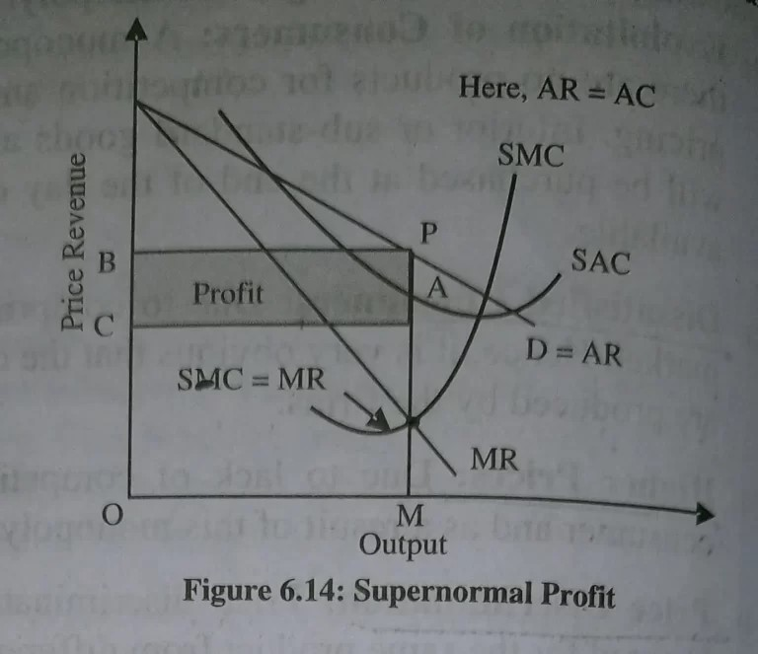
The monopoly price and output determination is must. The Monopolist can sell OM output at the MP Price. This price is MP. is higher than the cost of short-run MA. The Monopolist makes AP Profit per Unit of Output. So total profits from monopolies include:
APXCA= the area CAPB.
- Normal Profit
When monopolists earn just average profits, it can be in their short-run equilibrium shown in figure 6.15. OM output determines by equalization between the SMC curve and MR curve at point E. Its sale is at the MP Price. At this point in production, the company’s owner makes average profits as there is no loss as the SAC curve is tangent with the AR curve. The Monopolist knows that any output beyond OM could result in losses as the SAC curve is greater than the AR curve.
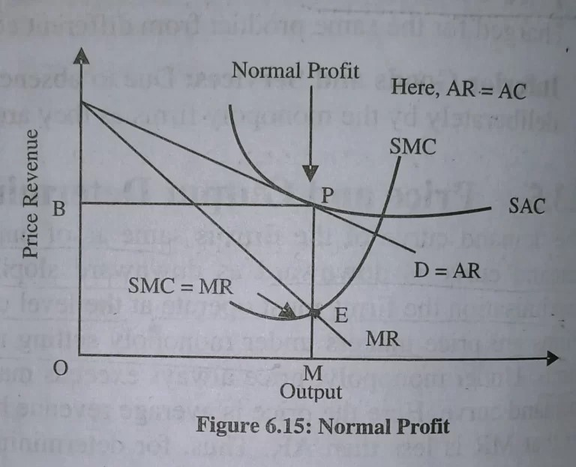

- Minimum Loss
The Monopolist suffers losses in a short-run scenario, as illustrated in figure 6.16. The equilibrium level E is calculated through the formula SMC=MR. However, the price for monopoly MP, determined by the demand conditions, doesn’t provide the cost of short-run production associated with production PA. The price and output determination under monopoly (with diagram) is as follows. The price only covers variable costs that are average MP. The tangency is the ratio between both the curve of demand D and the AVC curve at point P.
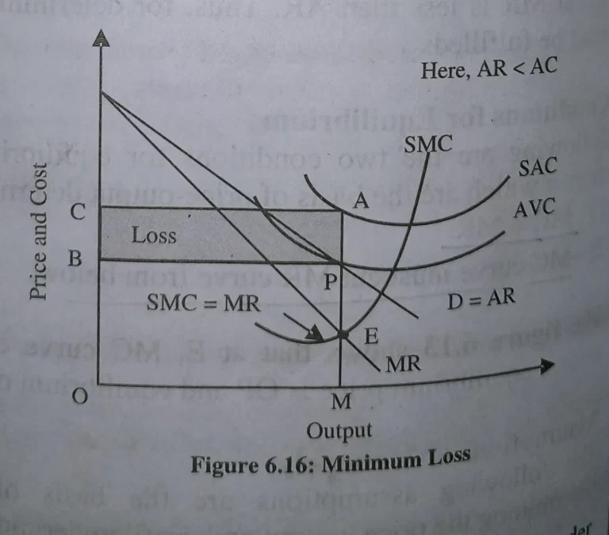
Therefore, the PA is responsible per unit loss for the Monopolist. We can help in price and output determination under monopoly. Total losses equal BPXPA=BPAC BPAC In this illustration, 6.16. P is the point of closure for this company. If the price at the point MP decreases downwards due to market conditions, production must temporarily stop by the Monopolist. The firm is shut down.

Price and Output Determination under Monopoly During Long-Run
At that point in production, the marginal cost is more significant than the marginal revenue, and the long-term equilibrium of the firm in the monopoly model is achievable. To determine price and output determination under monopoly, you have to use it. Due to the inability of new companies into markets, the income of the monopoly company is not as high in the long term. For price output determination under monopoly it is important to know about the monopoly firm. Despite this the fact that there is no loss for the monopoly firm since, over time, everything is reversible and is recoupable. Supposing that, in the end, the monopoly firm can’t cover the variable cost; the firm should cease production and exit the market.
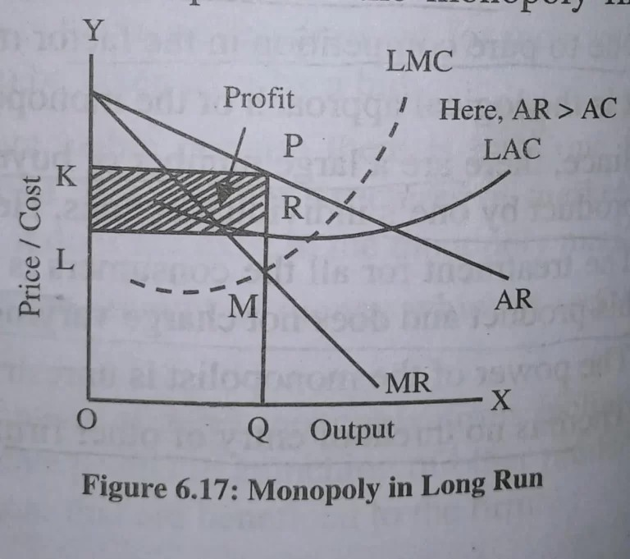
In diagram , M is the point at which the firm is at equilibrium when LMC for the company merges with MR. OQ output generates the firm in the price of equilibrium OK that is acceptable. The profit PR per unit reaches the production level, OQ, when the company’s average revenue is more significant than its cost of production, and the shading area KLRP is the same as the profit total.

Price-output determination under Monopolistic Competition: Equilibrium of a firm
In monopolistic competition, since the product is differentiated between firms, each firm does not have a perfectly elastic demand for its products. In such a market, all firms determine the price of their own products. Therefore, it faces a downward sloping demand curve. Overall, we can say that the elasticity of demand increases as the differentiation between products decreases.
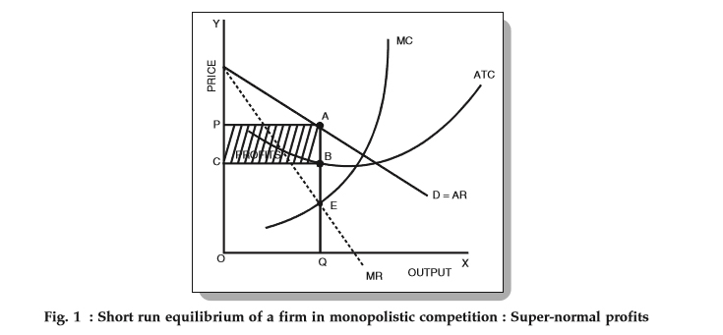
Fig. 1 above depicts a firm facing a downward sloping, but flat demand curve. It also has a U-shaped short-run cost curve.

Conditions for the Equilibrium of an individual firm
The conditions for price-output determination and equilibrium of an individual firm are as follows:
- MC = MR
- The MC curve cuts the MR curve from below.
In Fig. 1, we can see that the MC curve cuts the MR curve at point E. At this point,
- Equilibrium price = OP and
- Equilibrium output = OQ
Now, since the per unit cost is BQ, we have
- Per unit super-normal profit (price-cost) = AB or PC.
- Total super-normal profit = APCB
The following figure depicts a firm earning losses in the short-run.
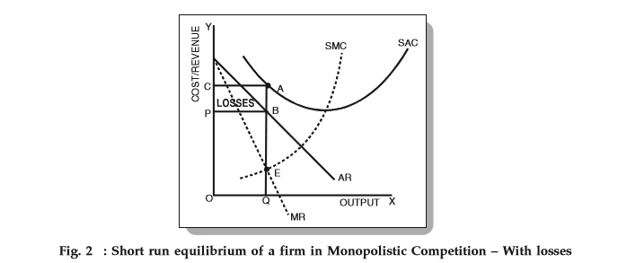
From Fig. 2, we can see that the per unit cost is higher than the price of the firm. Therefore,
- AQ > OP (or BQ)
- Loss per unit = AQ – BQ = AB
- Total losses = ACPB

Long-run equilibrium
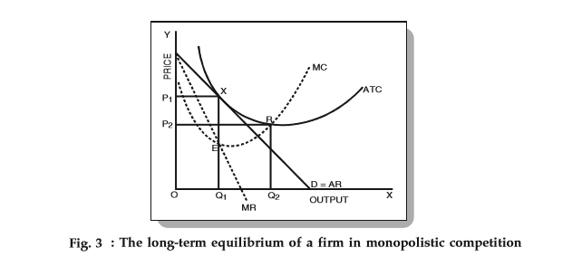
- If firms in a monopolistic competition earn super-normal profits in the short-run, then new firms will have an incentive to enter the industry. As these firms enter, the profits per firm decrease as the total demand gets shared between a larger number of firms. This continues until all firms earn only normal profits. Therefore, in the long-run, firms, in such a market, earn only normal profits.

- As we can see in Fig. 3 above, the average revenue (AR) curve touches the average cost (ATC) curve at point X. This corresponds to quantity Q₁ and price P₁. Now, at equilibrium (MC = MR), all super-normal profits are zero since the average revenue = average costs. Therefore, all firms earn zero super-normal profits or earn only normal profits.
- It is important to note that in the long-run, a firm is in an equilibrium position having excess capacity. In simple words, it produces a lower quantity than its full capacity. From Fig. 3 above, we can see that the firm can increase its output from Q₁ to Q₂ and reduce average costs. However, it does not do so because it reduces the average revenue more than the average costs. Hence, we can conclude that in monopolistic competition, firms do not operate optimally. There always exists an excess capacity of production with each firm.
- In case of losses in the short-run, the firms making a loss will exit from the market. This continues until the remaining firms make normal profits only.

Kinked Demand Curve
In many oligopolist markets, it has been observed that prices tend to remain inflexible for a very long time. Even in the face of declining costs, they tend to change infrequently. American economist Sweezy came up with the kinked demand curve hypothesis to explain the reason behind this price rigidity under oligopoly.
According to the kinked demand curve hypothesis, the demand curve facing an oligopolist has a kink at the level of the prevailing price. This kink exists because of two reasons:
- The segment above the prevailing price level is highly elastic.
- The segment below the prevailing price level is inelastic.
The following figure shows a kinked demand curve dD with a kink at point P.
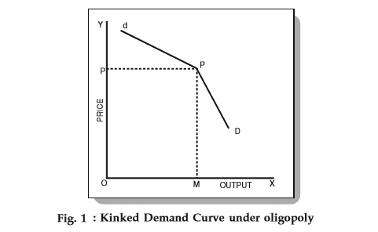
From the figure, we know that
- The prevailing price level = P
- The firm produces and sells output = OM
- Also, the upper segment (dP) of the demand curve (dD) is elastic.
- The lower segment (PD) of the demand curve (dD) is relatively inelastic.
This difference in elasticities is due to an assumption of the kinked demand curve hypothesis.

Assumption:
Each firm in an oligopoly believes the following two things:
- If a firm lowers the price below the prevailing level, then the competitors will follow him.
- If a firm increases the price above the prevailing level, then the competitors will not follow him.
There is logical reasoning behind this assumption. When an oligopolist lowers the price of his product, the competitors feel that if they don’t follow the price cut, then their customers will leave them and buy from the firm who is offering a lower price.
Therefore, they lower their prices too in order to maintain their customers. Hence, the lower portion of the curve is inelastic. It implies that if an oligopolist lowers the price, he can obtain very little sales.
On the other hand, when a firm increases the price of its product, it experiences a substantial reduction in sales. The reason is simple – consumers will buy the same/similar product from its competitors.
This increases the competitors’ sales and they will have no motivation to match the price rise. Therefore, the firm that raises the price suffers a loss and hence refrain from increasing the price.
This behavior of oligopolists can help us understand the elasticity of the upper portion of the demand curve (dP). The figure shows that if a firm raises the price of a product, then it experiences a large fall in sales.
Hence, no firm in an oligopolistic market will try to increase the price and a kink is formed at the prevailing price. This is how the kinked demand curve hypothesis explains the rigid or sticky prices.

Cournot’s Duopoly Model (With Diagram)
The earliest duopoly model was developed in 1838 by the French economist Augustin Cournot.
The original version is quite limited in that it makes the assumption that the duopolists have identical products and identical costs.
Actually Cournot illustrated his model with the example of two firms each owning a spring of mineral water, which is produced at zero costs. We will present briefly this version, and then we will generalize its presentation by using the reaction curves approach.
Cournot assumed that there are two firms each owning a mineral well, and operating with zero costs. They sell their output in a market with a straight-line demand curve. Each firm acts on the assumption that its competitor will not change its output, and decides its own output so as to maximize profit.
Assume that firm A is the first to start producing and selling mineral water. It will produce quantity A, at price P where profits are at a maximum (figure 9.1), because at this point MC — MR = 0. The elasticity of market demand at this level of output is equal to unity and the total revenue of the firm is a maximum. With zero costs, maximum R implies maximum profits, Π. Now firm B assumes that A will keep its output fixed (at 0/1), and hence considers that its own demand curve is CD’.
Clearly firm B will produce half the quantity AD’, because (under the Cournot assumption of fixed output of the rival) at this level (AB) of output (and at price F) its revenue and profit is at a maximum. B produces half of the market which has not been supplied by A, that is, B’s output is ¼ (= ½. ½) of the total market.
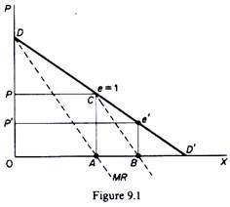
Firm A, faced with this situation, assumes that B will retain his quantity constant in the next period. So he will produce one-half of the market which is not supplied by B. Since B covers one-quarter of the market, A will, in the next period, produce ½(1 – ¼) = ½. ¾ = ⅜ of the total market.
Firm B reacts on the Cournot assumption, and will produce one-half of the unsupplied section of the market, i.e. ½ (1 – ⅜) = 5/16.
In the third period firm A will continue to assume that B will not change its quantity, and thus will produce one-half of the remainder of the market, i.e. ½ (1 – 5/16).
This action-reaction pattern continues, since firms have the naive behaviour of never learning from past patterns of reaction of their rival. However, eventually an equilibrium will be reached in which each firm produces one-third of the total market. Together they cover two-thirds of the total market. Each firm maximises its profit in each period, but the industry profits are not maximised.
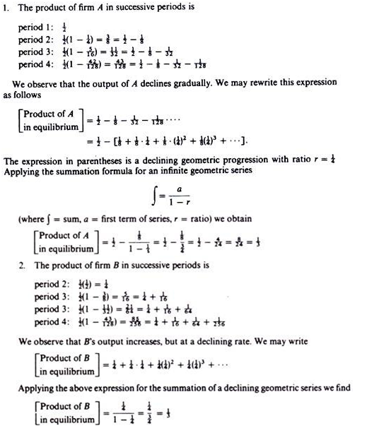

Difference between Perfect Competition, Monopoly, Monopolistic Competition, and Oligopoly
Basis | Perfect Competition | Monopoly | Monopolistic Competition | Oligopoly
Meaning | It is a market situation where a large number of buyers and sellers deal in a homogeneous product at a fixed price set by the market. | It is a market situation where there is only one seller in the market selling a product with no close substitutes. | It is a market situation in which there is a large number of firms selling closely related products that can be differentiated. | It is a market situation where the number of big sellers of a commodity is less and the number of buyers is more.
Number of Sellers | This market has very large number of sellers. | This market has a single seller. | This market has a large number of sellers. | This market has big sellers.
Number of Product | This market has homogeneous products. | There are no close substitutes in this market. | This market has closely related but differentiated products. | This market has homogeneous or differentiated products.
Entry and Exit of Firms | There is freedom of entry and exit in this market. | There is a restriction on the entry of new firms and exit of old firms. | There is freedom of entry and exit in this market. | There is a barrier on the entry of new firms into the market.
Demand Curve | This market has a perfectly elastic demand curve. | This market is less elastic and has a downward-sloping demand curve. | This market is more elastic but has a downward-sloping demand curve. | The demand curve of an oligopoly market is uncertain as one cannot determine the exact behaviour pattern of a producer.
Price | As each of the firms in this market is a price-taker, the price is uniform. | As the firms in this market are price-maker, there is a possibility of price discrimination. | The firms have partial control over the price because of product differentiation. | There is price rigidity in this market as the firms can influence it.
Selling Costs | In this market, no selling costs are incurred. | In this market, only informative selling costs are incurred. | In this market, high selling costs are spent. | In this market, huge selling cost is spent as it relies more on non-price competition.
Level of Knowledge | Perfect Knowledge | Imperfect Knowledge | Imperfect Knowledge | Perfect Knowledge

