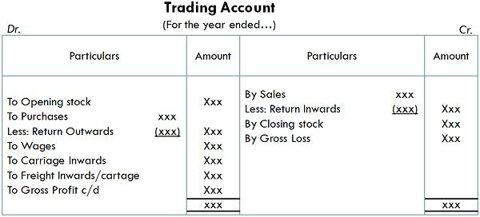
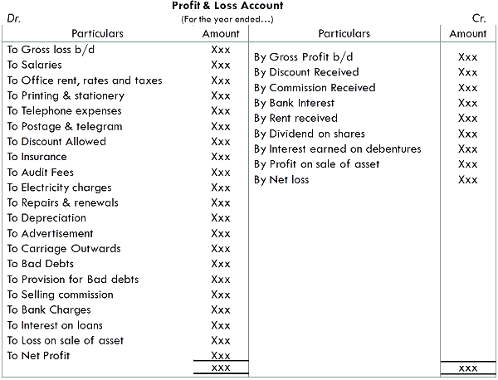

BALANCE SHEET
As on 31st March, 20XX
--------------------------------------------------------------------------------
| LIABILITIES ASSETS
--------------------------------------------------------------------------------
| Capital Fixed Asset:
Opening capital xx Land & Building
| Add: Net Profit xx Plant & Machinery
| Less: Drawings (xx) xx Furniture & Fixtures
| Vehicles
| Computers

| Long-term Liabilities Intangible Assets:
| Bank Loan Goodwill
| Debentures Patents
| Mortgage Loan Trademarks

| Current Liabilities Current Assets
| Sundry Creditors Cash in Hand
| Bills Payable Cash at Bank
| Outstanding Expenses Sundry Debtors
| Bank Overdraft Bills Receivable
| Short-term Loan Closing Stock
| Unearned Income(Income Prepaid Expenses
|received in advance) Accrued Income

| TOTAL LIABILITIES TOTAL ASSETS
|

Problems # 1:
From the following particulars taken out from the books of Abdul Hanan & Co. You are required to prepare Trading and Profit & Loss Account and Balance Sheet as at December 31st, 2019.
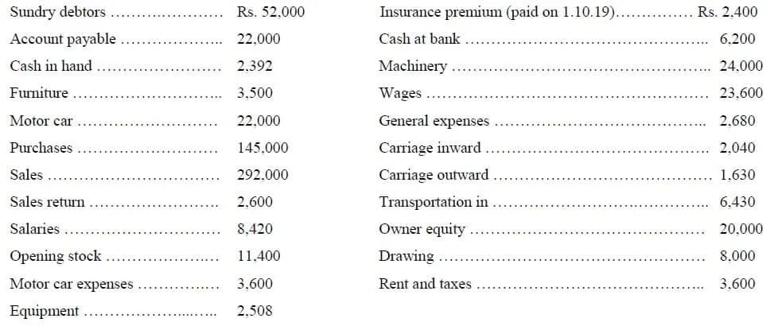

Adjustments:
(a) Closing stock Rs, 35,000.
(b) Provision for doubtful debts at 5% of sundry debtors.
(c) Depreciation furniture and machinery by 10%.
(d) Commission of Rs. 3,600 has been earned but not received till the closing of accounts.

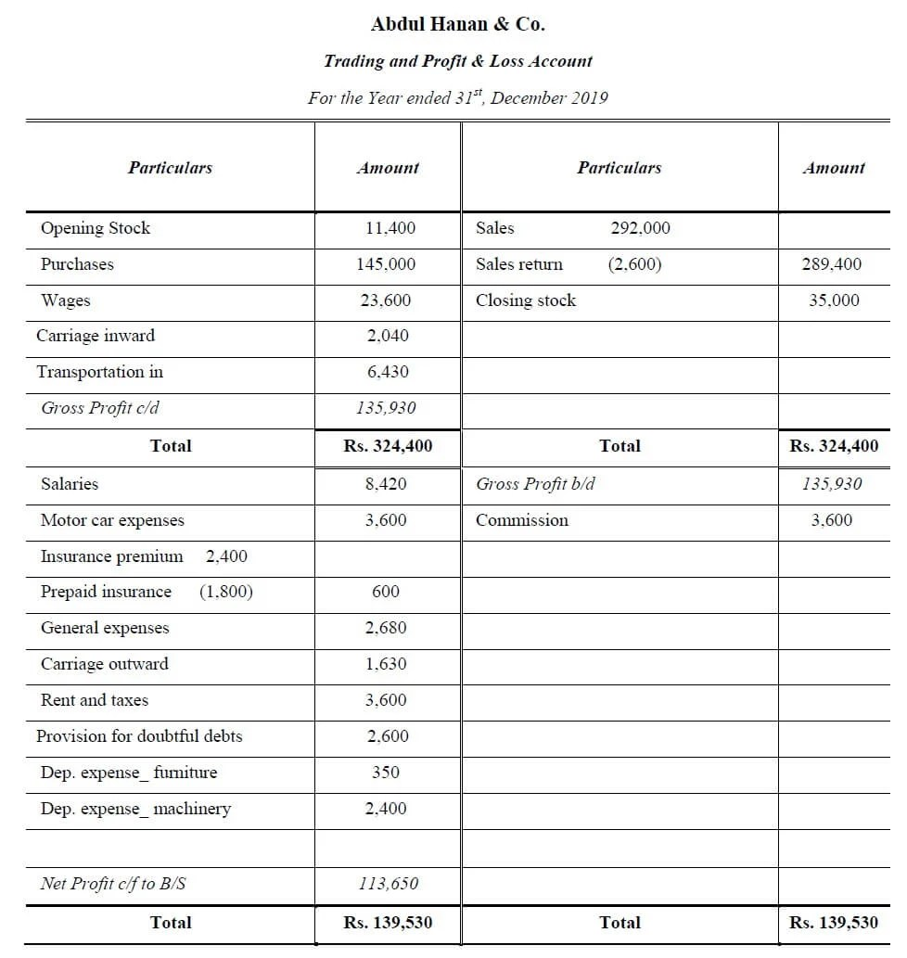
Working / Notes
- Sales (292,000) less Sales returns (2,600) = Net Sales 289,400 (used in Trading A/c).
- Commission ₹3,600 earned but not received → shown as other income and as a current asset (Commission receivable).
- Insurance paid on 1-10-2019 ₹2,400: for year to 30-9-2020; 3 months expired → insurance expense ₹600; prepaid (asset) ₹1,800.
- Provision for doubtful debts = 5% × Sundry Debtors (52,000) = ₹2,600.
- Depreciation: Furniture 10% of 3,500 = ₹350; Machinery 10% of 24,000 = ₹2,400.
- Net Profit = Gross Profit 135,930 + Commission 3,600 − Total expenses (25,880) = ₹113,650.

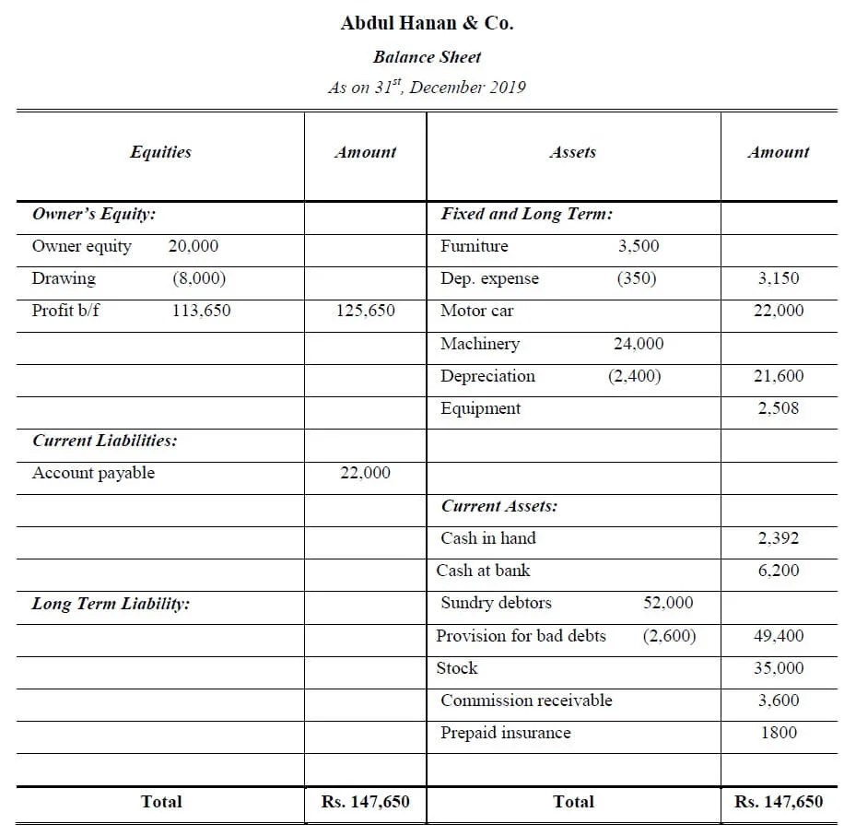
From the following Trial Balance of M/s Star Traders as on 31st March 2024, prepare:
- Trading Account
- Profit & Loss Account
- Balance Sheet
Particulars | Debit (₹) | Credit (₹)
Capital |  | 1,50,000
Drawings | 10,000
Opening Stock | 25,000
Purchases | 1,20,000
Sales |  | 2,30,000
Returns Inwards | 5,000
Returns Outwards |  | 3,000
Wages | 12,000
Carriage Inwards | 3,000
Salaries | 18,000
Rent | 9,000
Discount Allowed | 2,000
Discount Received |  | 3,500
Debtors | 40,000
Creditors |  | 35,000
Furniture | 20,000
Cash in Hand | 5,500
Bank Balance | 22,000
Total | 2,91,500 | 2,91,500

Adjustments
- Closing Stock as on 31-03-2024 is ₹30,000
- Outstanding Salaries ₹2,000
- Prepaid Rent ₹1,000
- Depreciate furniture @ 10% per annum

