**Managerial economics relationship with other disciplines:**

Many new subjects have evolved in recent years due to the interaction among basic disciplines. While there are many such new subjects in natural and social sciences, managerial economics can be taken as the best example of such a phenomenon among social sciences. Hence it is necessary to trace its roots and relationship with other disciplines.

1. **Relationship with economics:**

The relationship between managerial economics and economics theory may be viewed form the point of view of the two approaches to the subject Viz. Micro Economics and Marco Economics. Microeconomics is the study of the economic behavior of individuals, firms and other such micro organizations. Managerial economics is rooted in Micro Economic theory. Managerial Economics makes use to several Micro Economic concepts such as marginal cost, marginal revenue, elasticity of demand as well as price theory and theories of market structure to name only a few. Macro theory on the other hand is the study of the economy as a whole. It deals with the analysis of national income, the level of employment, general price level, consumption and investment in the economy and even matters related to international trade, Money, public finance, etc.

1. **Management theory and accounting:**

Managerial economics has been influenced by the developments in management theory and accounting techniques. Accounting refers to the recording of pecuniary transactions of the firm in certain books. A proper knowledge of accounting techniques is very essential for the success of the firm because profit maximization is the major objective of the firm.

Managerial Economics requires a proper knowledge of cost and revenue information and their classification. A student of managerial economics should be familiar with the generation, interpretation and use of accounting data. The focus of accounting within the firm is fast changing from the concepts of store keeping to that if managerial decision making, this has resulted in a new specialized area of study called “Managerial Accounting”.

1. **Managerial Economics and mathematics:**

The use of mathematics is significant for managerial economics in view of its profit maximization goal long with optional use of resources. The major problem of the firm is how to minimize cost, hoe to maximize profit or how to optimize sales. Mathematical concepts and techniques are widely used in economic logic to solve these problems. Also mathematical methods help to estimate and predict the economic factors for decision making and forward planning.

Mathematical symbols are more convenient to handle and understand various concepts like incremental cost, elasticity of demand etc., Geometry, Algebra and calculus are the major branches of mathematics which are of use in managerial economics.

1. **Managerial Economics and Statistics:**

Managerial Economics needs the tools of statistics in more than one way. A successful businessman must correctly estimate the demand for his product. He should be able to analyses the impact of variations in tastes. Fashion and changes in income on demand only then he can adjust his output. Statistical methods provide and sure base for decision- making. Thus statistical tools are used in collecting data and analyzing them to help in the decision making process.

Statistical tools like the theory of probability and forecasting techniques help the firm to predict the future course of events. Managerial Economics also make use of correlation and multiple regressions in related variables like price and demand to estimate the extent of dependence of one variable on the other. The theory of probability is very useful in problems involving uncertainty.

1. **Managerial Economics and Operations Research:**

Taking effectives decisions is the major concern of both managerial economics and operations research. The development of techniques and concepts such as linear programming, inventory models and game theory is due to the development of this new subject of operations research in the postwar years. Operations research is concerned with the complex problems arising out of the management of men, machines, materials and money.

Operation research provides a scientific model of the system and it helps managerial economists in the field of product development, material management, and inventory control, quality control, marketing and demand analysis. The varied tools of operations Research are helpful to managerial economists in decision-making.

1. **Managerial Economics and the theory of Decision- making:**

The Theory of decision-making is a new field of knowledge grown in the second half of this century. Most of the economic theories explain a single goal for the consumer i.e., Profit maximization for the firm. But the theory of decision-making is developed to explain multiplicity of goals and lot of uncertainty.

As such this new branch of knowledge is useful to business firms, which have to take quick decision in the case of multiple goals. Viewed this way the theory of decision making is more practical and application oriented than the economic theories.

1. **Managerial Economics and Computer Science*:***

Computers have changes the way of the world functions and economic or business activity is no exception. Computers are used in data and accounts maintenance, inventory and stock controls and supply and demand predictions. What used to take days and months is done in a few minutes or hours by the computers. In fact computerization of business activities on a large scale has reduced the workload of managerial personnel. In most countries a basic knowledge of computer science, is a compulsory programme for managerial trainees.

**Central Problems of an economy**

The basic economic activities of life are production, distribution, and disposition of goods and services. A society will be facing scarcity of resources during the time of fulfillment of these activities.

Scarcity is evident, due to the availability of limited resources, and human needs having no limit. This variation between the supply and demand leads to the formation of central problems of an economy.

The central problems of an economy revolve around the following factors:.

1. What to produce?
2. How to produce?
3. For whom to produce?

**What to produce?**

It is one of the central problems in an economy. It is related to the type and quantity of goods and services that need to be produced. Since resources are in limited quantities, producing more of one good will result in less production of the other.

**How to produce?**

This aspect deals with the process or technique by which the goods and services can be produced. Generally, there are two techniques of production:

1. Labour intensive techniques
2. Capital intensive techniques

The choice of technique for production depends on the availability of the resource in that nation,  hence resource allocation becomes a challenge.

**For whom to produce?**

This problem deals with determining the final consumers of the goods produced. As resources are scarce in an economy, it becomes difficult to cater to all sections of the society.

It leads to a problem of choice in an economy as a good that may be in demand among one section, may not be in demand for another section of the society.

Such a situation arises due to the difference in income distribution among the population, which causes a change in buying behaviour.

**The Economic Problem: Scarcity and Choice**

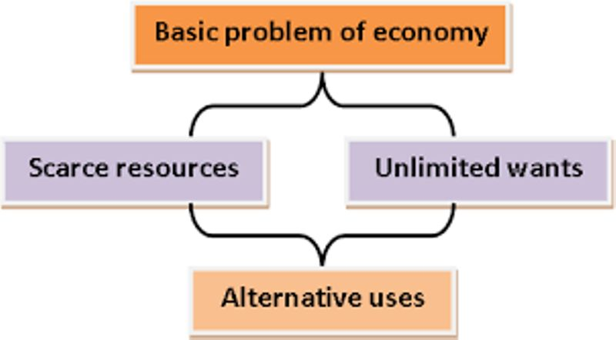Economy is derived from two Greek words which mean house and distribute. Economy was studied to understand the management of a household that later started being used to manage resources.

The basic problem of an economy deals with the needs and wants of a man being unlimited and the resources are scarce. The resources include the factors of production that are land, labour, capital and entrepreneurship.

Economics is the social science that studies how people use their scarce resources to satisfy unlimited needs and wants. From a teenager to a homemaker and then to a businessman all face the same issue of how to spend their income to attain maximum satisfaction.

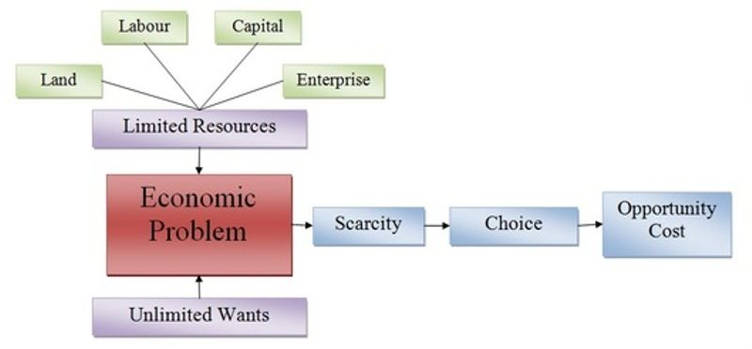

**Scarcity**

The purpose of production is to satisfy one’s want but as the resources are limited, not enough output is available to fulfil every man’s want. This explains that human wants are unlimited which are not fulfilled by the limited resources as stated by the Law of scarcity.

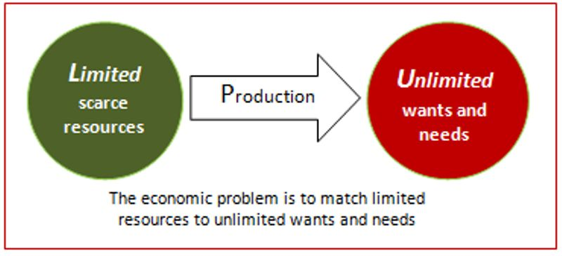

The demand is high as compared to the supply, and due to insufficient resources satisfaction is not achieved. To overcome this, the choice is made available to man to allocate their resources in such a way that maximum satisfaction can be achieved.

For instance, a man walks into a grocery store with ₹500, he would buy products in a way that when he walks out the products with him would be equal to the value of ₹500. He might want food grains, toiletries, milk, cooking essentials, etc but he would allocate the money available to him in such a way that he attains maximum satisfaction from his purchase.

**Choices**

Scarcity gives rise to the economic problem of choice. As there are limited resources, the choice is given to decide what one wishes to get by sacrificing one of its demand. When the choice is made there is sacrifice involved in it. The decision to consume a product also means a decision to not consume another. One product can only be consumed by giving up something in exchange. Opportunity Cost refers to the cost of sacrifice that is done to choose the next best alternative.

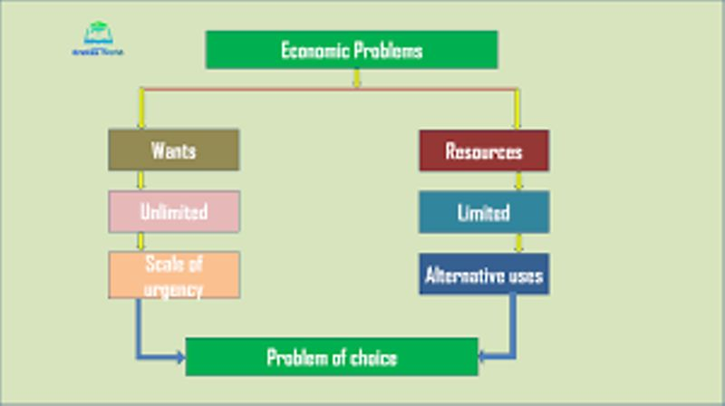

To Exemplify, a farmer has 10 acres of land he has a choice to either grow wheat or cotton on it. The limited land is a scarcity of the resource. The alternative crops wheat and cotton show how we have choices. To grow one of the two crops the other crop’s production has to be sacrificed, this is the opportunity cost involved.

**Inflation-**

* According to Crowther, “Inflation is a ‘state’ is which the value of money is falling i.e. the prices are rising.”
* According to [Milton Friedman](http://www.econlib.org/library/Enc/bios/Friedman.html), “Inflation is always and everywhere a monetary phenomenon.”
* According to [John Maynard Keynes](http://www.econlib.org/library/Enc/bios/Keynes.html), “Inflation is the result of the excess of aggregate demand over the available aggregate supply and true inflation starts only after full employment.”
* According to [Paul Samuelson](http://www.econlib.org/library/Enc/bios/Samuelson.html), “Inflation occurs when the general level of prices and costs is rising.”

**Types of Inflation**

The Types of inflation are as follows:

**Demand-Pull Inflation**:  According to the demand-pull theory, prices rise in response to an excess of aggregate demand over existing supply of goods and services. It is also called excess-demand inflation. In the excess-demand theories of inflation, excess demand means aggregate real demand for output in excess of maximum feasible, or potential, or full employment, output (at the going price level). The demand-pull theorists point out that inflation (demand-pull) might be caused, in the first place, by an increase in the quantity of money.

**Cost-Push Inflation**: Cost push inflation or cost inflation is induced by the wage-inflation process. This is especially [true for a Country like India](https://www.mbaknol.com/managerial-economics/case-study-inflation-in-india/), where labour intensive techniques are commonly used. Theories of [cost-push inflation](https://www.mbaknol.com/managerial-economics/demand-pull-and-cost-push-inflation/) (also called sellers’ or mark-up inflation) came to be put forward after the mid-1950s. Accordingly, cost-push inflation can have   the forms of   wage-push inflation, profit-push inflation, material-cost push inflation, or inflation of a mixed variety in which several push factors reinforce each other and that   the increase in costs is passed on to buyers of   goods in the form of higher prices, and not absorbed   by producers. Thus, a rise in wages leads to a rise in the   total cost of production and a consequent rise   in the price level, because fundamentally, prices are   based on   costs.

**Build-In Inflation**: Vicious cycle of Build-in inflation is induced by adaptive expectations of workers or employees who try to keep their wages or salaries high in anticipation of inflation. Employers and Organisations raise the prices of their respective goods and services in anticipation of the workers or employees’ demands. This overall builds a vicious cycle of rising wages followed by an increase in general prices of commodities.

**Creeping Inflation:** When prices are gently rising, it is referred as Creeping Inflation. It is the mildest form of inflation and also known as a Mild Inflation or Low Inflation. According to R.P. Kent, when prices rise by not more than (upto) 3% per annum (year), it is called Creeping Inflation.

**Chronic Inflation**: If creeping inflation persist (continues to increase) for a longer period of time then it is often called as Chronic or Secular Inflation. Chronic Creeping Inflation can be either Continuous (which remains consistent without any downward movement) or Intermittent (which occurs at regular intervals). It is called chronic because if an inflation rate continues to grow for a longer period without any downturn, then it possibly leads to Hyperinflation.

**Walking Inflation**: When the rate of rising prices is more than the Creeping Inflation, it is known as Walking Inflation. When prices rise by more than 3% but less than 10% per annum (i.e between 3% and 10% per annum), it is called as Walking Inflation. According to some economists, walking inflation must be taken seriously as it gives a cautionary signal for the occurrence of running inflation. Furthermore, if walking inflation is not checked in due time it can eventually result in Galloping inflation.

**Moderate Inflation**: Prof. Samuelson clubbed together concept of Creeping and Walking inflation into Moderate Inflation. When prices rise by less than 10% per annum (single digit inflation rate), it is known as Moderate Inflation. According to Prof.  Samuelson, it is a stable inflation and not a serious economic problem.

**Running Inflation**: A rapid acceleration in the rate of rising prices is referred as Running Inflation. When prices rise by more than 10% per annum, running inflation occurs. Though economists have not suggested a fixed range for measuring running inflation, we may consider price rise between 10% to 20% per annum (double digit inflation rate) as a running inflation.

**Galloping Inflation**: According to Prof. Samuelson, if prices rise by double or triple digit inflation rates like 30% or 400% or 999% per annum, then the situation can be termed as Galloping Inflation. When prices rise by more than 20% but less than 1000% per annum (i.e. between 20% to 1000% per annum), galloping inflation occurs. It is also referred as Jumping  inflation. India has been witnessing galloping inflation since the second five year plan period.

**Hyperinflation**: Hyperinflation refers to a situation where the prices rise at an alarming high rate. The prices rise so fast that it becomes very difficult to measure its magnitude. However, in quantitative terms, when prices rise above 1000% per annum (quadruple or four digit inflation rate), it is termed as Hyperinflation. During a worst case scenario of hyperinflation, value of national currency (money) of an affected country reduces almost to zero. Paper money becomes worthless and people start trading either in gold and silver or sometimes even use the old barter system of commerce. Two worst examples of hyperinflation recorded in world history are of those experienced by  Hungary  in year 1946 and Zimbabwe  during 2004-2009 under  Robert Mugabe’s regime.

**Causes of Inflation**

Take a quick look at the factors that cause inflation are:-

**Primary Causes**

In an economy, when the demand for a commodity exceeds its supply, then the excess demand pushes the price up. On the other hand, when the factor prices increase, the cost of production rises too. This leads to an increase in the price level as well.

**Increase in Public Spending**

In any modern [economy](https://www.toppr.com/guides/economics/indian-economy-1950-1990/types-of-economies/), Government spending is an important [element](https://www.toppr.com/guides/chemistry/classification-of-elements-and-periodicity-in-properties/elements/) of the total spending. It is also an important determinant of aggregate [demand](https://www.toppr.com/guides/business-economics/theory-of-demand/meaning-and-determinants-of-demand/).

Usually, in lesser developed economies, the Govt. spending increases which invariably creates inflationary pressure on the economy.

**Deficit Financing of Government Spending**

There are times when the spending of Government increases beyond what taxation can finance. Therefore, in order to incur the extra expenditure, the Government resorts to deficit financing.

For example, it prints more money and spends it. This, in turn, adds to inflationary pressure.

**Increased Velocity of Circulation**

In an economy, the total use of money = the money supply by the Government x the velocity of circulation of money.

When an economy is going through a booming phase, people tend to spend money at a faster rate increasing the velocity of circulation of money.

**Population Growth**

As the population grows, it increases the total demand in the market. Further, excessive demand creates inflation.

**Hoarding**

Hoarders are people or entities who stockpile commodities and do not release them to the market. Therefore, there is an artificially created demand excess in the economy. This also leads to inflation.

**Genuine Shortage**

It is possible that at certain times, the factors of production are short in supply. This affects production. Therefore, supply is less than the demand, leading to an increase in prices and inflation.

**Exports**

In an economy, the total production must fulfill the domestic as well as foreign demand. If it fails to meet these demands, then exports create inflation in the domestic economy.

**Trade Unions**

[Trade union](https://en.wikipedia.org/wiki/Trade_union) work in favor of the employees. As the prices increase, these unions demand an increase in wages for workers. This invariably increases the cost of production and leads to a further increase in prices.

**Tax Reduction**

While taxes are known to increase with time, sometimes, [Governments](https://www.toppr.com/guides/civics/what-is-government/meaning-of-government/) reduce taxes to gain popularity among people. The people are happy because they have more money in their hands.

However, if the rate of production does not increase with a corresponding rate, then the excess cash in hand leads to inflation.

**Imposition of Indirect Taxes**

Taxes are the primary source of revenue for a Government. Sometimes, Governments impose indirect taxes like excise duty, VAT, etc. on businesses. As these indirect taxes increase the total cost for the manufacturers and/or sellers, they increase the price of the product to have a minimal impact on their profits.

**Price-rise in the International Markets**

Some products require to import commodities or factors of production from the international markets like the United States. If these [markets](https://www.toppr.com/guides/business-economics/meaning-and-types-of-markets/market-meaning-and-classification/) raise prices of these commodities or factors of production, then the overall production cost in India increases too. This leads to inflation in the domestic market.

**Measures to Control Inflation**

Some of the important measures to control inflation are as follows: 1. Monetary Measures 2. Fiscal Measures 3. Other Measures.

**1. Monetary Measures:**

Monetary measures aim at reducing money incomes.

**(a) Credit Control:**

One of the important monetary measures is monetary policy. The central bank of the country adopts a number of methods to control the quantity and quality of credit. For this purpose, it raises the bank rates, sells securities in the open market, raises the reserve ratio, and adopts a number of selective credit control measures, such as raising margin requirements and regulating consumer credit.

**(b) Demonetization of Currency:**

However, one of the monetary measures is to demonetize currency of higher denominations. Such measures are usually adopted when there is abundance of black money in the country.

**(c) Issue of New Currency:**

The most extreme monetary measure is the issue of new currency in place of the old currency. Under this system, one new note is exchanged for a number of notes of the old currency. The value of bank deposits is also fixed accordingly. Such a measure is adopted when there is an excessive issue of notes and there is hyperinflation in the country.

**2. Fiscal Measures:**

Monetary policy alone is incapable of controlling inflation. It should, therefore, be supplemented by fiscal measures. Fiscal measures are highly effective for controlling government expenditure, personal consumption expenditure, and private and public investment.

**The principal fiscal measures are the following:**

**(a) Reduction in Unnecessary Expenditure:**

The government should reduce unnecessary expenditure on non-development activities in order to curb inflation. This will also put a check on private expenditure which is dependent upon government demand for goods and services. But it is not easy to cut government expenditure. Though this measure is always welcome but it becomes difficult to distinguish between essential and non-essential expenditure. Therefore, this measure should be supplemented by taxation.

**(b) Increase in Taxes:**

To cut personal consumption expenditure, the rates of personal, corporate and commodity taxes should be raised and even new taxes should be levied, but the rates of taxes should not be so high as to discourage saving, investment and production. Rather, the tax system should provide larger incentives to those who save, invest and produce more.

**(c) Increase in Savings:**

Another measure is to increase savings on the part of the people. This will tend to reduce disposable income with the people, and hence personal consumption expenditure. But due to the rising cost of living, people are not in a position to save much voluntarily. It should also introduce compulsory provident fund, provident fund-cum-pension schemes, etc. All such measures increase savings and are likely to be effective in controlling inflation.

**(d) Surplus Budgets:**

An important measure is to adopt anti-inflationary budgetary policy. For this purpose, the government should give up deficit financing and instead have surplus budgets. It means collecting more in revenues and spending less.

**(e) Public Debt:**

At the same time, it should stop repayment of public debt and postpone it to some future date till inflationary pressures are controlled within the economy. Instead, the government should borrow more to reduce money supply with the public.

**3. Other Measures:**

The other types of measures are those which aim at increasing aggregate supply and reducing aggregate demand directly.

**(a) To Increase Production:**

**The following measures should be adopted to increase production:**

(i) One of the foremost measures to control inflation is to increase the production of essential consumer goods like food, clothing, kerosene oil, sugar, vegetable oils, etc.

(ii) If there is need, raw materials for such products may be imported on preferential basis to increase the production of essential commodities,

**(b) Rational Wage Policy:**

Another important measure is to adopt a rational wage and income policy. Under hyperinflation, there is a wage-price spiral. To control this, the government should freeze wages, incomes, profits, dividends, bonus, etc. But such a drastic measure can only be adopted for a short period as it is likely to antagonise both workers and industrialists.

**(c) Price Control:**

Price control and rationing is another measure of direct control to check inflation. Price control means fixing an upper limit for the prices of essential consumer goods. They are the maximum prices fixed by law and anybody charging more than these prices is punished by law. But it is difficult to administer price control.

**(d) Rationing:**

Rationing aims at distributing consumption of scarce goods so as to make them available to a large number of consumers. It is applied to essential consumer goods such as wheat, rice, sugar, kerosene oil, etc. It is meant to stabilize the prices of necessaries and assure distributive justice. But it is very inconvenient for consumers because it leads to queues, artificial shortages, corruption and black marketing. Keynes did not favour rationing for it “involves a great deal of waste, both of resources and of employment.”