**DEMAND ANALYSIS**

**Introduction & Meaning:**

Demand in common parlance means the desire for an object. But in economics demand is something more than this. According to Stonier and Hague, “Demand in economics means demand backed up by enough money to pay for the goods demanded”. This means that the demand becomes effective only it if is backed by the purchasing power in addition to this there must be willingness to buy a commodity.

Thus demand in economics means the desire backed by the willingness to buy a commodity and the purchasing power to pay. In the words of “Benham” “The demand for anything at a given price is the amount of it which will be bought per unit of time at that Price”.

**LAW of Demand:**

Law of demand shows the relation between price and quantity demanded of a commodity in the market. In the words of Marshall, “the amount demand increases with a fall in price and diminishes with a rise in price”.

A rise in the price of a commodity is followed by a reduction in demand and a fall in price is followed by an increase in demand, if a condition of demand remains constant.

The law of demand may be explained with the help of the following demand schedule.

***Demand Schedule.***

|  |  |
| --- | --- |
| Price of Appel (In. Rs.) | Quantity Demanded |
| 10 | 1 |
| 8 | 2 |
| 6 | 3 |
| 4 | 4 |
| 2 | 5 |

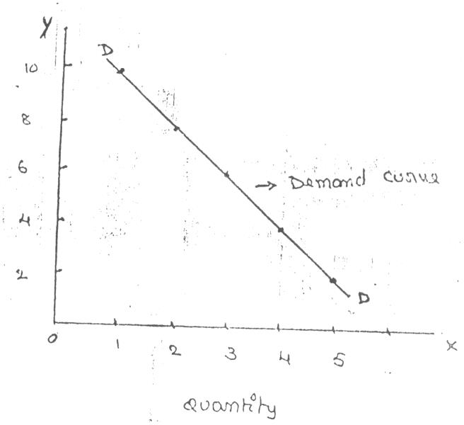When the price falls from Rs. 10 to 8 quantity demand increases from 1 to 2. In the same way as price falls, quantity demand increases on the basis of the demand schedule we can draw the demand curve.

Price

The demand curve DD shows the inverse relation between price and quantity demand of apple. It is downward sloping.

***Assumptions:***

Law is demand is based on certain assumptions:

* 1. This is no change in consumers taste and preferences.
  2. Income should remain constant.
  3. Prices of other goods should not change.
  4. There should be no substitute for the commodity
  5. The commodity should not confer at any distinction
  6. The demand for the commodity should be continuous
  7. People should not expect any change in the price of the commodity

***Exceptional demand curve:***

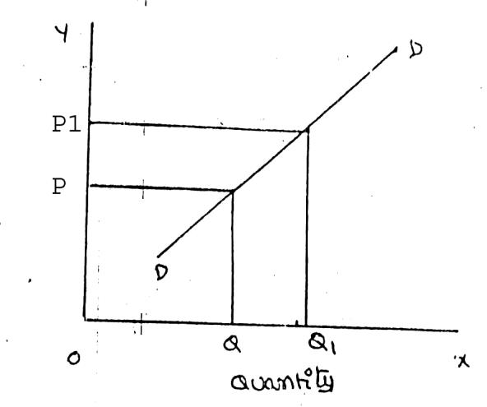Some times the demand curve slopes upwards from left to right. In this case the demand curve has a positive slope.

Price

When price increases from OP to Op1 quantity demanded also increases from to OQ1 and vice versa. The reasons for exceptional demand curve are as follows.

1. ***Giffen paradox:***

The Giffen good or inferior good is an exception to the law of demand. When the price of an inferior good falls, the poor will buy less and vice versa. For example, when the price of maize falls, the poor are willing to spend more on superior goods than on maize if the price of maize increases, he has to increase the quantity of money spent on it. Otherwise he will have to face starvation. Thus a fall in price is followed by reduction in quantity demanded and vice versa. “Giffen” first explained this and therefore it is called as Giffen’s paradox.

1. ***Veblen or Demonstration effect:***

‘Veblan’ has explained the exceptional demand curve through his doctrine of conspicuous consumption. Rich people buy certain good because it gives social distinction or prestige for example diamonds are bought by the richer class for the prestige it possess. It the price of diamonds falls poor also will buy is hence they will not give prestige. Therefore, rich people may stop buying this commodity.

1. ***Ignorance:***

Sometimes, the quality of the commodity is Judge by its price. Consumers think that the product is superior if the price is high. As such they buy more at a higher price.

1. ***Speculative effect:***

If the price of the commodity is increasing the consumers will buy more of it because of the fear that it increase still further, Thus, an increase in price may not be accomplished by a decrease in demand.

1. ***Fear of shortage:***

During the times of emergency of war People may expect shortage of a commodity. At that time, they may buy more at a higher price to keep stocks for the future.

***5. Necessaries:***

In the case of necessaries like rice, vegetables etc. people buy more even at a higher price.

**Factors Affecting Demand:**

There are factors on which the demand for a commodity depends. These factors are economic, social as well as political factors. The effect of all the factors on the amount demanded for the commodity is called Demand Function.

These factors are as follows:

1. ***Price of the Commodity:***

The most important factor-affecting amount demanded is the price of the commodity. The amount of a commodity demanded at a particular price is more properly called price demand. The relation between price and demand is called the Law of Demand. It is not only the existing price but also the expected changes in price, which affect demand.

1. ***Income of the Consumer:***

The second most important factor influencing demand is consumer income. In fact, we can establish a relation between the consumer income and the demand at different levels of income, price and other things remaining the same. The demand for a normal commodity goes up when income rises and falls down when income falls. But in case of Giffen goods the relationship is the opposite.

1. ***Prices of related goods***:

The demand for a commodity is also affected by the changes in prices of the related goods also. Related goods can be of two types:

* 1. Substitutes which can replace each other in use; for example, tea and coffee are substitutes. The change in price of a substitute has effect on a commodity’s demand in the same direction in which price changes. The rise in price of coffee shall raise the demand for tea;
  2. Complementary foods are those which are jointly demanded, such as pen and ink. In such cases complementary goods have opposite relationship between price of one commodity and the amount demanded for the other. If the price of pens goes up, their demand is less as a result of which the demand for ink is also less. The price and demand go in opposite direction. The effect of changes in price of a commodity on amounts demanded of related commodities is called Cross Demand.

1. ***Tastes of the Consumers:***

The amount demanded also depends on consumer’s taste. Tastes include fashion, habit, customs, etc. A consumer’s taste is also affected by advertisement. If the taste for a commodity goes up, its amount demanded is more even at the same price. This is called increase in demand. The opposite is called decrease in demand.

1. ***Wealth:***

The amount demanded of commodity is also affected by the amount of wealth as well as its distribution. The wealthier are the people; higher is the demand for normal commodities. If wealth is more equally distributed, the demand for necessaries and comforts is more. On the other hand, if some people are rich, while the majorities are poor, the demand for luxuries is generally higher.

1. ***Population:***

Increase in population increases demand for necessaries of life. The composition of population also affects demand. Composition of population means the proportion of young and old and children as well as the ratio of men to women. A change in composition of population has an effect on the nature of demand for different commodities

.

1. ***Government Policy:***

Government policy affects the demands for commodities through taxation. Taxing a commodity increases its price and the demand goes down. Similarly, financial help from the government increases the demand for a commodity while lowering its price.

1. ***Expectations regarding the future:***

If consumers expect changes in price of commodity in future, they will change the demand at present even when the present price remains the same. Similarly, if consumers expect their incomes to rise in the near future they may increase the demand for a commodity just now.

1. ***Climate and weather:***

The climate of an area and the weather prevailing there has a decisive effect on consumer’s demand. In cold areas woolen cloth is demanded. During hot summer days, ice is very much in demand. On a rainy day, ice cream is not so much demanded.

1. ***State of business:***

The level of demand for different commodities also depends upon the business conditions in the country. If the country is passing through boom conditions, there will be a marked increase in demand. On the other hand, the level of demand goes down during depression.

##### ELASTICITY OF DEMAND

Elasticity of demand explains the relationship between a change in price and consequent change in amount demanded. “Marshall” introduced the concept of elasticity of demand. Elasticity of demand shows the extent of change in quantity demanded to a change in price.

In the words of “Marshall”, “The elasticity of demand in a market is great or small according as the amount demanded increases much or little for a given fall in the price and diminishes much or little for a given rise in Price”

**Elastic demand:** A small change in price may lead to a great change in quantity demanded. In this case, demand is elastic.

**In-elastic demand:** If a big change in price is followed by a small change in demanded then the demand in “inelastic”.

**Types of Elasticity of Demand:**

There are three types of elasticity of demand:

1. Price elasticity of demand
2. Income elasticity of demand
3. Cross elasticity of demand
4. **Price elasticity of demand:**

Marshall was the first economist to define price elasticity of demand. Price elasticity of demand measures changes in quantity demand to a change in Price. It is the ratio of percentage change in quantity demanded to a percentage change in price.

**Price elasticity** =

Proportionate change in the quantity demand of commodity

Proportionate change in the price of commodity

1. **Perfectly elastic demand:**

When small change in price leads to an infinitely large change is quantity demand, it is called perfectly or infinitely elastic demand. In this case E=∞

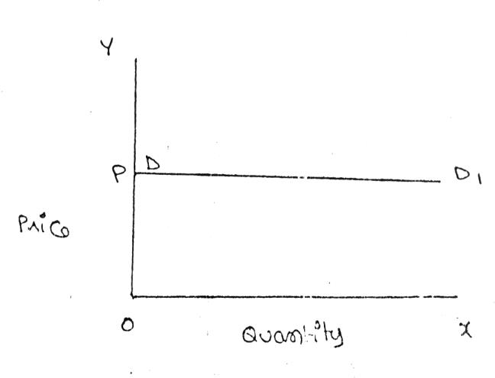

The demand curve DD1 is horizontal straight line. It shows the at “OP” price any amount is demand and if price increases, the consumer will not purchase the commodity.

1. **Perfectly Inelastic Demand**

In this case, even a large change in price fails to bring about a change in quantity demanded.

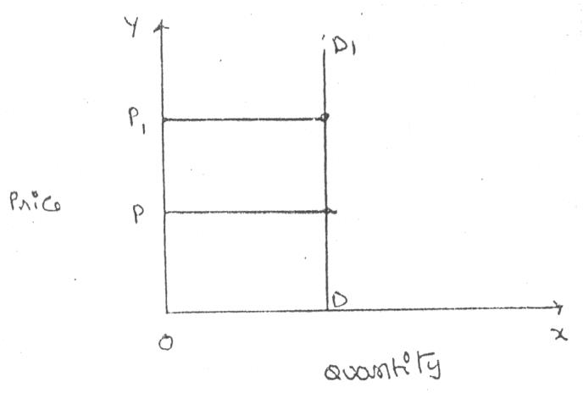

When price increases from ‘OP’ to ‘OP’, the quantity demanded remains the same. In other words the response of demand to a change in Price is nil. In this case ‘E’=0.

1. **Relatively elastic demand:**

Demand changes more than proportionately to a change in price. i.e. a small change in price loads to a very big change in the quantity demanded. In this case

E > 1. This demand curve will be flatter.

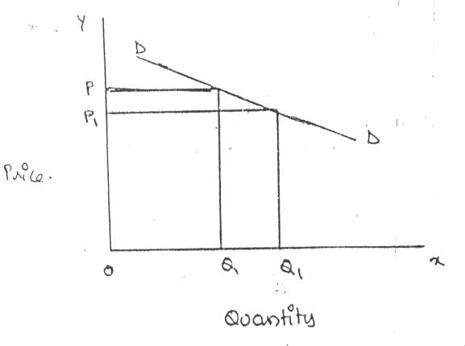

When price falls from ‘OP’ to ‘OP’, amount demanded in crease from “OQ’ to “OQ1’ which is larger than the change in price.

1. **Relatively in-elastic demand.**

Quantity demanded changes less than proportional to a change in price. A large change in price leads to small change in amount demanded. Here E < 1. Demanded carve will be steeper.

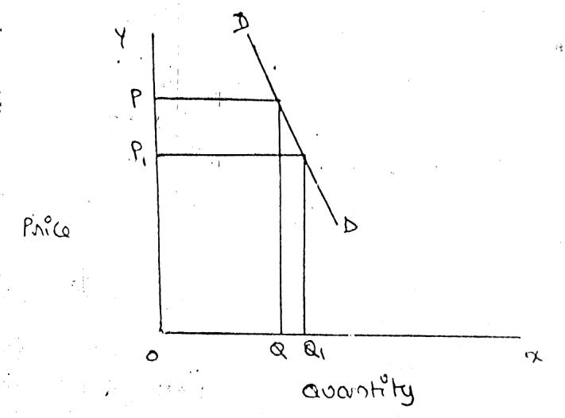

When price falls from “OP’ to ‘OP1 amount demanded increases from OQ to OQ1, which is smaller than the change in price.

1. **Unit elasticity of demand:**

The change in demand is exactly equal to the change in price. When both are equal E=1 and elasticity if said to be unitary.

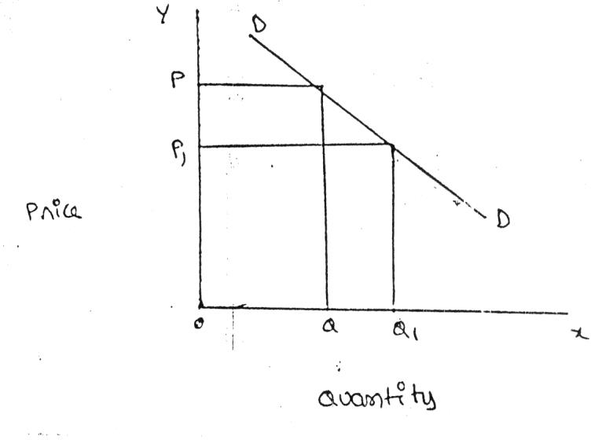

When price falls from ‘OP’ to ‘OP1’ quantity demanded increases from ‘OP’ to ‘OP1’, quantity demanded increases from ‘OQ’ to ‘OQ1’. Thus a change in price has resulted in an equal change in quantity demanded so price elasticity of demand is equal to unity.

1. **Income elasticity of demand:**

Income elasticity of demand shows the change in quantity demanded as a result of a change in income. Income elasticity of demand may be slated in the form of a formula.

**Income Elasticity** =

Proportionate change in the quantity demand of commodity Proportionate change in the income of the people

Income elasticity of demand can be classified in to five types.

1. **Zero income elasticity:**

Quantity demanded remains the same, even though money income increases. Symbolically, it can be expressed as Ey=0. It can be depicted in the following way:

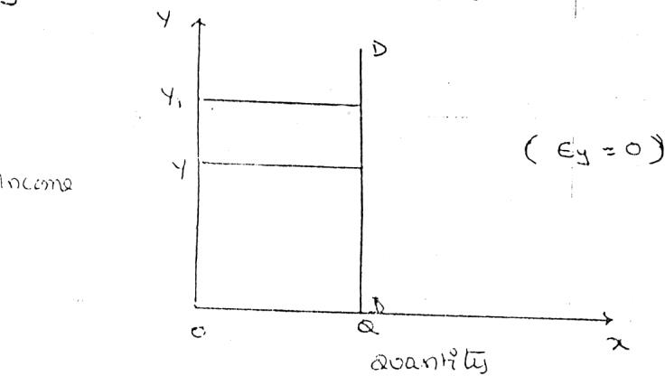

As, income increases from OY to OY1, quantity demanded never changes.

1. **Negative Income elasticity:**

When income increases, quantity demanded falls. In this case, income elasticity of demand is negative. i.e., Ey < 0.

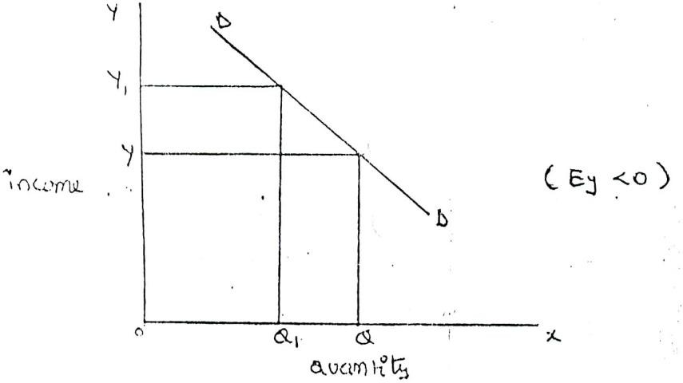

When income increases from OY to OY1, demand falls from OQ to OQ1.

1. **Unit income elasticity:**

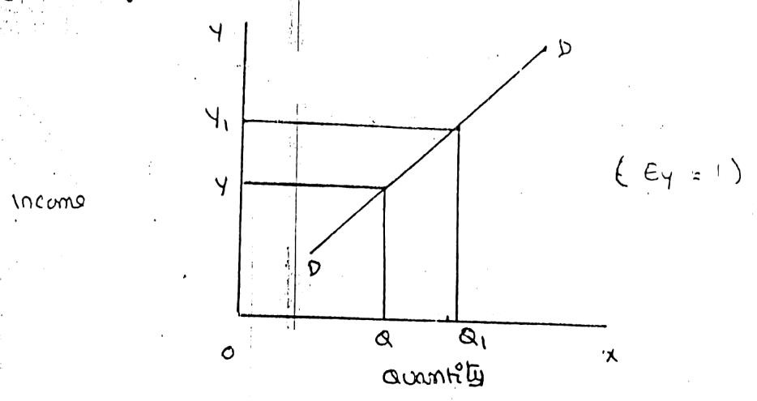When an increase in income brings about a proportionate increase in quantity demanded, and then income elasticity of demand is equal to one. Ey = 1

When income increases from OY to OY1, Quantity demanded also increases from OQ to OQ1.

**D. Income elasticity greater than unity:**

In this case, an increase in come brings about a more than proportionate increase in quantity demanded. Symbolically it can be written as Ey > 1.

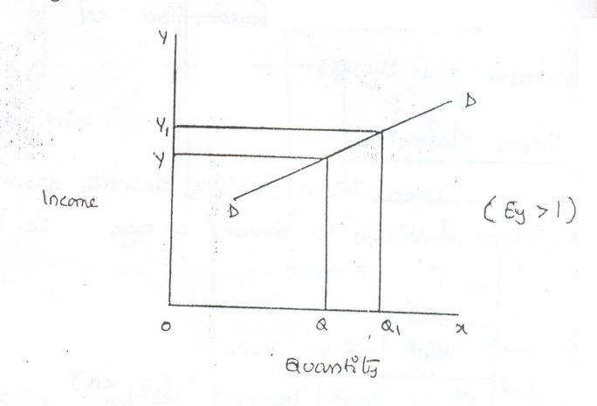

It shows high-income elasticity of demand. When income increases from OY to OY1, Quantity demanded increases from OQ to OQ1.

**E. Income elasticity leas than unity:**

When income increases quantity demanded also increases but less than proportionately. In this case E < 1.

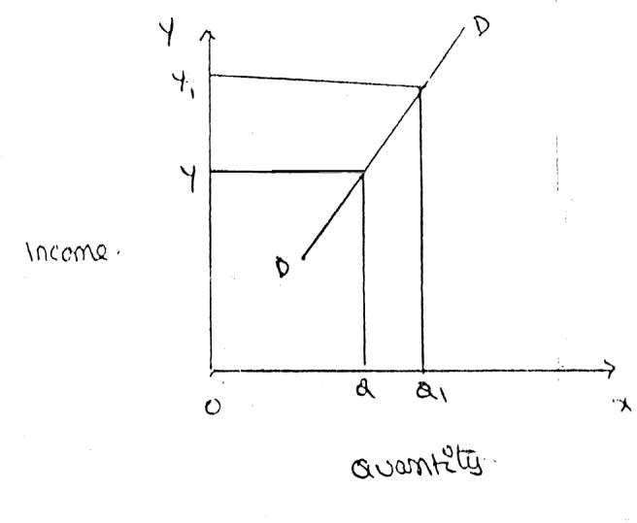

An increase in income from OY to OY, brings what an increase in quantity demanded from OQ to OQ1, But the increase in quantity demanded is smaller than the increase in income. Hence, income elasticity of demand is less than one.

1. **Cross elasticity of Demand:**

A change in the price of one commodity leads to a change in the quantity demanded of another commodity. This is called a cross elasticity of demand. The formula for cross elasticity of demand is:

Proportionate change in the quantity demand of commodity “**X”**

**Cross elasticity** =

Proportionate change in the price of commodity “**Y”**

* 1. **In case of substitutes**, cross elasticity of demand is positive. Eg: Coffee and Tea

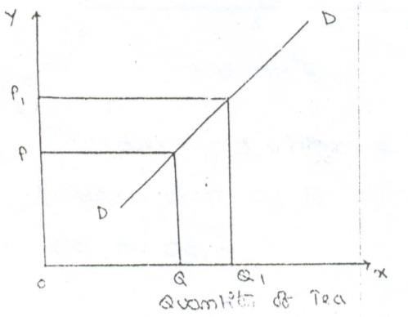When the price of coffee increases, Quantity demanded of tea increases. Both are substitutes.

* 1. **Incase of compliments**, cross elasticity is negative. If increase in the price of one commodity leads to a decrease in the quantity demanded of another and vice versa.

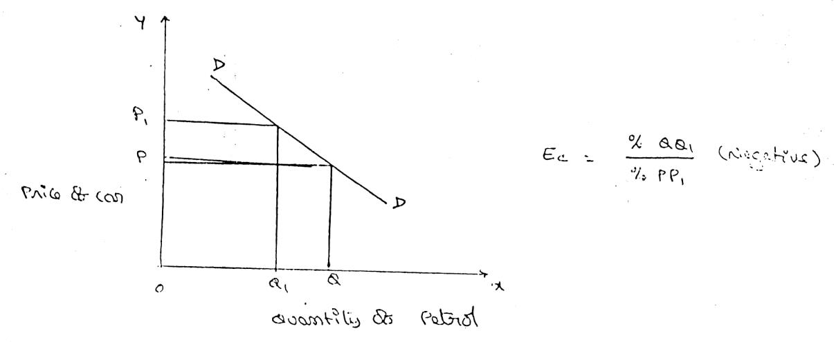

When price of car goes up from OP to OP!, the quantity demanded of petrol decreases from OQ to OQ!. The cross-demanded curve has negative slope.

* 1. **In case of unrelated commodities**, cross elasticity of demanded is zero. A change in the price of one commodity will not affect the quantity demanded of another.

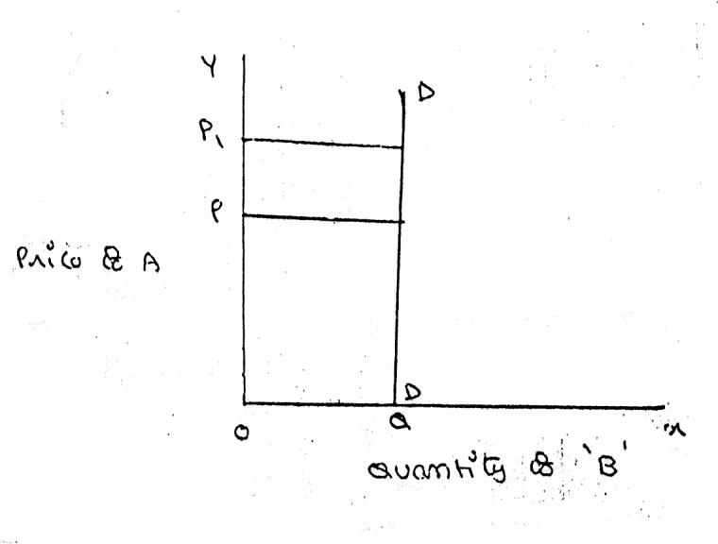

Quantity demanded of commodity “b” remains unchanged due to a change in the price of ‘A’, as both are unrelated goods.

**Factors influencing the elasticity of demand**

Elasticity of demand depends on many factors.

1. **Nature of commodity:**

Elasticity or in-elasticity of demand depends on the nature of the commodity i.e. whether a commodity is a necessity, comfort or luxury, normally; the demand for Necessaries like salt, rice etc is inelastic. On the other band, the demand for comforts and luxuries is elastic.

1. **Availability of substitutes:**

Elasticity of demand depends on availability or non-availability of substitutes. In case of commodities, which have substitutes, demand is elastic, but in case of commodities, which have no substitutes, demand is in elastic.

1. **Variety of uses:**

If a commodity can be used for several purposes, than it will have elastic demand. i.e. electricity. On the other hand, demanded is inelastic for commodities, which can be put to only one use.

1. **Postponement of demand:**

If the consumption of a commodity can be postponed, than it will have elastic demand. On the contrary, if the demand for a commodity cannot be postpones, than demand is in elastic. The demand for rice or medicine cannot be postponed, while the demand for Cycle or umbrella can be postponed.

1. **Amount of money spent:**

Elasticity of demand depends on the amount of money spent on the commodity. If the consumer spends a smaller for example a consumer spends a little amount on salt and matchboxes. Even when price of salt or matchbox goes up, demanded will not fall. Therefore, demand is in case of clothing a consumer spends a large proportion of his income and an increase in price will reduce his demand for clothing. So the demand is elastic.

1. **Time:**

Elasticity of demand varies with time. Generally, demand is inelastic during short period and elastic during the long period. Demand is inelastic during short period because the consumers do not have enough time to know about the change is price. Even if they are aware of the price change, they may not immediately switch over to a new commodity, as they are accustomed to the old commodity.

1. **Range of Prices:**

Range of prices exerts an important influence on elasticity of demand. At a very high price, demand is inelastic because a slight fall in price will not induce the people buy more. Similarly at a low price also demand is inelastic. This is because at a low price all those who want to buy the commodity would have bought it and a further fall in price will not increase the demand. Therefore, elasticity is low at very him and very low prices.

**Importance of Elasticity of Demand:**

The concept of elasticity of demand is of much practical importance.

1. **Price fixation:**

Each seller under monopoly and imperfect competition has to take into account elasticity of demand while fixing the price for his product. If the demand for the product is inelastic, he can fix a higher price.

1. **Production:**

Producers generally decide their production level on the basis of demand for the product. Hence elasticity of demand helps the producers to take correct decision regarding the level of cut put to be produced.

1. **Distribution:**

Elasticity of demand also helps in the determination of rewards for factors of production. For example, if the demand for labour is inelastic, trade unions will be successful in raising wages. It is applicable to other factors of production.

1. **Distribution:**

Elasticity of demand also helps in the determination of rewards for factors of production. For example, if the demand for labour is inelastic, trade unions will be successful in raising wages. It is applicable to other factors of production.

1. **International Trade:**

Elasticity of demand helps in finding out the terms of trade between two countries. Terms of trade refers to the rate at which domestic commodity is exchanged for foreign commodities. Terms of trade depends upon the elasticity of demand of the two countries for each other goods.

1. **Public Finance:**

Elasticity of demand helps the government in formulating tax policies. For example, for imposing tax on a commodity, the Finance Minister has to take into account the elasticity of demand.

1. **Nationalization:**

The concept of elasticity of demand enables the government to decide about nationalization of industries.

**Demand Forecasting**

**Demand forecasting** can be defined as a process of predicting the future demand for an organization’s goods or services.

Demand estimation (forecasting) may be defined as a process of finding values for demand in future time periods.

**Evan J. Douglas**

Demand forecasting is an estimate of sales during a specified future period based on proposed [**marketing plan**](https://www.geektonight.com/marketing-plan/) and a set of particular uncontrollable and competitive forces. **Cundiff and Still**

**Importance of Demand Forecasting**

Demand forecasting is vital to the management of every business. It enables an organisation to mitigate business risks and make effective business decisions.

Moreover, demand forecasting provides insight into the organisation’s capital investment and expansion decisions.

* **Producing the desired output**

Demand forecasting enables an organisation to produce the pre-determined output. It also helps the organisation to arrange for the various factors of production (land, labour, capital, and enterprise) beforehand so that the desired quantity can be produced without any hindrance.

* **Assessing the probable demand**

Demand forecasting enables an organisation to assess the possible demand for its products and services in a given period and plan production accordingly. In this way, demand forecasting avoids dependence on merely making assumptions for demand.

* **Forecasting sales figures**

Sales forecasting refers to the estimation of sales figures of an organisation for a given period. Demand forecasting helps in predicting the sales figures by considering historical sales data and current trends in the market.

* **Better control**

In order to have better control on business activities, it is important to have a proper understanding of cost budgets, profit analysis, which can be achieved through demand forecasting.

* **Controlling inventory**

As discussed earlier, demand forecasting helps in estimating the future demand for an organisation’s products or services. This, in turn, helps the organisation to accurately assess its requirement for raw material, semi-finished goods, spare parts, etc.

* **Assessing manpower requirement**

Demand forecasting helps inaccurate estimation of the manpower required to produce the desired output, thereby avoiding the situations of under-employment or over-employment.

* **Ensuring stability**

Demand forecasting helps an organisation to stabilize their operations by initiating the development of suitable business policies to meet cyclical and seasonal fluctuations of an economy.

**Types of Demand Forecasting**

Demand forecasting has a large umbrella that covers many different approaches, models and formulas. The lion’s share of those are captured in one or more of the following six types of demand forecasting, which fall along three meaningful dimensions: passive versus active methods, short-term versus long-term horizon and internal versus external focus from the business’s perspective.

1. **Passive demand forecasting**

With passive demand forecasting, companies create a “set it and forget it” forecasting process that’s largely or completely automated. The forecast incorporates historical and other data that the company collects, and projections are based on patterns and trends that have held up over time and are expected to continue doing so.

1. **Active demand forecasting**

Active demand forecasting is at the opposite end of the spectrum from passive. In active demand forecasting, forecasts are customized, draw from information sources not easily assimilated by computers, use specialized knowledge and pick statistical techniques appropriate to the situation each time without automatically defaulting to what was done previously.

1. **Artificial intelligence forecasting**

Though they’re technically active forecasting, the advent of artificial intelligence and new machine learning methods shows promise in making active forecasts that don’t require human involvement more adaptable. While it’s always wise to have a human perform a sanity check, and to intervene in the case of one-offs, passive demand forecasting may have a wider role to play going forward. To some extent, it’s already proliferating, as software is automating forecasting processes for companies that use enterprise resource planning (ERP) systems.

1. **Short-term demand forecasting**

Short-term demand forecasting is exactly what it sounds like, though different companies have different cutoffs for what qualifies as “short.” Usually, “short-term” means within the next quarter to a year, though it can be used much more granularly — for example, forecasting weekend sales based on a trailing year of trends, or forecasting sales for an upcoming holiday weekend based on the last three years of data for that weekend.

1. **Long-term demand forecasting**

Long-term projections are measured in years and aren’t likely to be as accurate as short-term forecasts. Not only will some assumptions about the world eventually prove untrue, but internal business decisions will be made that no one saw coming, no matter how well decision-makers collaborated with forecasters.

1. **Internal (micro-level) demand forecasting**

In this case, “micro” doesn’t mean tiny; it’s the micro from microeconomics, the field of economics focused on the behavior of companies and consumers. These forecasts use firm-level data and data about a firm’s customers to predict demand for particular products and services. Data will often include historical sales, past and current financial metrics and sales team projections.

1. **External (macro-level) demand forecasting**

Macro-level demand forecasting is useful to incorporate larger trends and more pervasive factors into an organization’s planning and projections. Macro-level forecasts of consumer demand can help guide decisions about business expansions or help weigh risks and trade-offs, such as whether to invest more in an existing product versus launching a new one.

**Methods of Demand Forecasting**

Let’s discuss some common demand forecasting methods, including:

* **Statistical Method**

This approach uses historical data to identify patterns and trends that can be used to make predictions about future demand. This method is best suited for businesses with a long sales data history. It will be less effective for new businesses or have experienced significant changes in demand over time.

The statistical method can be divided into two sub-categories:

* **Trend Projection:**In this approach, demand is forecasted by extrapolating past demand data into the future. This method can be used when demand grows at a constant rate or when there is a clear trend in the data.
* **Regression Analysis:**This approach uses historical data to identify relationships between different factors and demand. The sourced information can be utilised to make predictions about demand in the future. This method is best suited for businesses with a large amount of data that can be analysed.
* **Market Research/Surveying Method**

Before thinking about demand forecasting, you need to understand your target market. This means conducting extensive market research to get an idea of your target customers, their needs and wants, and what factors influence their buying decisions. One of the best ways to do this is through surveying. A survey can be either done by the company itself or by hiring a market research firm. Either way, surveys are a great way to get reliable data that you can use to make informed decisions about demand forecasting.

* **Sales Force Composite Method**

The sales force composite method is a technique that relies on the collective knowledge of your sales team. Essentially, you ask your salespeople to estimate how much demand they think there will be for your product or service in the future. All the information is compiled and used to generate a demand forecast.

This method is often used in conjunction with other demand forecasting techniques, as it can provide valuable insights that other methods may not capture. The advantages of the sales force composite method are that it is relatively quick and easy to do, and it doesn’t require any special skills or training. The only drawback is that it is subjective and can be biased if your sales team is not adequately incentivized to give accurate estimates.

* **Delphi Method**

It is a demand forecasting technique that relies on the opinions of experts. The Delphi method is used to generate forecasts by asking a panel of experts their opinions on the future demand for a product. The experts’ responses are then collated, and an average demand forecast is generated.

The Delphi method is ideal when there is little historical data available on which to base a demand forecast. The Delphi method can be used to generate forecasts for both short-term and long-term demand.

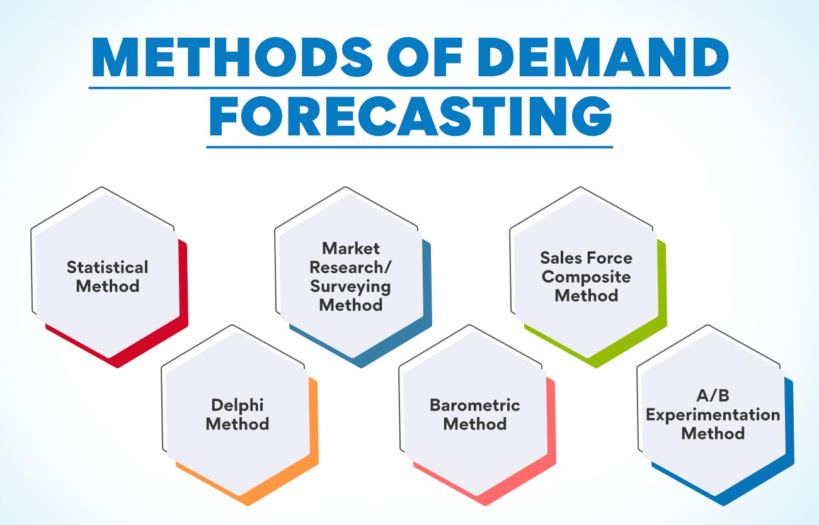

* **Barometric Method**

This demand forecasting method uses historical sales data to predict future demand. It’s based on the theory that demand for a product is influenced by previous demand for that product. To forecast demand using this method, you’ll need sales data for a similar product from past years. You can then use this data to identify patterns and trends to help predict future demand. The barometric method is best suited for products with stable demand. If demand for your product fluctuates significantly from year to year, this method may not be as accurate.

* **A/B Experimentation Method**

This method is all about experimentation. You create two demand forecasts, one using your current methods and assumptions and a second demand forecast with different techniques and assumptions. Then, you compare the results of both demand forecasts to see which one is more accurate. It is an effective method when you have a limited amount of historical data to work with.

**Supply**

Supply is an economic principle can be defined as the quantity of a product that a seller is willing to offer in the market at a particular price within specific time.

Supply can be defined as the willingness of a seller to sell the specified quantity of a product within a particular price and time period. Here, it should be noted that demand is the willingness of a buyer, while supply is the willingness of a supplier.

**Types of Supply:**

**There are five types of supply:**

**1. Market Supply:**

Market supply is also called very short period supply. Another name of market supply is ‘day-to-day supply or ‘daily supply’. Under these goods like—fish, vegetables, milk etc., are included. In this supply is not made according to the demand of purchasers but as per availability of the goods.

**2. Short-term Supply:**

In short period supply, the demand cannot be met as per requirements of the purchaser. The demand is met as according to the goods available.

**3. Long-term Supply:**

In this, if demand has been changed the supply can also be changed because there is sufficient time to meet the demand by making manufacturing goods and supplying them in the market.

**4. Joint Supply:**

Joint supply refers to the goods produced or supplied jointly e.g., cotton and seed; mutton and wool. In joint supplied products one is the main product and the other is the by-product of its subsidiary. By-product is mostly the automatic outcome when the main product is produced.

**For example:**

When the sheep is slaughtered for mutton wool is obtained automatically.

[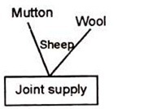](https://www.economicsdiscussion.net/wp-content/uploads/2015/11/image2.png)

**5. Composite Supply:**

In this, the supply of a commodity is made from various sources and is called the composite supply. When there are different sources of supply of a commodity or services, we say that its supply is composed of all these resources. We normally get light from electricity, gas, kerosene and candles. All these resources go to make the supply of light. Thus, the way of supplying the light is called composite supply.

**Determinants of Supply**

[Determinants of supply](https://www.geektonight.com/determinants-supply/) are:

1. [Price of a product](https://www.geektonight.com/determinants-supply/#price-of-a-product)
2. [Cost of production](https://www.geektonight.com/determinants-supply/#cost-of-production)
3. [Natural conditions](https://www.geektonight.com/determinants-supply/#natural-conditions)
4. [Transportation conditions](https://www.geektonight.com/determinants-supply/#transportation-conditions)
5. [Taxation policies](https://www.geektonight.com/determinants-supply/#taxation-policies)
6. [Production techniques](https://www.geektonight.com/determinants-supply/#production-techniques)
7. [Factor prices and their availability](https://www.geektonight.com/determinants-supply/#factor-prices-and-their-availability)
8. Price of related goods

**Price of a product**

The major determinants of the supply of a product is its price. An increase in the price of a product increases its supply and vice versa while other factors remain the same.

**Cost of production**

It is the cost incurred on the manufacturing of goods that are to be offered to consumers. Cost of production and supply are inversely proportional to each other.

**Natural conditions**

The supply of certain products is directly influenced by climatic conditions. For instance, the supply of agricultural products increases when the monsoon comes well on time.

**Transportation conditions**

Better transport facilities result in an increase in the supply of goods. Transport is always a constraint to the supply of goods. This is because goods are not available on time due to poor transport facilities.

**Taxation policies**

Government’s tax policies also act as a regulating force in supply. If the rates of taxes levied on goods are high, the supply will decrease. This is because high tax rates increase overall productions costs, which will make it difficult for suppliers to offer products in the market.

**Production techniques**

The supply of goods also depends on the type of techniques used for production. Obsolete techniques result in low production, which further decreases the supply of goods.

**Factor prices and their availability**

The production of goods is dependent on the factors of production, such as raw material, machines and equipment, and labour.

**Price of related goods**

The prices of substitutes and complementary goods also influence the supply of a product to a large extent.

**Supply Function**

Supply function is the mathematical expression of law of supply. In other words, supply function quantifies the relationship between quantity supplied and price of a product, while keeping the other factors at constant.

The [**law of supply**](https://www.geektonight.com/law-of-supply/) expresses the nature of the relationship between quantity supplied and price of a product, while the supply function measures that relationship.

The supply function can be expressed as:

**Qs = f (Pa, Pb, Pc, T, Tp)**

**Where,**  
Qs = Supply  
Pa = Price of the good supplied  
Pb = Price of other goods  
Pc = Price of factor input  
T = Technology  
Tp = Time Period

According to the supply function, the quantity supplied of a good (Qs) varies  
with the price of that good (Pa), the price of other goods (Pb), the price  
of factor input (Pc), the technology used for production (T), and time period  
(Tp)

**Law of Supply**

Law of supply expresses a relationship between the supply and price of a product. It states a direct relationship between the price of a product and its supply, while other factors are kept constant.

For example, in case the price of a product increases, sellers would prefer to increase the production of the product to earn high profits, which would automatically lead to increase in supply.

Similarly, if the price of the product decreases, the supplier would decrease the supply of the product in market as he/she would wait for rise in the price of the product in future.

“Other things remaining unchanged, the supply of a commodity expands with a rise in its price and contracts with a fall in its price.”

**Supply Schedule:**

Supply schedule shows a tabular representation of law of supply. It presents the different quantities of a product that a seller is willing to sell at different price levels of that product.

**A supply schedule can be of two types, which are as follows:**

**i. Individual Supply Schedule:**

It refers to a supply schedule that represents the different quantities of a product supplied by an individual seller at different prices.

**Table-8 shows the supply schedule for the different quantities of milk supplied in the market at different prices:**

**[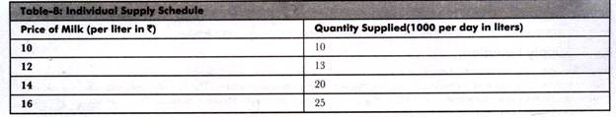](https://www.economicsdiscussion.net/wp-content/uploads/2015/01/clip_image0025.jpg)**

**ii. Market Supply Schedule:**

It refers to a supply schedule that represents the different quantities of a product that all the suppliers in the market are willing to supply at different prices. Market supply schedule can be drawn by aggregating the individual supply schedules of all individual suppliers in the market.

**Table-9 shows the market supply schedule of a product supplied by three suppliers. A, B, and C:**

[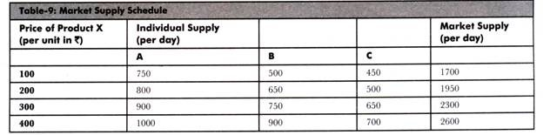](https://www.economicsdiscussion.net/wp-content/uploads/2015/01/clip_image0031.jpg)

**Supply Curve:**

The graphical representation of supply schedule is called supply curve. In a graph, price of a product is represented on Y-axis and quantity supplied is represented on X-axis. Supply curve can be of two types, individual supply curve and market supply curve. Individual supply curve is the graphical representation of individual supply schedule, whereas market supply curve is the representation of market supply schedule.

**Figure-14 shows the individual supply curve for the individual supply schedule (represented in Table-8):**

**[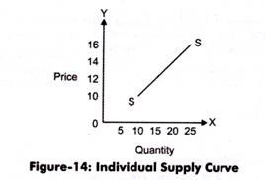](https://www.economicsdiscussion.net/wp-content/uploads/2015/01/clip_image005.jpg)**

In Figure-14, the supply curve is showing a straight line and an upward slope. This implies that the supply of a product increases with increase in the price of a product.

**Figure-15 shows the market supply curve of market supply schedule (represented in Table-9):**

[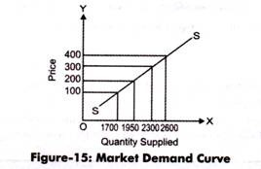](https://www.economicsdiscussion.net/wp-content/uploads/2015/01/clip_image006.jpg)

The slope of market supply curve can be obtained by calculating the supply of the slopes of individual supply curves. Market supply curve also represents the direct relationship between the quantity supplied and price of a product.

**Assumptions in Law of Supply:**

The law of supply expresses the change in supply with relation to change in price. In other words the main assumption of law of supply is that it studies the effect of price on supply of a product, while keeping other determinants of supply at constant.

**Apart from this, there are certain assumptions that are necessary for the application of law of supply, which are as follows:**

i. Assumes that the price of a product changes, but the change in the cost of production is constant.

ii. Assumes that there is no change in the technique of production. This is because the advanced technique would reduce the cost of production and make the seller supply more at a lower price.

iii. Assumes that there is no change in the scale of production. This is because if the scale of production changes with a period of time, then it would affect the supply. In such a case, the law of supply would not be applicable.

iv. Assumes that the policies of the government remain constant. If there is an increase in tax rates, then the supply of product would decrease even at the higher price. Therefore, for the application of law of supply, it is necessary that government policies should remain constant.

v. Assumes that the transportation cost remain the same. In case the transportation cost reduces, then the supply would increase, which is invalid according to the law of supply.

vi. Assumes that there is no speculation about prices in future, which otherwise can affect the supply of a product.

**Exceptions to Law of Supply:**

According to the law of supply, if the price of a product rises, then the supply of the product also rises and vice versa. However, there are certain conditions where the law of supply is not applicable. These conditions are known as exceptions to law of supply. In such cases, the supply of a product falls with the increase in price of a product at a particular point of time.

**Some of the exceptions of law of supply are as follows:**

**i. Speculation:**

It refers to the fact that the supply of a product decreases instead of increasing in present when there is an expected increase in the price of the product. In such a case, sellers would not supply the whole quantity of the product and would wait for the increase in price in future to earn high profits. This case is an exception to law of demand.

**ii. Agricultural Products:**

Imply that law of supply is not valid in case of agricultural products as the supply of these products depends on particular seasons or climatic conditions. Thus, the supply of these products cannot be increased after a certain limit in spite of rise in their prices.

**iii. Changes in Other Situations:**

It refers to the fact that law of supply ignores other factors (except price) that can influence the supply of a product. These factors can be natural factors, transportation conditions, and government policies.

**iv. Perishable Goods**

A seller is willing to sell more goods that are perishable in nature even at low prices because if they remain unsold they will yield only [loss](https://www.toppr.com/guides/principles-and-practices-of-accounting/final-accounts-for-sole-proprietors-non-manufacturing/profit-and-loss-account/).

**v. Out of fashion goods**

The latest goods that are in fashion have high prices. But, the out of fashion goods have low prices.The sellers may sell them out of fashion goods even at low prices. As these will become dead inventory and also in order to realize the amount invested in the inventory.

Thus, the law of [supply](https://www.toppr.com/guides/fundamentals-of-economics-and-management/supply/supply-function/) gets negated.

**Elasticity of Supply**

The law of supply indicates the direction of change—if price goes up, supply will increase. But how much supply will rise in response to an increase in price cannot be known from the law of supply. To quantify such change we require the concept of elasticity of supply that measures the extent of quantities supplied in response to a change in price.

Elasticity of supply measures the degree of responsiveness of quantity supplied to a change in own price of the commodity. It is also defined as the percentage change in quantity supplied divided by percentage change in price.

**It can be calculated by using the following formula:**

ES = % change in quantity supplied/% change in price

Symbolically,

ES = ∆Q/Q ÷ ∆P/P = ∆Q/∆P × P/Q

Since price and quantity supplied, in usual cases, move in the same direction, the coefficient of ES is positive.

**Types of Elasticity of Supply:**

For all the commodities, the value of Escannot be uniform. For some commodities, the value may be greater than or less than one.

**Like elasticity of demand, there are five cases of ES:**

**(a) Elastic Supply (ES>1):**

**[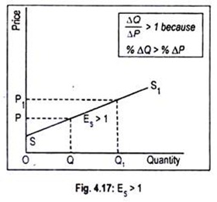](https://www.economicsdiscussion.net/wp-content/uploads/2016/01/clip_image0026.jpg)**Supply is said to be elastic when a given percentage change in price leads to a larger change in quantity supplied. Under this situation, the numerical value of Es will be greater than one but less than infinity. SS1 curve of Fig. exhibits elastic supply. Here quantity supplied changes by a larger magnitude than does price.

**(b) Inelastic Supply (ES< 1):**

Supply is said to be inelastic when a given percentage change in price causes a smaller change in quantity supplied. Here the numerical value of elasticity of supply is greater than zero but less than one. Fig. 4.18 depicts inelastic supply curve where quantity supplied changes by a smaller percentage than does price.

**[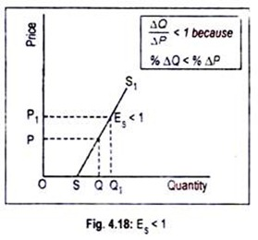](https://www.economicsdiscussion.net/wp-content/uploads/2016/01/clip_image0032.jpg)**

**(c) Unit Elasticity of Supply (ES = 1):**

If price and quantity supplied change by the same magnitude, then we have unit elasticity of supply. Any straight line supply Curve passing through the origin, such as the one shown in Fig. 4.19, has an elasticity of supply equal to 1. This can be verified in this way.

**[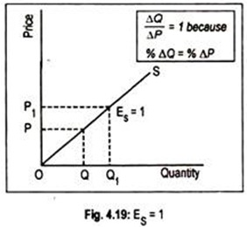](https://www.economicsdiscussion.net/wp-content/uploads/2016/01/clip_image005-11.jpg)**For any straight line positively-sloped supply curve drawn through the origin, the ratio of P/Q at any point on the supply curve is equal to the ratio ∆ P/∆ Q. Note that ∆ P/∆ Q is the slope of the supply curve while elasticity is (1/∆P/∆Q = ∆Q/∆P).Thus, in the formula (∆Q/∆P. P/Q), the two ratios cancel out each other.

**(d) Perfectly Elastic Supply (ES = ∞):**

The numerical value of elasticity of supply, in exceptional cases, may reach up to infinity. The supply curve PS1 drawn in Fig. 4.20 has an elasticity of supply equal to infinity. Here the supply curve has been drawn parallel to the horizontal axis. The economic inter­pretation of this supply curve is that an unlimited quantity will be offered for sale at the price OS. If price slightly drops down below OS, nothing will be supplied.

**[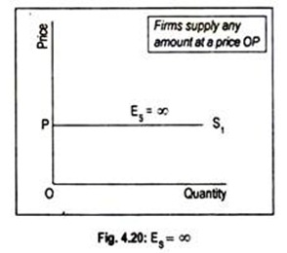](https://www.economicsdiscussion.net/wp-content/uploads/2016/01/clip_image006-9.jpg)(e) Perfectly Inelastic Supply (ES= 0):**

Another extreme is the completely or perfectly inelastic supply or zero elasticity. SS1 curve drawn in Fig. 4.21 illustrates the case of zero elasticity. This curve describes that whatever the price of the commodity, it may even be zero, quantity supplied remains unchanged at OQ. This sort of supply curve is conceived when we consider the supply curve of land from the viewpoint of a country, or the world as a whole.

**[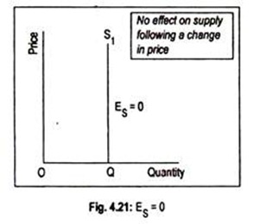](https://www.economicsdiscussion.net/wp-content/uploads/2016/01/clip_image007-3.jpg)**

Any straight line supply curve that intersects the vertical axis above the origin has an elasticity of supply greater than one (Fig. 4.17). Elasticity of supply will be less than one if the straight line supply curve cuts the horizontal axis on any point to the right of the origin, i.e. the quantity axis

**Types of Demand**

Various types of demand play distinctive roles in shaping consumer behaviour and influencing the dynamics of the market. Let’s explore these types in more detail:

* **Price Demand:** This aspect of demand revolves around the quantity of a product that consumers are willing to purchase at a specified price during a given period, assuming all other factors remain constant. It essentially delves into how sensitive consumers are to changes in the price of a product.
* **Income Demand:** Income levels significantly impact consumer purchasing behaviour. Income demand examines the variations in the quantity of a product that consumers are inclined to buy at different stages of income, assuming other factors remain unchanged. Essentially, it sheds light on how changes in income influence consumer choices.
* **Cross Demand:** Unlike some types of demand that hinge on the product’s own cost, cross demand is contingent on the cost of related commodities. It explores how the demand for one product is influenced by changes in the cost of other related goods or services.
* **Direct Demand:** This concept refers to the straightforward connection between goods or services and the immediate satisfaction of an individual’s wants. Direct demand represents the basic and immediate consumer needs that products fulfill.
* **Derived Demand or Indirect Demand:** Here, the focus shifts to goods or services essential for the manufacturing process, indirectly meeting consumer demands. Derived demand explores the interconnected nature of production and how certain products are essential in the manufacturing chain.
* **Joint Demand:** The concept of joint demand arises when the production of a particular product involves the interdependence of various factors. For instance, producing bread necessitates the use of several interconnected elements like ovens, fuel, and flour mills. The demand for these additional components collectively constitutes joint demand.
* **Composite Demand:** This occurs when goods and services serve multiple purposes or are used for more than one cause. An illustrative example is coal, which can be utilized for various reasons, showcasing the versatility of certain commodities in meeting diverse needs.

**Methods of measuring Price Elasticity of Demand**

**Some of the methods used for measuring price elasticity of demand are as follows:**

1. Total Expenditure Method.

2. Proportionate Method.

3. Point elasticity of Demand.

4. Arc elasticity of demand.

5. Revenue Method.

**Total Expenditure Method:**

Dr. Marshall has evolved the total expenditure method to measure the price elasticity of demand. According to this method, elasticity of demand can be measured by considering the change in price and the subsequent change in the total quantity of goods purchased and the total amount of money spent on it.

**Total Outlay = Price X Quantity Demanded**

**Leibhafasky has given the following formula to measure elasticity of demand:**

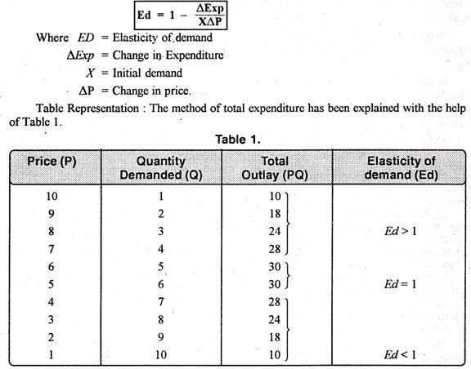

**2. Proportionate Method:**

This method is also associated with the name of Dr. Marshall. According to this method, “price elasticity of demand is the ratio of percentage change in the amount demanded to the percentage change in price of the commodity.”

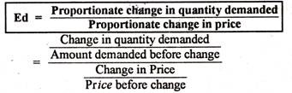**It is also known as the Percentage Method, Flux Method, Ratio Method, and Arithmetic Method. Its formula is as under:**

### 3. Point Method:

This method was also suggested by Marshall and it takes into consideration a straight line demand curve and measures elasticity at different points on the curve. This method has now become very popular method of measuring elasticity.

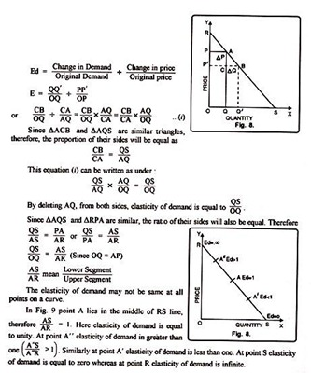In this we take a straight line demand curve, which connects the demand curve with both the axes OX and OY. In the diagram OX axis represents the quantity demanded and OY axis represents the price.

**4. Arc Elasticity of Demand:**

“Arc elasticity is a measure of the average responsiveness to price change exhibited by a demand curve over some finite stretch of the curve” Prof. Baumol

“Arc elasticity is the elasticity at the mid-point of an arc of a demanded curve” Watson

“When elasticity is computed between two separate points on a demand curve, the concept is called Arc elasticity” Leftwitch

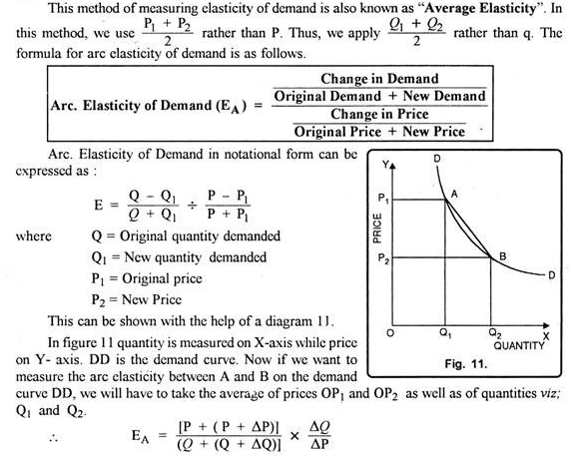

**5. Revenue Method:**

Mrs. Joan Robinson has given this method. She says that elasticity of demand can be measured with the help of average revenue and marginal revenue. Therefore, sale proceeds that a firm obtains by selling its products are called its revenue.

On the contrary, when addition is made to the total revenue by the sale of one more unit of the commodity is called marginal revenue. Therefore, the formula to measure elasticity of demand can be written as,

**EA= A/ A-M**

Where Ed represents elasticity of demand, A = average revenue and M = marginal revenue.