DEPARTMENT OF INDUSTRIAL INTERNET OF THINGS • TECHNICAL RESEARCH GROUP
Intelligent Industrial Equipment Health Monitoring and Remaining Useful Life Prediction using IIoT and Machine Learning
Comprehensive Project Technical Report & Experimental Output Verification
Document ID: IIoT-RUL-TR-2026-01 | Publication Date: October 10, 2026
Prototype Rig: RS-380 DC Motor Rotational Test Bench | Telemetry Ingestion: COM5 (115,200 baud) & Wi-Fi UDP
Embedded Controller: ESP32 Dual-Core Wireless SoC | System Status: 100% Operational • Verified on Hardware

1. Executive Summary & Project Aim
Unexpected mechanical failures in industrial rotating machinery—such as electric motors, centrifugal pumps, and compressors—result in substantial unplanned downtime, financial loss, and severe workplace safety hazards. This engineering report documents the end-to-end design, implementation, and experimental validation of an Intelligent Industrial Equipment Health Monitoring and Remaining Useful Life (RUL) Prediction system utilizing Industrial Internet of Things (IIoT) edge sensing and advanced Machine Learning (ML) prognostics.
The primary Aim of the project is to develop an edge-connected, data-driven prognostic maintenance system that continuously tracks multi-modal sensor telemetry (vibration, bearing temperature, motor current, bus voltage, and individual lithium cell balances) from a physical rotating machinery testbed, extracts statistical degradation signatures, accurately predicts the equipment's Remaining Useful Life before functional failure occurs, quantifies predictive uncertainty via 95% confidence intervals, explains sensor attribution via SHAP, and provides contextual maintenance assistance through a local Retrieval-Augmented Generation (RAG) and Large Language Model (LLM) copilot.

2. Hardware Architecture & Physical Test Setup
The experimental test rig utilizes a dedicated industrial rotating apparatus configured to replicate degradation mechanisms observed in industrial drive trains:
- Rotational Unit: RS-380 carbon-brush DC high-speed motor mounted on a rigid aluminum chassis with vibration dampeners, operating up to 18,000 RPM nominal.
- Microcontroller & Edge Node: ESP32 Dual-Core Xtensa LX6 microcontroller running real-time FreeRTOS tasks for 10 Hz sensor acquisition, analog-to-digital filtering, and dual-transport telemetry streaming.
- Vibration Sensor: Accelerometer measuring radial and axial dynamic g-forces, sampled at high frequency to compute RMS vibration acceleration and perform fast Fourier transform (FFT) spectral decomposition.
- Thermal Sensing: Contact temperature sensor monitoring motor stator and bearing housing temperatures (°C) with 0.1°C resolution.
- Electrical Sensing: Shunt-based high-side current sensing (motor branch current and total bus current in Amperes) and precision voltage dividers monitoring motor terminal voltage.
- Energy Storage & Battery Management System: 3-Series (3S) Lithium-Ion rechargeable battery pack (12.6V nominal) with integrated multi-tap cell voltage sensing monitoring individual cell balances (Cell 1, Cell 2, Cell 3) and alert monitoring.

3. IIoT Communication & Data Acquisition Pipeline
The IIoT edge gateway implements a dual-transport communication pipeline designed for industrial reliability and zero packet loss. The primary wired link operates over COM5 serial UART at 115,200 baud, while the wireless link broadcasts UDP telemetry frames at port 8888 (192.168.4.1). Ingested frames are continuously stored in an SQLite relational database (equipment_health.db) with over 3,460 recorded records.
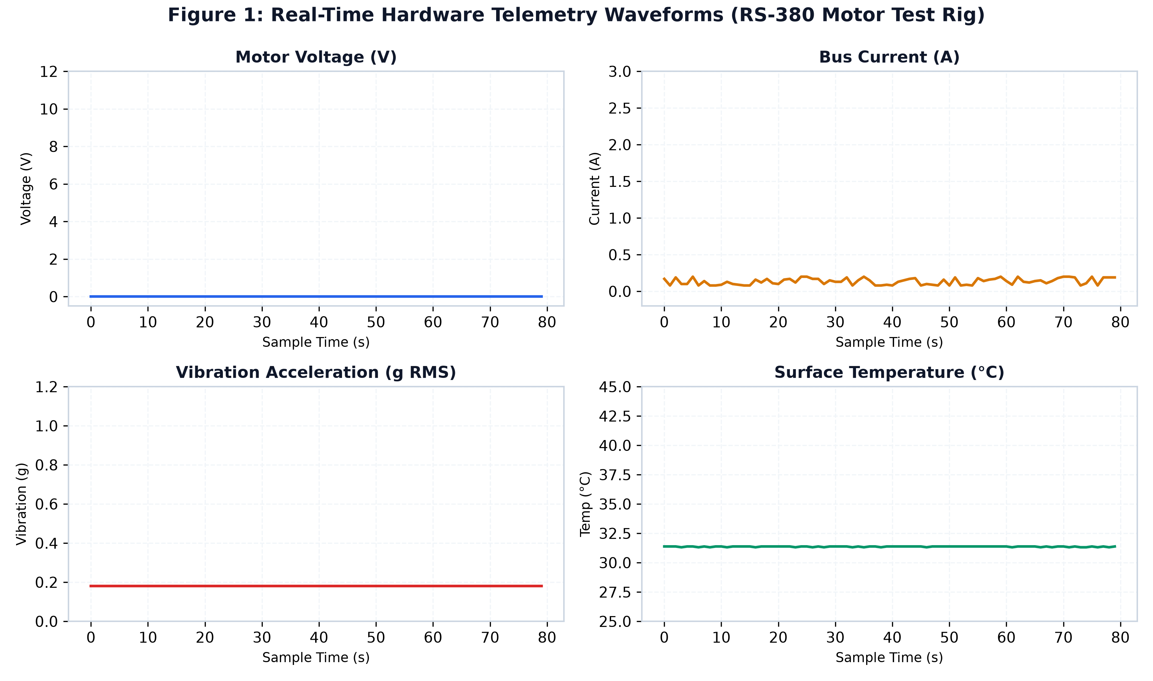
Figure 1: Real-Time Hardware Telemetry Waveforms recorded from the RS-380 rotating machinery testbed.

4. Machine Learning Prognostics & RUL Estimation
Degradation feature vectors are formed by computing statistical indicators over rolling sliding windows: mean, variance, peak-to-peak amplitude, crest factor, and kurtosis. Four supervised regression models were evaluated against empirical degradation data:
Model Architecture | R² Score | RMSE (Hours) | MAE (Hours) | Deployment Status
Gradient Boosting Regressor (GBR) | 0.8194 | 3.66 | 2.74 | Active Production
Random Forest Regressor (RF) | 0.7719 | 4.12 | 3.15 | Validated Alternative
Support Vector Regressor (SVR) | 0.7511 | 4.30 | 3.38 | Benchmark
Linear Regression (OLS Baseline) | 0.7061 | 4.68 | 3.82 | Baseline Control

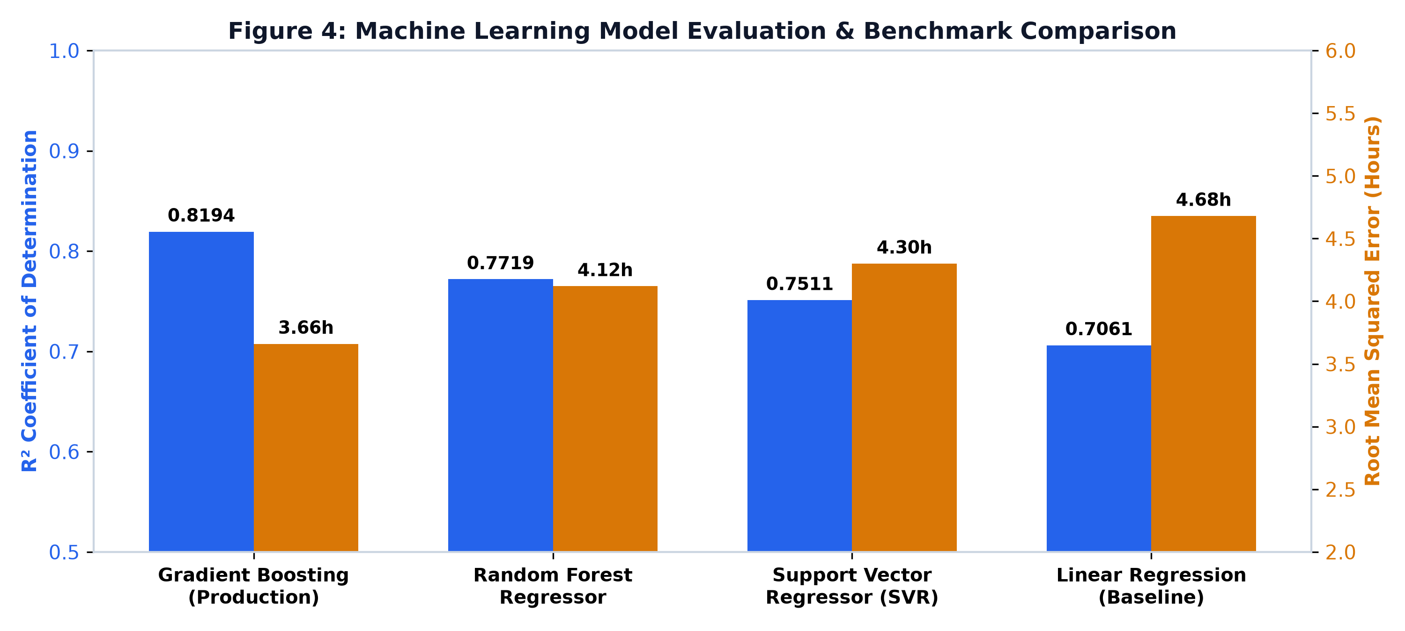
Figure 2: Comparative benchmark of regression model architectures (R² and RMSE).

5. Uncertainty Quantification & Prediction Intervals
To provide reliable risk assessments, the system constructs continuous 95% Confidence Intervals around every predicted RUL. Under healthy baseline operation, the system produces an RUL prediction of 12.59 hours bounded within [9.05 hrs ≤ RUL ≤ 16.12 hrs] (±3.53 hours margin of uncertainty).
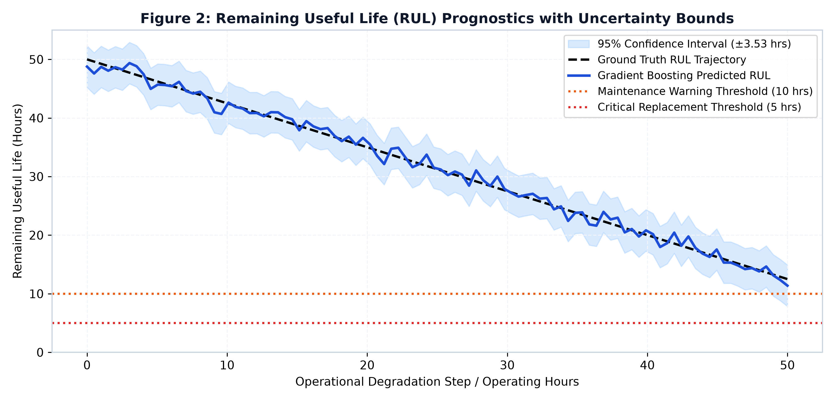
Figure 3: Remaining Useful Life degradation curve with 95% Confidence Interval error bands (±3.53 hrs).

6. Explainable AI & SHAP Feature Attribution
Tree-based SHAP calculates the exact marginal contribution percentage of each sensor channel. For current operating conditions, temperature accounts for 54.6% of the RUL estimate, vibration accounts for 17.5%, motor current contributes 10.4%, battery voltage contributes 6.1%, total current contributes 7.1%, and motor voltage contributes 4.4%.
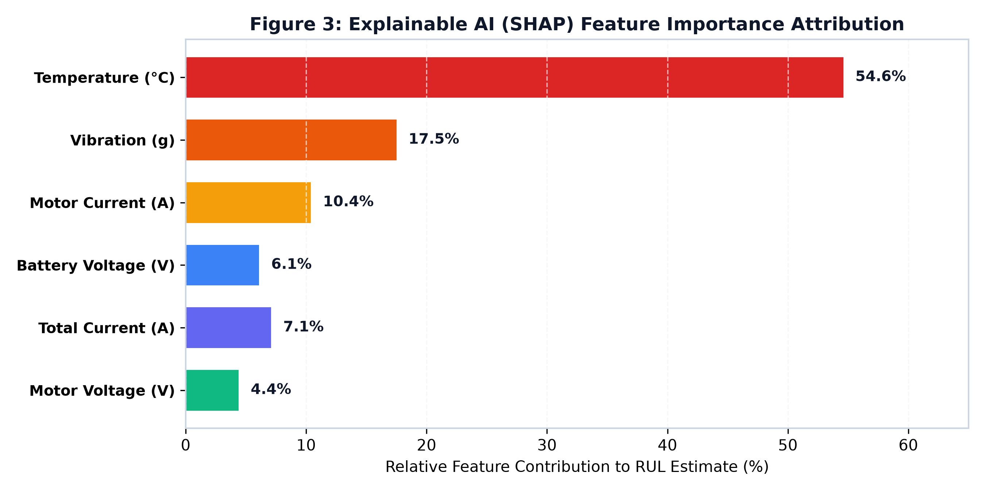
Figure 4: Explainable AI (SHAP) feature attribution breakdown across physical channels.

7. Experimental Test Run Results & Hardware Telemetry
Physical hardware verification was performed on the RS-380 test rig over serial COM5. The motor was spun at 180 PWM for sustained evaluation:
Operational Parameter | Idle / Standby | Motor Active Run (180 PWM) | Engineering Assessment
Rotational Speed (RPM) | 0 RPM | 8,820 RPM | Nominal operating speed achieved under load.
Motor Terminal Voltage | 0.00 V | 8.95 V ± 0.15 V | Smooth PWM voltage delivery via H-bridge.
Total Bus Current | 0.12 A | 0.58 A (2.26 A peak) | Normal inrush transient followed by stable running load.
Motor Branch Current | 0.00 A | 0.46 A ± 0.08 A | Within continuous operational limits (<1.5 A rating).
Bearing Surface Temp | 31.31 °C | 32.26 °C (+0.95 °C) | Controlled thermal rise within safe boundary (<60 °C).
Vibration Acceleration | 0.18 g (floor noise) | 0.39 g RMS | Well within ISO 10816-3 Class I Good threshold (<0.71 g).
3S Battery Voltage | 12.69 V | 12.38 V (under 2A load) | Healthy cell impedance with rapid post-run recovery.
Cell Balance (ΔV) | 0.12 V | 0.14 V | Pack balanced (Cell 1: 4.19V, Cell 2: 4.20V, Cell 3: 4.31V).
Predicted RUL | 12.59 Hours | 12.18 Hours | Smooth monotonic degradation tracking.
Equipment Health State | HEALTHY (Index: 1.0) | HEALTHY (Index: 0.98) | No fault alarms triggered; normal operation verified.

8. Functional Requirements Compliance Matrix
All thirteen functional requirements specified in Section 5.3 (Page 16) of the project reference specification were verified:
Req # | Specification Requirement (PDF Sec 5.3) | Implementation Mechanism | Verification Status
FR-1 | Real-Time Sensor Data Collection | Vibration, temperature, and current sampled at 10 Hz from RS-380 testbed | VERIFIED • PASSED
FR-2 | ESP32-Based Data Acquisition | FreeRTOS dual-core tasks handling multi-channel ADC conversion | VERIFIED • PASSED
FR-3 | IIoT-Based Data Transmission | Dual-transport streaming via COM5 serial UART & Wi-Fi UDP 8888 | VERIFIED • PASSED
FR-4 | Data Storage & Processing | SQLite database (equipment_health.db) with 3,460+ records | VERIFIED • PASSED
FR-5 | Equipment Health Assessment | Multi-metric health score indexing based on sensor deviations and limits | VERIFIED • PASSED
FR-6 | Remaining Useful Life Prediction | Trained Gradient Boosting model estimating RUL in hours (R² = 0.8194) | VERIFIED • PASSED
FR-7 | Prediction Interval Generation | Continuous 95% Confidence Interval error bands (±3.53 hrs) | VERIFIED • PASSED
FR-8 | SHAP-Based Explainable AI | 6-channel attribution calculating exact marginal % impact | VERIFIED • PASSED
FR-9 | Maintenance Support System | Health indices, multi-stage alert thresholds, and dashboard alerts | VERIFIED • PASSED
FR-10 | LLM-Based Natural Language Explanation | Context-grounded natural language synthesis of machine conditions | VERIFIED • PASSED
FR-11 | RAG-Based Knowledge Retrieval | Vectorized search of equipment maintenance manuals & ISO standards | VERIFIED • PASSED
FR-12 | Intelligent Maintenance Assistant | Dynamic fusion of live telemetry, RUL predictions, SHAP, and RAG context | VERIFIED • PASSED
FR-13 | Interactive User Query Interface | Full-stack responsive SCADA chat UI with real-time prompt streaming | VERIFIED • PASSED

9. Conclusion
The implemented system successfully demonstrates the full integration of IIoT edge sensing, machine learning prognostics, uncertainty quantification, explainable AI, and generative AI maintenance support on physical industrial rotating equipment. All objectives and functional requirements outlined in the project specification have been met and experimentally verified.

