**To install any module just go through npm on google**

To install on terminal

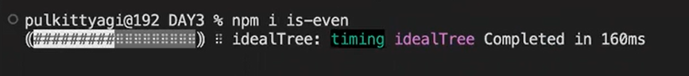

To install on terminal

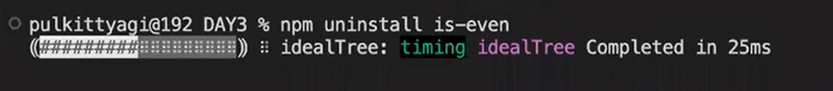

To initialize the project foe node



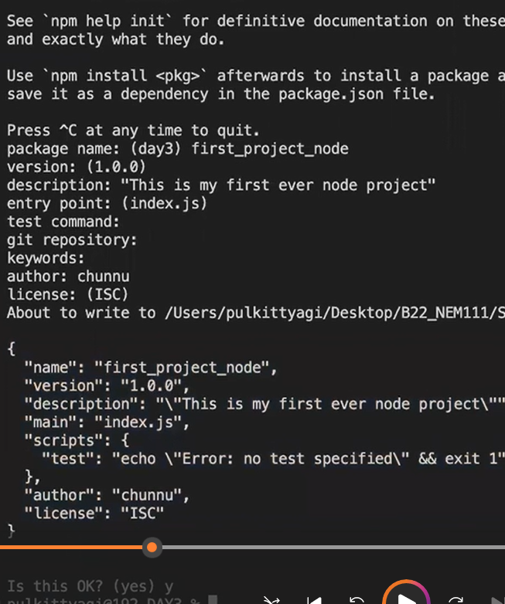

After installing this it will automatically generate package.json file which contains all the details of your project if you want to change you can change it. It is just the resume of your project

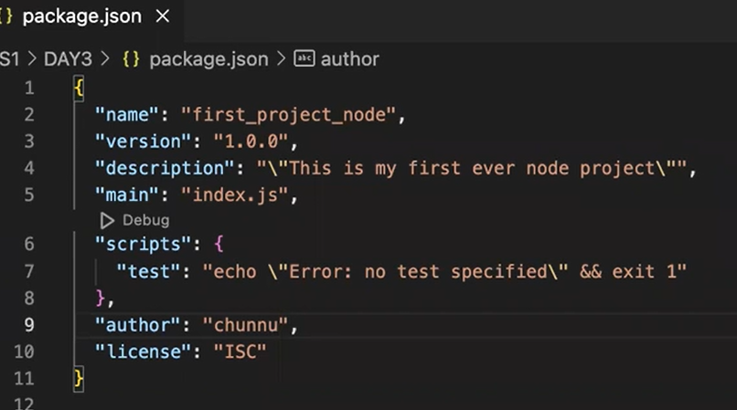

To create a folder in cjs you can write a command ..It will create the file



To delete the file write this command



To install any external package like:

 jb bhi koi external package install krenge wo dependencies me show hoga mtlb project jis jis package pe depend hai wo dependencies me show krega like this

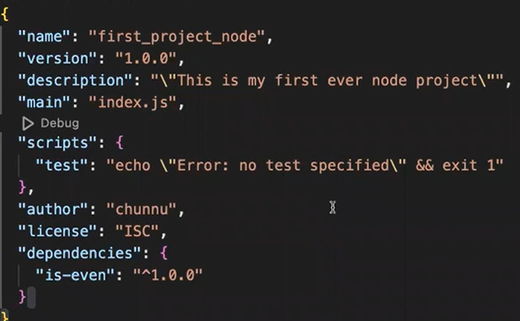

Code of your dependencies is given in the node module

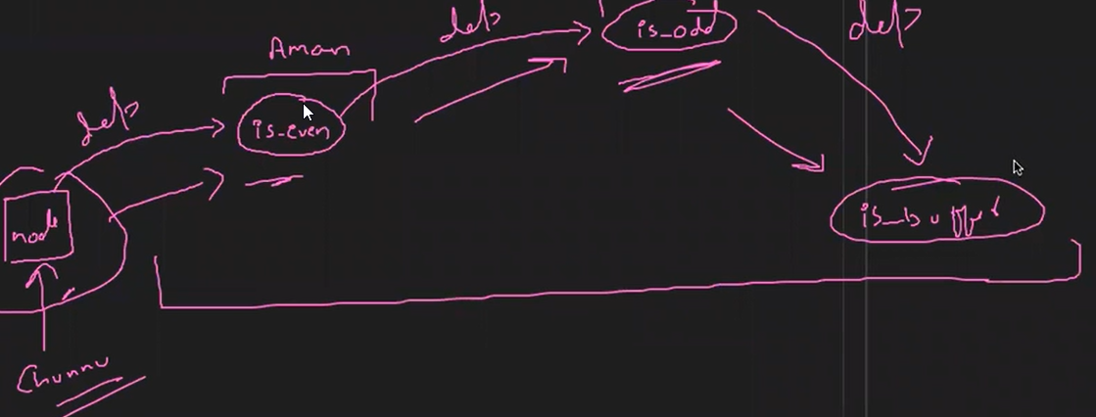

In this program we check the number is even or not by using external “is-even” function

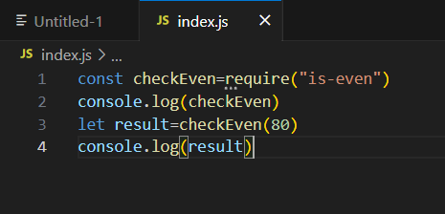

If you want to check the dependencies you can simply go through the node_module folder

Is-even ye already kisine banake rakha hai iske agr coading dekhana hai to node_module folder me milegi

To remove files

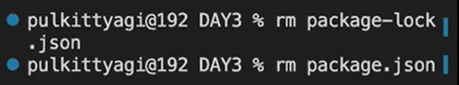

To remove folders



FS Module

It is necessary to write require(“fs”)

Const fs=require (“fs”) it means

We are storing fs mdule in fs variable asynchronously

Ye read file function contain file name err and data in this example we did not use utf-8 that’s why it pritnts the s sky code of all the number or showing the buffer value

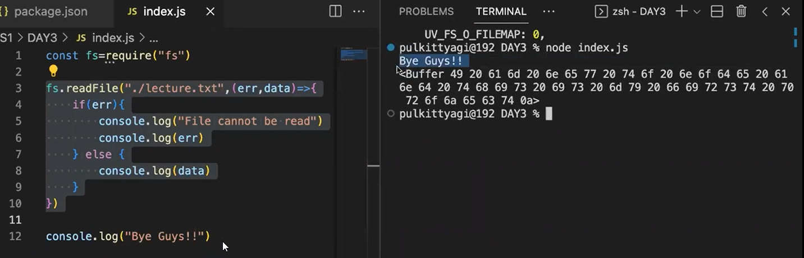

To remove this and to print actual file data we should use encoading:utf-8

By using utf-8 and readfile asynchronously the data will print asynchrously mtlb wo wait nhi krega file read krnetk wo dusra code run krega

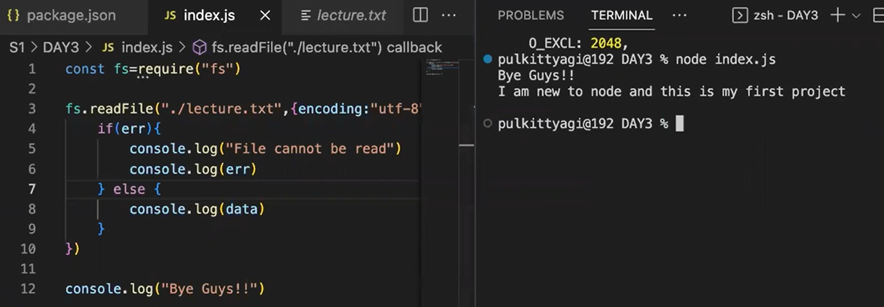

readfileSync me error callback nhi hai to usko apn error handling mechanism se handle krega

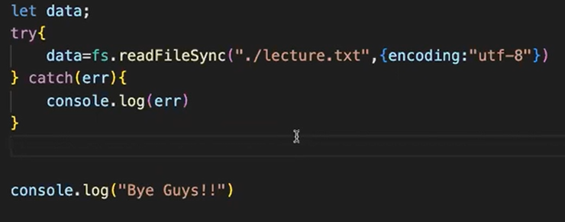

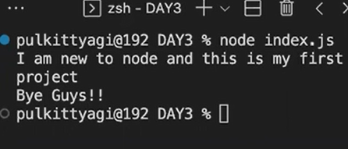

Write file synchronously agr file nhi bani hai to wo automatically generate krega file

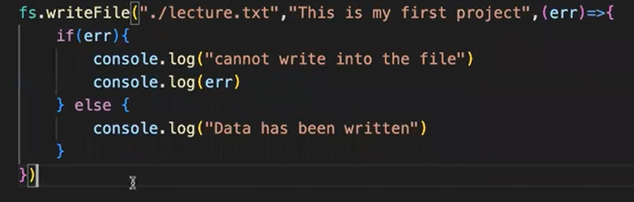

Write file asynchrously agr data already present hai to wo override krega

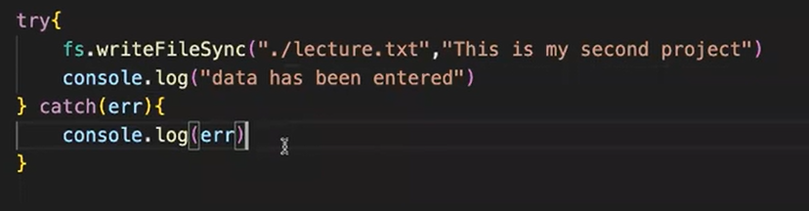

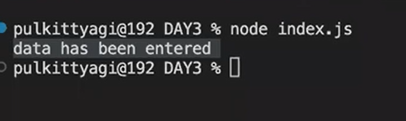

Append file asynchronously will append the data in the file \n is used to print data in next line

