It is the communication between client and server

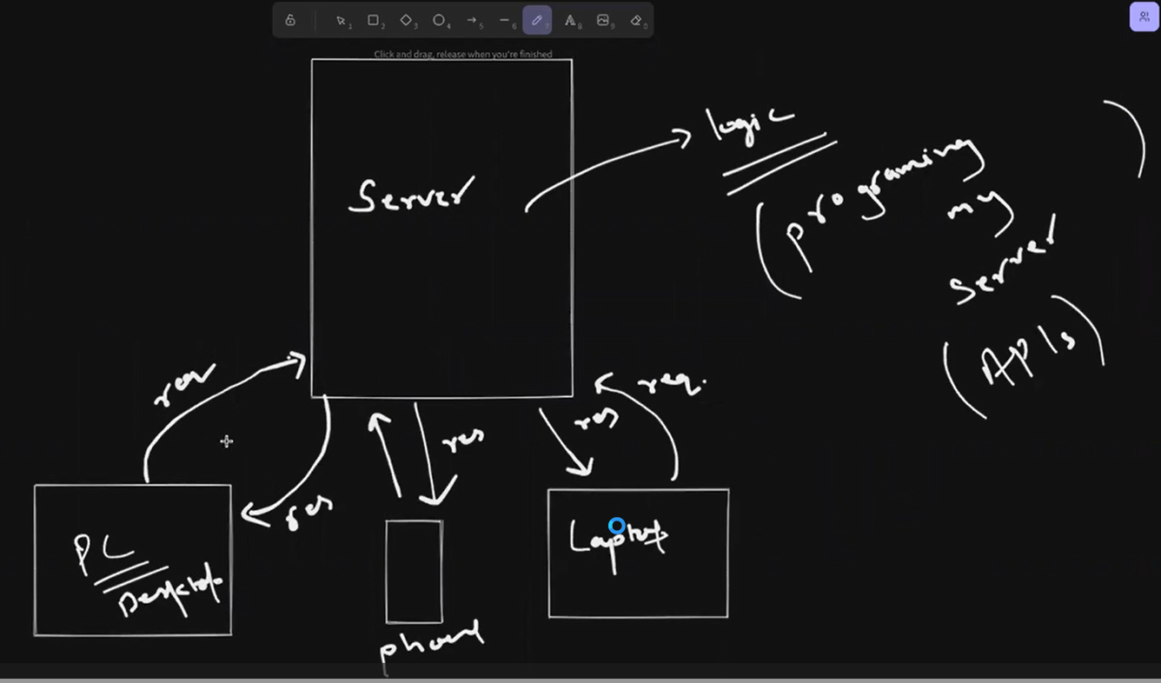

http and https

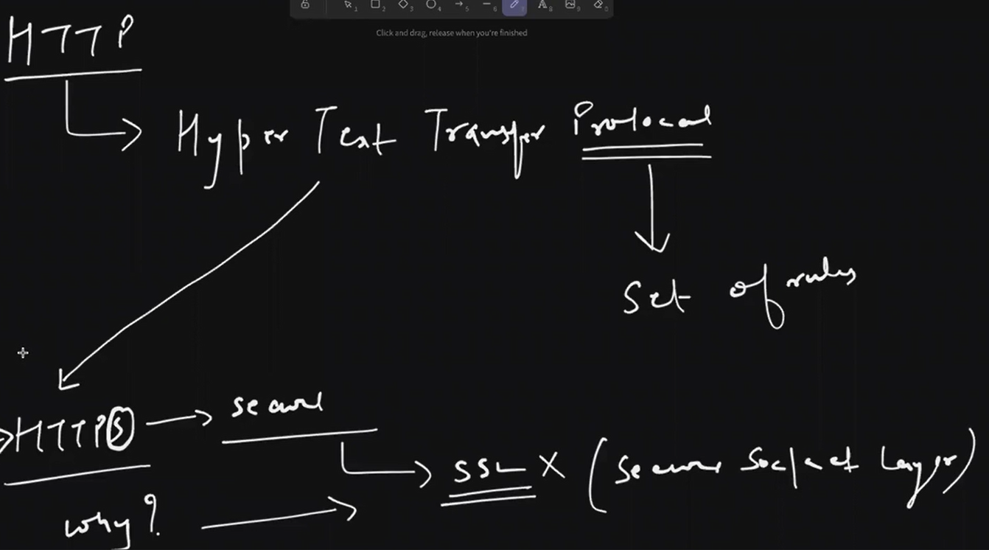

How server works

Firstly client will tell the intension then server acknowledge the things means understand the purpose of the client and then client request the server it is called as 3ways of handshake

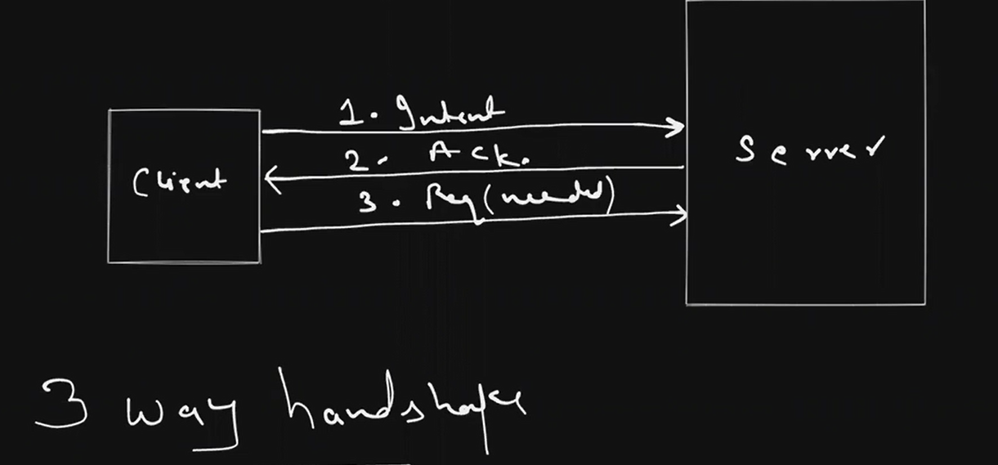

Mb-Megabit

MB-Megabyte

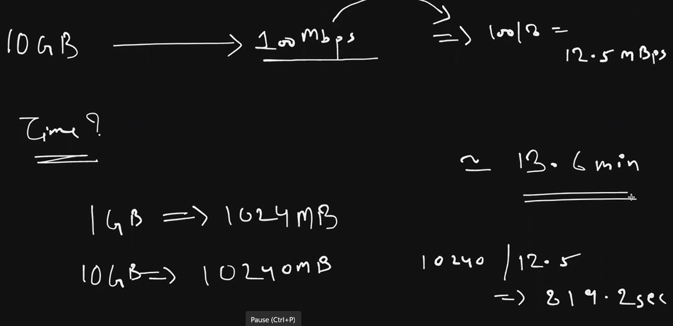

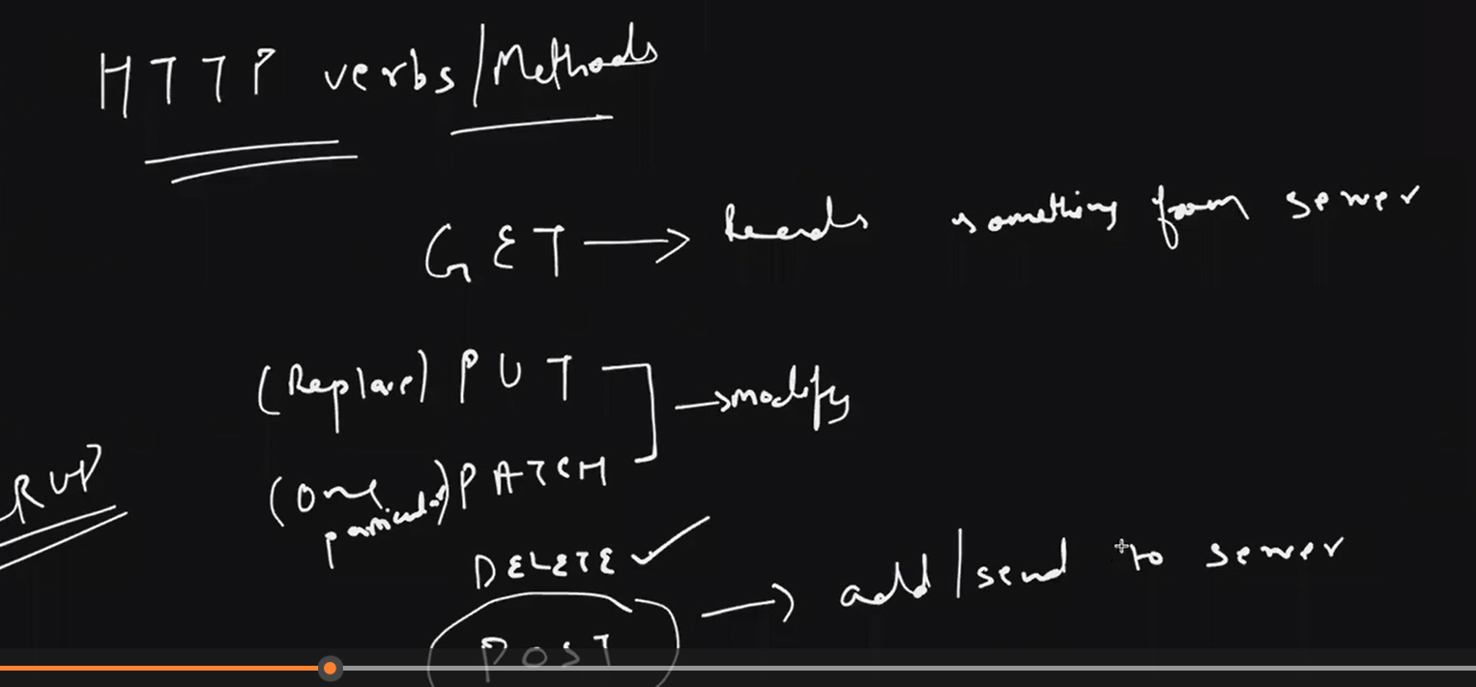

**Http server**

In this code you can see that we import the http server and then by using http object hmne server create kiya by using callback function usme two parameters hai request and response badme usme apn ne condition likha hai server ko request bhejne ke liye request.url ===”/” response.end mtlb apna response end honeke bad wo kya print krega uska response end honeke bad reload ka option dikhega

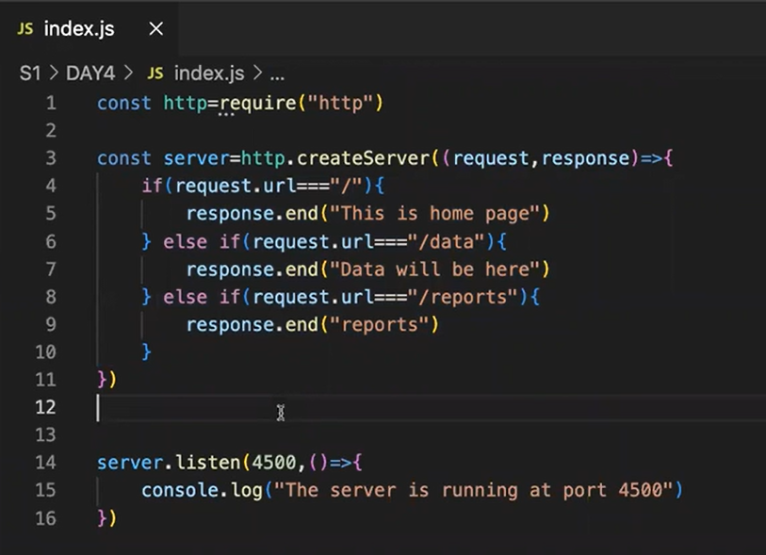

Ctrl+c terminal me file rerun krne ke liye use hota hai

Server will have a dedicated port where it will be running like aeroplane airport pe rukta hai buses bustop pe like that

Jaise abhi ek bus apne jage pe khadi hai mtlb usne uske jge le liye hai to uske jage pe dusri bus khadi nhi ho skti just like that kuch port already reserve rehete hai unko apn dobara use nhi kr skte

Response.write bhi apn likh skte hai lekin uska mtlb ye hota hai ki response end nhi huwa hai isliye wo loading hota rhega it will keeping on the response that’s why we use response.end over hear it tells the client that response is ended

It is the actual api for data in this code we read the file and it response to client

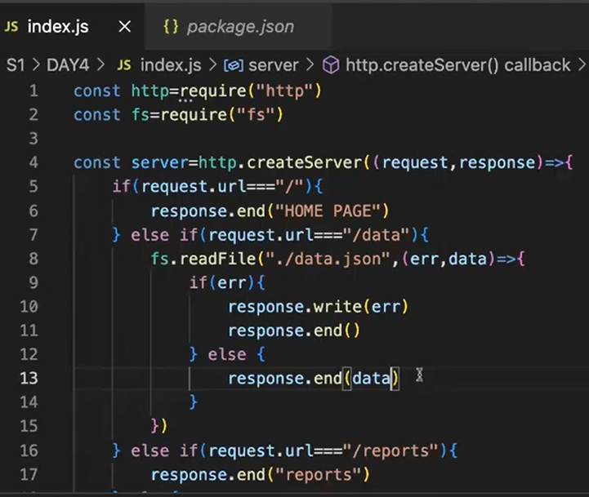

Response.write(err) se firstly wo error write krega aur badme wo response.end end me show krega

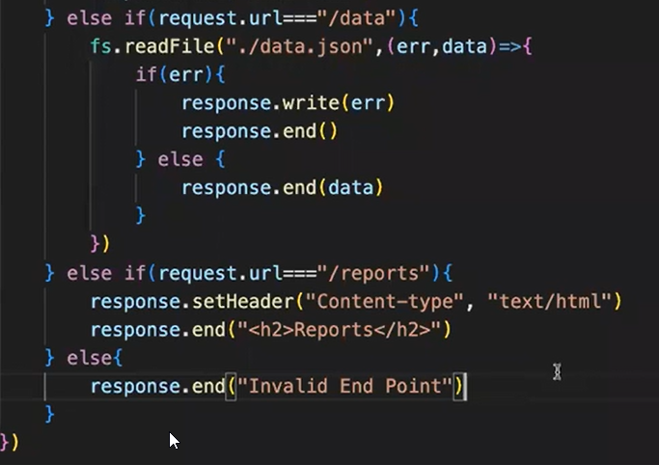

Response.setHeader will give the extra information like it is in which format you want .you can show mmmmhe data using html also <h2>Reports</h2> print the heading in h2 format

The package that use for benchemarking is autocannon

Npx-x means execute it is same as npm but did not need to installing any kind of package we can excute it without installing so that without using autocannon we can use it.

How to install npx

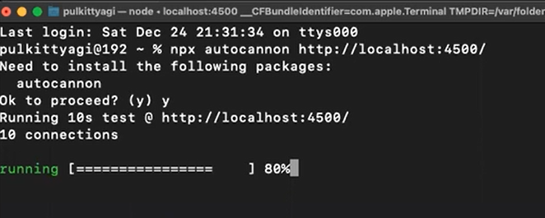

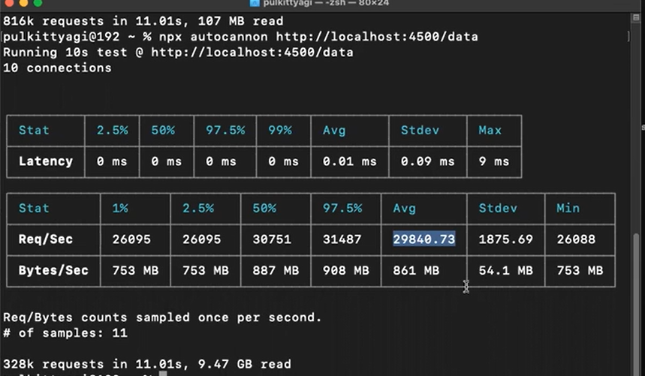

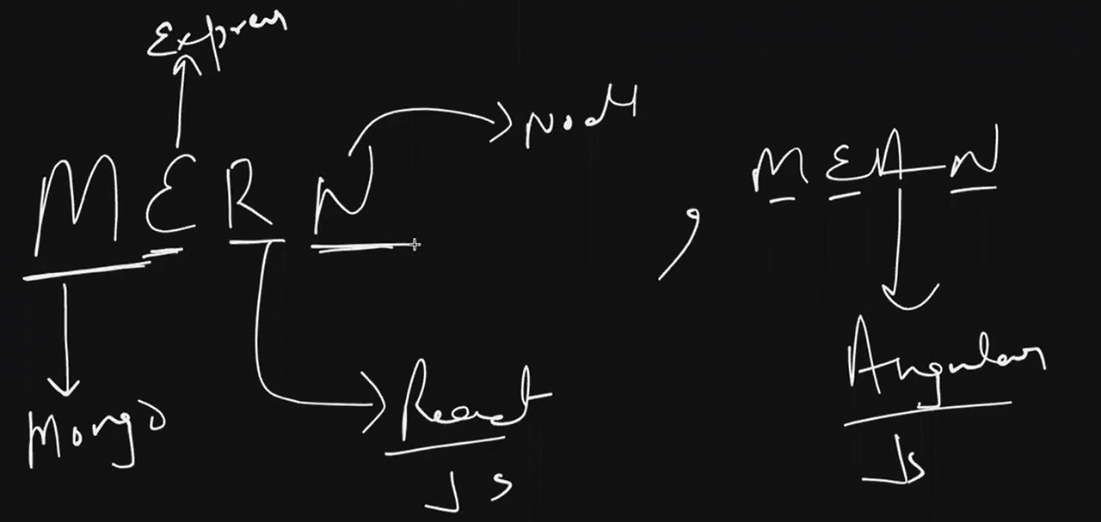

to use nodemon I haveto change in the scripts

