Name:- Bhavesh Gadling
MIS:- 612415061
Div: 1 (ADSL2)

Part A:-

- Find the number of instructors who have never taught any course. If the result of your query is empty, add the appropriate data (and include corresponding insert statements) to ensure the result is not empty.NOTE: IN THE SUBMISSION FILE, PASTE DATA INSERTED BELOW THIS STATEMENT AS A REMARK.
→
SELECT COUNT(*) AS instructors
FROM instructor WHERE ID NOT IN (
SELECT ID FROM teaches
);


- Find the total capacity of every building in the university.
→ SELECT building, SUM(capacity) as total_capacity FROM classroom GROUP BY building;
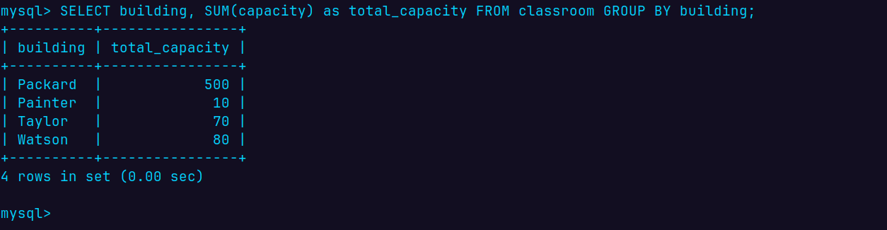
- Find all departments that have at least one instructor, and list the names of the departments along with the number of instructors; order the result in descending order of number of instructors.
→ SELECT i.dept_name, COUNT(i.ID) as instructors FROM instructor as i GROUP BY i.dept_name ORDER BY instructors DESC;
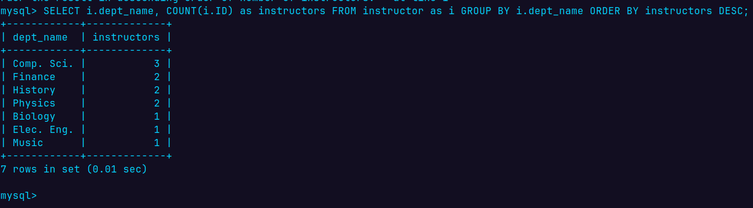
- For each student, compute the total credits they have successfully completed, i.e. total credits of courses they have taken, for which they have a non-null grade other than 'F'. Do NOT use the tot_credits attribute of student.
→
SELECT s.ID, s.name, SUM(c.credits) AS total_credits FROM student AS s JOIN takes AS t ON s.ID = t.ID JOIN course AS c ON t.course_id = c.course_id WHERE t.grade IS NOT NULL AND t.grade <> 'F' GROUP BY s.ID, s.name;
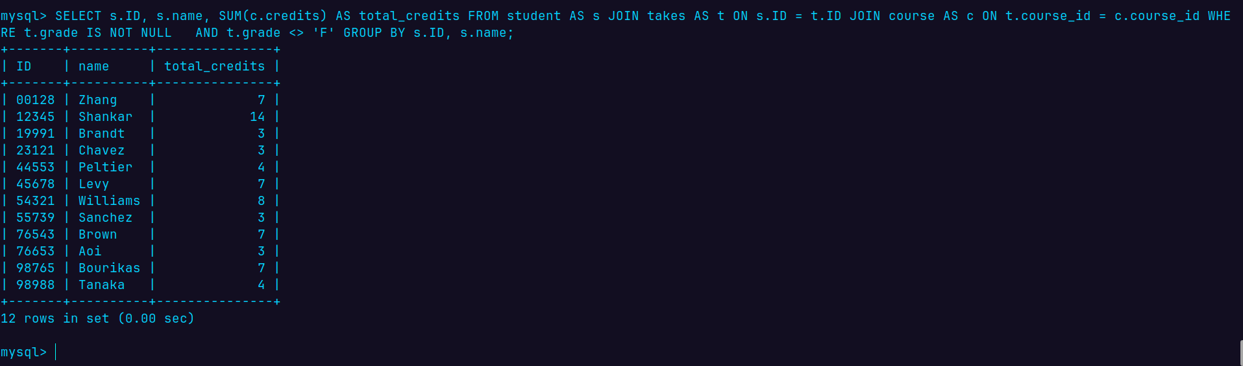

Part B:
- Find the id and title of all courses which do not require any prerequisites.
→
SELECT c.course_id, c.title FROM course AS c WHERE c.course_id NOT IN ( SELECT p.course_id FROM prereq AS p );
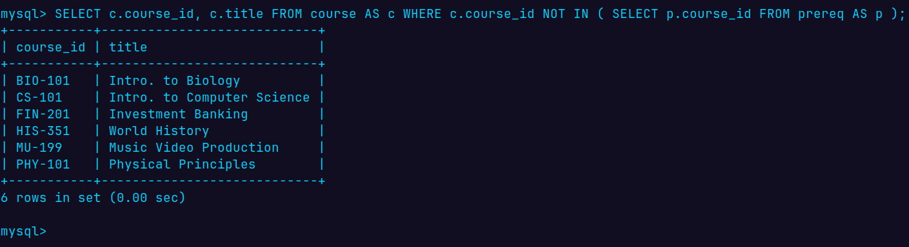
- Find the names of students who have not taken any biology dept. courses.
→
SELECT s.name FROM student AS s WHERE s.ID NOT IN ( SELECT t.ID FROM takes AS t WHERE t.course_id IN ( SELECT c.course_id FROM course AS c WHERE c.dept_name = 'Biology' ) );

