Each offering of a course (i.e. a section) can have many Teaching assistants;f each teaching assistant is a student. Extend the existing schema(Add/Alter tables) to accommodate this requirement.

→ CREATE TABLE ta ( s_id VARCHAR(5), course_id VARCHAR(20), sec_id VARCHAR(10), semester VARCHAR(10), year DECIMAL(4,0),
PRIMARY KEY (s_id, course_id, sec_id, semester, year),
FOREIGN KEY (s_id) REFERENCES student(ID),
FOREIGN KEY (course_id, sec_id, semester, year) REFERENCES section(course_id, sec_id, semester, year)
);
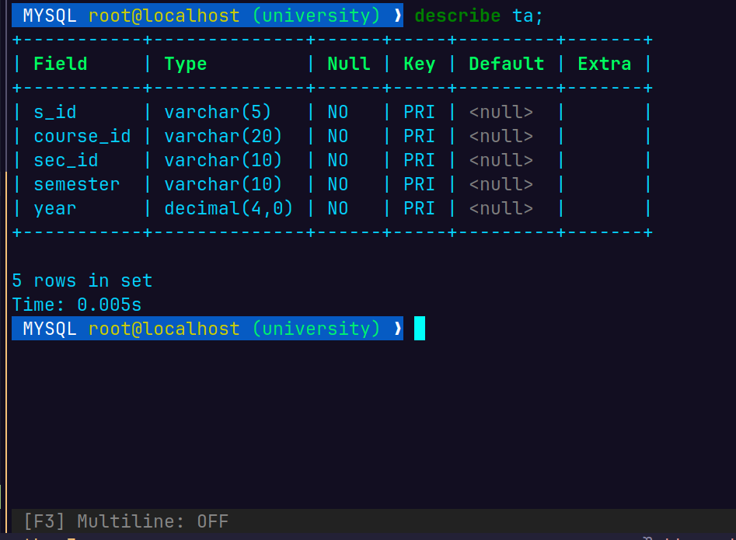

Alter the schema to allow a student to have multiple advisors and make sure that you are able to insert multiple advisors for a student.
→
ALTER TABLE advisor DROP FOREIGN KEY advisor_ibfk_1;
ALTER TABLE advisor MODIFY i_ID VARCHAR(5) NOT NULL, DROP PRIMARY KEY, ADD PRIMARY KEY (s_ID, i_ID);
ALTER TABLE advisor ADD CONSTRAINT fk_advisor_instructor FOREIGN KEY (i_ID) REFERENCES instructor(ID);

Testing
INSERT INTO advisor VALUES ('00128', '10101');
insert into advisor values ('00128', '12121');
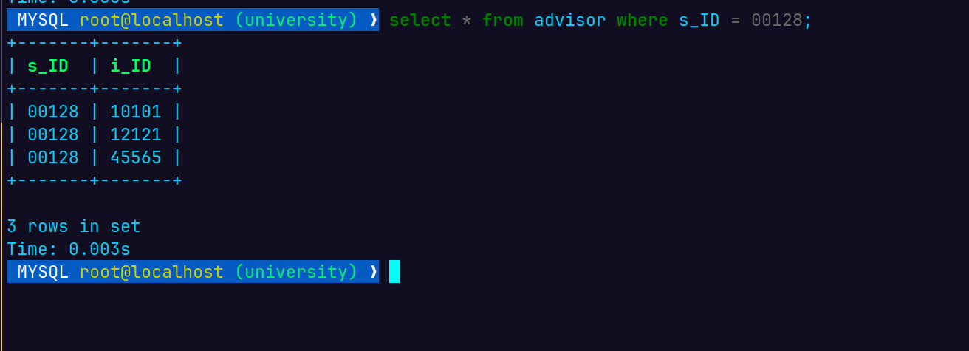
Write SQL queries on the modified schema. You will need to insert data to ensure the query results are not empty.
- Find all students who have more than 3 advisors
- Find all students who are co-advised by Prof. Srinivas and Prof. Ashok.
- Find students advised by instructors from different departments. etc.
→ INSERT INTO instructor (ID, name, dept_name, salary)
VALUES ('99999', 'Ashok', 'Elec. Eng.', 60000);
INSERT INTO advisor (s_ID, i_ID) VALUES
('00128', '10101'),
('00128', '12121'),
('00128', '22222'),
('00128', '15151'),
('00128', '99999'),
('12345', '10101'),
('12345', '99999'),
('23121', '12121'),
('00128', '22222'),
('23121', '22222');

Find all students who have more than 3 advisors

SELECT s.ID, s.name, COUNT(*) AS advisor_count
FROM student s
JOIN advisor a ON s.ID = a.s_ID
GROUP BY s.ID, s.name
HAVING COUNT(*) > 3;

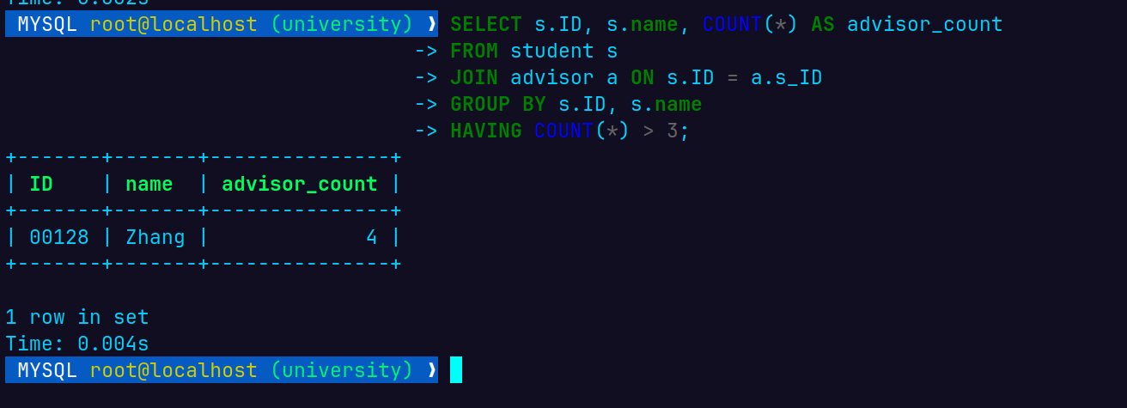

Find all students who are co-advised by Prof. Srinivas and Prof. Ashok
INSERT INTO advisor (s_ID, i_ID) VALUES ('12345', '99999');
SELECT s.ID, s.name
FROM student s
JOIN advisor a ON s.ID = a.s_ID
JOIN instructor i ON a.i_ID = i.ID
WHERE i.name IN ('Srinivasan', 'Ashok')
GROUP BY s.ID, s.name
HAVING COUNT(DISTINCT i.name) = 2;
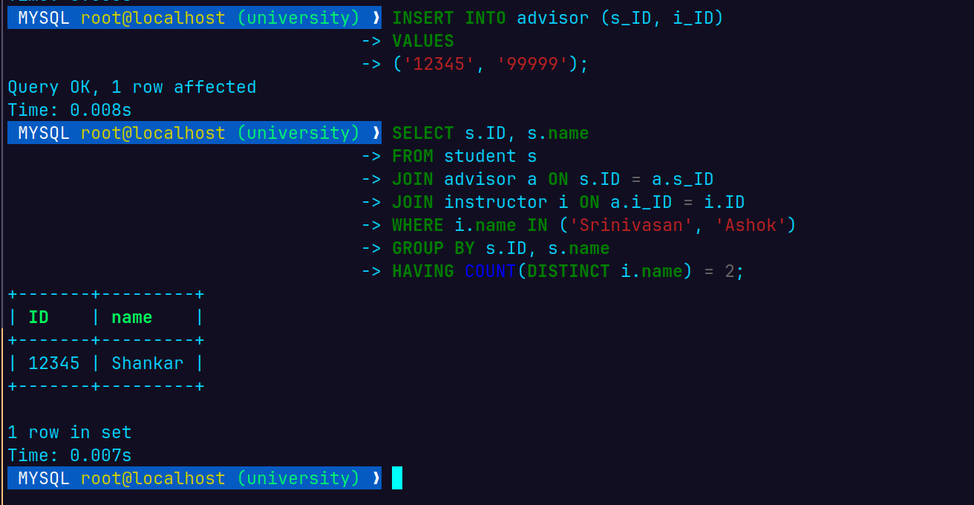

Find students advised by instructors from different departments. etc.

SELECT s.ID, s.name
FROM student s
JOIN advisor a ON s.ID = a.s_ID
JOIN instructor i ON a.i_ID = i.ID
GROUP BY s.ID, s.name
HAVING COUNT(DISTINCT i.dept_name) > 1;
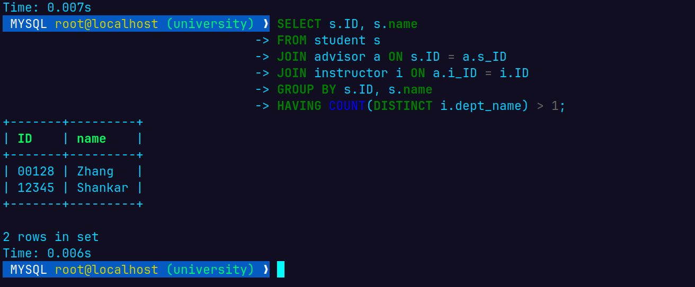
Delete all information in the database which is more than 10 years old. Add data as necessary to verify your query.
DELETE FROM section
WHERE year < 2016;
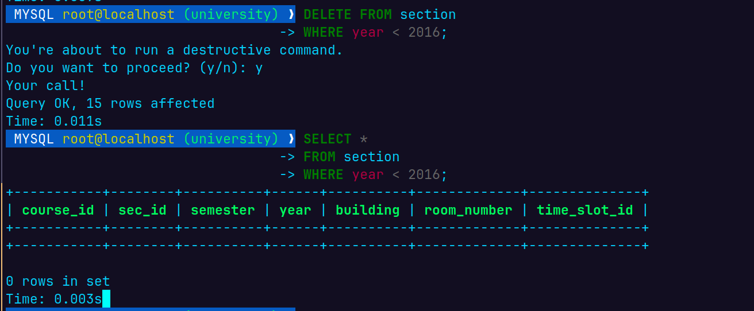

Delete the course CS 101. Any course which has CS 101 as a prereq should remove CS 101 from its prereq set. Create a cascade constraint to enforce the above rule, and verify that it is working.

ALTER TABLE prereq DROP FOREIGN KEY prereq_ibfk_2;
ALTER TABLE prereq ADD CONSTRAINT fk_prereq_course FOREIGN KEY (prereq_id) REFERENCES course(course_id) ON DELETE CASCADE;
SHOW CREATE TABLE prereq;

DELETE FROM course
WHERE course_id = 'CS-101';
--verify
SELECT *
FROM course
WHERE course_id = 'CS-101';

