Assignment 5: Schema creation and constraints
Statement: Create the schema and constraints on the relations.

Modify the trains schema which we saw earlier to create constraints to check the following:
- The value of timein is always less than or equal to timeout
→
ALTER TABLE trainhalts
ADD CONSTRAINT chk_time
CHECK (timein <= timeout);

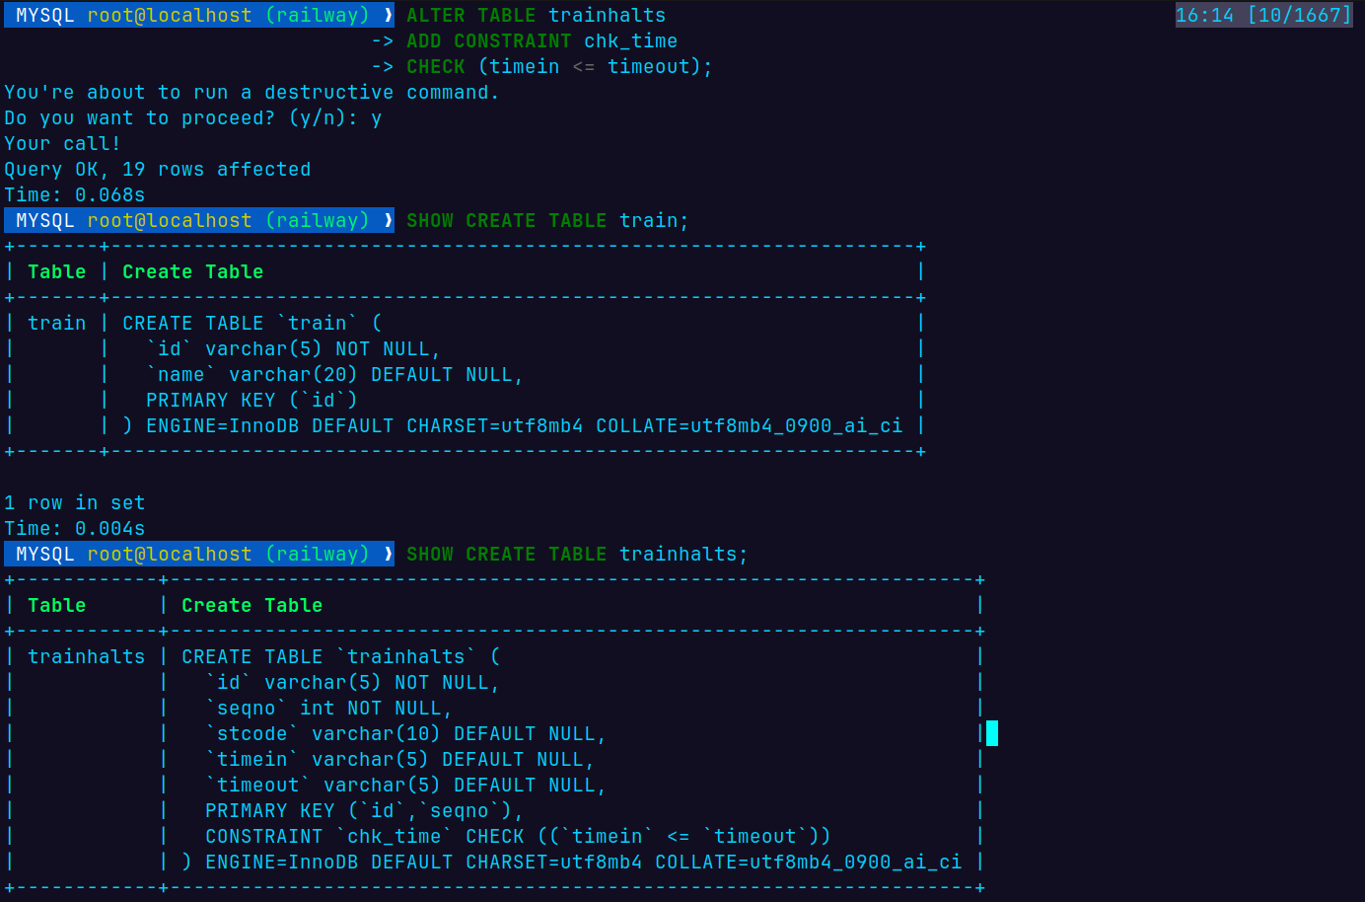
- When a train is removed from service, all its halts should be deleted.

ALTER TABLE trainhalts ADD CONSTRAINT fk_trainhalts_train FOREIGN KEY (id) REFERENCES train(id) ON DELETE CASCADE;

INSERT INTO train VALUES ('T20', 'Mahrashtra Express');

INSERT INTO trainhalts (id, seqno, stcode, timein, timeout) VALUES
('T20', 999, 'PUNE', '12:00', '13:00');

DELETE FROM train WHERE id = ‘T20’

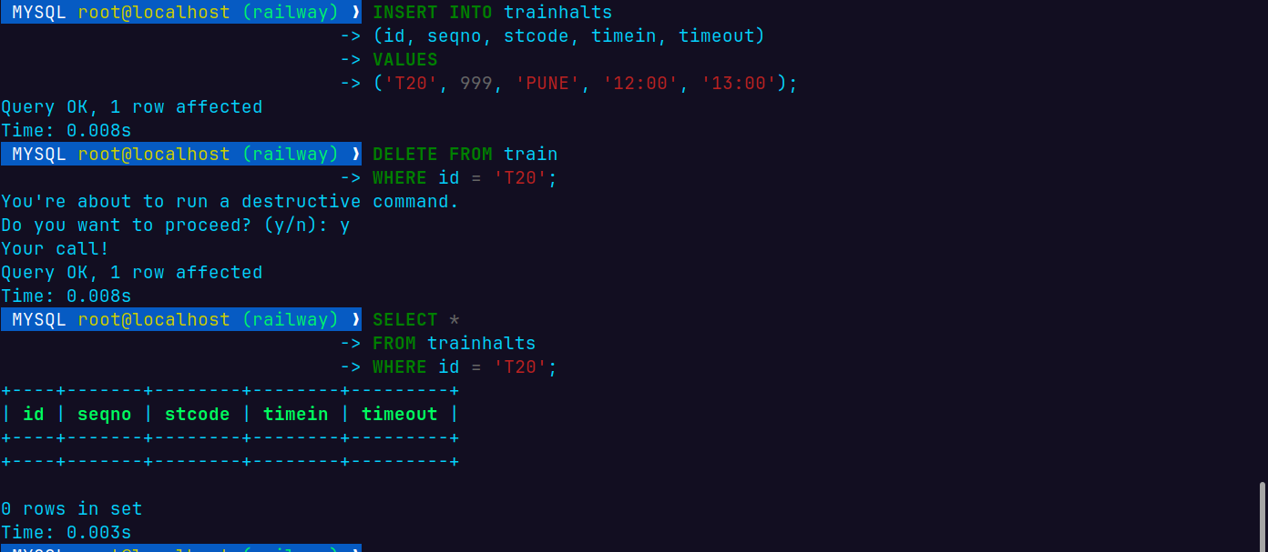
- Insert inconsistent data and verify the constraints.
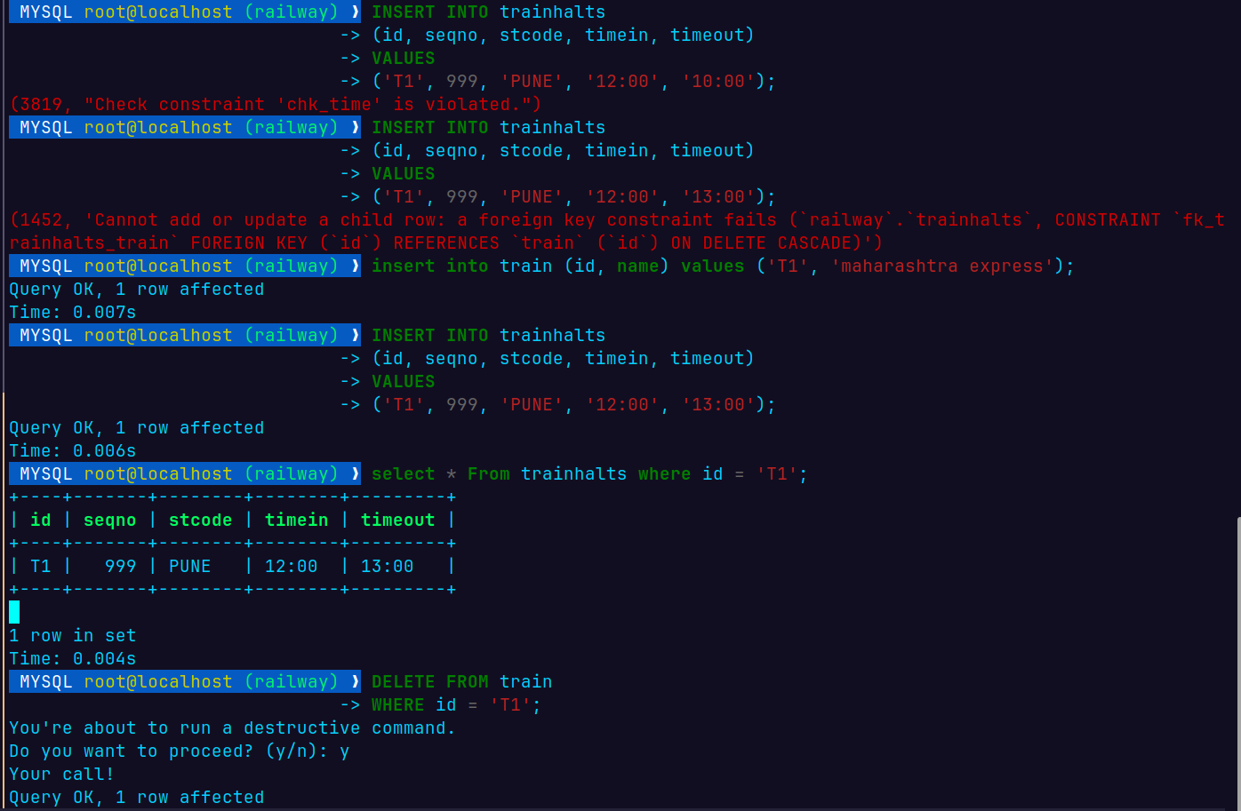
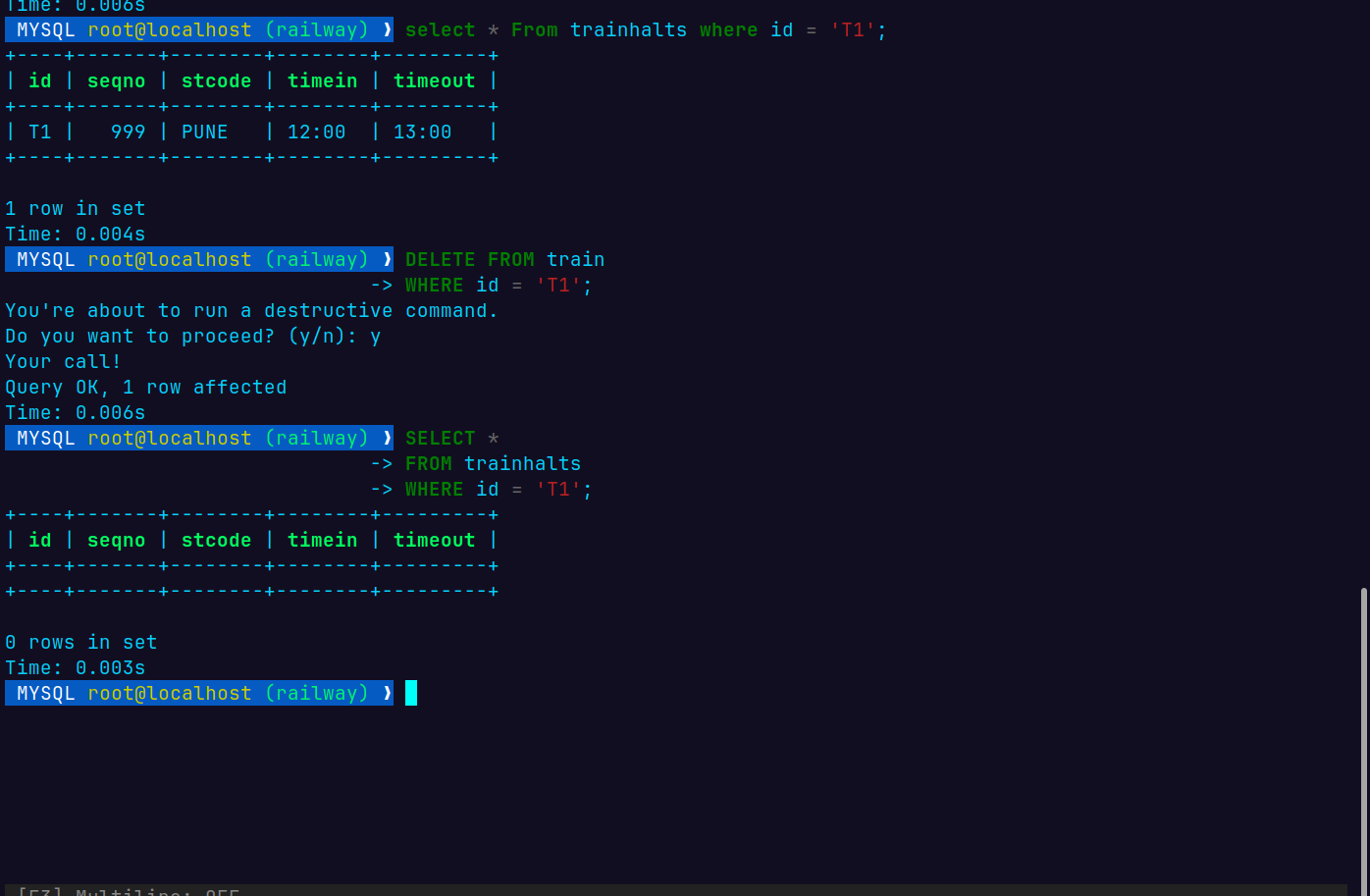
Write SQL Create table statements to create the following schema. Include all appropriate primary and foreign key declarations. Choose appropriate types for each attribute.
  - remotecentre(centreId, college, town, state)
  - person(ID, name, email)
  - programme(progId, title, fromdate, todate)
  - coordinator(ID, progId, centreId)
  - participant(ID, progId, centreId)
→
CREATE TABLE remotecentre (
centreId INT PRIMARY KEY,
college VARCHAR(100) NOT NULL,
town VARCHAR(50),
state VARCHAR(50)
);

CREATE TABLE person (
ID INT PRIMARY KEY,
name VARCHAR(100) NOT NULL,
email VARCHAR(100) UNIQUE
);

CREATE TABLE programme (
progId INT PRIMARY KEY,
title VARCHAR(100) NOT NULL,
fromdate DATE,
todate DATE,
CHECK (fromdate <= todate)
);

CREATE TABLE coordinator (
ID INT,
progId INT,
centreId INT,

PRIMARY KEY (ID, progId, centreId),

FOREIGN KEY (ID)
REFERENCES person(ID),

FOREIGN KEY (progId)
REFERENCES programme(progId),

FOREIGN KEY (centreId)
REFERENCES remotecentre(centreId)
);

CREATE TABLE participant (
ID INT,
progId INT,
centreId INT,

PRIMARY KEY (ID, progId, centreId),

FOREIGN KEY (ID)
REFERENCES person(ID),

FOREIGN KEY (progId)
REFERENCES programme(progId),

FOREIGN KEY (centreId)
REFERENCES remotecentre(centreId)
);

