For University Dataset Questions.

1. Find the names of all the students whose total credits are greater than 100 .

Query:- SELECT name FROM student WHERE tot_cred>100;
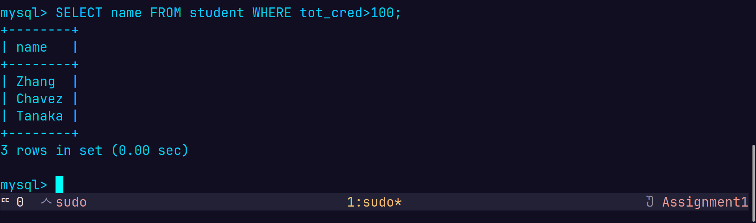
2. Find the course id and grades of all courses taken by any student named 'Tanaka'.

Query:- SELECT t.course_id, t.grade FROM takes as t join student as s on s.ID=t.ID WHERE s.name='Tanaka';

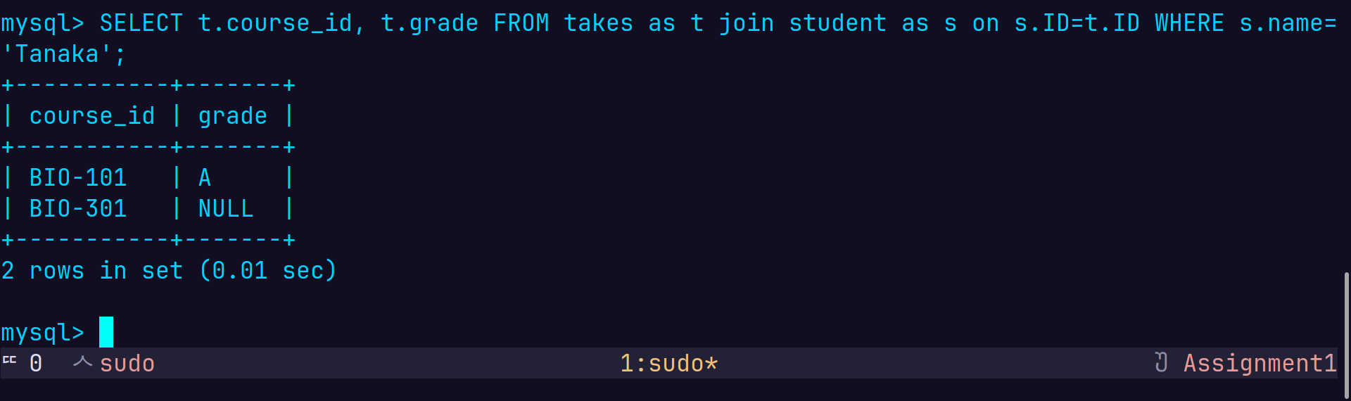

3. Find the courses which are offered in both 'Fall' and 'Spring' semester (not necessarily in the same year).
Query:- SELECT c.course_id, c.title FROM course c JOIN section s ON c.course_id = s.course_id WHERE s.semester IN ('Fall', 'Spring') GROUP BY c.course_id, c.title HAVING COUNT(DISTINCT s.semester) = 2;

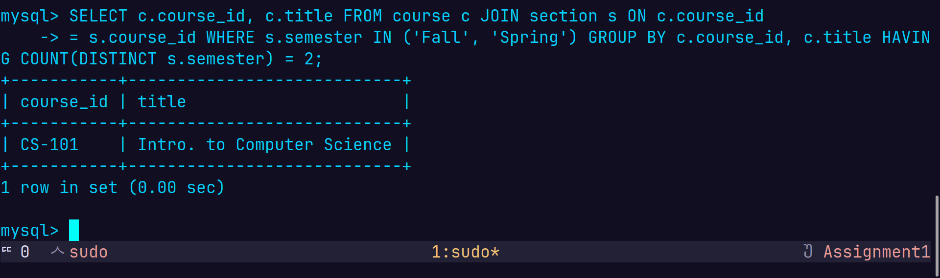
4. Find the names of all the instructors from Comp. Sci. department.

Query:- SELECT name FROM instructor WHERE dept_name='Comp. Sci.';
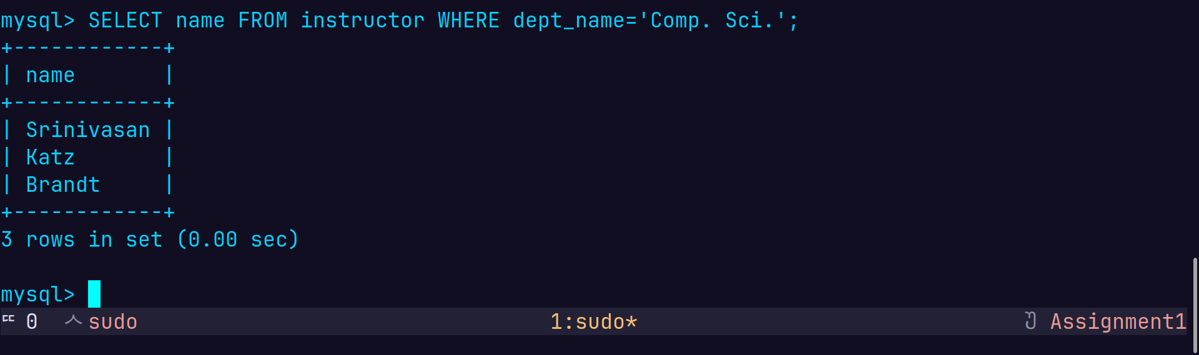

5. Find the course id and titles of all courses taught by an instructor named 'Srinivasan'

Query:- SELECT c.course_id,c.title FROM course as c JOIN teaches as t On c.course_id=t.course_id JOIN instructor as i ON i.ID=t.ID WHERE i.name='Srinivasan';

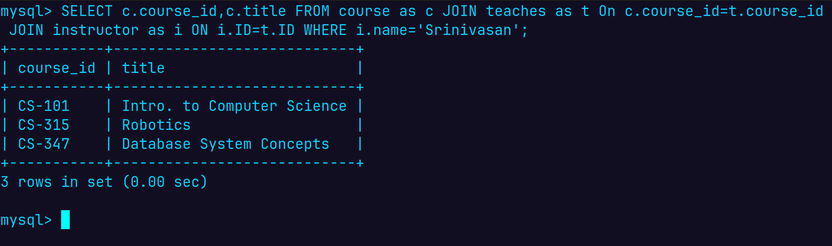

6. Find the names of instructors who have taught at least one course in Spring 2009.

Query:- SELECT DISTINCT i.name FROM instructor as i JOIN teaches as t ON i.ID=t.ID WHERE t.semester='Spring' AND t.year=2009;
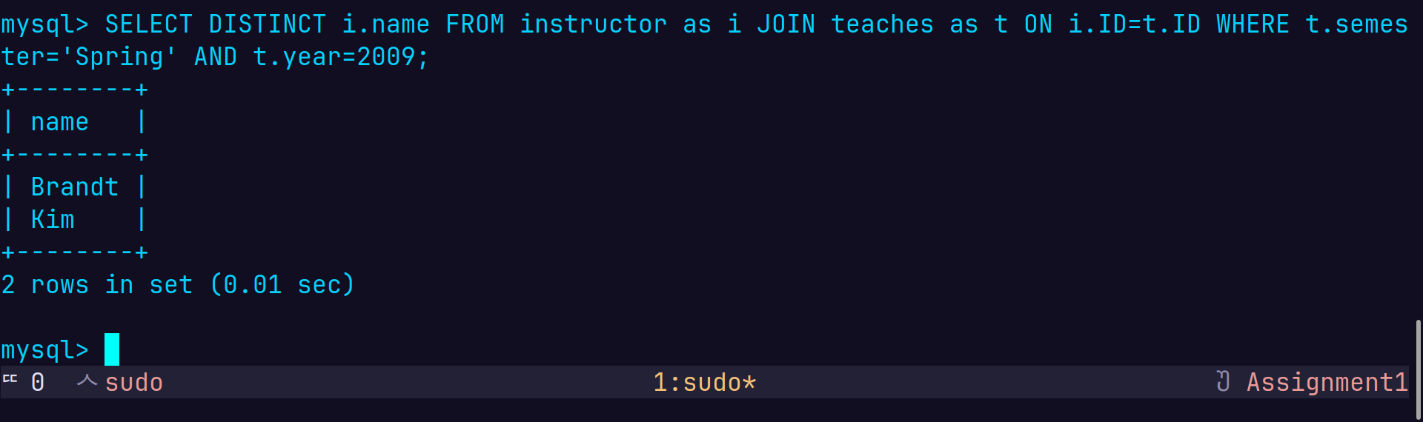

For Railway Dataset,

1. Find pairs of stations (station codes) that have a track (direct connection) with distance less than 20Kms between them.

Query:- SELECT stcode1, stcode2 FROM track WHERE distance<20;
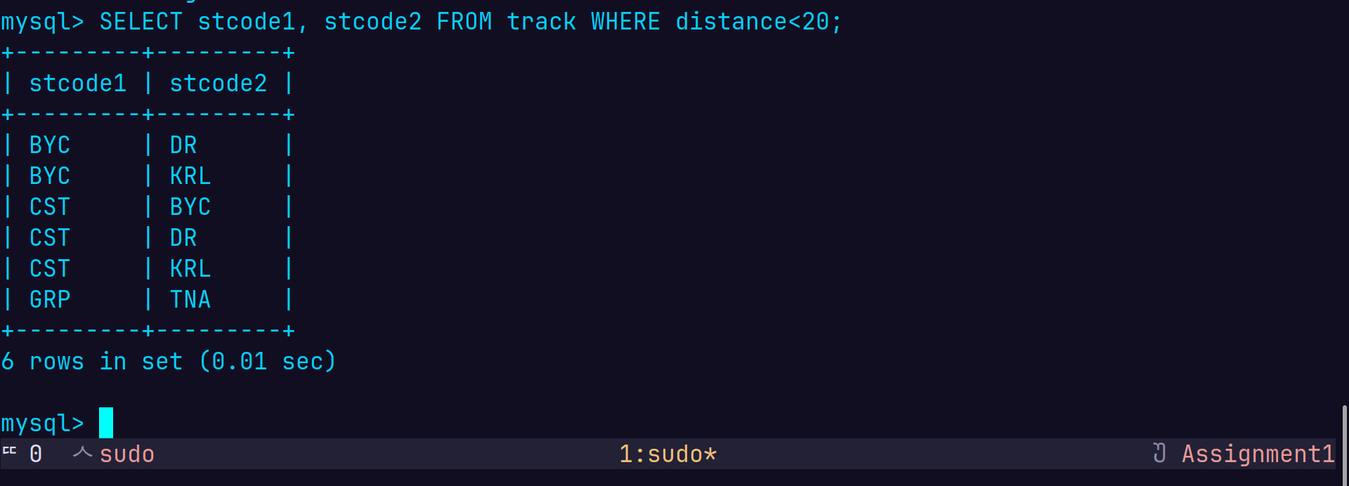

2. Find the IDs of all the trains which have a stop at THANE

Query:- SELECT id FROM trainhalts as th JOIN station as s ON s.stcode=th.stcode where s.name='Thane';

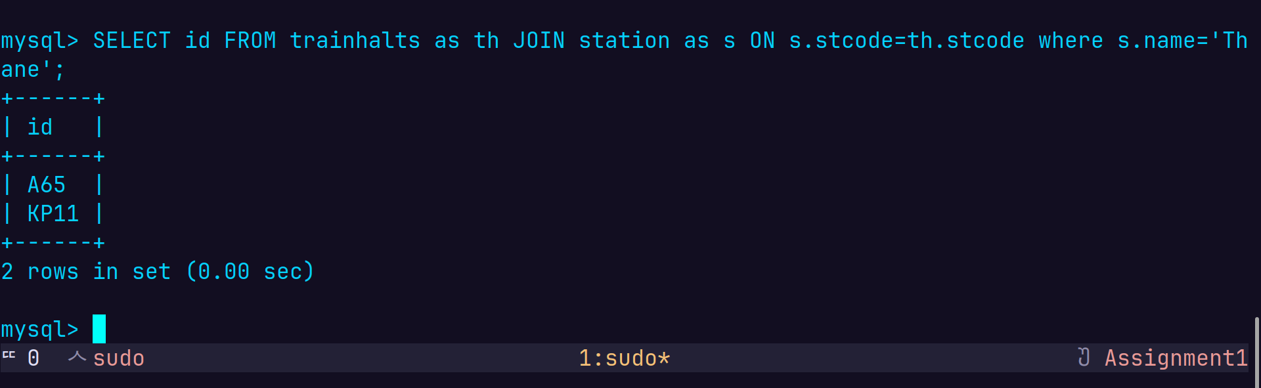

3. Find the names of all trains that start at MUMBAI.

Query:- SELECT t.name FROM train as t JOIN trainhalts th ON t.id=th.id JOIN station as s ON th.stcode=s.stcode WHERE th.seqno=0 AND s.name='MUMBAI';

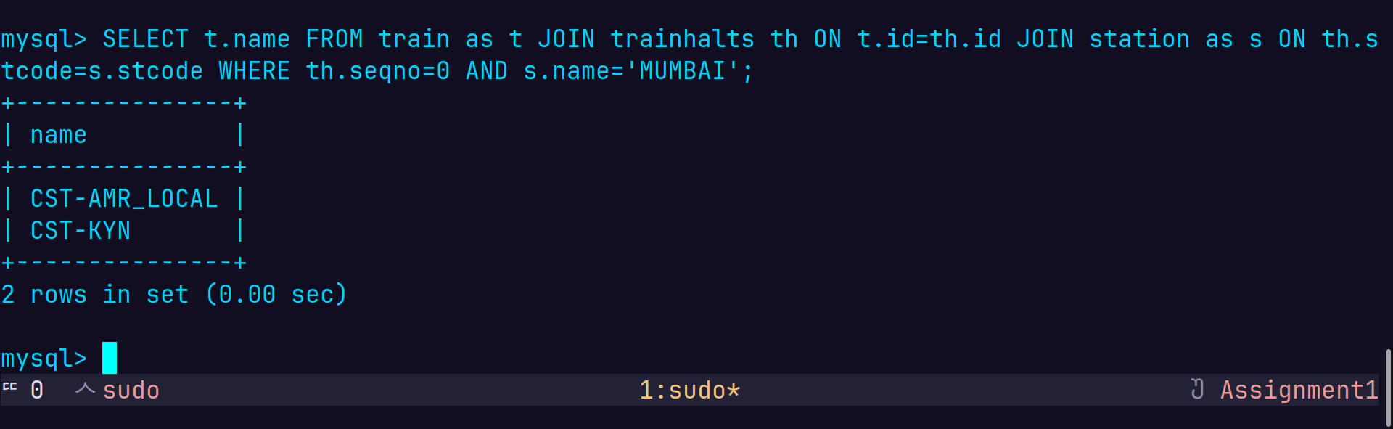
4. List all the stations in order of visit by the train 'CST-AMR_LOCAL'.

Query:- SELECT st.name FROM trainhalts AS th JOIN station AS st ON st.stcode=th.stcode WHERE id = (SELECT t.id FROM train AS t WHERE t.name = 'CST-AMR_LOCAL'
) ORDER BY seqno;

