YUVaintern Internship
WEEK 4 FINAL REPORT
Comprehensive Data Analysis Reporting and Presentation
Integrated Project: Titanic Passenger Dataset
Weeks 1–3 Consolidation: Cleaning, Visualization, Statistical Analysis and Predictive Modeling
Tools: R, RStudio, ggplot2, dplyr, caret, pROC

1. Executive Summary
This final report integrates the three previous weeks of analysis into one end-to-end data project. The Titanic dataset contains 891 passenger records and 12 original variables. The workflow begins with data quality assessment and cleaning, continues through exploratory visualization and statistical testing, and ends with a logistic regression model for survival prediction.
The cleaned analysis found 177 missing Age values, 687 missing Cabin values and 2 missing Embarked values. The overall observed survival rate was 38.38%. Female passengers had a survival rate of 74.20% compared with 18.89% for males, while class 1, 2 and 3 survival rates were 62.96%, 47.28% and 24.24% respectively.
The final logistic regression model achieved 0.810 accuracy and 0.840 ROC-AUC on the held-out test set. These results show that the passenger characteristics contain useful predictive information, while the model remains simple and interpretable.

2. Project Objectives
- Prepare a real-world dataset through documented cleaning and transformation.
- Use visualizations to communicate distributions, comparisons, relationships, and anomalies.
- Apply statistical tests to evaluate meaningful relationships and group differences.
- Build and validate a classification model for passenger survival.
- Integrate the results into a coherent narrative for technical and non-technical audiences.
- Identify limitations and practical directions for future analysis.

3. Dataset Overview and Rationale
The Titanic passenger dataset was selected across all four weeks because it combines a binary prediction target with numerical and categorical predictors, realistic missing values, and enough variation to demonstrate multiple analysis techniques. It is also easy to communicate to a broad audience because questions about survival, passenger class, age, fare and embarkation are intuitive.
Variable Group | Examples | Purpose
Outcome | Survived | Prediction target
Categorical | Sex, Embarked | Group comparisons and model predictors
Numerical | Age, Fare, SibSp, Parch | Statistics, distributions and model predictors
Ordinal/Categorical | Pclass | Passenger segmentation and predictor
Identifier/Text | PassengerId, Name, Ticket, Cabin | Identification or feature engineering candidates

4. Integrated Methodology
The project follows a repeatable data-analysis pipeline: inspect → clean → transform → visualize → test hypotheses → build model → validate → interpret → recommend. This sequence prevents the predictive model from becoming a disconnected step and ensures that statistical findings can be cross-checked using visual evidence.
titanic <- read.csv("train.csv", stringsAsFactors = FALSE, na.strings = c("", "NA"))
str(titanic)
summary(titanic)
# cleaning, visualization, hypothesis tests and model building follow

5. Week 1 – Data Preparation

5.1 Data Quality Assessment
Missing-value analysis showed 177 missing ages (19.87%), 687 missing cabin entries (77.10%) and 2 missing embarkation values (0.22%). There were 0 exact duplicate rows.

5.2 Cleaning Decisions
- Age: missing values were replaced by the median because the variable is numerical and can contain skew and outliers.
- Embarked: the two missing values were replaced by the mode because the variable is categorical and the missing proportion is very small.
- Cabin: a CabinKnown indicator was created rather than inventing cabin numbers because 77% of entries were missing.
- Outliers: IQR-based detection was used to identify unusual numeric values; legitimate extreme fares were retained rather than deleted automatically.
- Encoding and normalization: selected categorical variables were numerically encoded and selected numeric variables were min-max normalized for analytical use.
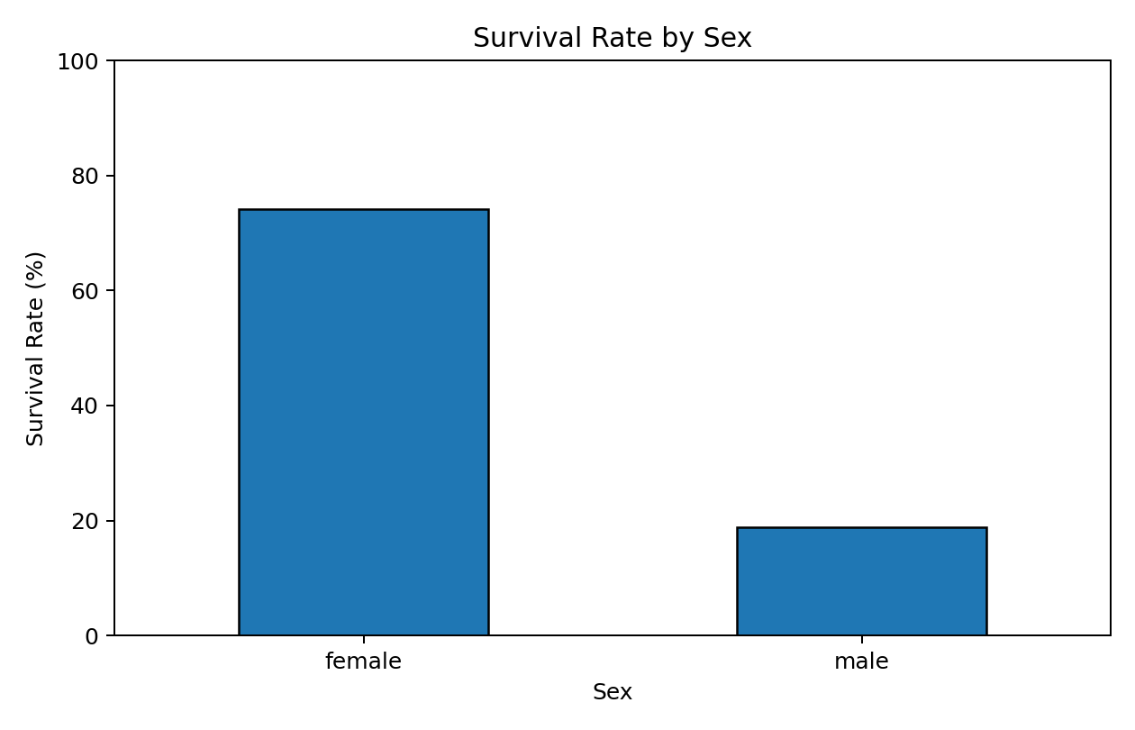
Figure 1. Week 1 visual showing a key cleaned-data insight: survival differs substantially by sex.

6. Week 2 – Visualization and Insight Communication
Week 2 focused on turning cleaned data into visual stories. Different chart types were selected based on the question being asked rather than using one generic chart for every variable.
- Bar charts: compare survival counts/rates across categories such as sex and passenger class.
- Histogram: shows the distribution and concentration of passenger ages.
- Scatter plot: examines a relationship between two numerical variables such as Age and Fare.
- Line chart: shows how survival rate changes across ordered age groups.
- Boxplot: compares fare distributions and highlights spread and potential outliers.
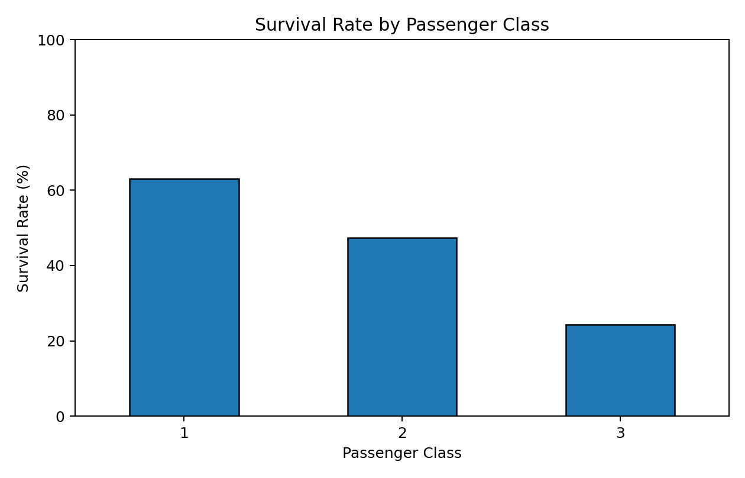
Figure 2. Week 1/2 visual demonstrating the communication value of comparing survival rates by class.
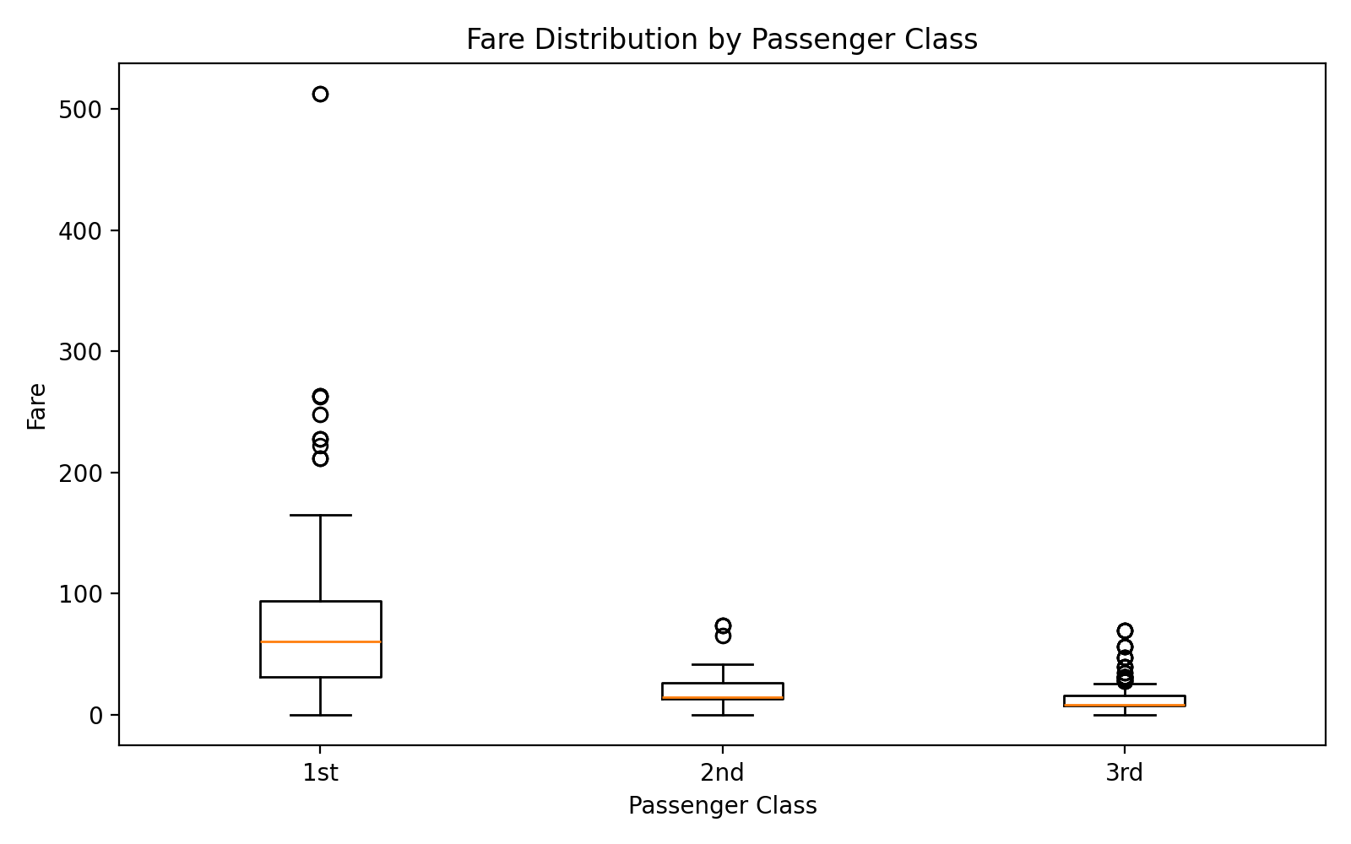
Figure 3. Week 2 boxplot showing the spread and differences in fare across passenger classes.

7. Week 3 – Statistical Analysis

7.1 Hypothesis Testing
chisq.test(table(titanic$Sex, titanic$Survived))
wilcox.test(Fare ~ Survived, data = titanic)
cor.test(titanic$Age, titanic$Fare, method = "pearson")

The chi-square test produced p = 1.2e-58, providing strong evidence of an association between sex and survival. The Wilcoxon rank-sum test produced p = 4.553e-22, indicating a statistically significant difference in Fare distributions between survivors and non-survivors. Pearson correlation between Age and Fare was r = 0.097 (p = 0.003867), which indicates only a modest positive linear relationship.
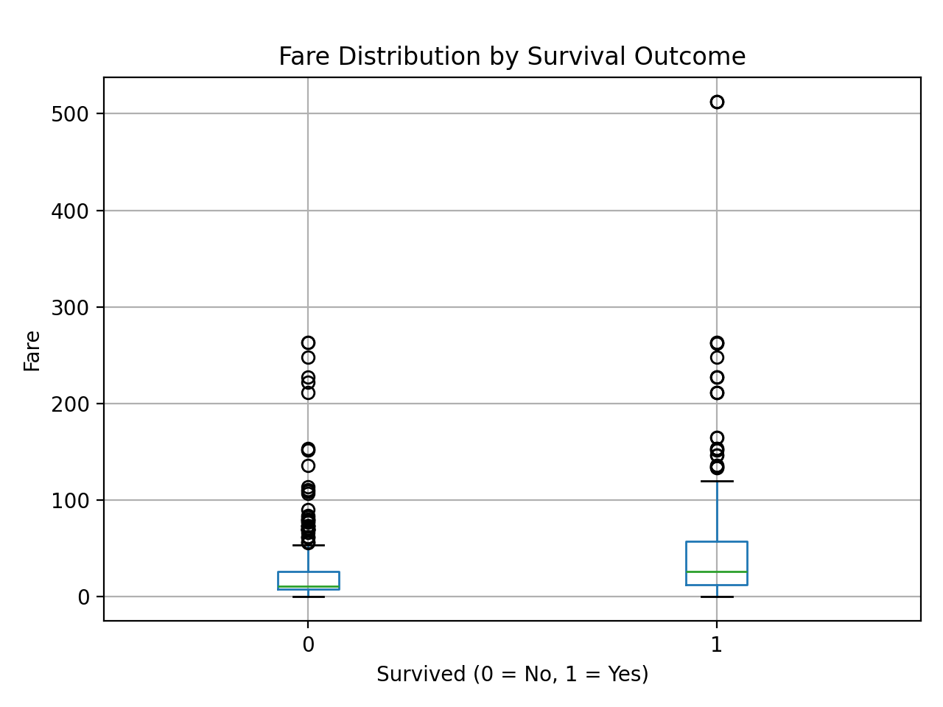
Figure 4. Statistical evidence supporting a difference in fare distributions between survival groups.

8. Predictive Modeling
A logistic regression classifier was selected because Survived is binary and logistic regression is interpretable. Predictors were Pclass, Sex, Age, SibSp, Parch, Fare, Embarked and CabinKnown. The modeling workflow used an 80/20 stratified train/test split and 5-fold cross-validation.
set.seed(42)
idx <- createDataPartition(model_data$Survived, p = 0.80, list = FALSE)
train_data <- model_data[idx, ]
test_data <- model_data[-idx, ]
logit_model <- train(
Survived ~ Pclass + Sex + Age + SibSp + Parch + Fare + Embarked + CabinKnown,
data = train_data, method = "glm", family = binomial(),
metric = "ROC", trControl = ctrl
)

Test Metric | Result
Accuracy | 0.810
Precision | 0.778
Recall | 0.710
F1 Score | 0.742
ROC-AUC | 0.840
The test results indicate useful predictive performance. Accuracy summarizes the percentage of correctly classified passengers, while precision and recall describe performance for the survivor class. F1 combines precision and recall, and ROC-AUC evaluates how well the model ranks survivors above non-survivors across thresholds.
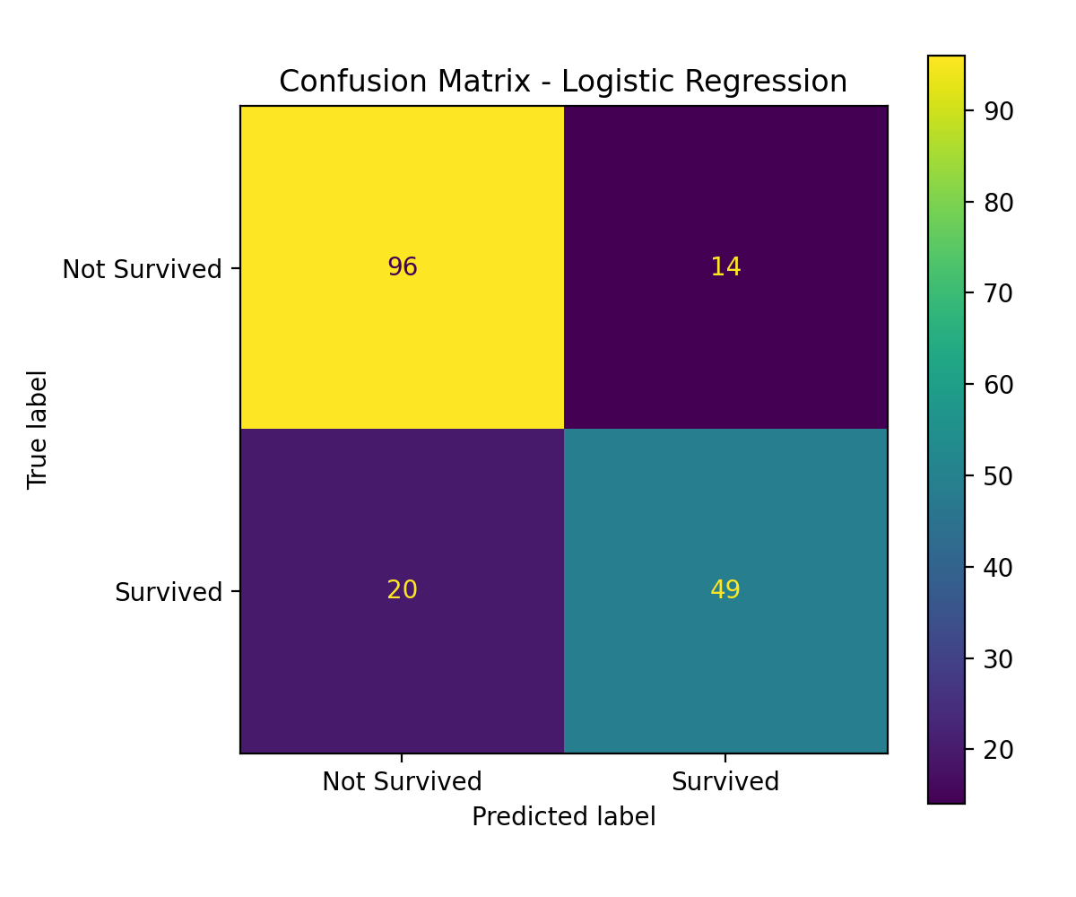
Figure 5. Confusion matrix for the final logistic regression model.
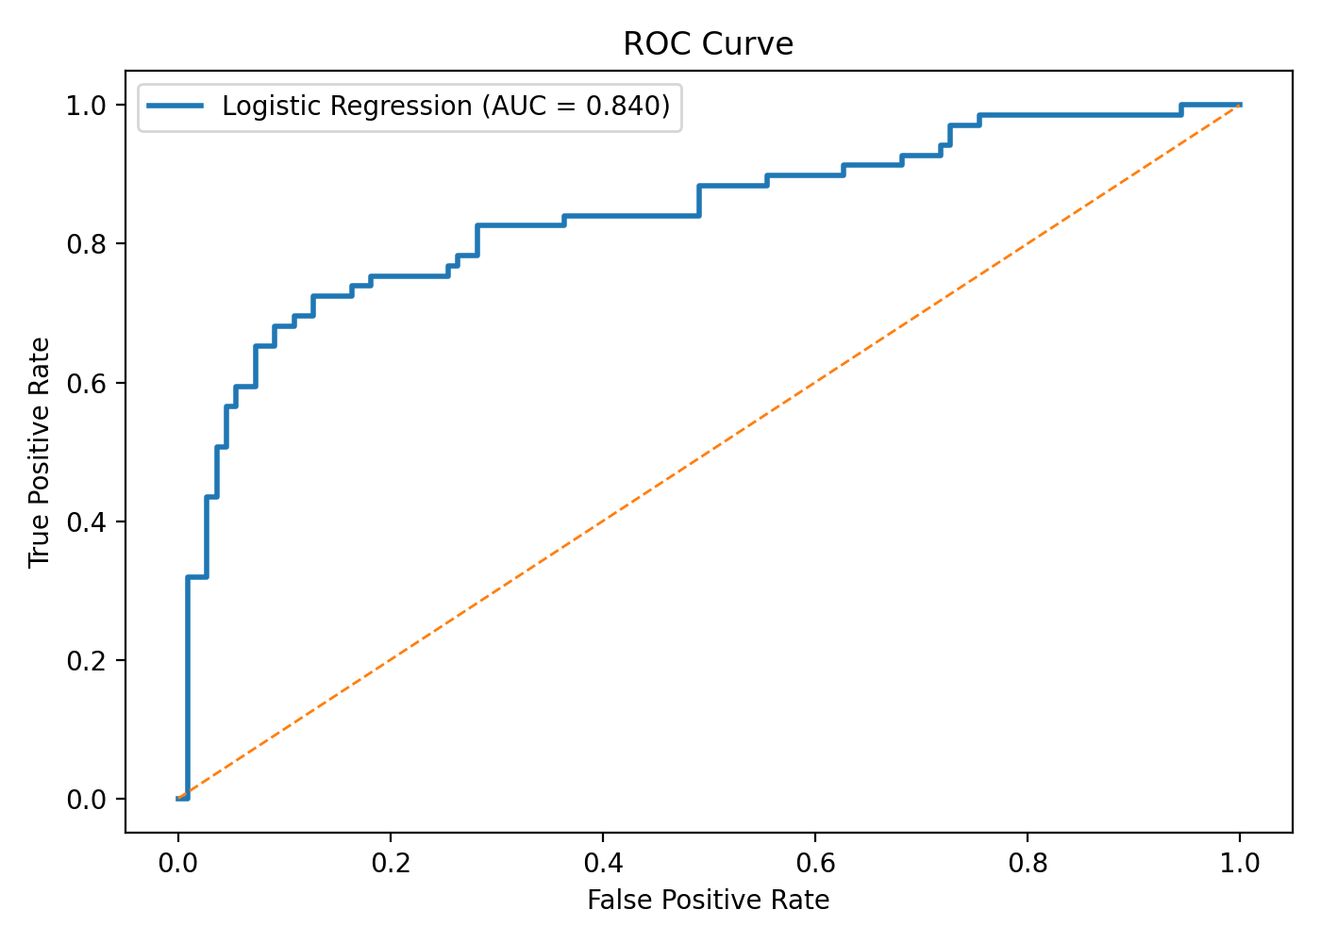
Figure 6. ROC curve showing test-set discrimination.

9. Validation and Diagnostics
Cross-Validation Metric | Mean | Std. Dev.
ACCURACY | 0.793 | 0.026
PRECISION | 0.740 | 0.034
RECALL | 0.713 | 0.053
F1 | 0.725 | 0.040
ROC_AUC | 0.854 | 0.023
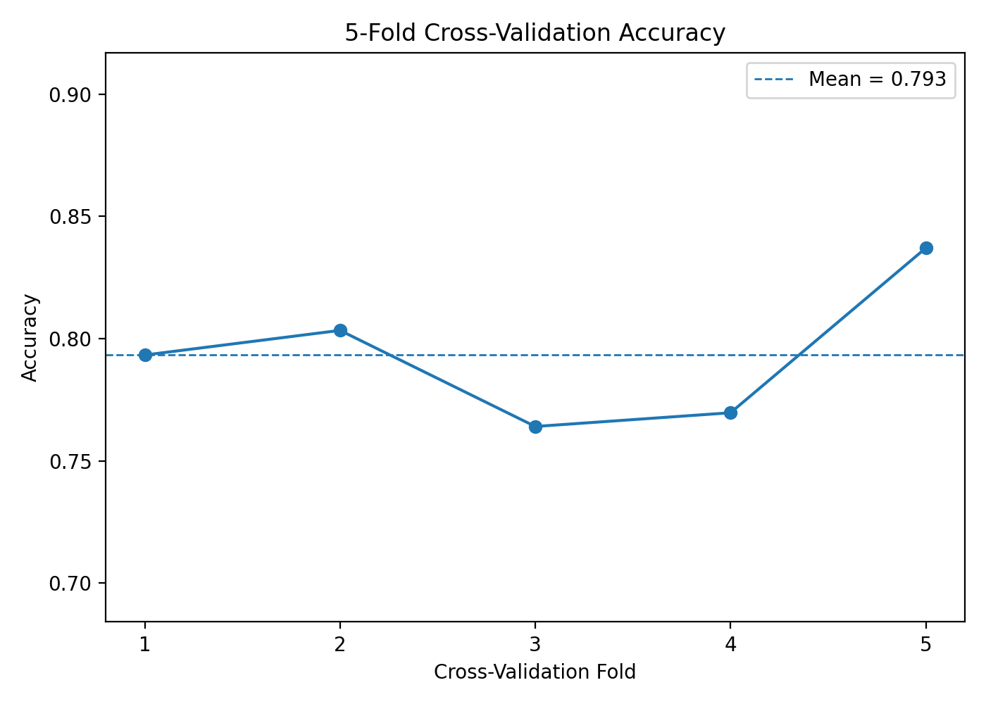
Figure 7. 5-fold cross-validation accuracy by fold.
Cross-validation is important because a single train/test split can be affected by sampling variation. The fold-level results show how consistent the classifier is across different partitions of the data. The R script also includes deviance-residual and Cook's-distance diagnostics for further inspection in RStudio.

10. Integrated Findings
- Data quality matters: missingness was not handled uniformly; each variable received a treatment based on its type and missingness level.
- Visualization and statistics tell the same broad story: survival varies strongly across sex and passenger class, and fare distributions differ by survival outcome.
- Statistical significance should be distinguished from causation. A small p-value shows evidence against a null hypothesis, not proof that one variable causes another.
- The predictive model converts these observed patterns into estimated survival probabilities and provides an objective way to evaluate predictive usefulness.
- Using the same dataset through all four weeks makes the analysis coherent and reproducible, while keeping the preprocessing choices consistent.

11. Discussion and Practical Implications
For a non-technical audience, the most important message is not the individual R functions but what the analysis reveals. Passenger sex and class are strongly associated with survival in the historical data. Fare also separates the survivor and non-survivor groups, which is consistent with the role of socioeconomic position in the dataset. From a business-analytics perspective, the project demonstrates how data quality, visualization, statistical inference and prediction can be combined to support evidence-based decisions.
A decision-maker should not treat the model as a perfect predictor. Historical datasets can contain biases, omitted variables, and patterns that do not transfer to another population. The model should therefore be used as an analytical aid rather than as proof of a causal mechanism.

12. Challenges Encountered and How They Were Addressed
- High Cabin missingness: handled with a missingness indicator rather than artificial values.
- Skewed Fare distribution: used a non-parametric hypothesis test and retained legitimate high fares.
- Mixed variable types: categorical encoding and model pipelines were used so the classifier could process both categorical and numerical predictors.
- Model evaluation: used both a held-out test set and 5-fold cross-validation to reduce reliance on one split.
- Communication: every major visual was paired with a plain-language explanation so a non-technical reader can understand the insight.

13. Recommendations for Future Work
- Compare logistic regression with random forest, gradient boosting or other classifiers using identical cross-validation procedures.
- Engineer additional features from Name, Ticket and Cabin, such as family size, title, ticket group size and cabin deck.
- Test interaction and nonlinear terms to determine whether relationships vary by sex or passenger class.
- Perform threshold tuning based on the business objective, such as prioritizing recall or precision.
- Use calibration plots and probability-based evaluation when predicted risks are used for decision support.
- Document data provenance and reproduce the entire workflow with a version-controlled R project.

14. Conclusion
This Week 4 report integrates the full Yuvaintern data-analysis journey into one coherent workflow. The project begins with data cleaning, progresses through descriptive visualization and statistical testing, and concludes with validated logistic regression modeling. The results demonstrate that careful preprocessing, appropriate visualization, hypothesis-driven testing and disciplined model evaluation reinforce one another. The most important lesson is that strong data analysis is not only about producing code or charts; it is about making defensible decisions, explaining uncertainty, and communicating evidence clearly.

15. Project Deliverables and Reproducibility
- Week 1 report: data cleaning and preliminary analysis.
- Week 2 report: data visualization and insight communication.
- Week 3 report: statistical analysis and predictive modeling.
- Week 4 report: integrated final report.
- R scripts for the individual weeks and reproducible plots.
- Cleaned dataset and visualization/model-evaluation assets.

