Speed Control of Three Phase BLDC Motor Using MATLAB Simulation of Matrix Converter
Mr. Pravin Turare
GOVERNMENT COLLEGE OF ENGINEERING, CHANDRAPUR, MAHARASHTRA(INDIA)
^{email:pravinturare@gmail.com}

ABSTRACT
Brushless DC (BLDC) motor drives find wide application in industries due to their high-power density and control capabilities. This paper deals with matrix converter-based drive techniques for control of three phase BLDC motor. MATLAB simulation technique is use to generate PWM signal. WM signal modulate the pulse width. Modulated pulses are gives to the digital control electronics circuit to commuted the current. The simulation of matrix converter is done by MATLAB simulation. Matrix converter shown in accordance with switching algorithm table. The need of the proposed work is to make simple hardware circuit which is more reliable, more efficient, less noisy, excellent speed control and smooth transition between the quadrants.
Keywords: BLDC motor, Matrix Converter, PWM signal, MATLAB simulation, Current Commutation
- INTRODUCTION

Permanent Magnet Brushless DC Motor is a kind of three phase synchronous motor, having a rotor with permanent magnet, that replacing the commutation and brushes. Stator winding of BLDC motor is wound such that back electromotive force is trapezoidal.BLDC motor is driven with trapezoidal or rectangular voltage coupled with rotor position. The voltage stroke is properly aligned with flux, so that angle between stator and rotor flux is kept close to 900, to get maximum torque. In some applications, when speed control is required, large size of DC Brushed motors are use and have a much maintenance, lower efficiency and also it has a very high temperature etc. In electric technology development it comes to achievement of new motor for speed control – Brushless DC motor. In BLDC motor, the brushes are not present, so that it is maintenance free, better performance no matter in high or low speed region. When the power output is same, half size of BLDC motor is use as compare to DC Brushed motor.
The speed control of BLDC motor is possible by using pulse width modulation technique. Therefore, to obtain the reliable speed measurements, BLDC motor consists of rotor with permanent magnets and a stator with windings. It is also known as electronically commutated motor that are powered by DC electric source via inverter, which produces ac electric signal to drive the motor. The brushes and commutator have been eliminated and the windings are connected to the control electronics. The control electronics replaces the function of the commutator and energize the proper winding. The motor has less inertia; therefore, it is easy to start and stop. Some of the qualities of BLDC motor are good potential, more efficient, comparatively faster and more reliable. BLDC motor is driven by DC voltage but current commutation is controlled by solid state switches. BLDC motors are used in Automotive, Aerospace, Consumer, Medical, Industrial Automation equipment and instrumentation [1].

- COMPLETE DRIVE SYSTEM
The digital pulse width modulation control of BLDC motor will be efficient and cost effective. The digital control of three phase BLDC motor is achieved with MATLAB simulation for generating the actual PWM signal. The digital controller combines the digital signal processor features and PIC microcontroller features, making it versatile. The required duty cycle and the reference speed can be fed into the PI controller.
The schematic diagram of the drive arrangement of the three phase BLDC motor is shown in Fig.1. BLDC motor is a brushless motor it does not use brushes for the commutation. So that the commutation is performed electronically by using an array of switching devices based on the rotor position information and the rotor position information is obtained from the Hall Effect sensors. Whenever the rotor magnetic poles pass near the Hall Effect sensors, indicating either North Pole or South Pole, the rotor position is sensed by the Hall Effect sensors which provides signal to the respective switches and according to that exact sequence of commutation is determined. These signals are decoded by combinational logic to provide the firing signals for 1200 conduction on each of the three phases.
The hall sensor inputs which gives the position of rotor is fed to the microcontroller. The microcontroller compares it with the reference speed and generates an error signal. The PWM module of the controller generates appropriate PWM signals, which are applied to the three phase inverter at the appropriate time to trigger the appropriate switches. In three phase inverter circuit proposed
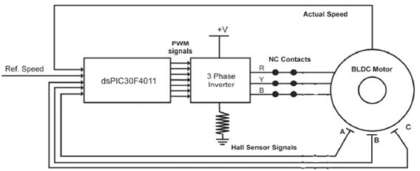
Fig.1 Closed Loop Drive

Matrix converter is used shown in Fig.2. in which switching devices have to be turn on and off in accordance with the switching algorithm table which is consider.
- METHODOLOGY: PROPOSED MATRIX CONVERTER
The proposed Technology for the matrix converter consists of two signal phase to three phase inverters for positive and negative half cycle of the input signal phase voltage source. The implementation technique of the proposed matrix converter is similar to the “Separation and Link topology”.
The method reported for separation and link and in conventional converter topologies consist of switches in the inverter do not need anti parallel freewheeling diode. At the correct instant of time the freewheeling path are provided by the commutation. The proposed matrix converter-based BLDC motor drive system is as shown in fig.2 consist of two signal phase to three phase inverters. The nomenclature of the switches use in the matrix converter is as follows.
- The inverter-1 consist of switches A1,A2,B1,B2 and C1,C2
- The inverter-2 consist of switches A3,A4,B3,B4 and C3,C4

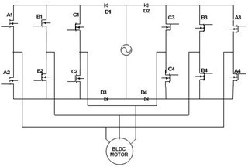
Fig.2 Proposed Matrix Converter based BLDC motor Drive
During the positive half cycle of the supply voltage, power to the load is supplied by the inverter-1 and inverter-2 is in the freewheeling path. During the negative half cycle of the supply voltage, power to the load is supplied by the inverter-2 and inverter-1 is in the freewheeling path. In both the cases freewheeling current path are provided by the forced commutation of the switches. Four diode such as D1,D2,D3,D4 are selected for the appropriate half cycle of the input voltage source to the relevant inverter and also it avoids the reverse voltage applied to the switching devices and protect the input side short circuits.
Fig.3. consist of two single phase to three phase matrix converters of proposed matrix converter-based BLDC Motor drive. It consists of two single phase to three phase Inverter for positive and negative half cycle of input single phase voltage source. Inverter-1 comprised of switches A1, A2, B1, B2, C1 and C2. Inverter-2 comprised of switches A3, A4, B3, B4, C3 and C4. During the positive half cycle, power supplied to the load by inverter-1 and freewheeling path are provided by inverter-2. During negative half cycle, power Supplied to the load by inverter-2 and freewheeling path are provided by inverter-1. Reverse voltage applied to the switching devices can be avoided by applying the proper input voltage half cycle for selected inverter. At the correct instant of time freewheeling path are provided at the force commutation of appropriate switching devices.
The precaution should be taken to operate the converter in safe mode to avoid the occurrence of high current due to supplying input voltage. In case of safe operating mode, don’t turn on both switches at a time. Second precaution is to avoid the higher voltage, don’t open circuited the output lines at a time. The matrix converter is the most popular and widely used converter topology in the family of direct converters.
The practical implementation of the four-quadrant control of three phase BLDC motor based on advanced matrix switching will be developed. The hardware model consists of BLDC motor, MOSFET gate drive, power supply, Hall Effect sensor. The simulation model of the proposed matrix converter based on BLDC motor will be modeled using MATLAB and the simulation results will be analyzed.

GENRATION OF PWM SWITCHING SIGNAL
Output torque of the BLDC motor is directly proportional to the magnitude of the stator input current. The magnitudes of the stator input current are sense by all three input phases of the motor and compeered with reference current signal, so that it generates the current reference signal of the phase current.
The value of the measured current is then taken to compare it with reference current value. Calculated current error with the reference value is then feed to the PI controller, to force them to the zero value. The schematic generation of the PWM switching signal is as shown in the fig.3.PI controller is also use in current measurement as that of the speed measurement. Signal from the controller output compared with the triangular waveform to produce the PWM signal for switches to adjusted the gain of the PI controller. The switching devices can trigger by the PWM signals in accordance to the switching algorithm table.

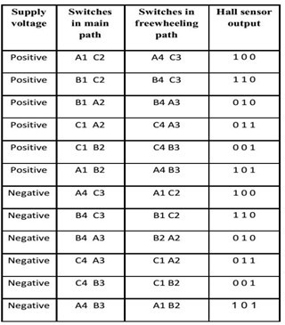
TABLE I SWITCHING ALGORITHM FOR A BRUSHLESS DC MOTOR WITH
TRAPEZOIDAL BACK EMF
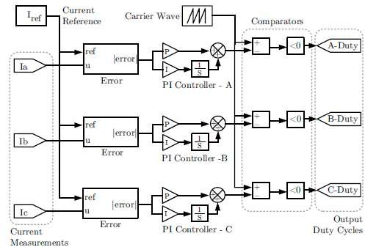

Fig.3 Generation of PWM switching signal

CONTROLLING DC WITH PVM
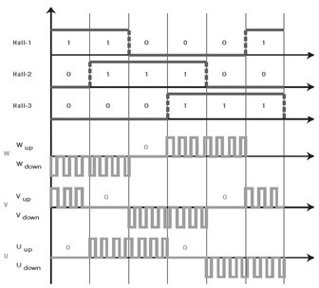
PWM is a pulse width modulation to change the width of pulses and then adjusting the amount of power delivered to the load. Smooth speed variation without reducing the starting torque and eliminates harmonics can be allowing the PWM technique. In PWM method, power required to operate the motors is turned on and off to modulate the current to the motor. The Speed of the motor is determined by the term duty cycle. It is the ratio of on to off time.PWM technique embedded in microcontroller to achieve the desired speed by controlling the duty cycle of DC motor drive. Matrix converter based on BLDC motor will be modeled using MATLAB and the simulation results will be analyzed.

Fig.4. PWM output with respect to hall sensor output
- PI CONTROLLER
The speed controllers are conventional PI controller and current controllers are the P controllers to achieve high performance. Conventional PI controller is used as a speed controller for recovering the actual motor speed to the reference. The reference and the measured speed are the input signals to the PI controller. The KP and KI values of the controller are determined by trial and error method for each set speed. The controller output is limited to give the reference torque.80%of the controller are PI controllers because they are facile.

- MATLAB SIMULATION MODEL FOR PROPOSED SYSTEM
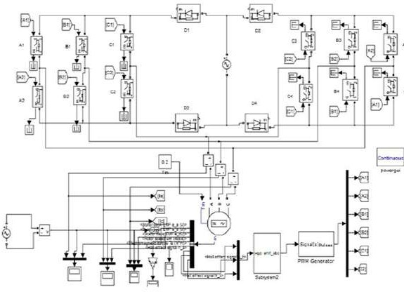

Fig.5 Simulation Model

The simulation model consists of two single phase to three phase matrix converters named as Inverter-1 and Inverter-2 for positive and negative half cycles of the input single phase voltage source. When the supply voltage is in its positive half cycle, the inverter-1 supplies power to the load and the inverter-2 provides freewheeling paths. When the supply voltage is in its negative half cycle, the inverter-2 supplies power to the load and the inverter-1 provides freewheeling paths. The gating pulse generation for matrix converter is designed in such a manner that only two devices conduct at a time Hall Effect sensor signals obtained from the output bus of the used machine model, are processed to determine the appropriate switching devices, which have to be turn on and off.
- SIMULATION RESULT

The simulation results for rotor speed and electromagnetic torque waveform are shown in Fig.7. The speed is ripple due to zero crossing points (zero voltage points) in supply voltage Vs. As shown in Fig.7, the speed increases upto 800 rpm and after 800 rpm constant speed is obtained. Also, the ripple torque is obtained due to the zero crossing points (zero current points) in the input voltage source Vs.

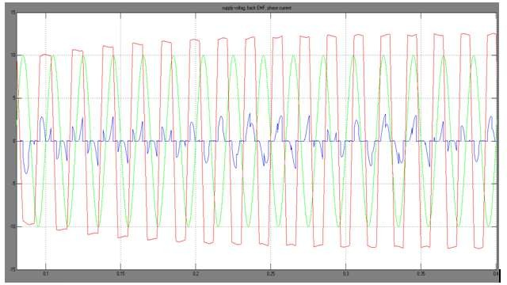

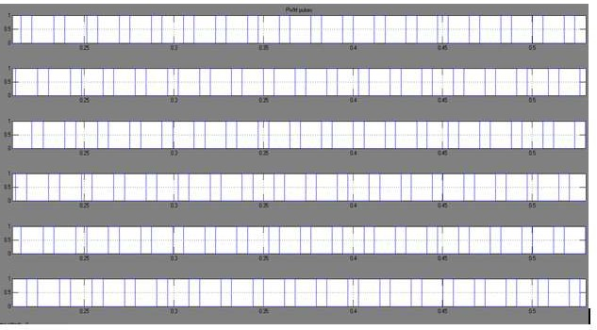
Fig.6 Phase A Current and Back EMF waveform with Supply Voltage

Fig.7 PWM Switching Signals
The PWM switching signals are shown in Fig.8 Six PWM switching signals are generated. Those signals are used to trigger the appropriate switching devices, which are used in the simulation model.
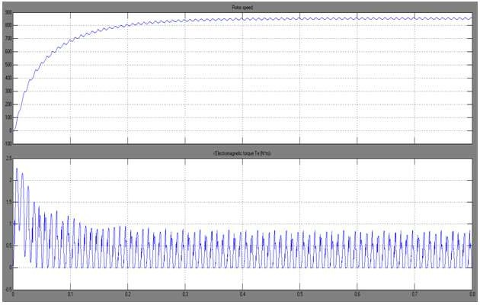
Fig.8 Rotor Speed and Electromagnetic Torque

The simulation results for rotor speed and electromagnetic Torque waveforms are shown in Fig.9. The speed is ripple due to zero crossing points (zero voltage points) in supply voltage Vs. As shown in Fig.9 the speed increases upto 800 rpm and after 800 rpm constant speed is obtained. Also, the ripple torque is obtained due to the zero crossing points (zero current points) in the input voltage source Vs.
- CONCLUSION
The mentioned speed control of BLDC motor is used to control the speed of the BLDC motor using MATLAB simulation technique. This work is to make simple software circuit which is more reliable, more efficient, less noisy, excellent speed control. If mentioned method is implemented in higher rating motors, arcing might occur during the switching on and off of the relay contacts. But if the mentioned method is implemented in low power motors like motors used in sewing/ embroidery machine, arcing will be very less which is not even visible. It is also useful method to run the motor without brushes, so that commutation is done using control electronics circuitry. In the above method matrix converter topology is used to control the current and supplied the power to the three phase BLDC motor during the entire input cycle. By using the above mentioned method we must have to improve the performance of motor.

- REFERENCES
[1]C.S. Joice, Dr. S.R. Paranjothi, and Dr. V.J.S. Kumar, —Digital control strategy for four quadrant operation of three phase BLDC motor with load variation,” IEEE Trans. On industrial informaiics, vol.9, no.2, May 2013.
[2] H.K. SamithaRansara, U.k.Madawala , —A new matrix converter based three phase brushless dc motor drive,‖ IEEE 2011.
[3] C. S. Joice, Dr. S. R. Paranjothi, and Dr. V. J. S. Kumar, —Practical implementation of four quadrant operation of three phase Brushless DC motor using dsPIC,‖ in Proc. IConRAEeCE 2011, 2011, pp. 91–94, IEEE.
[4]B. Singh and S. Singh, —State of the art on permanent magnet brushless DC Motor drives,‖ J. Power Electron., vol. 9, no. 1, pp. 1–17, Jan. 2009.
[5]T. Saito, M. Takeshita and N. Matsui, —A single to three phase matrix converter with a power decoupling capability,‖ in Power Electronics Specialists Conference, 2004. PESC 04.2004 IEEE35th Annual, vol. 3, June 2004, pp. 2400 – 2405 Vol.3.
[6] Xiaoyan Huang, Andrew Goodman, Chris Gerada, Youtong Fang,Qinfen Lu, —A Single sided matrix converter drive for a brushless dc motor in Aerospace applications,” IEEE Trans. on industrial electronics, vol.59, no.9, September 2012.
[7] Vashit Bist and Bhim singh, —A PFC - based bldc motor drive using a canonical Switching cell converter,‖ IEEE Trans. on industrial informatics, vol.10, no.2 May 2014.
[8] C. Xia, Z. Li, and T. Shi, —A control strategy for four - switch three phase brushless DC motor using single current sensor,‖ IEEE Trans.Ind. electronics, vol. 56, no. 6, pp. 2058–2066, June 2009.
[9] A. Sathyan, M. Krishnamurthy, N. Milivojevic, and A. Emadi, — A low cost digital control scheme for brushless DC motor drives in domestic applications,‖ in Proc. Int. Electric Machines Drives Conf., 2009, pp. 76–82.
[10] R. Krishnan, S.-Y. Park, and K. Ha, —Theory and operation o f a four quadrant Switchedreluctance motor drive with asingle controllable switch—the lowest Cost four - quadrant brushless motor rive,‖ IEEE Trans. Ind. Appl.,vol. 41,no. 4, pp. 1047–1055, 2005.
[11] V. U, S.Pola, and K. P. Vittal, ―Simulation of four quadrant operation & Speed control of BLDC motor on MATLAB/SIMULINK,‖ in Proc.IEEE Region 10 Conference, 2008, pp. 1–6.

