**Artificial Intelligence in Finance: Applications, Challenges and Opportunities**

**Prem Borkar *1, Yash Mukherjee*2**

*1,2 Student, Computer Engineering, Government College of Engineering, Yavatmal, Maharashtra, India

**ABSTRACT**

Artificial Intelligence (AI) is reshaping the financial industry by introducing innovative solutions for algorithmic trading, fraud detection, and risk management. This paper explores the current state of AI applications in finance, delves into the challenges related to data quality, regulatory compliance, and algorithmic bias, and discusses potential solutions. The findings underscore the transformative potential of AI in finance while highlighting the critical issues that need addressing to ensure a fair, transparent, and efficient financial ecosystem.

**Keywords:** Technology, research, investigation, artificial intelligence, identifiers

1. **INTRODUCTION**

In the ever-evolving landscape of finance, the integration of Artificial Intelligence (AI) has emerged as a transformative force, reshaping traditional practices and paving the way for unprecedented innovations. This research paper delves into the multifaceted realm of AI in finance, exploring its diverse applications, confronting challenges, and illuminating the vast array of opportunities it presents. The union of finance and AI has propelled the industry into a new era of efficiency, accuracy, and insight. From algorithmic trading and risk management to customer service and fraud detection, AI systems have revolutionized how financial institutions operate and serve their clients. These advancements not only enhance productivity but also enable better decision-making processes, thereby optimizing resource allocation and mitigating risks.

However, amid the promises of AI lie intricate challenges that demand attention and strategic solutions. Ethical considerations, data privacy concerns, and the risk of algorithmic biases pose significant hurdles that necessitate careful navigation. Moreover, the rapid pace of technological advancement exacerbates the need for robust regulatory frameworks to ensure the responsible deployment of AI in financial settings. Yet, within these challenges lie immense opportunities for innovation and growth. The fusion of AI with finance has the potential to democratize access to financial services, enhance market transparency, and foster financial inclusion on a global scale. Moreover, the synthesis of AI with emerging technologies like blockchain and the Internet of Things (IoT) opens up new avenues for disruption, offering novel solutions to age-old problems.

Through this comprehensive exploration, this research paper aims to provide a nuanced understanding of the role of AI in finance. By analysing its applications, confronting its challenges, and highlighting its opportunities, we aim to equip stakeholders with the knowledge and insights necessary to navigate this transformative journey with confidence and foresight.

1. **AI IN ALGORITHMIC TRADING**

Algorithmic trading, also known as algo-trading, is the process of using computer algorithms to automate trading decisions in financial markets. This technology has revolutionized trading by allowing for faster and more efficient transactions. Here's an in-depth examination of this concept, focusing on both the benefits and challenges.

**Benefits of Algorithmic Trading**

* Speed and Efficiency: Algorithmic trading enables trading at extraordinary speeds. By leveraging advanced computing power, AI-based trading systems can process market data and execute trades within microseconds. This rapid execution allows traders to capitalize on fleeting opportunities and maintain a competitive edge.
* High-Frequency Trading (HFT): One of the significant advantages of AI-driven algorithms is their ability to perform high-frequency trading (HFT). HFT involves making a large number of trades within a short timeframe, often in milliseconds. These rapid trades can exploit minor price discrepancies, leading to significant profits.
* Sophisticated Trading Strategies: AI allows for more complex trading strategies that are beyond human capability. By analysing vast amounts of financial data, these algorithms can identify patterns and trends that might go unnoticed by human traders. This capability facilitates advanced trading techniques, such as statistical arbitrage, market making, and momentum trading.
* Adaptability: AI-based trading systems can adapt to changing market conditions. They can be programmed to adjust their strategies based on real-time data, ensuring that they remain effective even as market dynamics evolve. This adaptability reduces the need for constant human intervention.
* Reduced Human Error: Automation reduces the risk of human error, which can be caused by fatigue, stress, or emotional decision-making. Algorithmic trading ensures consistent and rational trading, reducing the potential for costly mistakes.

**Challenges in Algorithmic Trading**

* Data Quality and Consistency: The effectiveness of algorithmic trading relies heavily on accurate and timely data. If the data fed into the algorithms is incorrect, incomplete, or delayed, it can lead to erroneous trades or missed opportunities. Ensuring data quality and consistency is a critical challenge for algo-trading.
* Regulatory Compliance: Financial markets are subject to strict regulations designed to ensure fair trading practices and market stability. Algorithmic trading must comply with these regulations, which vary by region and asset class. Non-compliance can result in significant legal consequences and financial penalties. Compliance with regulations like the Markets in Financial Instruments Directive II (MiFID II) in Europe or the Securities and Exchange Commission (SEC) rules in the U.S. is crucial.
* Flash Crashes: Algorithmic trading carries the risk of "flash crashes," where rapid, automated trading causes sudden and extreme market volatility. This phenomenon can occur when algorithms trigger a cascade of trades due to unexpected market conditions or algorithmic errors. Flash crashes can lead to significant losses and undermine market confidence.
* Market Manipulation: Algorithmic trading can sometimes be used for manipulative practices, such as spoofing (placing fake orders to influence prices) or layering (placing and quickly cancelling large orders to create false impressions of market demand). These practices are illegal and can result in regulatory action.
* Operational Risks: Technical failures, software glitches, or cyberattacks can disrupt algorithmic trading systems, leading to financial losses or systemic risks to the broader market. Ensuring robust cybersecurity and operational resilience is essential to mitigate these risks.

1. **NEED OF AI IN FINANCE**

Artificial Intelligence (AI) is increasingly crucial in the finance industry due to its ability to process vast amounts of data and drive smarter, faster decision-making. Financial institutions deal with enormous data streams, from market data and customer transactions to risk assessments and compliance reports. AI excels at analyzing this data at high speed, uncovering patterns and insights that would be impossible or time-consuming for humans to detect. This ability to rapidly process and derive actionable information helps financial firms stay competitive and responsive in a dynamic market environment.

AI's capacity for automation significantly boosts efficiency and reduces operational costs. In finance, many routine tasks, like transaction processing, reconciliation, and compliance checks, can be automated using AI, freeing up human resources for more complex, value-added activities. AI-powered chat bots and virtual assistants are increasingly used to handle customer inquiries, providing 24/7 service and improving customer satisfaction. This automation leads to greater accuracy and reduced human error, contributing to smoother financial operations and enhanced customer experiences.

AI plays a critical role in risk management and fraud detection, two key areas where financial institutions need robust solutions. Machine learning models can analyse historical data to identify potential risks, allowing institutions to take proactive measures to mitigate them. Similarly, AI-based systems can detect unusual patterns that may indicate fraud, reducing the chances of financial crime and protecting both institutions and customers. These AI-driven insights into risk and fraud bolster the security and stability of financial systems, contributing to a safer financial environment.

Finally, AI's use in algorithmic trading and personalized financial services offers significant advantages to financial institutions. AI algorithms can execute trades at high frequency, enabling more efficient market operations and better liquidity. These advanced trading systems can also adapt to changing market conditions, improving profitability and reducing risks. In addition, AI's ability to analyse customer data allows financial institutions to offer personalized products and services, enhancing customer satisfaction and loyalty. This personalized approach, combined with the benefits of AI-driven efficiency and automation, gives financial institutions a distinct competitive edge in the rapidly evolving financial landscape.

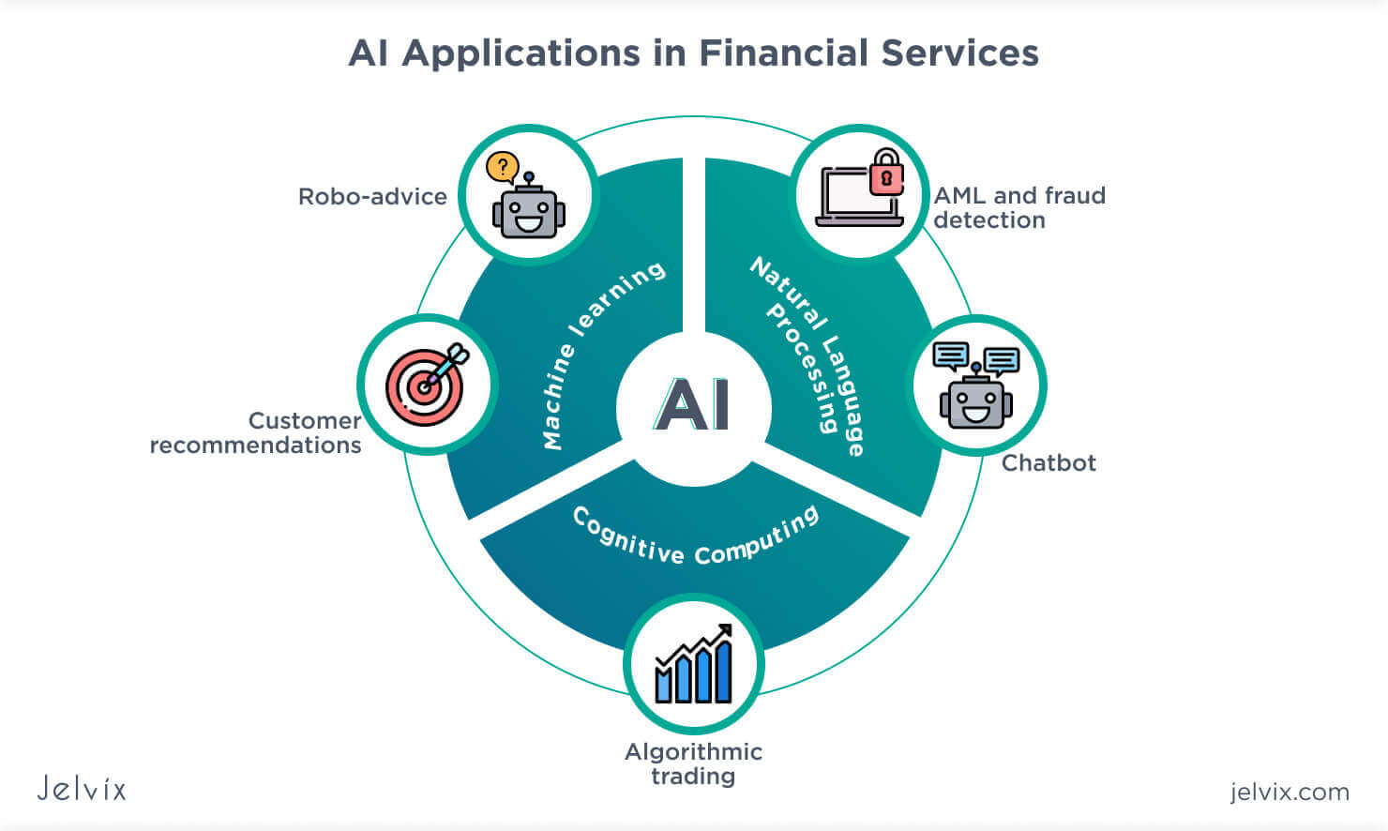

**Figure 1:** AI Application in Finance.

1. **TECHIQUES USED IN AI IN FINANCES**

Artificial Intelligence (AI) in finance employs a variety of sophisticated techniques to optimize operations, improve decision-making, and enhance customer experience. One of the fundamental techniques is machine learning (ML), which allows AI systems to learn from data and improve their performance over time without explicit programming. In finance, ML models are used for tasks such as credit scoring, fraud detection, and risk assessment, where they can identify patterns and trends that are not immediately obvious to humans.

Another key technique is natural language processing (NLP), which enables AI systems to understand and process human language. In finance, NLP is applied in areas like automated customer support, compliance monitoring, and sentiment analysis. By processing large volumes of text data from sources like news articles, social media, and customer communications, NLP can uncover valuable insights and automate tasks like responding to customer inquiries or analysing regulatory documents.

Deep learning is a subset of machine learning that uses neural networks with multiple layers to simulate complex decision-making processes. In finance, deep learning is used in high-frequency trading, where split-second decisions are crucial, and in credit risk analysis, where complex factors need to be considered. Deep learning models are also valuable for making sense of unstructured data, such as images and audio, which can be useful in areas like biometric security and voice recognition for customer authentication.

Lastly, robotic process automation (RPA) is a technique that involves automating routine tasks through software robots, or "bots." RPA is extensively used in finance to automate repetitive processes such as data entry, reconciliation, and report generation. By automating these tasks, financial institutions can reduce errors, improve efficiency, and allow employees to focus on more strategic activities. This combination of machine learning, natural language processing, deep learning, and robotic process automation forms the backbone of AI in finance, enabling a wide range of applications from trading and risk management to customer service and compliance.

1. **CONCLUSION**

AI has transformed the financial industry by introducing innovative solutions for algorithmic trading, fraud detection, and risk management. However, significant challenges related to data quality, regulatory compliance, and algorithmic bias must be addressed to ensure a fair and efficient financial ecosystem. By investing in robust data management practices, collaborating with regulators, and addressing ethical concerns, financial institutions can harness the full potential of AI while mitigating risks.

1. **REFERENCES**
2. Aldridge, I. (2013). High-Frequency Trading: A Practical Guide to Algorithmic Strategies and Trading Systems. Wiley.
3. Treleaven, P., Galas, M., & Lalchand, V. (2013). Algorithmic trading review. Communications of the ACM, 56(11), 76–85.
4. Hamori, S., & Ohtani, K. (2020). Financial big data and machine learning. Journal of Risk and Financial Management, 13(5), 88.
5. Shweta Kolekar, Mansi Surve, Pallavi Redkar, Sachin Bojewar, “A Review: E-Counselling”, International

Journal of Scientific Research in Computer Science, Engineering and Information Technology,

IJSRCSEIT, Volume 3, Issue 3.

[5] Patel, H., & Shah, M. (2019). Artificial Intelligence and Machine Learning in Business Management. CRC Press. [6] Baciu, G., & Lee, K. S. (2018). Machine Learning and Data Mining: Methods and Applications. Springer.