**Advancements and Applications of Drone Technology: A Comprehensive Review**

**Aman Deepak Yadav*1**

*1Student, Department of Industrial Design, IIITDM Jabalpur, Madhya Pradesh, India

**ABSTRACT**

Drones, or unmanned aerial vehicles (UAVs), have transformed various industries, including agriculture, logistics, surveillance, and entertainment. This paper explores the evolution of drone technology, highlighting its key applications, challenges, and future directions. The paper discusses how drones are used in diverse fields and the associated regulatory, ethical, and technical issues. The study aims to provide a comprehensive overview of drone technology and propose potential solutions to the identified challenges.

**Keywords:** drones, technology, automation, research, aerodynamics.

1. **INTRODUCTION**

Drones have gained significant attention in recent years due to their increasing utility across various sectors. These unmanned aerial vehicles come in a range of shapes and sizes, from small consumer drones to large military-grade UAVs. The accessibility and affordability of drone technology have spurred innovation, leading to new applications that were once considered impractical or too expensive. The advancement in drone technology has been fuelled by improvements in battery life, sensor technology, and artificial intelligence, allowing drones to perform complex tasks autonomously.

The growing use of drones has not been without challenges, however. Regulatory bodies worldwide are struggling to keep pace with the rapid technological advancements, leading to a patchwork of regulations and safety standards. Additionally, the potential for drones to invade personal privacy or cause safety risks has raised public concern. This paper aims to provide a detailed exploration of the current state of drone technology, focusing on key applications and the challenges faced by the industry. One significant aspect driving drone adoption is the economic potential they represent. In sectors like logistics and agriculture, drones can significantly reduce operational costs and improve efficiency. This economic incentive has led to increased investment in drone technology, further accelerating its development. At the same time, this rapid growth requires a balanced approach to ensure that drones are used safely and ethically.

1. **KEY APPLICATION OF DRONES**

Drones are finding applications in a variety of industries, each with unique requirements and benefits. In the field of agriculture, drones are revolutionizing traditional farming practices. Equipped with high-resolution cameras and multispectral sensors, drones can monitor crop health, detect irrigation issues, and even apply pesticides and fertilizers precisely. This precision agriculture approach allows farmers to optimize their resources, leading to higher yields and reduced environmental impact.

In the logistics and delivery sector, drones are being explored as a means to expedite package delivery and reduce transportation costs. Companies like Amazon and UPS have conducted pilot programs to test drone deliveries, particularly in urban and remote areas. Drones can navigate challenging terrains and bypass traffic congestion, making them an attractive option for last-mile delivery. This application not only promises increased efficiency but also has the potential to reduce carbon emissions by lowering reliance on traditional delivery vehicles.

Drones are also playing a crucial role in surveillance and security. Law enforcement agencies are using drones for crowd monitoring, crime scene analysis, and search-and-rescue operations. Drones provide a bird's-eye view, allowing authorities to cover large areas quickly and safely. Additionally, drones are employed in disaster response scenarios, where they can assess damage and locate survivors more efficiently than traditional methods. This use of drones in public safety and emergency response demonstrates their versatility and potential to save lives.

The entertainment and media industry has embraced drones for their ability to capture stunning aerial footage. Filmmakers and photographers use drones to achieve shots that were previously impossible or prohibitively expensive. Drones equipped with high-definition cameras have transformed the way we capture events, landscapes, and even real estate properties. This application has opened new creative possibilities and changed the way visual content is produced and consumed.

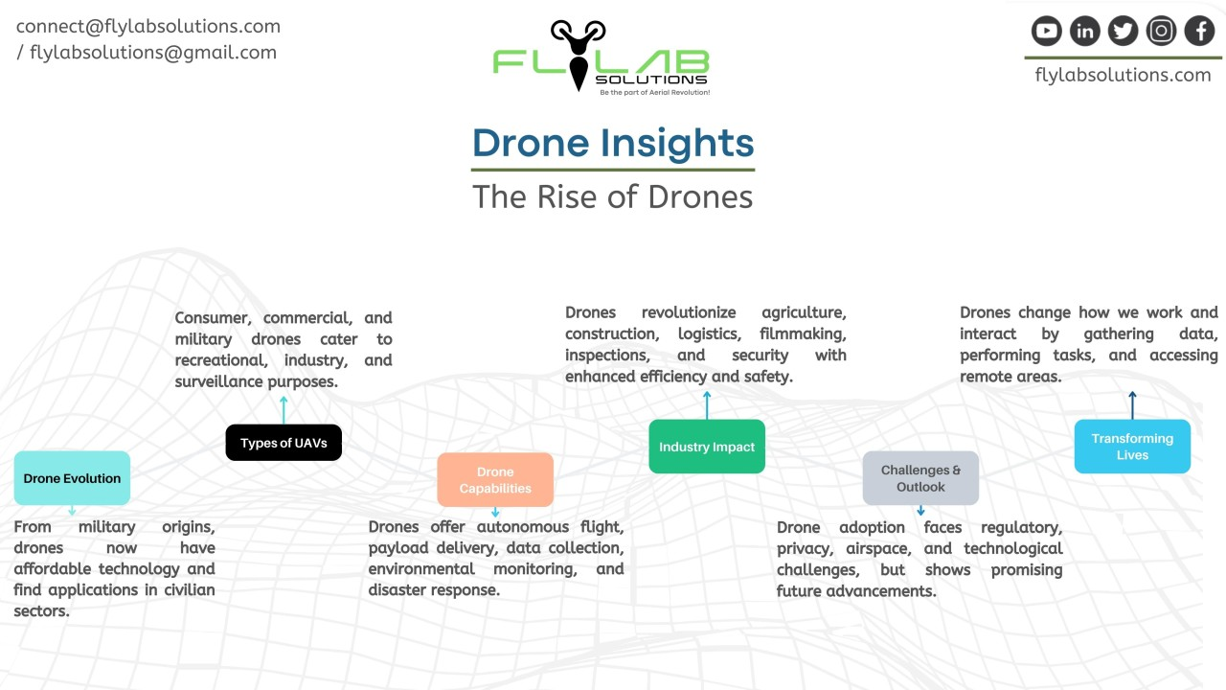

**Figure 1:** Drone Insights

1. **CHALLENGES AND CONCERNS**

While drones offer significant benefits, their widespread adoption raises several challenges and concerns. Regulatory compliance is a major issue, as drone usage is subject to rules that vary by country and region. In the United States, the Federal Aviation Administration (FAA) regulates drone operations, requiring operators to follow specific guidelines for commercial and recreational use. These regulations aim to ensure safety and privacy, but the rapidly evolving nature of drone technology often outpaces regulatory changes, leading to uncertainty and potential legal risks for operators.

Privacy and security are other critical concerns associated with drone technology. Drones equipped with cameras and other sensors can capture sensitive information, raising the risk of unauthorized surveillance or data breaches. This potential for privacy invasion has led to public apprehension and increased scrutiny of drone operations. Security risks also extend to the possibility of drones being hacked or used for malicious purposes. As drones become more sophisticated and connected, ensuring their security against cyber threats becomes paramount.

Safety is a significant challenge, especially as drones operate in crowded or sensitive environments. The risk of collisions with people, property, or other aircraft is a serious concern. Incidents involving drones near airports or public events have highlighted the need for strict safety measures. To address these risks, drone manufacturers and operators must implement safety protocols, such as geofencing and collision avoidance systems. However, these safety measures must be balanced with the need for flexibility and functionality.

Ethical considerations are also at the forefront of drone-related concerns. The use of drones for surveillance, especially by law enforcement or military organizations, raises ethical questions about privacy, human rights, and the potential for misuse. As drones become more integrated into daily life, ethical frameworks must be established to guide their responsible use. This includes addressing issues like consent, transparency, and accountability in drone operations.

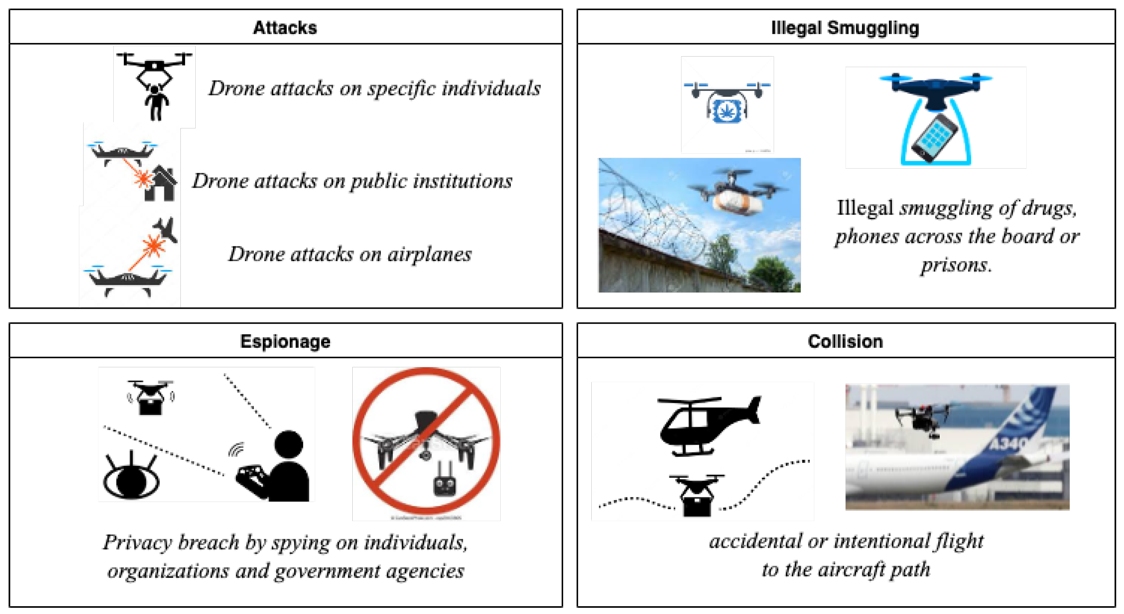

**Figure 2**: Challenges and concerns.

1. **FUTURE DIRECTIONS**

To ensure the responsible growth and integration of drone technology, several future directions should be considered. One key area is the advancement of drone autonomy. As artificial intelligence (AI) and machine learning (ML) evolve, drones can become more autonomous, reducing the need for constant human supervision. This can lead to safer and more efficient drone operations, particularly in complex environments. However, increased autonomy raises questions about accountability and the need for human oversight, which must be addressed.

Regulatory harmonization is another crucial future direction. The patchwork of regulations across different countries and regions creates obstacles for the broader adoption of drone technology. Efforts to standardize drone regulations can facilitate innovation and reduce compliance risks. International organizations, such as the International Civil Aviation Organization (ICAO), play a vital role in promoting regulatory harmonization, which can help create a more consistent framework for drone operations worldwide.

Improving safety measures will be essential as drone technology continues to evolve. This involves developing advanced safety protocols and technologies to prevent collisions and ensure controlled drone operations. Innovations like sense-and-avoid systems, automatic return-to-home functionality, and geofencing can significantly enhance safety. Additionally, training and certification programs for drone operators can ensure that they are well-equipped to handle various situations safely and responsibly.

Establishing ethical frameworks is another critical future direction. As drones are used in sensitive applications, such as surveillance and military operations, ethical guidelines must be in place to prevent misuse and protect individual rights. This includes promoting transparency in drone operations and providing mechanisms for public accountability. Ethical frameworks can help ensure that drone technology is used for the greater good while respecting privacy and human rights.

1. **FUTURE WORK**

The results from this study underscore the potential of combining deep learning with explainable artificial intelligence (XAI) for improved credit risk assessment in financial institutions. The hybrid approach demonstrated that it is possible to maintain high predictive accuracy while providing transparent and interpretable explanations for model decisions. This dual benefit addresses a significant challenge in the financial sector, where institutions must balance the need for powerful predictive models with the requirement to understand and explain these models' outputs to meet regulatory standards and ensure ethical practices. The study’s findings suggest that incorporating explainable AI techniques like SHAP into deep learning workflows can lead to more trustworthy credit risk assessments, enhancing confidence among stakeholders.

Looking ahead, several avenues for future work emerge from this research. One direction is exploring other explainable AI methods to compare their effectiveness in providing clear, actionable insights into model behaviour. This could lead to even more robust approaches to explainability in finance. Additionally, future studies might investigate the application of this hybrid approach to different types of financial data, such as corporate credit risk or insurance underwriting, to test its versatility across various domains. Another critical area for further research is the ongoing monitoring and adaptation of these AI models to ensure they remain accurate and fair as data and market conditions evolve. By addressing these future work opportunities, researchers and financial institutions can continue to refine and improve AI-based credit risk assessment, contributing to a more resilient and transparent financial industry.

1. **CONCLUSION**

Drones have significantly impacted various industries, offering new opportunities and efficiencies.  
In conclusion, the review paper highlights the remarkable advancements and diverse applications of drone technology across various industries. From aerial photography and surveillance to agriculture, logistics, and disaster management, drones have demonstrated their versatility and potential to revolutionize traditional practices.

Throughout the review, it becomes evident that the integration of drones into existing workflows offers numerous benefits, including cost reduction, increased efficiency, and improved safety. However, the widespread adoption of drone technology also poses challenges, such as regulatory hurdles, privacy concerns, and technological limitations. Despite these challenges, the rapid pace of innovation in drone technology continues to drive its evolution, opening up new possibilities for applications in fields such as environmental monitoring, infrastructure inspection, and healthcare delivery.

Looking ahead, continued research and development efforts, along with collaborative initiatives between industry stakeholders and regulatory bodies, will be essential to harnessing the full potential of drone technology while addressing the associated challenges. With careful consideration of ethical, legal, and societal implications, drones have the potential to transform various aspects of our lives and contribute to a safer, more efficient, and sustainable future.

Furthermore, as drone technology continues to evolve, there is a growing emphasis on enhancing capabilities such as autonomy, navigation, and payload capacity. These advancements are poised to unlock even more innovative applications, such as urban air mobility, delivery services, and search and rescue operations in challenging environments.

1. **REFERENCES**
2. Drones: What Everyone Needs to Know" by David Brotherton (2017)
3. Machine Learning" by Marcos Lopez de Prado (2018)
4. Artificial Intelligence in Asset Management: State-of-the-Art Investment Management Using Big Data and Machine Learning" by Christian L. Dunis, Jason Laws, and Patrick Naïm (2019)
5. Introduction to UAV Systems" by Paul G. Fahlstrom and Thomas J. Gleason (2012)
6. Quantitative Strategies" by Raja Velu and Lakshman Bulusu (2020)
7. Drone Pilot's Handbook" by Craig Crossman (2015)
8. The Age of Surveillance Capitalism" by Shoshana Zuboff (2019)