**PAPER TITLE, FONT TYPE-CAMBRIA, BOLD, FONT SIZE 14**

**First Author *1, Second Author*2, Third Author*3, Fourth Author*3 (Font-Cambria, Bold, Font Size -12)**

*1Affiliation, Department, Institute, City, State, Country (Font-Cambria, Font Size -11)

*2Affiliation, Department, Institute, City, State, Country

*3Affiliation, Department, Institute, City, State, Country

*4Affiliation, Department, Institute, City, State, Country

(Ex- Assistant Professor, Department of XYZ Engineering, Institute Name, City, state, Country)

**ABSTRACT (Font-Cambria, Bold, Font Size -12)**

The abstract of a research paper is a concise summary of the key points and findings of the study and should be written in Times new roman with font size- 10. The abstract should not be more than 200 words and written in single paragraph. This electronic document is a “live” template. The abstract includes the overall purpose of the study you investigated, the basic design of the study, results of your analysis and brief summary of your interpretations and conclusion.

**Keywords:** Technology, research, investigation (7-8 Keywords, Font-Cambria, Font Size – 10).

1. **INTRODUCTION (Font-Cambria, Bold, Font Size -12)**

The introduction of a research paper serves as a roadmap for readers, providing them with a glimpse of what to expect in the study. The introduction should be typed in Times New with font size 10. In this section highlight the importance of topic, making general statements about the topic and presenting an overview on current research on the subject. The simplest way is to replace(copy-paste) the content with your own material. Your introduction should clearly identify the subject area of interest.

1. **METHODOLOGY**

The methodology section of a research paper outlines the process by which the study was conducted, providing a detailed explanation of how the research was designed, data collected, and analysed. Method and analysis which is performed in your research work should be written in this section. A simple strategy to follow is to use keywords from your title in first few sentences.

**Subheading**

Subheading should be Font Size- 10pt, Font Type- Cambria, justified.

**Subheading**

Subheading should be 10pt Times new Roman,

1. **MODELLING AND ANALYSIS**

The modelling and analysis section of a research paper typically involves describing the theoretical or computational models used to address the research question or hypothesis, as well as the methods employed to analyse the data or outcomes generated by these models. Model and Material which are used is presented in this section. Table and model should be in prescribed format.

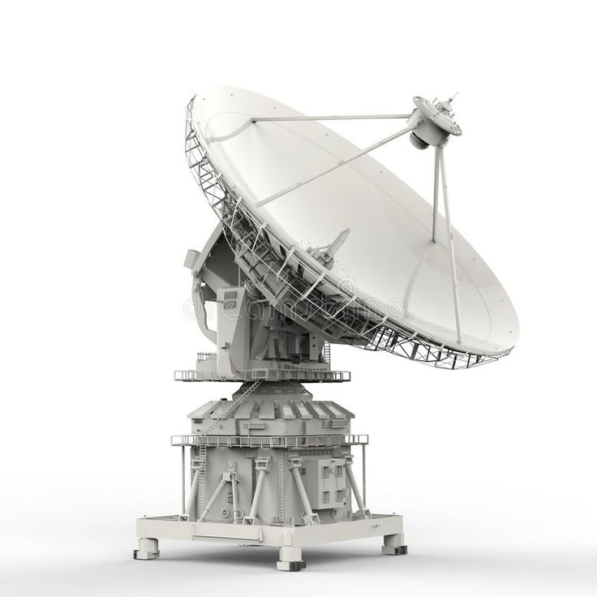

**Figure 1:** Image of Satellite Dish.

1. **RESULTS AND DISCUSSION**

The "Results and Discussion" section of a research paper is where the findings of the study are presented and interpreted. This section is crucial as it showcases the outcomes of the research and provides an analysis of those results in the context of the study's objectives and existing literature. The results and discussion may be combined into a common section or obtainable separately. They may also be broken into subsets with short, revealing captions. An easy way to comply with the conference paper formatting requirements is to use this document as a template and simply type your text into it. This section should be typed in character size 10pt Times New Roman.

**Table 1.** Comparison of stages of all 4 instances

|  |  |  |  |
| --- | --- | --- | --- |
| SN. | Stage Type | Relative Zone | Output |
| 1 | Stage-A | 6 | 10.99 mm |
| 2 | Stage -B | 6 | 11.335 mm |
| 3 | Stage -C | 6 | 10.248 mm |
| 4 | Stage -D | 6 | 11.364 mm |
| 5 | Stage -E | 6 | 10.248 mm |
| 6 | Stage -F | 6 | 10.99 mm |
| 7 | Stage -G | 6 | 11.29mm |
| 8 | Stage -H | 6 | 13.20mm |
| 9 | Stage -I | 6 | 11.29mm |

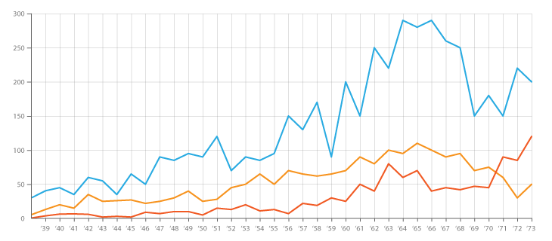

**Figure 2:** Graph name (Font size-10)

1. **CONCLUSION**

The conclusion of a research paper serves as the final section where the researcher summarizes the key findings, discusses their implications, and offers insights into potential future research directions. All the main points of the research work are written in this section. Ensure that abstract and conclusion should not same. Graph and tables should not use in conclusion.

**ACKNOWLEDGEMENTS**

An acknowledgment section in a research paper is a brief expression of gratitude to individuals or organizations that have contributed to the research or the writing process but may not meet the criteria for authorship. The authors can acknowledge professor, friend or family member who help in research work in this section. (This section is Optional)

1. **REFERENCES**
2. Rucha Rangnekar, Khyati Pradeep Suratwala, Sanjana Krishna,Dr. Sudhir Dhage, “Career Prediction

Model Using Data Mining And Linear Classification”, IEEE2018.

1. Vishal Bende, Prachi Erande, Priyanka Jore, Ankita Bhor, Ms.Dumbre, “ONLINE CAREER GUIDANCE

SYSTEM”, INTERNATIONAL JOURNAL OF ENGINEERING SCIENCES & RESEARCH TECHNOLOGY,

February 2016.

1. Chengwei Liu, Yixiang Chan, Syed Hasnain Alam Kazmi, Hao Fu, “Financial Fraud Detection Model: Based on Random Forest,” International Journal of Economics and Finance, Vol. 7, Issue. 7, pp. 178-188, 2015.
2. Shweta Kolekar, Mansi Surve, Pallavi Redkar, Sachin Bojewar, “A Review:E-Counseling”, International

Journal of Scientific Research in Computer Science, Engineering and InformationTechnology,

IJSRCSEIT, Volume 3, Issue 3.

[5] Rucha Rangnekar, Khyati Pradeep Suratwala, Sanjana Krishna,Dr. Sudhir Dhage, “Career Prediction

Model Using Data Mining and Linear Classification”, IEEE2018.

[6] Prof. Seema K. Yadav, Mr. Sujit J. Singh, Mr. Akshay M. Bora, Mr. Shashankit N. Thakur, “Educational

Recommendation and Tracking System”,International Journal of Scientific & Engineering Research,

Volume 7, Issue 11, 1443 ISSN 2229-5518, November-2016.