

***Comprehensive Cryptocurrency Dataset Analysis Report***

**Analysis and Insights on Cryptocurrency Market Trends**

#### ****Dataset Overview****

***The dataset contains historical data of cryptocurrencies up to 2021. It includes:***

* **Key Metrics**: Opening and closing prices, market capitalization, trading volume, and daily high/low values.
* **Structure**: No null values, clean, and ready for analysis.
* **Source**: Merged from individual datasets provided by CoinMarketCap.

#### *****Explanation of the Columns in the Dataset and Their Relevance :*****

1. **Sno**:

* Unique row identifier.
* Not crucial for analysis but helpful for indexing or referencing specific records.

1. **Name**:

* The name of the cryptocurrency or asset (e.g., Bitcoin, Ethereum).
* Used to identify and filter the data for specific cryptocurrencies during analysis.

1. **Symbol**:

* A shorthand identifier for the cryptocurrency (e.g., BTC for Bitcoin, ETH for Ethereum).
* Useful when working with multiple cryptocurrencies, allowing for quick lookup and categorization.

1. **Date** :

* The date of the recorded data.
* Relevance: Key for time-series analysis, such as tracking trends, calculating returns, and identifying patterns over time.

1. **High**:

* The highest price the cryptocurrency reached on a given day.
* Relevance: Indicates peak trading activity and helps analyze volatility.

1. **Low**:

* The lowest price the cryptocurrency reached on a given day.
* Relevance: Used alongside the high price to measure the daily price range, providing insights into market volatility.

1. **Open**:

* The price of the cryptocurrency at the start of the day.
* Relevance: Useful for understanding daily price movement when compared to the close price.

1. **Close**:

* The price of the cryptocurrency at the end of the day.
* Relevance: Used to calculate daily returns and monitor overall price trends.

1. **Volume**:

* The total amount of cryptocurrency traded during the day (typically in units or currency terms).
* Relevance: Indicates market activity and interest. High volume may signal strong investor interest or significant price changes.

1. **Marketcap(Market Capitalization)**:

* The total value of the cryptocurrency's circulating supply (calculated as Marketcap = Close Price × Circulating Supply).
* Relevance: Represents the overall market size of the cryptocurrency, useful for comparing different assets.

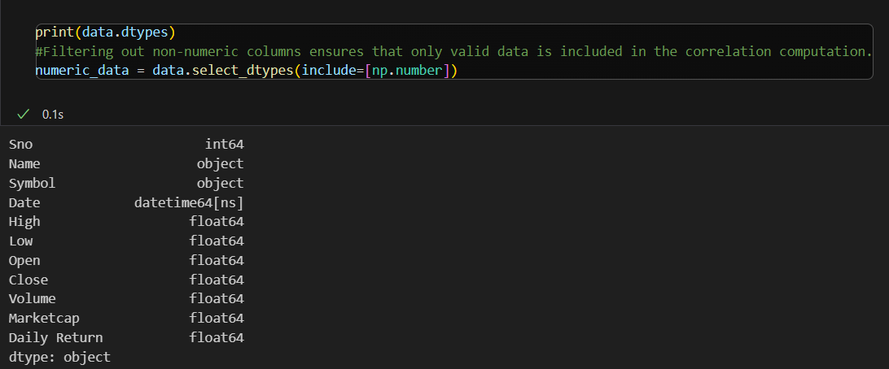

#### ****Potential Uses****

1. **Trend Analysis**: By examining opening and closing prices along with volume traded, analysts can identify bullish or bearish trends in the cryptocurrency market.
2. **Volatility Assessment**: The highest and lowest daily prices can be used to calculate volatility metrics for each cryptocurrency, aiding in risk assessment.
3. **Comparative Analysis**: The dataset allows for comparisons between different cryptocurrencies to identify which are performing better relative to others.
4. **Market Capitalization Insights**: Analyzing changes in market cap over time can provide insights into the growth or decline of specific cryptocurrencies.

**Insights from Data Analysis**

Using tools like Pandas in Python, you can easily manipulate and visualize this data. Here are some potential analytical approaches:

* **Time Series Analysis**: Conducting time series analysis can help in forecasting future prices based on historical trends.
* **Correlation Studies**: Investigating correlations between different cryptocurrencies can reveal how they move in relation to one another, which is crucial for portfolio diversification strategies.
* **Machine Learning Applications**: Implementing machine learning models to predict price movements based on historical data could yield actionable trading strategies.

#### ****Analytical Approaches****

1. **Monitor Price Volatility**: Calculate daily fluctuations

* Purpose: Assess how much the price fluctuates over time.
* Method: Calculate daily price range using High - Low and measure percentage volatility as:
* Volatility = (High - Low) / Open × 100

1. **Calculate Investment Returns**: Measure profit/loss over time.

* Purpose: Determine profit or loss over a specific period.
* Method:

1. Use the daily return formula:
2. Daily Return = (Close_t - Close_t-1) / Close_t-1
3. **Trends and Patterns**: Use moving averages for noise reduction.

* Purpose: Identify long-term growth or decline.
* Method:

1. Plot Close prices over time.
2. Use moving averages (e.g., 7-day, 30-day) to smooth out noise and highlight trends.
3. **Correlation Studies**: Identify relationships between cryptocurrencies.

* Purpose: Explore relationships between multiple cryptocurrencies.
* Method: Compute a correlation matrix using columns like Close or Volume to identify patterns.

1. ****Seasonal Patterns****: Detect periodic behaviors.

* Purpose: Detect patterns related to time (e.g., bull or bear markets).
* Method:

1. Group data by month or day of the week.
2. Analyze average price changes to identify periodic behavior.
3. ****Identify Trading Patterns****:

* Purpose: Understand market behavior during specific conditions.
* Method:

1. Check the relationship between Volume and price changes.
2. Analyze High and Low to detect periods of extreme volatility.
3. ****Market Health****:

* Purpose: Determine the asset’s significance in the market.
* Method:

1. Use Marketcap to assess the overall size.
2. Compare Volume with Marketcap to understand liquidity.

#### ****Key Visualizations****

1. **Line Charts**: Track trends over time.
2. **Candlestick Charts**: Represent daily price actions.
3. **Heatmaps**: Explore correlations.
4. **Bar Charts**: Highlight trading volume.

Python Libraries: pandas, matplotlib, seaborn, plotly

**CODES**

* Import neded libraries from the virtual environment(.venv). Load dataset via pandas library

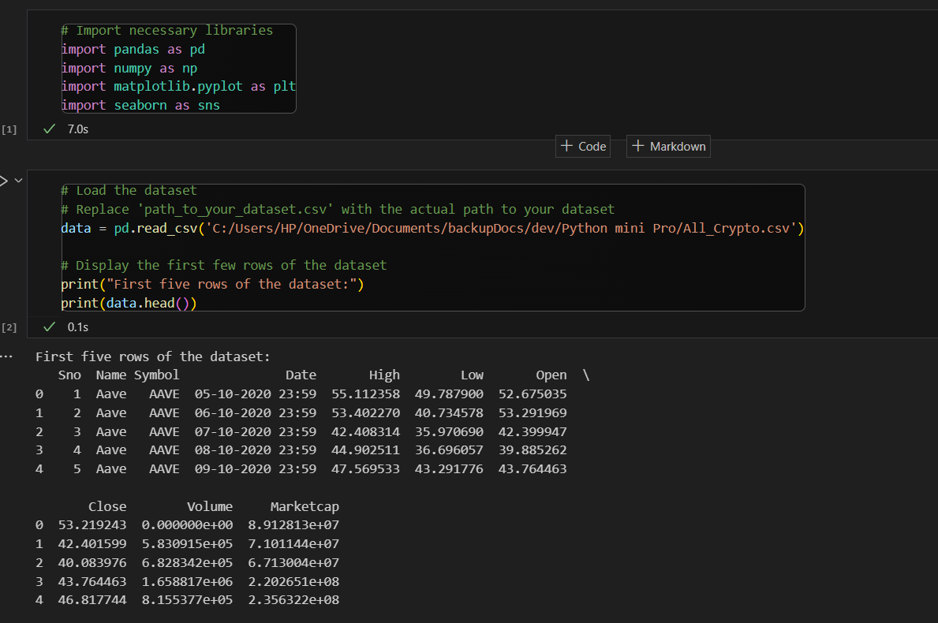

* Summary of entire dataset

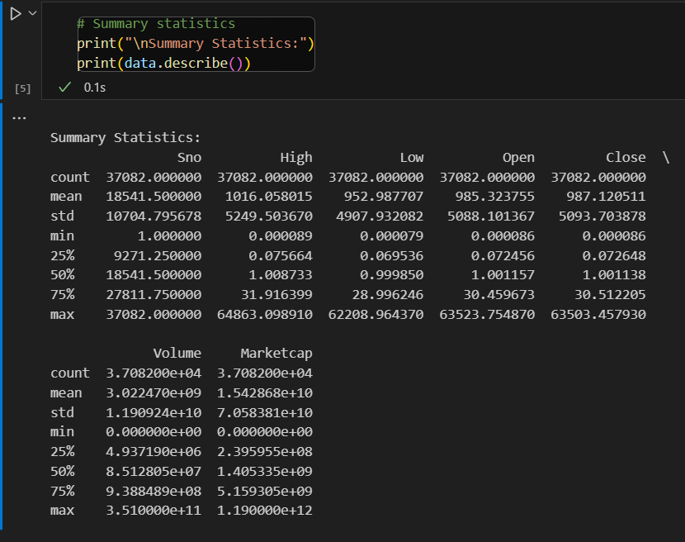

* Shape of dataset and list of names of all the crpto currencies

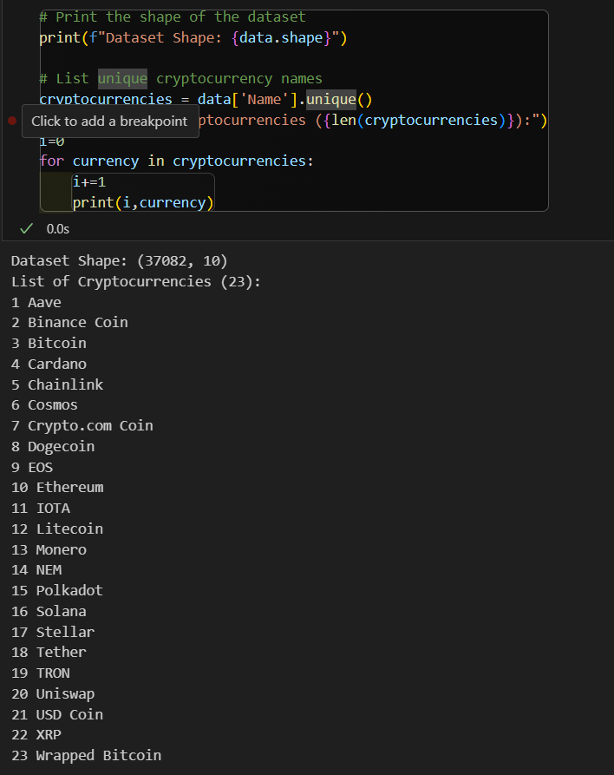

* Using plotly to create an interactive plot

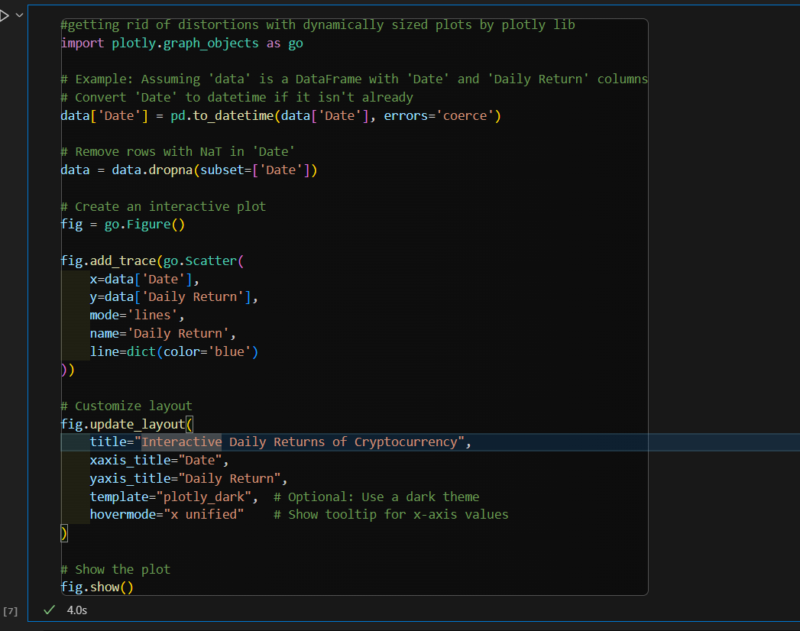

* Monitor price volatility

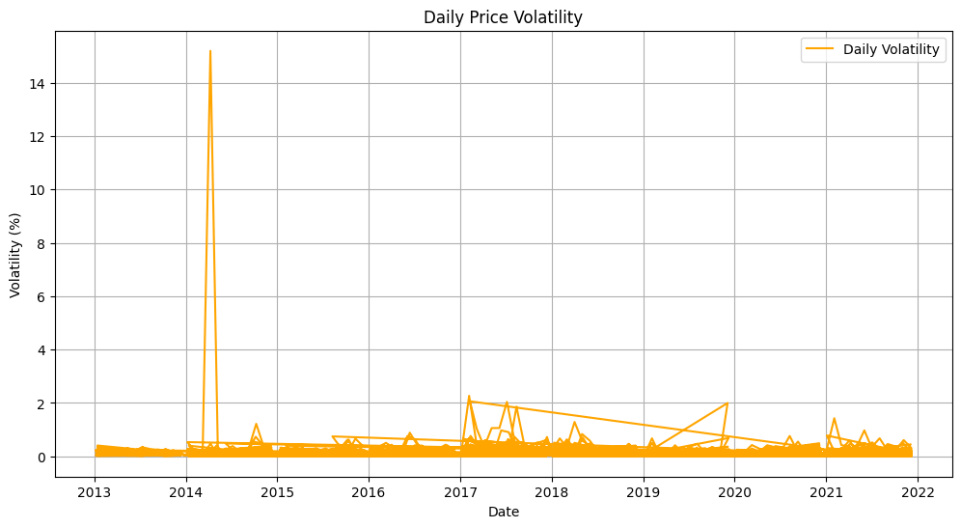

* Calculate Investment Returns

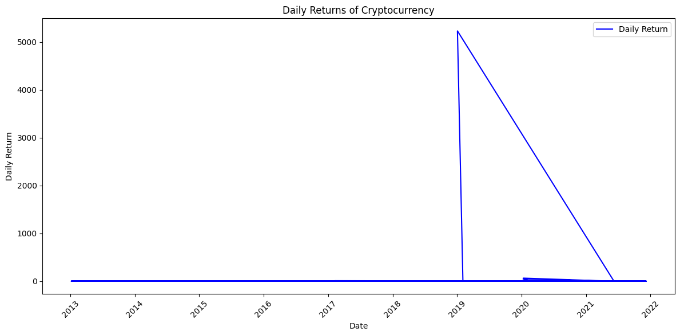

* Analyze trends

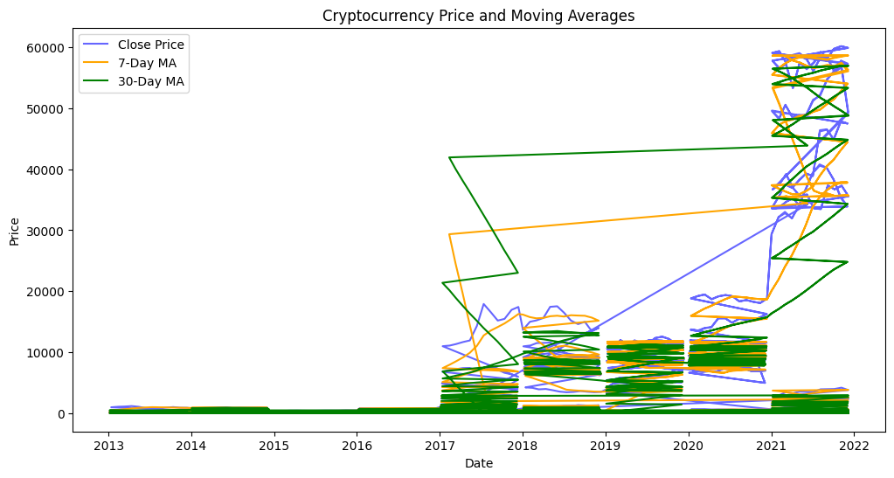

* Study Correlations

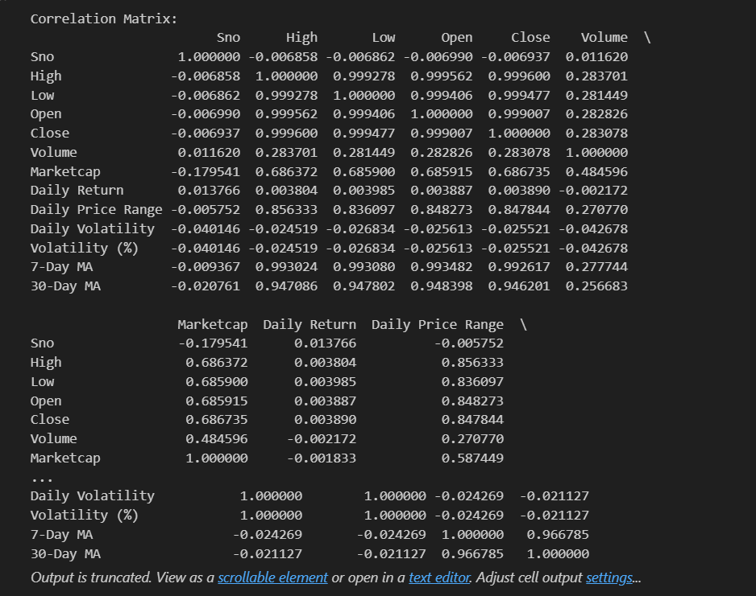

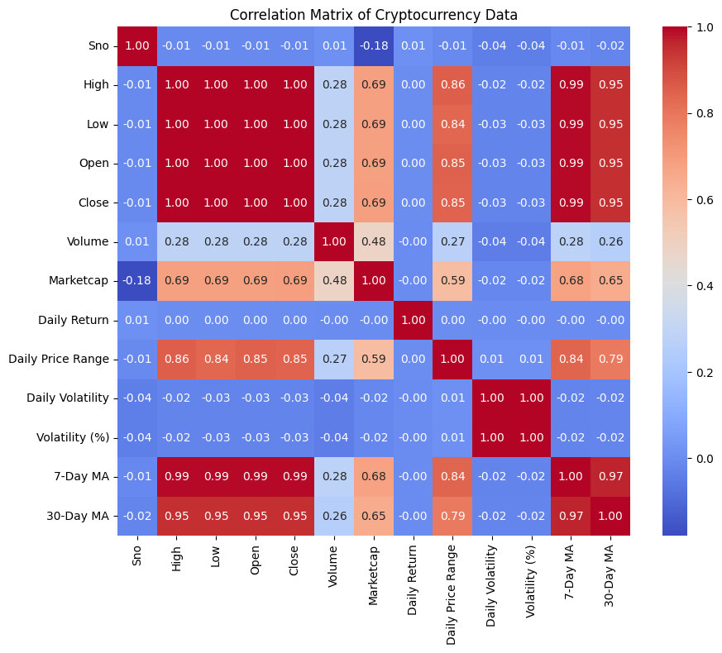

* Seasonal or Periodic Patterns

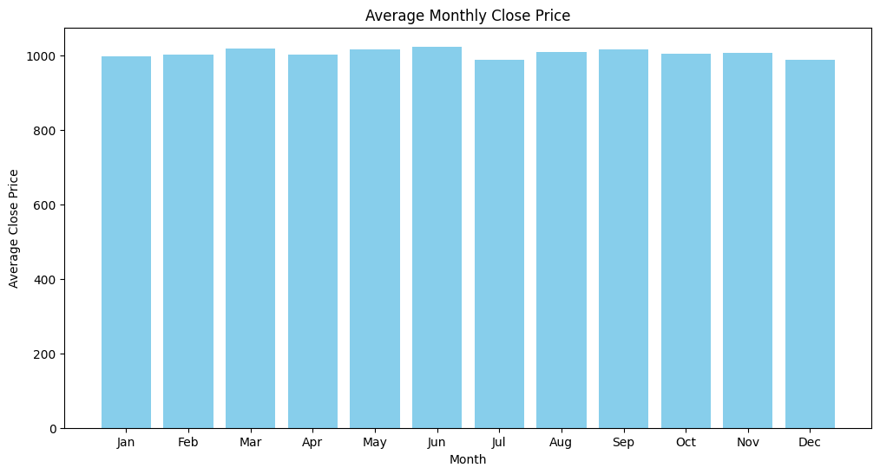

* Analyze trends in closing prices

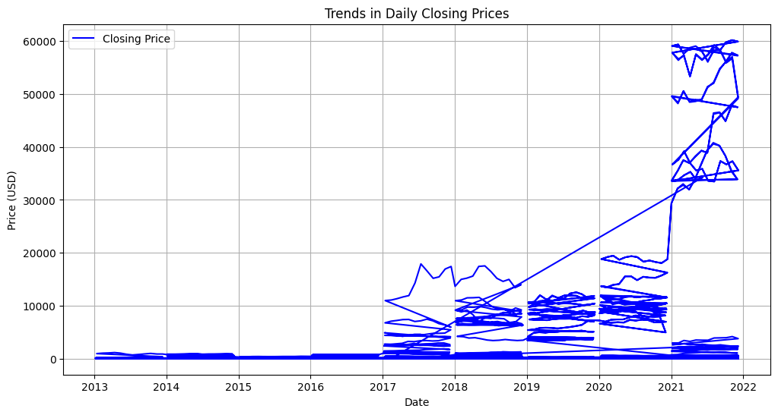

* Save processed data in a file

