Date: 04-08-2021

Session: Basic Introduction

Given Task: Make GitHub repo and HTML practice

My Task:

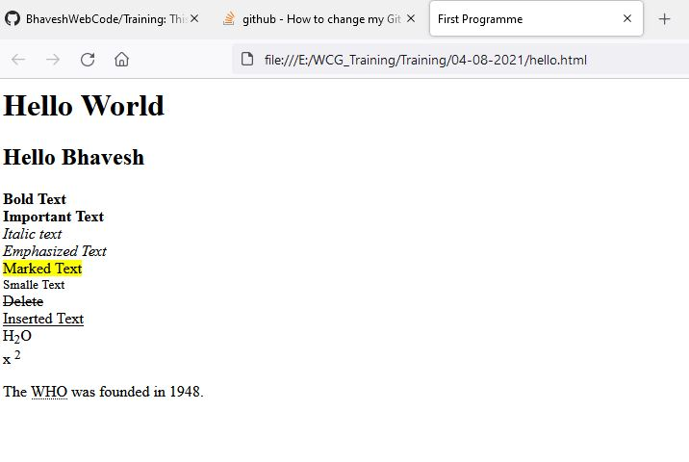I create my new GitHub account and make first repo there and then I install GitHub desktop app and using that I push my code on GitHub.