Date: 05-08-2021

Session: HTML Introduction

Given Task: Make static resume type website

Time Limit: 2days

My Task:

I created Home page, contact page, project page, and education page.

I try to cover all tags which is tech by akash sir and try to use table and form tag.

1. 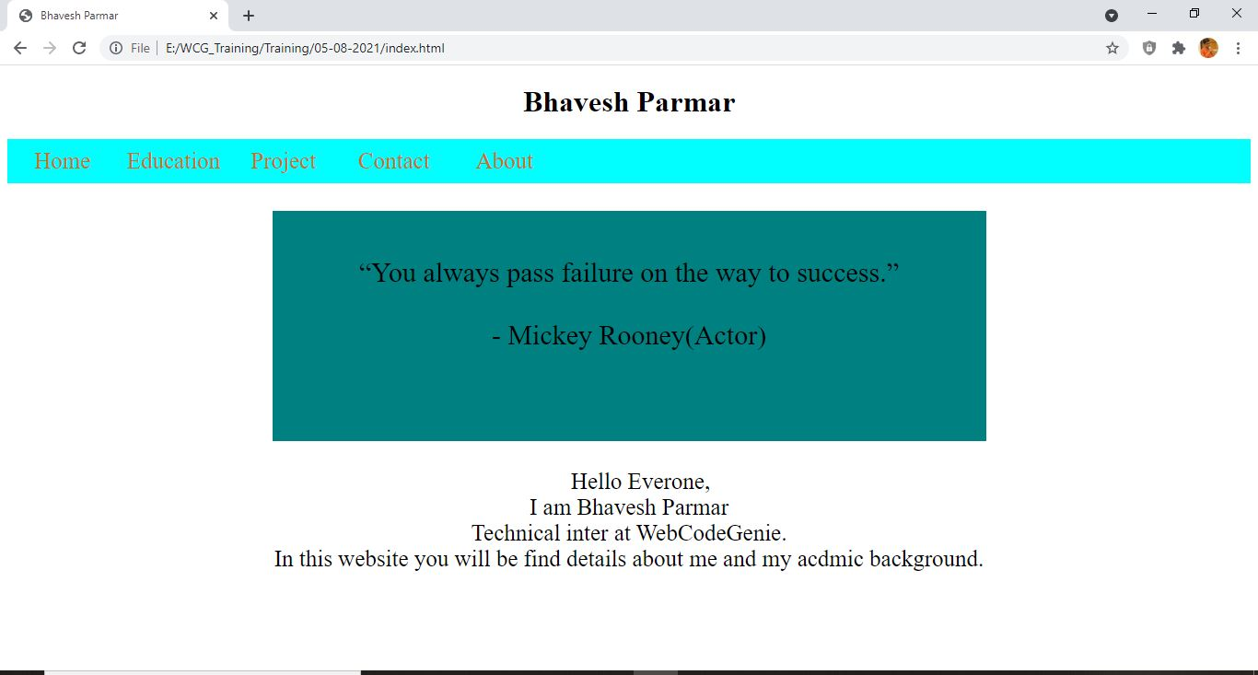Home Page
2. 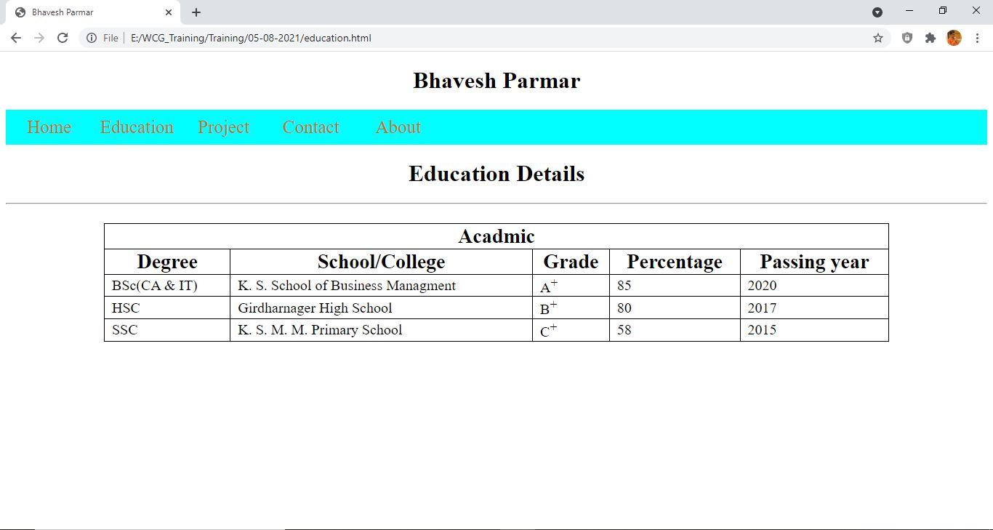Education
3. Contact Page

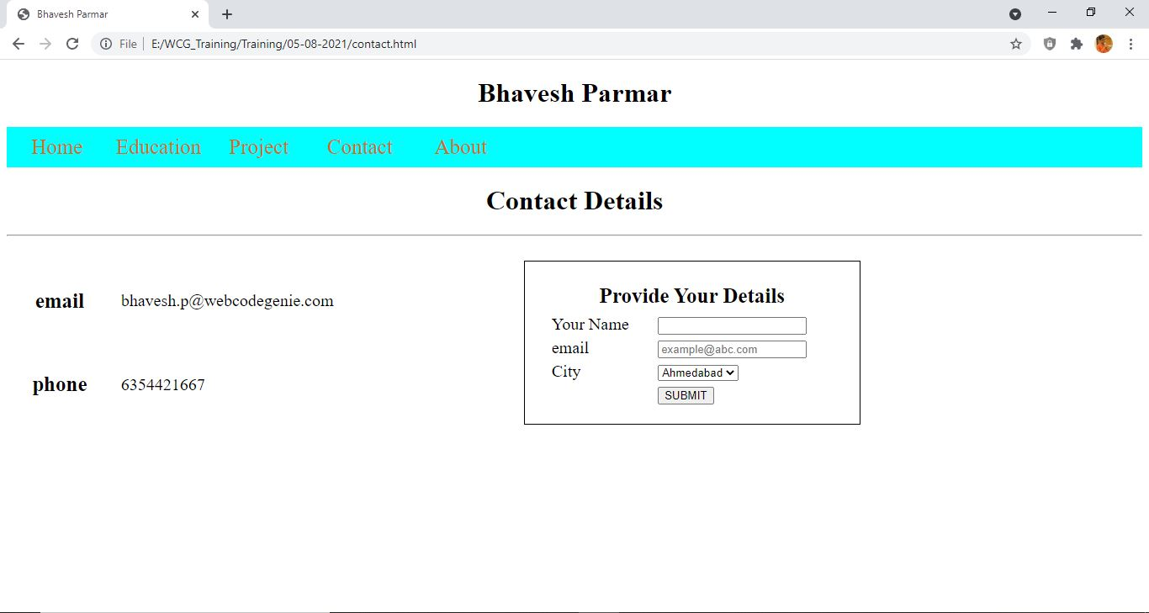

1. 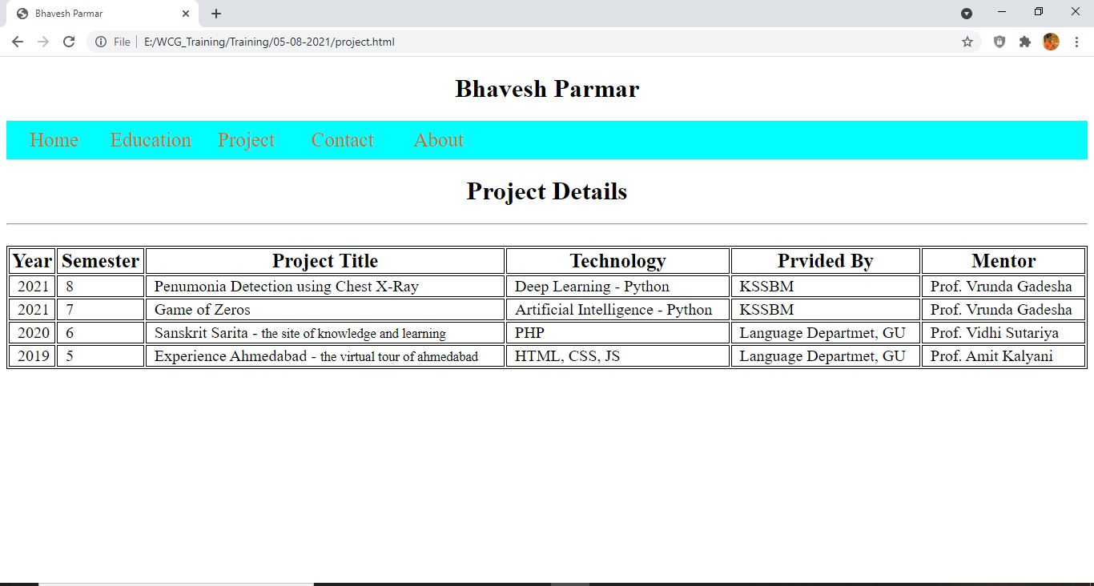Project Page