Date: 06-08-2021

Session: Form Tag

Given Task: Make registration form for hiring process

Time Limit: 1 day

My Task:

I created two form one is very simple and second is good design and divided in different part.

1. Simple form

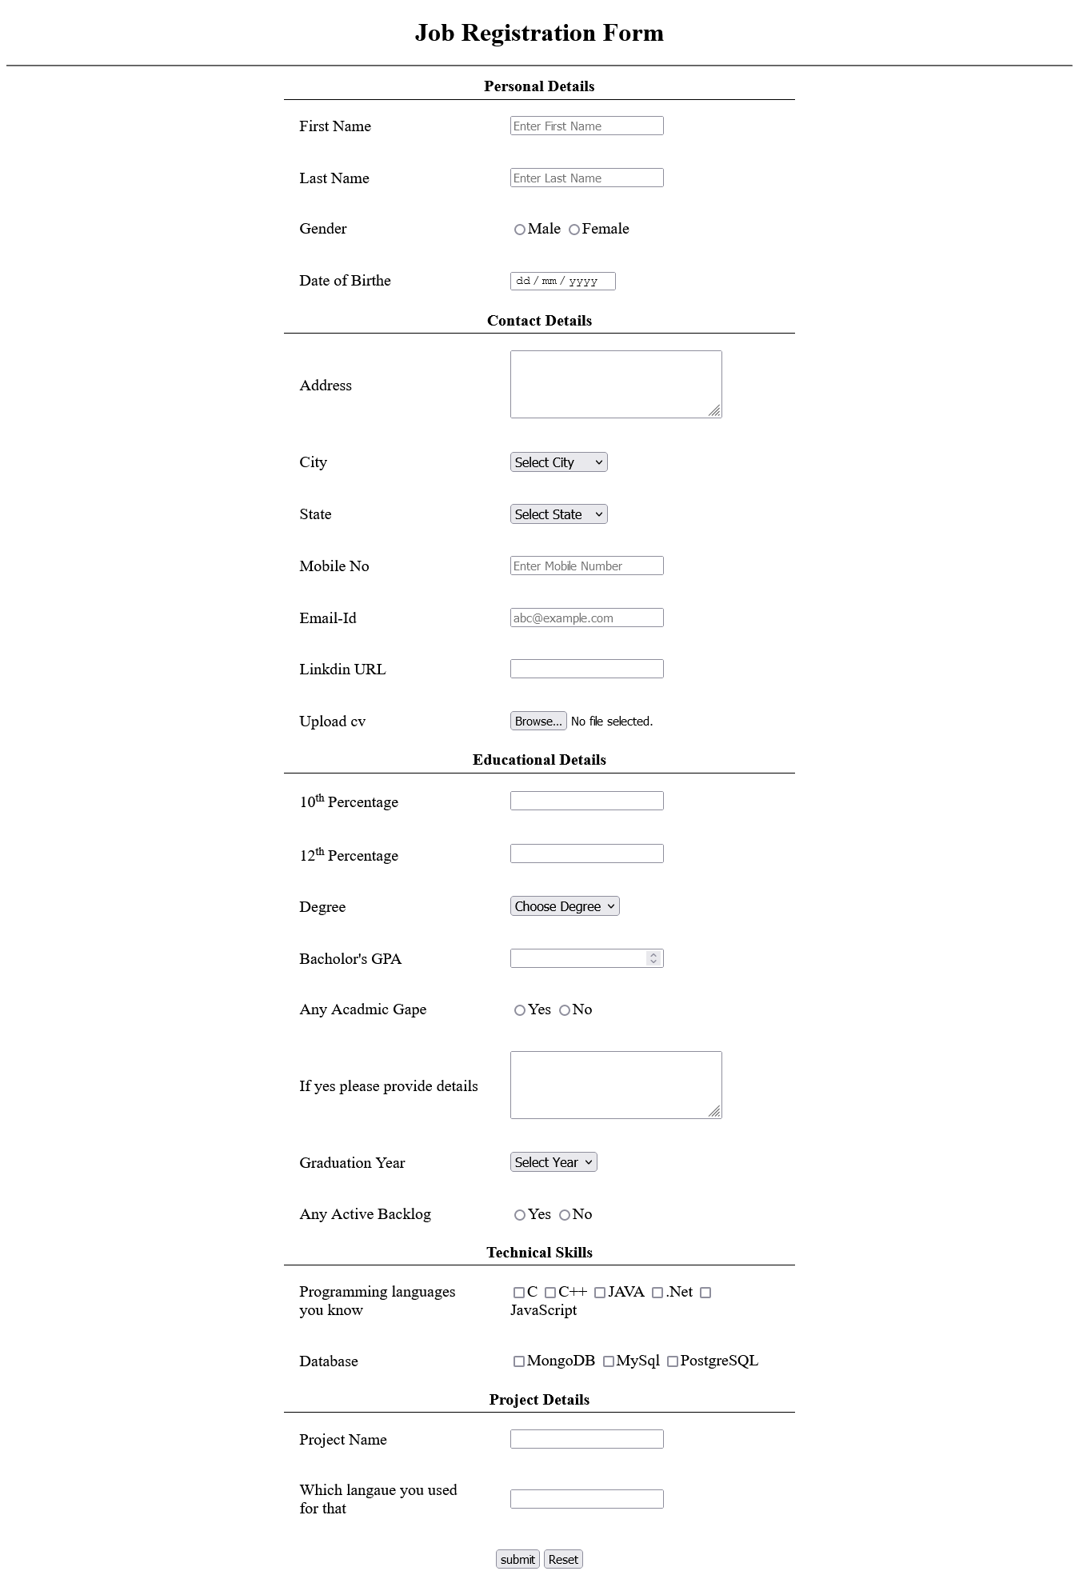

1. Form with Design
2. Personal Details

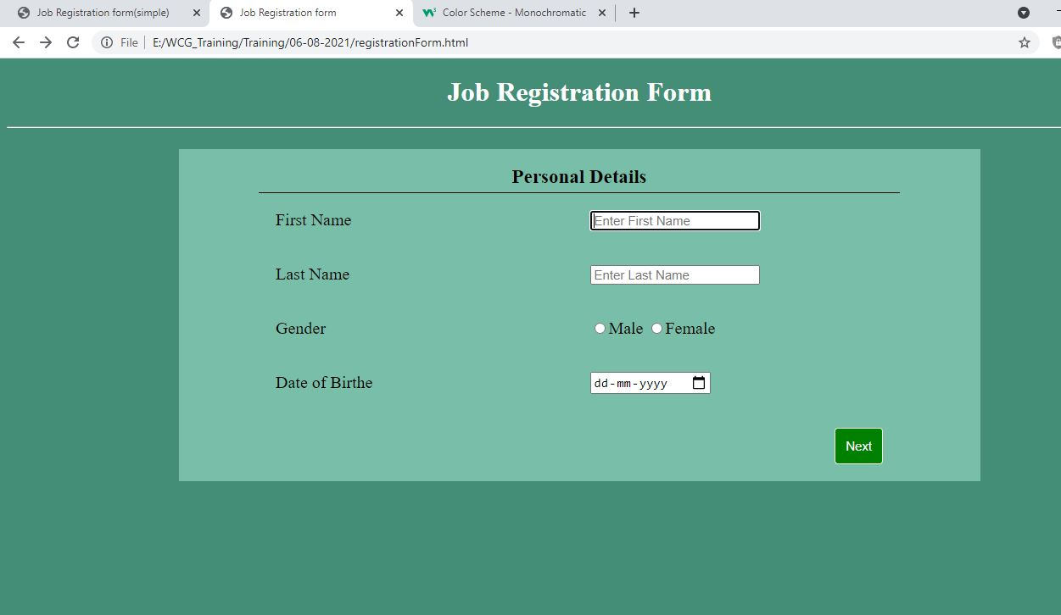

1. 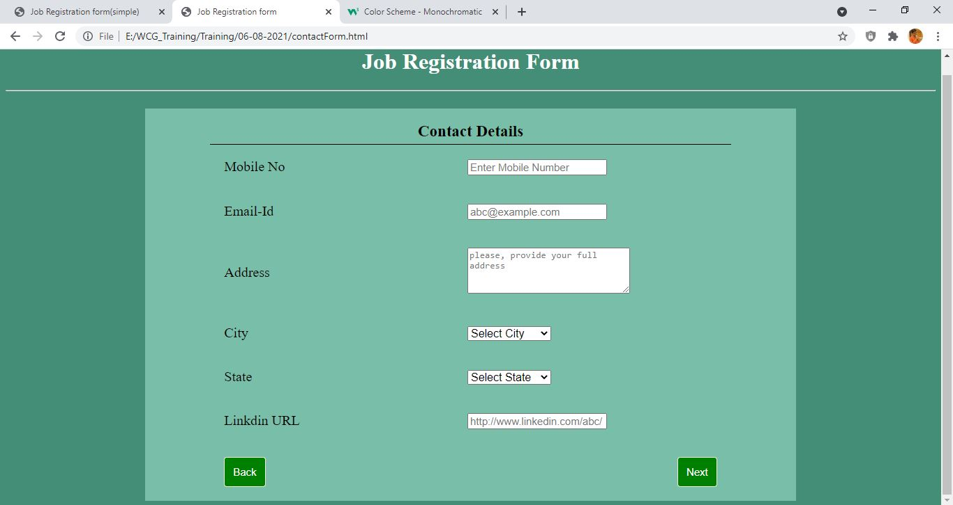Contact Details
2. Education Details
3. 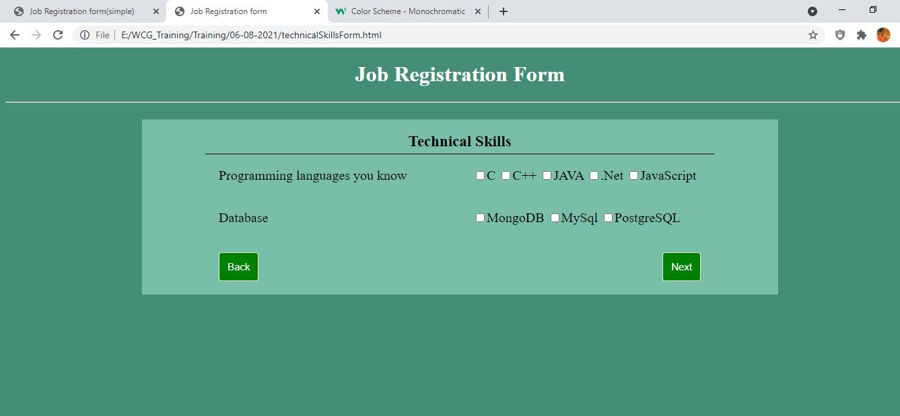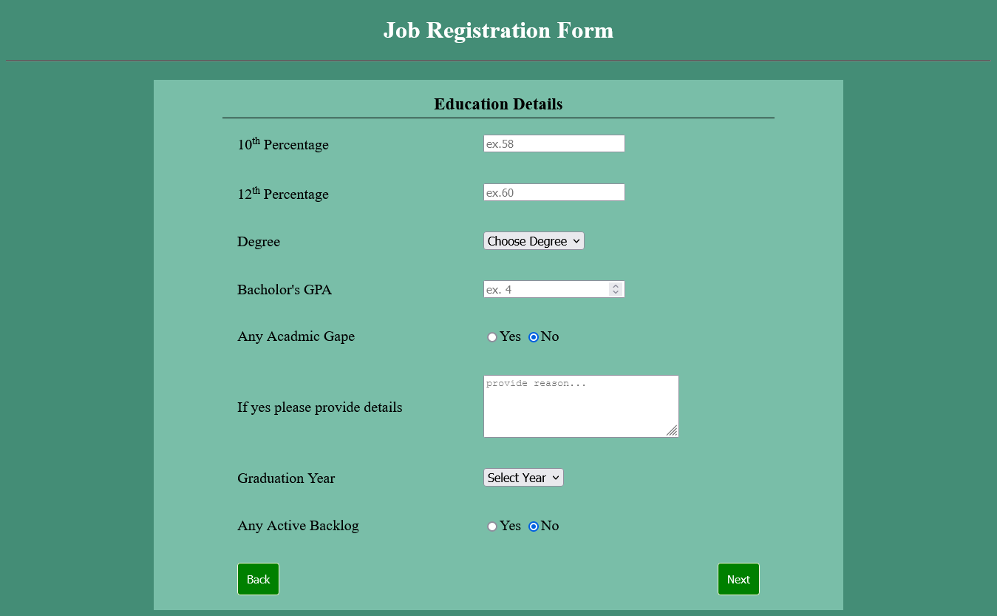Technical Details
4. Project Details

