**Name: Bhavesh Kewalramani**

**Roll No.: A-25**

**Practical No. 1**

**Theory**

**LEX:**

Lex is a program generator designed for lexical processing of character input streams. It accepts a high level, problem oriented specification for character string matching, and produces a program in a general purpose language which recognizes regular expressions. The regular expressions are specified by the user in the source specifications given to Lex. The Lex written code recognizes these expressions in an input stream and partitions the input stream into strings matching the expressions. At the boundaries between strings program sections provided by the user are executed. The Lex source file associates the regular expressions and the program fragments. As each expression appears in the input to the program written by Lex, the corresponding fragment is executed.

Lex is not a complete language, but rather a generator representing a new language feature which can be added to different programming languages, called ``host languages.'' Just as general purpose languages can produce code to run on different com puter hardware, Lex can write code in different host languages.

Lex turns the user's expressions and actions (called source in this pic) into the host general-purpose language; the generated program is named yylex. The yylex program will recognize expressions in a stream (called input in this pic) and perform the specified actions for each expression as it is detected.

**Diagram of Lex**

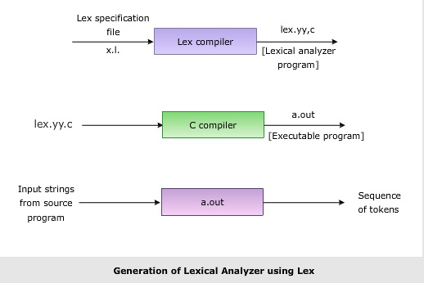

**Format for Lex file**

The general format of Lex source is:

{definitions}

%%

{rules}

%%

{user subroutines}

where the definitions and the user subroutines are often omitted. The second %% is optional, but the first is required to mark the beginning of the rules. The absolute minimum Lex program is thus %% (no definitions, no rules) which translates into a program which copies the input to the output unchanged.

**Regular Expression**

A regular expression (or RE) specifies a set of strings that matches it; the functions in this module let you check if a particular string matches a given regular expression (or if a given regular expression matches a particular string, which comes down to the same thing).

Regular expressions can be concatenated to form new regular expressions; if A and B are both regular expressions, then AB is also a regular expression. In general, if a string p matches A and another string q matches B, the string pqwill match AB. This holds unless A or B contain low precedence operations; boundary conditions between A and B; or have numbered group references. Thus, complex expressions can easily be constructed from simpler primitive expressions.Regular expressions can contain both special and ordinary characters. Most ordinary characters, like "A", "a", or "0", are the simplest regular expressions; they simply match themselves. You can concatenate ordinary characters, so last matches the string 'last'. (In the rest of this section, we'll write RE's in this special style, usually without quotes, and strings to be matched 'in single quotes'.)

Some characters, like "|" or "(", are special. Special characters either stand for classes of ordinary characters or affect how the regular expressions around them are interpreted.

**Lex Library Routines**

Lex library routines are those functions which have a detailed knowledge of the lex functionalities and which can be called to implement various tasks in a lex program.

The following table gives a list of some of the lex routines.

|  |  |
| --- | --- |
| Lex Routine | Description |
| Main() | Invokes the lexical analyzer by calling the yylex subroutine. |
| yywrap() | Returns the value 1 when the end of input occurs. |
| yymore() | Appends the next matched string to the current value of the yytext array rather than replacing the contents of the yytext array. |
| yyless(int n) | Retains n initial characters in the yytext array and returns the remaining characters to the input stream. |
| yyreject | Allows the lexical analyzer to match multiple rules for the same input string. (The yyreject subroutine is called when the special action REJECT is used.) |
| yylex() | The default main() contains the call of yylex() |

**Answer the Questions:**

1. Why is –ll option used for running lex.yy.c

The lex library supplies a default **main()** that calls the function **yylex()**, so you need not supply your own **main()**. The library is accessed by invoking the **-ll** option. The **-ll** option is used to link the object file created from this C source with **lex** library

1. Use of yywrap

Function yywrap is called by lex when input is exhausted. Return 1 if you are done or 0 if more processing is required. Every C program requires a main function. In this case we simply call yylex that is the main entry-point for lex. Some implementations of lex include copies of main and yywrap in a library thus eliminating the need to code them explicitly. This is why our first example, the shortest lex program, functioned properly.

1. Internal representation of Lex

**LEX** is a tool used to generate a lexical analyzer. This document is a tutorial for the use of LEX for **ExpL Compiler** development. Technically, LEX translates a set of regular expression specifications (given as input in input_file.l) into a C implementation of a corresponding finite state machine (lex.yy.c). This C program, when compiled, yields an executable lexical analyzer.



The source ExpL program is fed as the input to the the lexical analyzer which produces a sequence of tokens as output. (Tokens are explained below). Conceptually, a lexical analyzer scans a given source ExpL program and produces an output of tokens.

Each token is specified by a token name. The token name is an abstract symbol representing the kind of lexical unit, e.g., a particular keyword, or a sequence of input characters denoting an identifier. The token names are the input symbols that the parser processes. For instance integer, boolean, begin, end, if, while etc. are tokens in ExpL.

A lex program consists of three parts: the definition section, the rules section, and the user subroutines.

...definition section ...

%%

... rules section ...

%%

... user subroutines ...

The parts are separated by lines consisting of two percent signs. The first two parts are required, although a part may be empty. The third part and the preceding %% line may be omitted. (This structure is the same as that used by yacc, from which it was copied.)

## **Definition Section**

The definition section can include the literal block, definitions, internal table declarations, start conditions, and translations. (There is a section on each in this reference.) Lines that start with whitespace are copied verbatim to the C file. Typically this is used to include comments enclosed in “/*” and “*/”, preceded by whitespace.

## **Rules Section**

The rules section contains pattern lines and C code. A line that starts with whitespace, or material enclosed in “%{” and “%}” is C code. A line that starts with anything else is a pattern line.

C code lines are copied verbatim to the generated C file.

**Practicals**

**Aim (I1):** Write a Lex specification to declare whether the entered word starts with a vowel or not.

**Program:**

%{

#include<stdio.h>

%}

%%

[aeiouAEIOU][a-zA-Z0-9]* {printf("Word starts with a Vowel : \t%s\n",yytext);};

[a-zA-Z0-9]+ {printf("Word does not starts with a Vowel : \t%s\n",yytext);};

%%

int main(){

yyin = fopen("I1.txt","r");

yylex();

}

int yywrap() {return 1;}

**Output:**

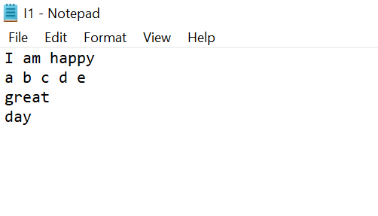

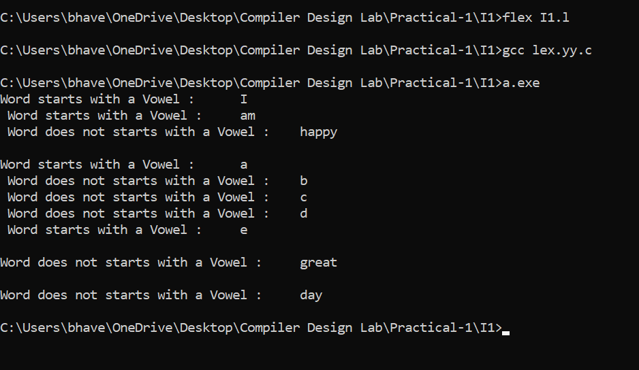

**Aim (I2):** Write a Lex Specification to count the number of words, lines, small letters, capital letters,digits and special characters in a given input file.

**Program:**

%{

#include<stdio.h>

int lines=0,words=0,smallchar=0,capitalchar=0,digits=0,specialchar=0;

%}

%%

\n {lines++; words++;}

[\t' '] words++;

[a-z] smallchar++;

[A-Z] capitalchar++;

[0-9] digits++;

. specialchar++;

%%

void main()

{

yyin = fopen("I2.txt","r");

yylex();

printf("\n File has %d lines",lines);

printf("\n File has %d words",words);

printf("\n File has %d small characters",smallchar);

printf("\n File has %d capital characters",capitalchar);

printf("\n File has %d digits",digits);

printf("\n File has %d special characters",specialchar);

printf("\n File has %d total characters in all",smallchar+capitalchar+digits+specialchar);

}

int yywrap(){ return 1;}

**Output:**

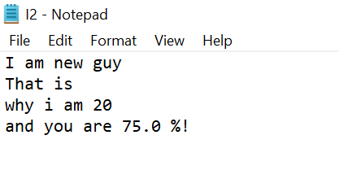

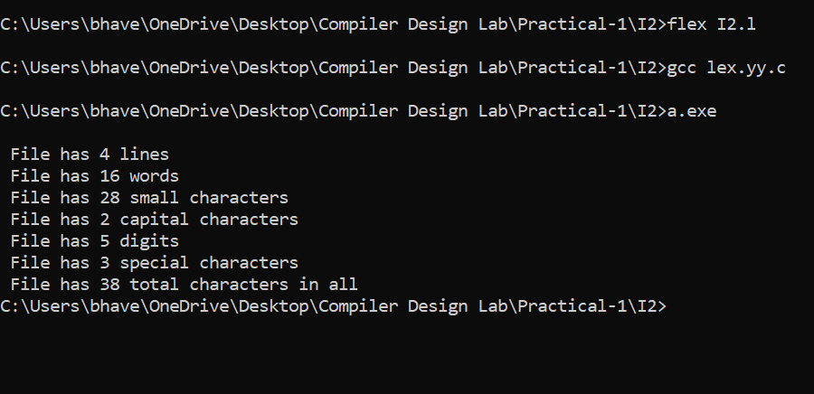

**Aim (S1):** Design a lexical analyser to identify the tokens such as keywords, identifiers, operators, symbols and strings for C language using Lex.

**Program:**

%{

#include<stdio.h>

%}

digit [0-9]

letter[a-zA-Z]

symbol [,|;|&|%|(|)|"|'|{|}|<|>]

string (\".*\")

%%

if|else|switch|while|do|void|main|printf|scanf|for {printf("\n %s is a KEYWORD",yytext);}

{letter}({letter}|{digit})* {printf("\n %s is an IDENTIFIER",yytext);}

{string} {printf("\n %s is a STRING",yytext);}

"&&"|"=="|"="|"++"|"+"|"-"|"*"|"/"|"||"|"!" {printf("\n %s is an OPERATOR",yytext);}

({digit})* {printf("\n %s is a DIGIT",yytext);}

{symbol} {printf("\n %s is a SYMBOL",yytext);}

\n {printf("\n %s is a NEW LINE",yytext);}

\t {printf("\n %s is a TAB SPACE",yytext);}

%%

void main(){

yyin = fopen("S1.txt","r");

yylex();

}

int yywrap(){return 1;}

**Output:**

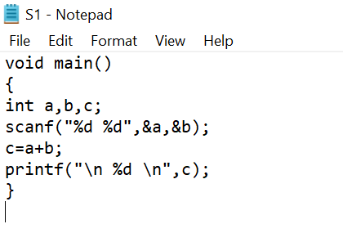

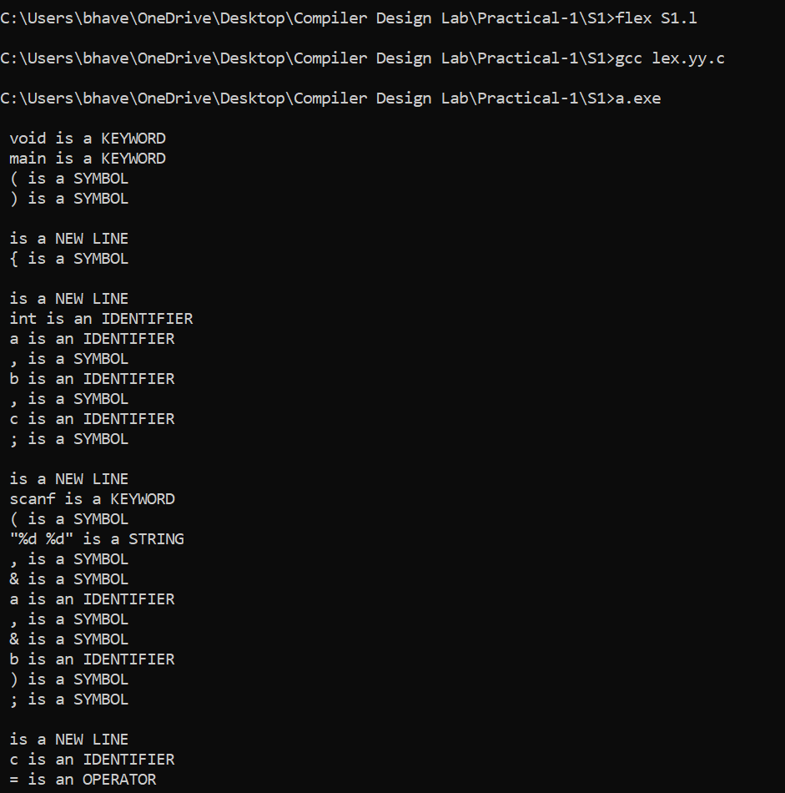

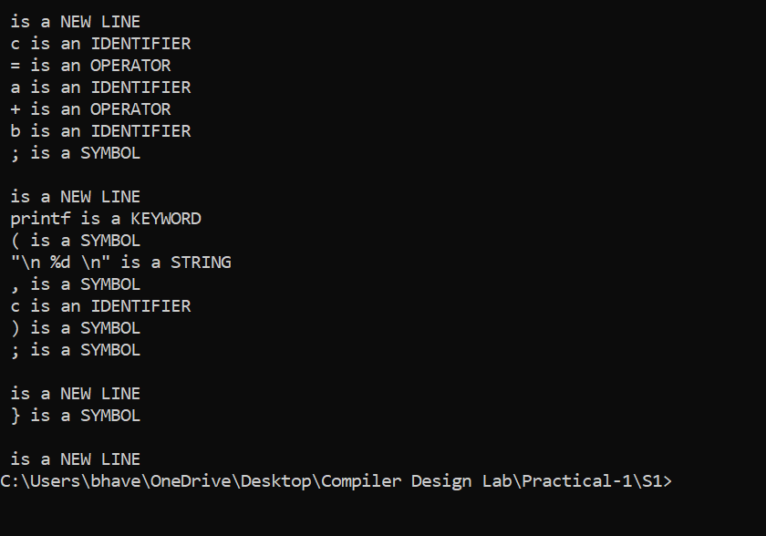

**Aim (E1):** Use the above code (S1) and perform the additional tasks: If a keyword is found append AAA to the identified keyword. For identifier append III. Also add 2 to digit and display the answer.

**Program:**

%{

#include<stdio.h>

#include<string.h>

#include<stdlib.h>

int val;

char c[100];

%}

digit [0-9]

letter [a-zA-Z]

symbol [,|;|&|%|(|)|"|'|{|}|<|>]

string (\".*\")

%%

if|else|switch|while|do|void|main|printf|scanf|for|int|bool|char|float|double {strcpy(c,yytext);strcat(c,"AAA");printf("\n KEYWORD: %s",c);}

{letter}({letter}|{digit})* {strcpy(c,yytext);strcat(c,"III");printf("\n IDENTIFIER: %s",c);}

({digit})* {val = atoi(yytext);printf("\n DIGIT: %d",val+2);}

%%

void main(){

yyin = fopen("E1.txt","r");

yylex();

}

int yywrap(){return 1;}

**Output:**

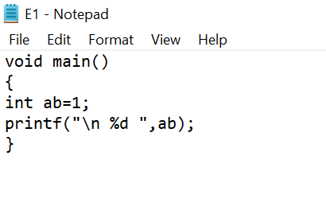

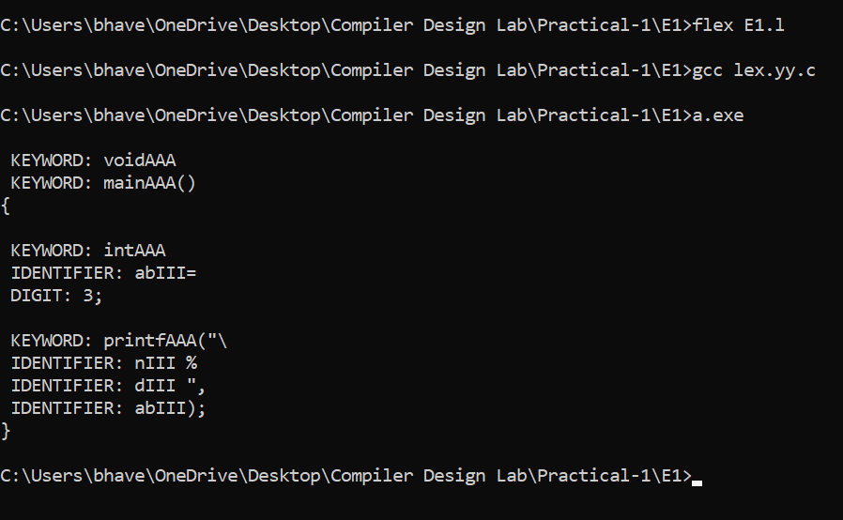

**Aim (E2):** Write a LEX specification to take the contents from a file while adding 3 to number divisible by 7 and adding 4 to number divisible by 2.

**Program:**

%{

#include<stdio.h>

#include<string.h>

#include<stdlib.h>

int val;

%}

digit [0-9]

%%

({digit})* {

val = atoi(yytext);

if(val%7==0)

printf("\n %d \t %d",val,val+3);

else if(val%2==0)

printf("\n %d \t %d",val,val+4);

else

printf("\n %d",val);

}

%%

void main(){

yyin = fopen("E2.txt","r");

yylex();

}

int yywrap(){return 1;}

**Output:**

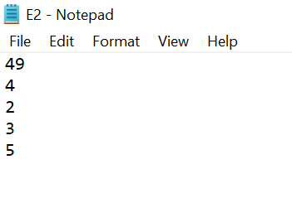

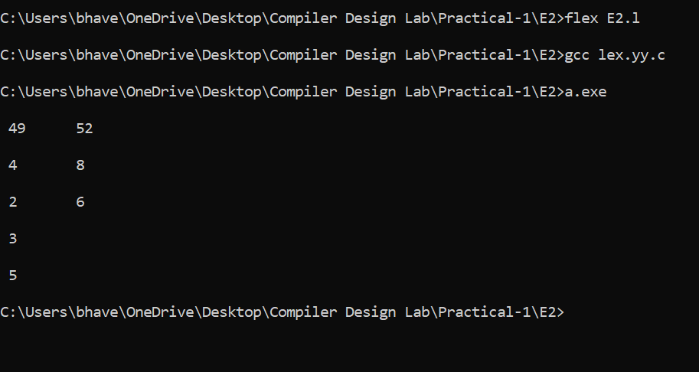

**Aim (E3):** Write a lex specification to display the histograms of length of words.

**Program:**

%{

#include<stdio.h>

#include<string.h>

#include<stdlib.h>

int val;

char c[100];

%}

%%

[a-zA-Z0-9]* {strcpy(c,yytext);}

%%

void main(){

yyin = fopen("E3.txt","r");

yylex();

char ch;

int i=0,j,s=0,w=0,ndig[10],len=0;

for(i=0;i<10;i++)

ndig[i]=0;

i=0;

while(c[i]!=EOF)

{

if(s==1)

len++;

if(c[i]==' '||c[i]=='\n'||c[i]=='\t')

{

s=0;

if(len<10)

++ndig[len];

len=0;

}

else if(s==0)

{

s=1;

w++;

}

i++;

}

for(i=0;i<10;i++)

{

printf("%d =\t %d",i,ndig[i]);

printf("\n");

}

}

int yywrap(){return 1;}

**Output:**

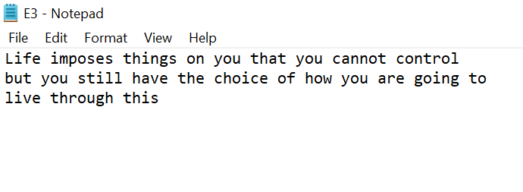

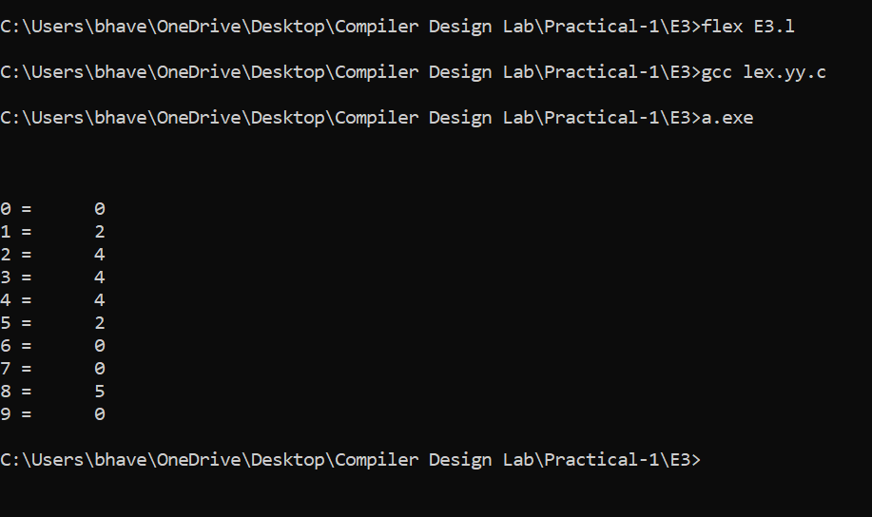

**Aim (E4):** Write a LEX specification to search the input file. Let the input file contain some text,

comments and digits.

(i) Convert text present in file to LOWERCASE.

(ii) Report occurrence of comments and special characters.

**Program:**

%{

#include<stdio.h>

#include<string.h>

#include<stdlib.h>

#include<ctype.h>

char c[100];

int i;

%}

symbol [,|;|&|%|(|)|"|'|{|}|<|>|!|@|#|$|^]

letter[a-zA-Z]

digit [0-9]

%%

[a-zA-Z] { strcpy(c,yytext);

for(i=0;c[i]!='\0';i++)

{

if(c[i]>='A' && c[i]<='Z')

{

c[i]=c[i]+32;

}

}

printf("%s",c);

}

[0-9]* {printf("\n Digit: %s",yytext);}

"//".*\n { printf("\n Single Line Comment \t");

strcpy(c,yytext);

for(i=0;c[i]!='\0';i++)

{

if(c[i]>='A' && c[i]<='Z')

{

c[i]=c[i]+32;

}

if(c[i]=='/')

{

c[i]=' ';

}

}

printf("%s",c);

}

"/*"[^*/]*"*/" {printf("\n Multi-Line Comment \n");

strcpy(c,yytext);

for(i=0;c[i]!='\0';i++)

{

if(c[i]>='A' && c[i]<='Z')

{

c[i]=c[i]+32;

}

if(c[i]=='/' || c[i]== '*')

{

c[i]=' ';

}

}

printf("%s",c);

}

{symbol}+ {printf("\n \n Special Character: %s",yytext);}

%%

void main(){

yyin = fopen("E4.txt","r");

yylex();

}

int yywrap(){return 1;}

**Output:**

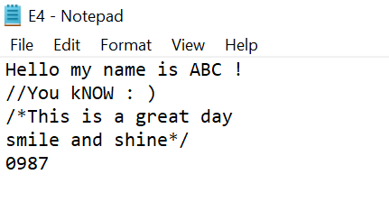

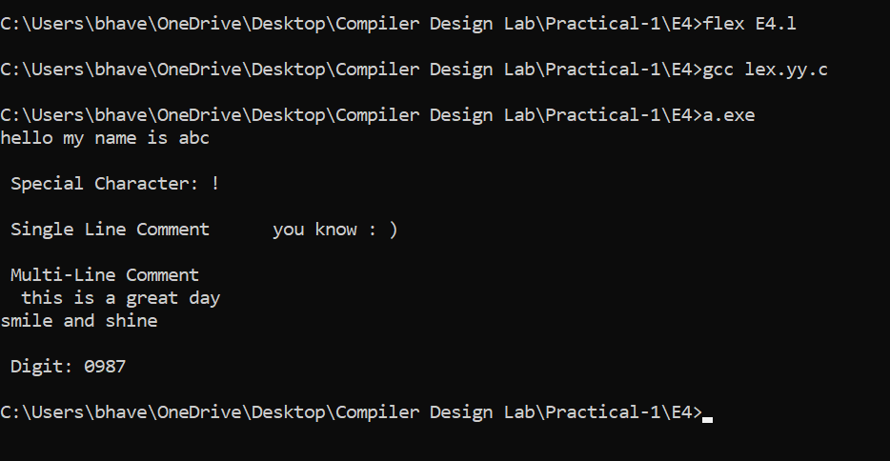

**Aim (E5):** Translate an HTML file with some HTML tags to text file using lex. Consider input from stdin. Discard all HTML tags and comments and write the remaining text to stdout. The text output should simulate the HTML characteristics such as list, indent and paragraphs. Font

characters such as bold and italics may not be simulated.

**Program:**

%{

#include<stdio.h>

#include<string.h>

char c[100];

int flagOL=0,flagUL=0,i=1,j,k;

%}

%%

"</br>" {printf("\n");}

"<p>".*\n {k=0;for(j=0;j<strlen(yytext)-5;j++)

{

if(yytext[j]=='<' && yytext[j+1]=='p')

{

j=j+3;

}

if(yytext[j]=='<' && yytext[j+1]=='\\')

{

j=j+4;

}

c[k]=yytext[j];

k++;

}

printf("\n %s ",c);

}

"<ol>" {flagOL=1;

flagUL=0;

}

"</ol>" {i=0,flagOL=0;}

"<li>".*"</li"> { if(flagOL==1 && flagUL==0)

{

printf("\n %d \t",i);

i++;

}

if(flagOL==0 && flagUL==1)

{

printf("\n # \t");

}

for(j=4;j<strlen(yytext)-5;j++)

{

printf("%c",yytext[j]);

}

}

"<ul>" {flagOL=0;

flagUL=1;

}

"</ul>" {flagUL=0;}

%%

void main(){

yyin = fopen("E5.txt","r");

yylex();

}

int yywrap(){return 1;}

**Output:**

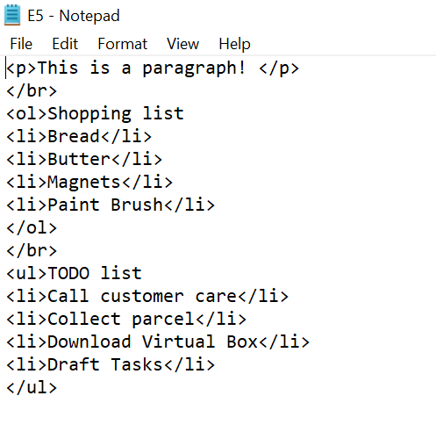

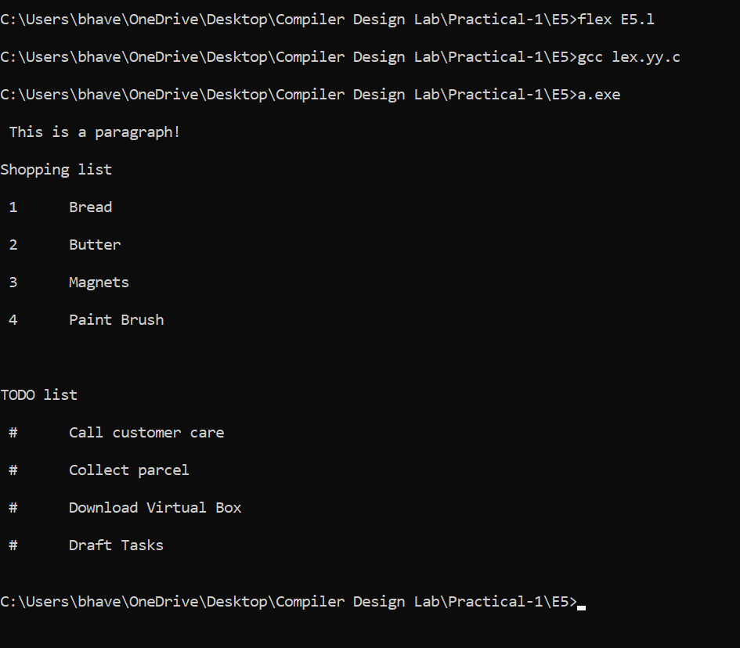

**Aim (E6):** Write a Lex program to find the parameters given below. Consider as input a question paper of an examination and find:

Date of examination, semester, number of questions, numbers of words, lines, small letters,

capital letters, digits, and special characters.

**Program:**

%{

#include<stdio.h>

#include<string.h>

int lines=0,words=0,smallchar=0,capitalchar=0,digits=0,specialchar=0,questions=0;

char ch[100];

int i,j,k;

%}

%%

\n {lines++; words++;}

([0-2][0-9]|3[0-1])\/(0[1-9]|1[0-2])\/([1-2][0-9][0-9][0-9]) {printf("\n Date of Examination : %s",yytext);}

[a-zA-Z0-9]*"College "[a-zA-Z0-9]* {printf("\n College Name : %s",yytext);

strcpy(ch,yytext);

for(i=0;ch[i]!='\0';i++)

{

if(ch[i]>='a' && ch[i]<='z')

{

smallchar++;

}

if(ch[i]>='A' && ch[i]<='Z')

{

capitalchar++;

}

if(ch[i]>='0' && ch[i]<='9')

{

digits++;

}

}

lines++;

}

"Sem:".*\n {

strcpy(ch,yytext);

for(i=0;ch[i]!='\0';i++)

{

if(ch[i]>='a' && ch[i]<='z')

{

smallchar++;

}

if(ch[i]>='A' && ch[i]<='Z')

{

capitalchar++;

}

if(ch[i]>='0' && ch[i]<='9')

{

digits++;

}

if(ch[i]==' ')

{

words++;

}

if(ch[i]>='S' && ch[i+1]<='e' && ch[i+2]=='m' && ch[i+3]==':')

{

ch[i]=' ';

ch[i+1]=' ';

ch[i+2]=' ';

ch[i+3]=' ';

i=i+3;

}

}

printf("\n Semester : %s",ch);

lines++;

}

"Question".*\n {questions++;

strcpy(ch,yytext);

for(i=0;ch[i]!='\0';i++)

{

if(ch[i]>='a' && ch[i]<='z')

{

smallchar++;

}

if(ch[i]>='A' && ch[i]<='Z')

{

capitalchar++;

}

if(ch[i]>='0' && ch[i]<='9')

{

digits++;

}

if(ch[i]==' ')

{

words++;

}

if(ch[i]>='S' && ch[i+1]<='e' && ch[i+2]=='m' && ch[i+3]==':')

{

ch[i]=' ';

ch[i+1]=' ';

ch[i+2]=' ';

ch[i+3]=' ';

i=i+3;

}

}

lines++;

}

[\t' '] words++;

[a-z] smallchar++;

[A-Z] capitalchar++;

[0-9] digits++;

. specialchar++;

%%

void main()

{

yyin = fopen("E6.txt","r");

yylex();

printf("\n Number of Questions : %d",questions);

printf("\n File has %d lines",lines);

printf("\n File has %d words",words);

printf("\n File has %d small characters",smallchar);

printf("\n File has %d capital characters",capitalchar);

printf("\n File has %d digits",digits);

printf("\n File has %d special characters",specialchar);

printf("\n File has %d total characters in all",smallchar+capitalchar+digits+specialchar);

}

int yywrap(){ return 1;}

**Output:**

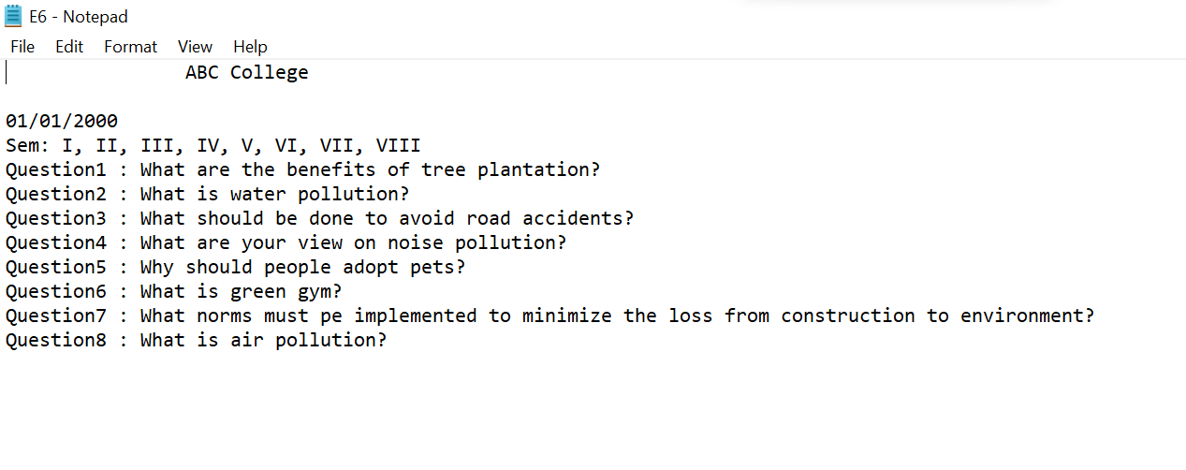

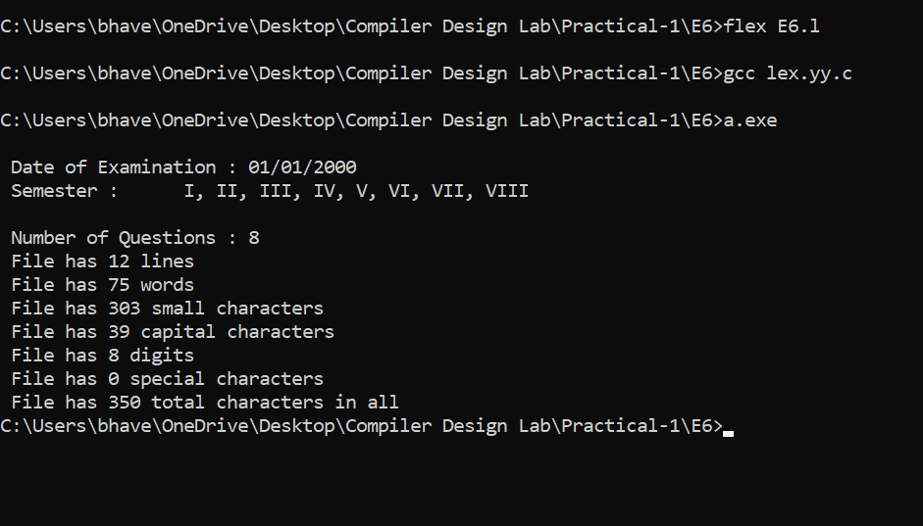

**Aim (E7):** Create a txt file to containing the following without heading: Name of Student, Company Placed in (TCS, Infosys, Wipro, Accenture, Informatica), Male/female, CGPA (floating point number), Department (CSE, IT, EC), Package (floating point number), mail id, mobile number (integer exactly 10 digits). At least 25 records must be present.

Write a Lex program to find the parameters given below:

* Identify Name of student and display it.
* Identify CGPA and display (should be less than 10)
* Identify Package and display it
* Identify mail id and display
* Identify mobile number and display
* Find number of students placed in each of the company
* Number of female students
* Number of male students
* Number of CSE, IT and EC students who are placed

**Program:**

%{

#include<stdio.h>

#include<string.h>

char ch[100];

int a=0,b=0,c=0,d=0,e=0,nf=0,nm=0,nc=0,ni=0,ne=0;

%}

%%

"TCS"|"Infosys"|"Wipro"|"Accenture"|"Informatica" {strcpy(ch,yytext);

printf("\n Company Name : %s",ch);

if(strcmp(ch,"TCS")==0) a++;

if(strcmp(ch,"Infosys")==0) b++;

if(strcmp(ch,"Wipro")==0) c++;

if(strcmp(ch,"Accenture")==0) d++;

if(strcmp(ch,"Informatica")==0) e++;

}

"CSE"|"IT"|"EC" {strcpy(ch,yytext);

printf("\n Branch : %s",ch);

if(strcmp(ch,"CSE")==0) nc++;

if(strcmp(ch,"IT")==0) ni++;

if(strcmp(ch,"EC")==0) ne++;

}

"Male"|"Female" {strcpy(ch,yytext);

printf("\n Gender : %s",ch);

if(strcmp(ch,"Female")==0) nf++;

if(strcmp(ch,"Male")==0) nm++;

}

[7-9][0-9][0-9][0-9][0-9][0-9][0-9][0-9][0-9][0-9] {printf("\n Mobile : %s",yytext);}

[1-9][0-9][0-9][0-9][0-9][0-9]* {printf("\n Package : %s",yytext);}

[a-z.0-9_]+@[a-z]+".com"|[a-z.0-9_]+@[a-z]+".in"|[a-z.0-9_]+@[a-z]+".edu" {printf("\n Mail id : %s",yytext);}

[0-9]"."[0-9]* {printf("\n CGPA : %s",yytext);}

[a-zA-Z]* {printf("\n Name of the student : %s",yytext);}

%%

void main()

{

yyin = fopen("E7.txt","r");

yylex();

printf("\n\n\n");

printf("\n Number Of students placed in TCS : %d ",a);

printf("\n Number of students placed in Infosys : %d ",b);

printf("\n Number of students placed in Wipro : %d ",c);

printf("\n Number of students placed in Accenture : %d ",d);

printf("\n Number of students placed in Informatica : %d ",e);

printf("\n Number of Female students : %d ",nf);

printf("\n Number of Male students : %d ",nm);

printf("\n Number of CSE students placed : %d ",nc);

printf("\n Number of IT students placed : %d ",ni);

printf("\n Number of EC students placed : %d ",ne);

}

int yywrap(){ return 1;}

**Output:**

