CUSTOMER RETENTION & CHURN ANALYTICS
Comprehensive Predictive Data Science & Executive Intelligence Report
Future Interns Task 2 | Track Code: DS | Repository: FUTURE_DS_02

1. Executive Summary & Strategic Problem Statement
Customer churn represents one of the single largest financial leakages in SaaS, telecommunications, and subscription-based business models. Acquiring a new customer costs 5x to 7x more than retaining an existing one. This analytics initiative investigates subscriber behavior, contract friction, service engagement patterns, and payment defaults across 7,043 subscriber accounts in the Telco dataset.
The overarching objective is to convert static transactional records into an operational Predictive Revenue Protection Engine. By combining Python data science (supervised Random Forest machine learning and cohort heatmaps), SQL Server Management Studio (SSMS Star Schema relational data modeling and advanced T-SQL queries), and Power BI executive dashboards, this project bridges technical analytical precision with high-impact business strategy.
💡 EXECUTIVE FINANCIAL BASELINE
Financial Baseline & Risk Exposure:
• Total Active Base: 7,043 Accounts
• Baseline Attrition Rate: 26.54% (1,869 Churned Subscribers) — over 5x higher than healthy SaaS benchmarks (<5%).
• Monthly Revenue at Risk (Lost MRR): $139,130.85 per month.
• Annualized Financial Exposure: $1,669,570.20 per year.

2. End-to-End Analytics Architecture & Methodology
The project was executed across three interconnected technical layers to guarantee institutional-grade data integrity, scalability, and executive usability.
Phase 1: Python Data Engineering & Predictive Machine Learning
- Data Cleansing & Type Conversion: Resolved blank space strings in 'TotalCharges' for zero-tenure accounts by casting to float and imputing with $0. Standardized redundant categorical text (e.g., 'No internet service' -> 'No').
- Feature Engineering: Constructed domain-specific retention metrics including Tenure_Cohort ('0-1 Year' through '5+ Years'), Total_AddOn_Services (count of 6 security/streaming add-ons), and Value_Segment (quantile billing split).
- Cohort Retention Heatmap: Generated a two-dimensional cohort retention matrix mapping tenure length against contract duration to isolate attrition velocity points.
- Random Forest Predictive Scoring: Trained a supervised Random Forest Classifier (100 estimators, max depth 8) achieving an AUC-ROC score of 0.813. Applied model predictions back to the core dataset to assign every active customer an individual Churn_Probability_Pct score (0.0% to 100.0%).
Phase 2: SQL Server Database Modeling & Advanced T-SQL
- Star Schema Architecture: Decomposed raw customer attributes into a dimensional data warehouse consisting of Dim_Customer, Dim_Services, Dim_Billing, and Fact_Churn_Retention.
- Master Analytical Views: Compiled 5 production SQL views in SSMS (vw_Customer_360_Master, vw_Cohort_Retention_Summary, vw_Services_Impact_Analysis, vw_High_Risk_Churn_Watchlist, vw_Revenue_At_Risk_Executive).
- Problem-Solving T-SQL Queries: Engineered 10 advanced queries utilizing Common Table Expressions (CTEs), window functions (DENSE_RANK(), cumulative sums), and conditional aggregations.
Phase 3: Power BI Executive Command Center
- Relational Data Model: Established 1-to-Many star schema relationships between Fact and Dimension tables.
- DAX Measures Library: Created centralized measures for Active MRR, Lost MRR, Overall Churn Rate %, Average LTV, and Active High-Risk Accounts.
- High-Contrast Visual UI: Designed a dark-navy themed executive command center featuring 7 top-level KPI cards, 4 global dynamic slicers, and 6 business-focused analytical visuals.
3. Core Key Performance Indicators (KPIs)
The table below details the executive KPIs established in Power BI and verified in SSMS:
Metric Name | Value | Business Strategic Context
Total Customer Base | 7,043 | Establishes total subscriber volume baseline.
Overall Churn Rate | 26.54% | Quantifies baseline attrition against SaaS benchmark target (<5%).
Active Monthly Revenue (MRR) | $316,985.45 | Current healthy, predictable monthly recurring revenue stream.
Lost Monthly Revenue (Lost MRR) | $139,130.85 | Monthly financial leakage directly attributed to customer cancellation.
Annualized Revenue Exposure | $1.67 Million | Calculated as Lost MRR x 12; total annual revenue loss if unmitigated.
Average Customer LTV | $2,283.30 | Cumulative historical revenue generated per account prior to cancellation.
Active High-Risk Accounts | 835 Accounts | Active accounts flagged with >=70% ML churn probability for triage.

4. Deep-Dive Analytical Insights & Visual Evidence
Insight 1: Early Tenure Onboarding Friction & Contract Lock-In
Cohort analysis reveals an undeniable correlation between contract structure and customer retention. Month-to-month subscribers in their first year (0-1 Year tenure) exhibit a staggering churn rate of 51.4%. In stark contrast, customers who commit to One-Year or Two-Year contracts in their first year experience churn rates of only 10.5% and 0.0% respectively.
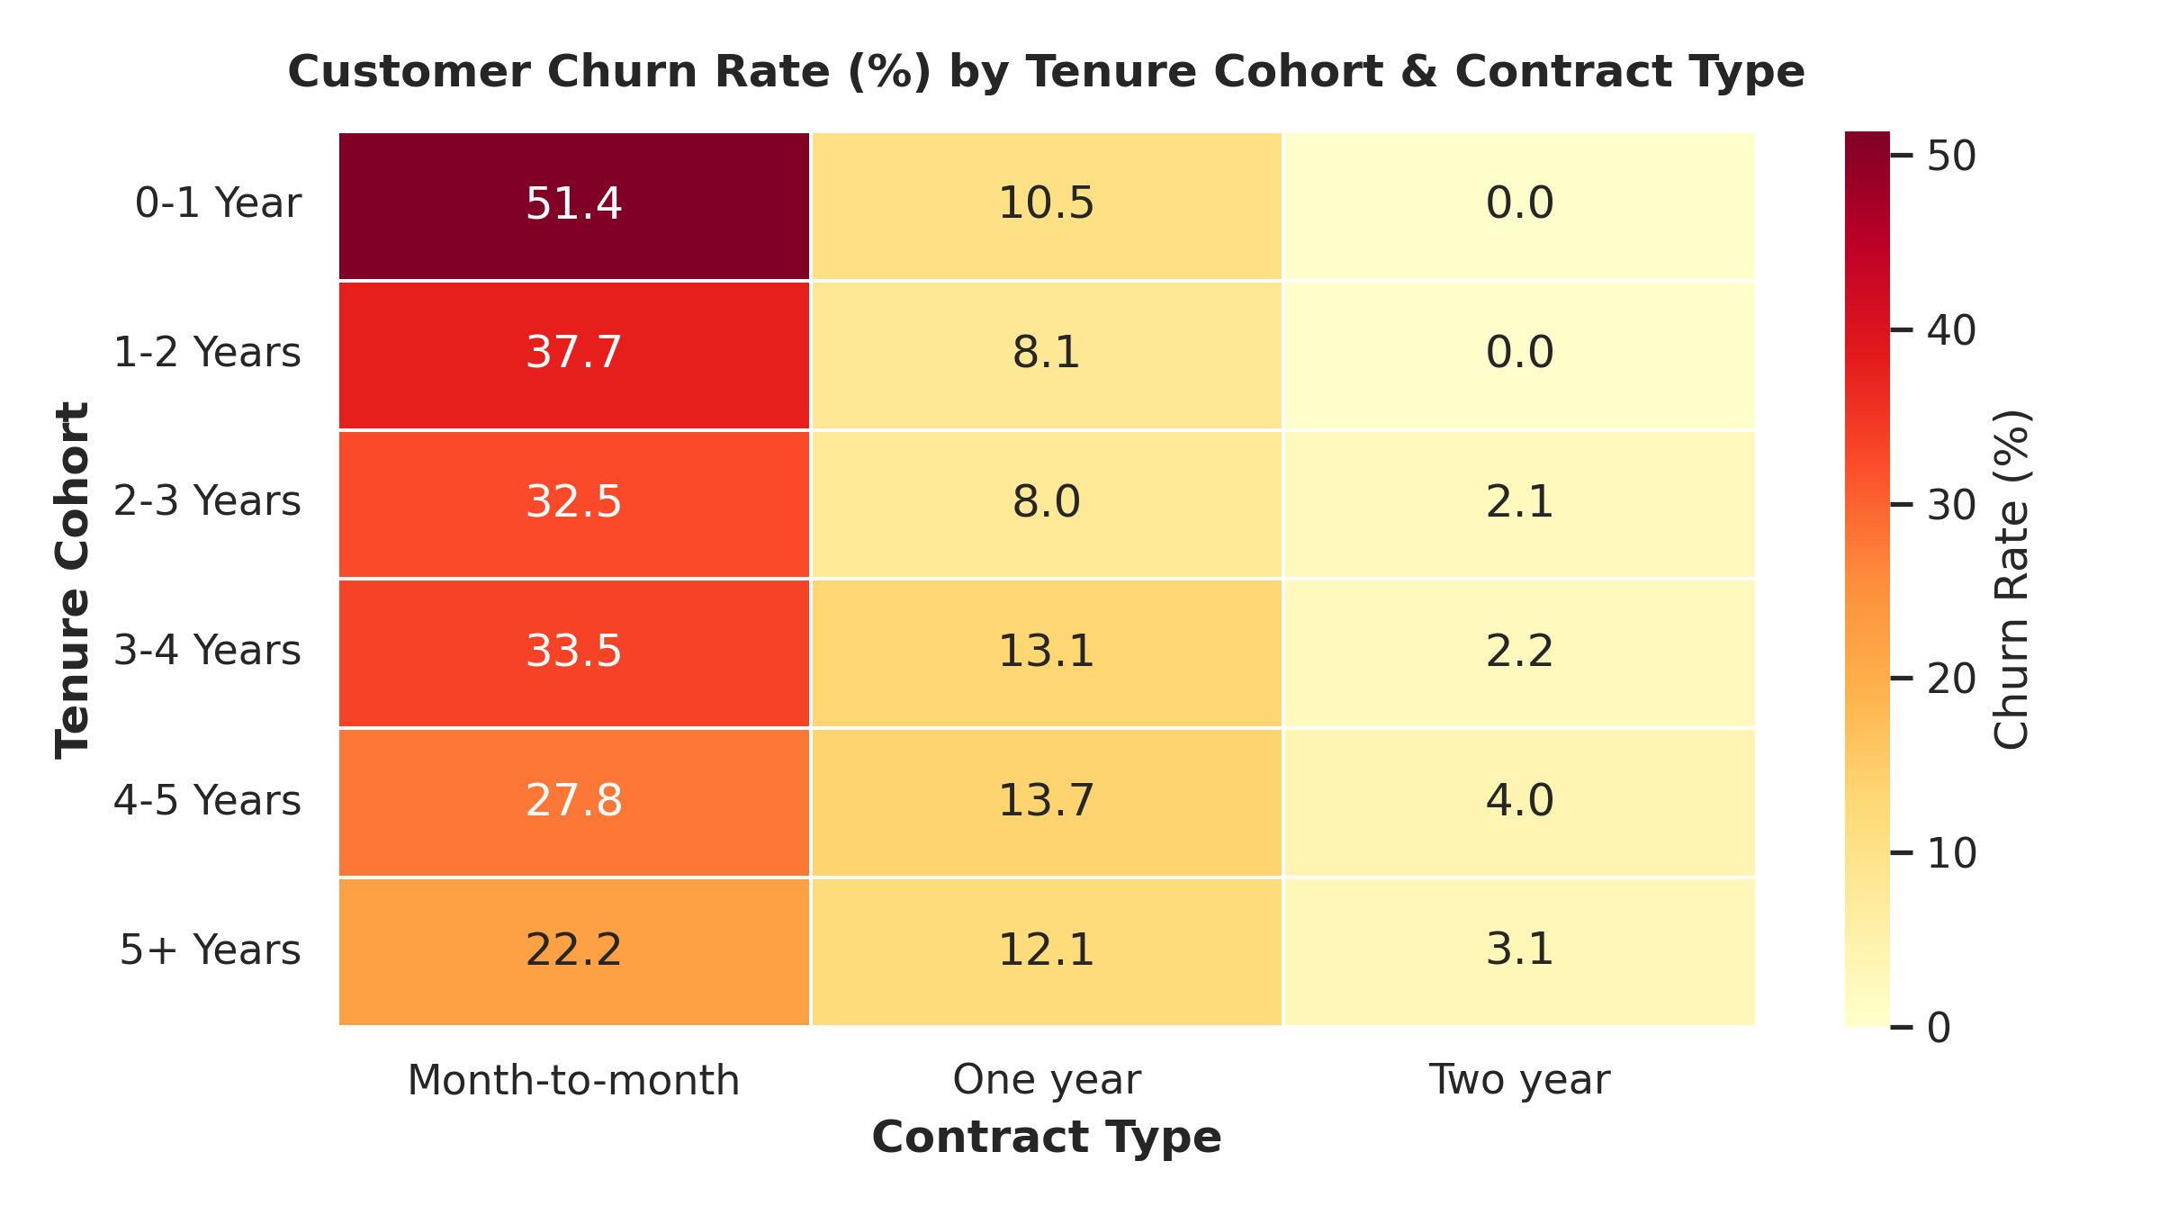
Figure 1: Customer Churn Rate (%) by Tenure Cohort & Contract Type (Seaborn Heatmap)
💡 ONBOARDING INSIGHT
Strategic Onboarding Intervention: The initial 90 days represent the critical window for customer retention. Month-to-month subscribers lack financial lock-in and churn rapidly when encountering minor service or billing friction. Strategic recommendation: Introduce a 15% discount for converting from Month-to-Month to an Annual contract during month 3.

Insight 2: Machine Learning Key Drivers of Customer Churn
To understand why customers churn, a Random Forest classification model was trained on subscriber attributes. The model identified Tenure Length, Total Charges, Monthly Charges, Fiber Optic Internet Service, and Electronic Check Payment Method as the top 5 predictive drivers of churn.
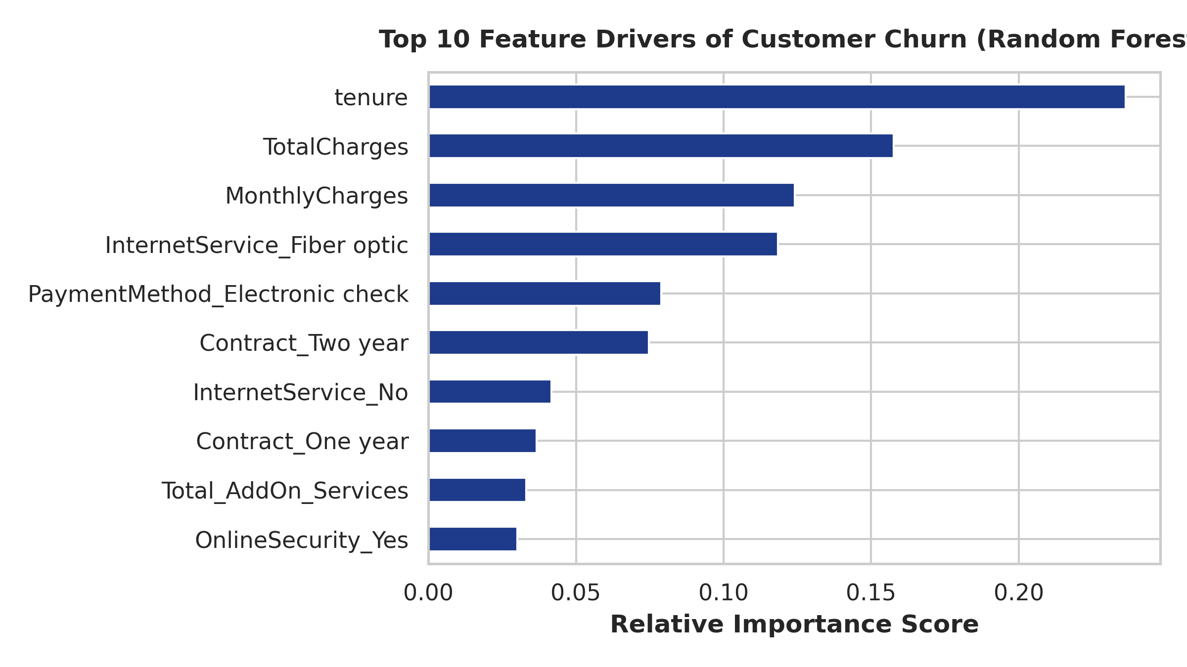
Figure 2: Top 10 Feature Importance Drivers derived from Random Forest Model
Insight 3: The 'Service Protection Shield' (Ecosystem Lock-In)
A remarkable finding from the service analysis is the protective effect of add-on services (Tech Support, Online Security, Online Backup, Device Protection, Streaming TV/Movies). Customers with 1 add-on service churn at 45.8%. However, as subscribers adopt more add-ons, churn drops systematically: 3 add-ons (27.4%), 5 add-ons (12.4%), and 6 add-ons (5.3%).
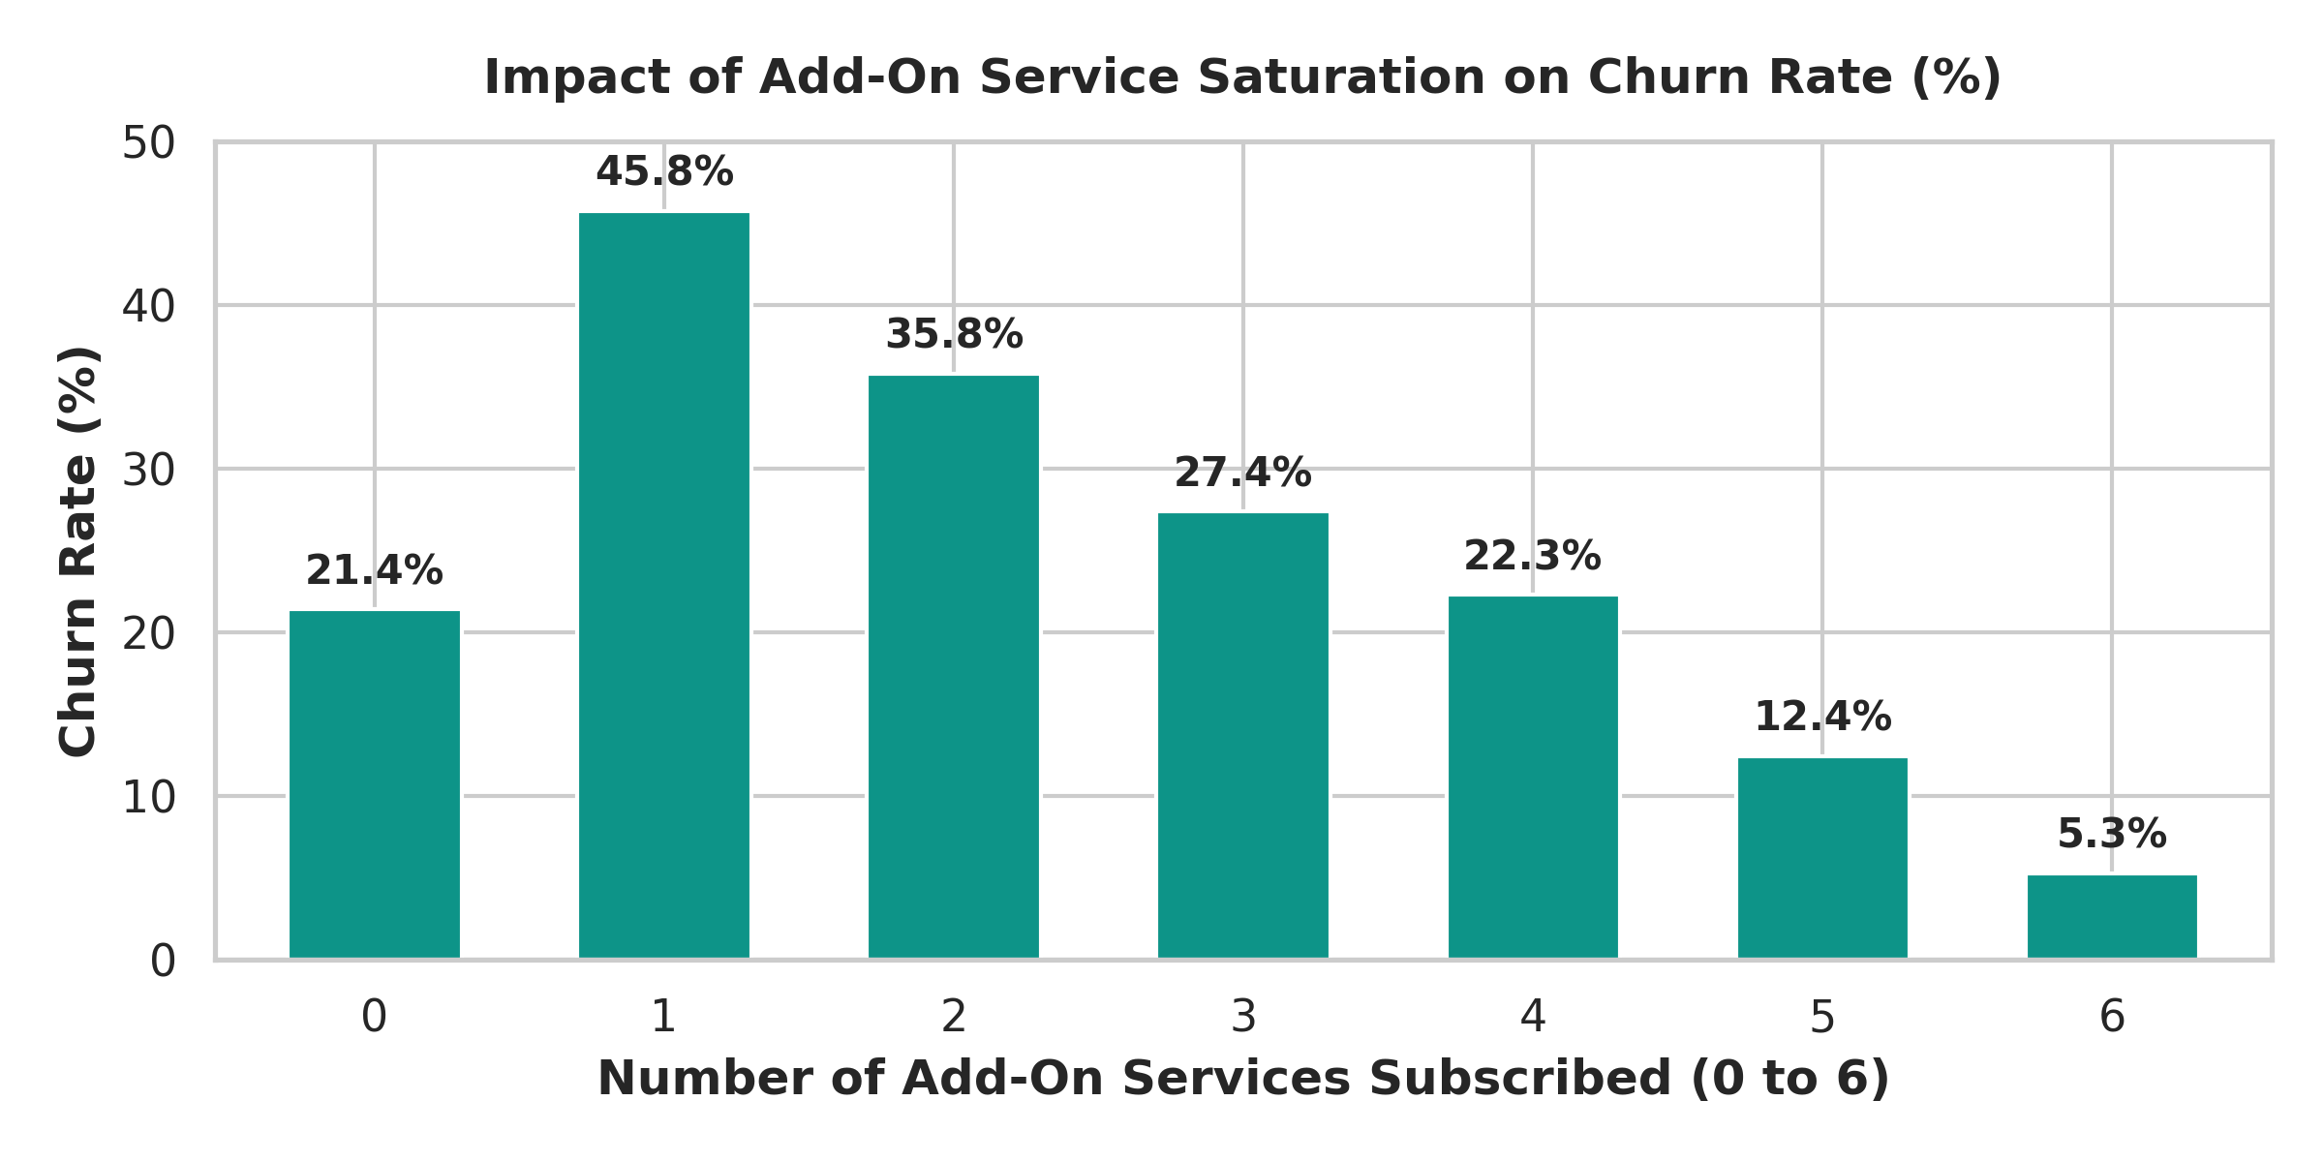
Figure 3: Impact of Add-On Service Saturation on Churn Rate (%)
💡 ECOSYSTEM LOCK-IN INSIGHT
Ecosystem Bundling Strategy: Tech Support and Online Security act as digital 'glue'. Subscribers who utilize Tech Support experience friction-free problem resolution, significantly decreasing churn. Strategic recommendation: Bundle free 6-month Tech Support and Online Security into all entry-level Fiber Optic packages.

Insight 4: Payment Method Default Friction & MRR Leakage
Analyzing payment methods reveals a dramatic disparity in financial leakage. Subscribers paying via Electronic Check churn at a rate of 45.3%, accounting for $84,289 in lost MRR (60.6% of total revenue leakage). Conversely, automated payment methods (Bank Transfer Automatic at 16.7% churn and Credit Card Automatic at 15.2% churn) demonstrate vastly superior stability.
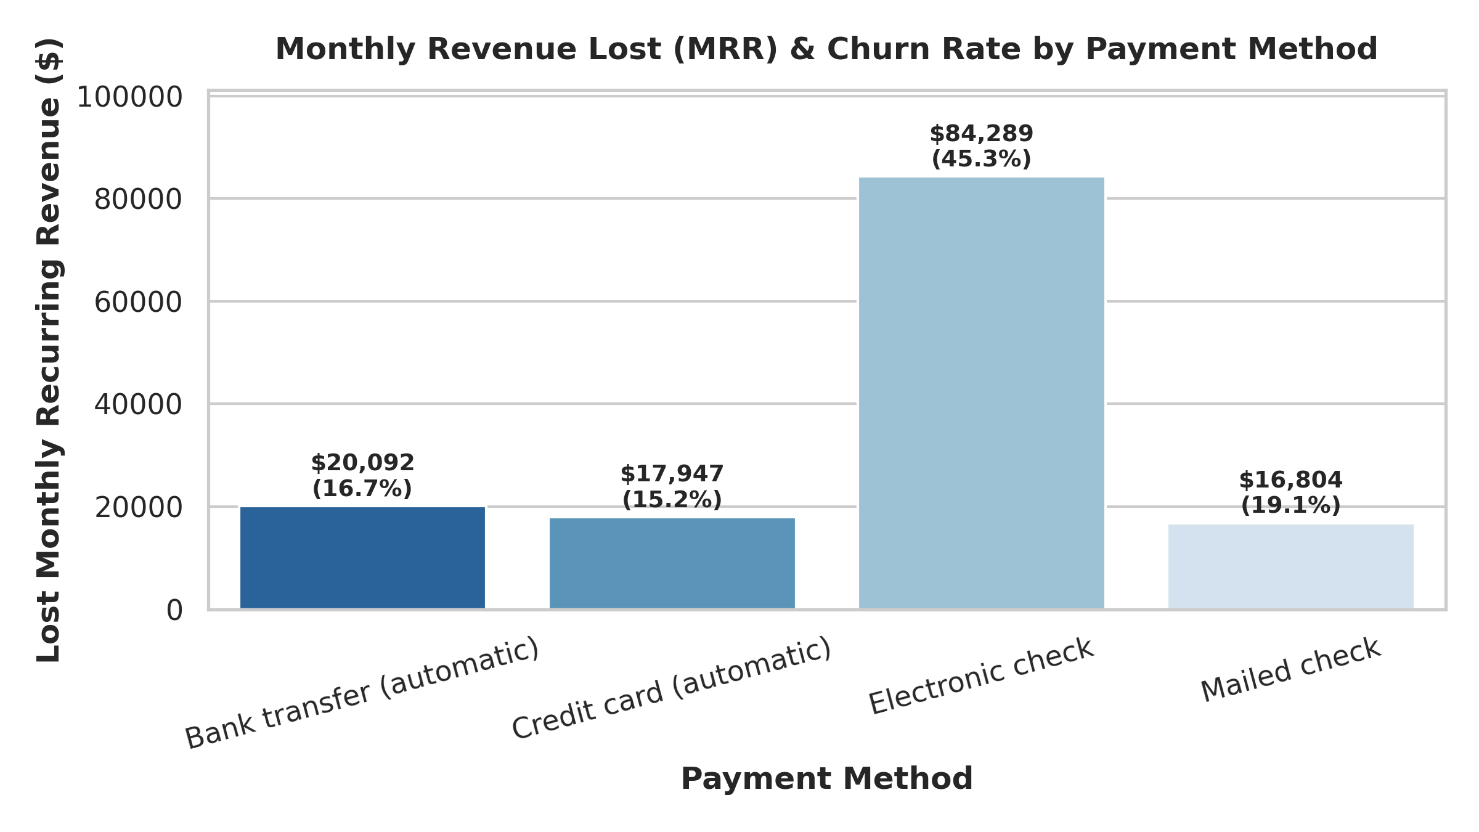
Figure 4: Lost Monthly Recurring Revenue (MRR) & Churn Rate by Payment Method
5. Technical Implementation Details: SQL & Power BI
Database Schema & Master Views (SSMS)
The database 'ChurnAnalytics' was architected into 4 core tables and 5 master views:
- vw_Customer_360_Master: Primary denormalized view combining demographics, services, billing, and ML probability scores.
- vw_Cohort_Retention_Summary: Pre-aggregated matrix calculating churn and retention percentages across tenure cohorts and contracts.
- vw_Services_Impact_Analysis: Evaluates customer counts and monthly revenue at risk across add-on service configurations.
- vw_High_Risk_Churn_Watchlist: Operational triage view filtering active accounts with Churn_Probability_Pct >= 60.0%.
- vw_Revenue_At_Risk_Executive: Financial breakdown comparing Active MRR versus Lost MRR and cumulative lost LTV.
Summary of 10 Analytical T-SQL Queries
Query # | Business Analytical Focus & Technical Logic
Query 1 | Baseline Exposure: Calculates total active MRR ($316.98K), lost MRR ($139.13K), and annualized loss ($1.67M).
Query 2 | Tenure Cohort Velocity: Evaluates churn rates and lost MRR across tenure cohorts (0-1 Year at 47.7% vs 5+ Years at 16.9%).
Query 3 | Contract & Payment CTE: Uses CTEs and DENSE_RANK() to rank highest risk combinations (Month-to-Month + Electronic Check = Rank 1).
Query 4 | TechSupport Protection Shield: Quantifies churn drop from 41.6% (No Tech Support) down to 15.2% (Tech Support Enabled).
Query 5 | Add-On Service Saturation: Tracks mean churn probability decreasing monotonically from 45.8% (0 add-ons) to 5.3% (6 add-ons).
Query 6 | High-Value Active Triage: Retrieves TOP 20 active customers with highest monthly charges and >=70% ML churn probability.
Query 7 | Fiber Optic Price Sensitivity: Cross-tabulates InternetService and Value_Segment showing High-Value Fiber Optic churn at 42.1%.
Query 8 | Demographic Vulnerability: Aggregates SeniorCitizen, Partner, and Dependents (Senior citizens living alone churn at 47.5%).
Query 9 | Payment Automation Friction: Groups payment methods into Automatic vs Manual (Manual churn is 37.2% vs Automatic at 15.9%).
Query 10 | Cumulative Revenue Loss (Window Function): Calculates cumulative lost MRR percentage across contracts using SUM() OVER().

6. Actionable Executive Recommendations & Playbook
- 1. Establish an Active High-Risk Triage Unit: Deploy Customer Success teams to contact the 835 active accounts identified in the ML Watchlist with Churn_Probability_Pct >= 70%. Provide a targeted 20% bill discount for 6 months in exchange for upgrading to a 1-year contract.
- 2. Mandatory Auto-Pay Incentivization: Implement a $5/month bill credit for subscribers who transition from Electronic Check to Credit Card or Bank Auto-Pay, directly attacking the $84.2K monthly revenue leakage.
- 3. Product Bundling ('Security & Support Shield'): Bundle free Online Security and Tech Support for 12 months with all Fiber Optic broadband signups to lock in ecosystem engagement and suppress early-tenure attrition.
- 4. First-Year Onboarding Milestones: Automate personalized email and product walkthrough campaigns at day 30, 60, and 90 to guide new Month-to-Month users toward adoption of add-on services.

