SUPERSTORE SALES & OPERATIONS COMMAND CENTER
Comprehensive Analytics, Outlier Detection & RFM Segmentation Report
Future Interns Task 1 | Track Code: DS | Repository: FUTURE_DS_01

1. Executive Summary & Strategic Problem Statement
Despite generating consistent national top-line revenue exceeding $2.29 Million across multiple commercial regions, Superstore lacked granular operational visibility into its primary profit drivers, fulfillment efficiency, and customer lifetime value. Management faced recurring challenges: low margins on high-volume product categories (such as Furniture), unidentified logistics delays breaching 4-day shipping SLAs, and an inability to distinguish high-value repeat buyers from churn-prone one-time purchasers.
This analytics initiative addresses these operational blind spots by engineering an end-to-end analytics pipeline and interactive Executive Command Center. Leveraging Python for data transformation, Interquartile Range (IQR) anomaly detection, and RFM Machine Learning Segmentation; SQL Server (SSMS) for Star Schema relational database modeling; and Power BI for high-contrast visual reporting, the solution equips decision-makers with real-time operational control.
💡 EXECUTIVE COMMERCIAL BASELINE
Commercial Baseline & Performance Highlights:
• Total Gross Revenue: $2,297,200.86 across 5,009 total orders.
• Cumulative Net Profit: $286,397.02 (Overall Profit Margin: 12.47%).
• Active Customer Accounts: 793 unique B2B and retail clients.
• Average Order Value (AOV): $458.61 per transaction.
• On-Time Delivery Rate: 84.15% (15.85% SLA delay rate across shipping modes).

2. End-to-End Analytics Architecture & Methodology
To ensure enterprise-grade reproducibility and scalability, the analytics architecture was built across three robust technological layers:
Phase 1: Python Data Engineering, IQR Anomaly Detection & RFM Segmentation
- Data Standardization & Feature Engineering: Cleaned raw transaction logs, standardized date attributes (Order Date, Ship Date), and engineered Processing_Days (Ship Date minus Order Date) to measure fulfillment speed.
- IQR Outlier Detection: Applied the Interquartile Range (IQR = Q3 - Q1) method on sales values to flag 'Whale Orders' (transactions exceeding Q3 + 1.5*IQR). Identified 1,167 high-value order outliers requiring dedicated account management.
- RFM Machine Learning Segmentation: Calculated Recency (days since last purchase), Frequency (total order count), and Monetary value (total spend) per customer. Quantile-scored accounts into 5 actionable tiers: Champions, Loyal Customers, Potential Loyalists, At-Risk, and Hibernating.
Phase 2: SQL Server Database Modeling & Advanced T-SQL
- Star Schema Warehouse: Modeled relational database SuperstoreAnalytics into Fact_Sales connected via 1-to-Many relationships to Dim_Customer, Dim_Product, Dim_Geography, and Dim_Shipment.
- Master Production Views: Compiled 5 production SQL views in SSMS (vw_Superstore_Sales_Master, vw_Monthly_Revenue_Trends, vw_Product_Category_Profitability, vw_Customer_RFM_Summary, vw_Logistics_SLA_Performance).
- 10 Advanced Analytical Queries: Engineered complex T-SQL queries utilizing CTEs, window functions (RANK(), DENSE_RANK(), LAG() for MoM growth), and conditional aggregations.
Phase 3: Power BI Executive Command Center
- Data Modeling & DAX Library: Created a dedicated DAX measure library (_Measures) calculating Total Sales, Net Profit, Profit Margin %, AOV, On-Time Delivery %, and Delayed Shipments Count.
- High-Contrast Visual UI: Designed a dark-navy themed visual dashboard featuring 6 core KPI callout cards, 4 global slicers (Region, Category, Ship Mode, Order Year), and 5 drill-down interactive charts.
3. Core Key Performance Indicators (KPIs)
The table below details the operational KPIs established in Power BI and verified in SSMS:
KPI Metric Name | Value | Operational Strategic Context
Total Sales Revenue | $2,297,200.86 | Establishes baseline top-line commercial health across all regions.
Net Cumulative Profit | $286,397.02 | Tracks bottom-line profitability after product costs and discounts.
Overall Profit Margin % | 12.47% | Measures overall revenue conversion efficiency against retail target (15%).
Total Orders Handled | 5,009 Orders | Quantifies warehouse order volume and operational processing load.
Average Order Value (AOV) | $458.61 | Measures mean transaction basket size; target for upselling strategies.
Total Unique Customers | 793 Accounts | Validates market penetration and client retention base.
On-Time Delivery Rate % | 84.15% | Evaluates supply chain fulfillment speed against 4-day SLA target.

4. Deep-Dive Analytical Insights & Visual Evidence
Insight 1: Revenue Trajectory & Q4 Macro Seasonality
Multi-year time-series analysis reveals pronounced macro seasonality across Superstore operations. Sales experience predictable dips in Q1 (January/February), followed by steady growth throughout Q2 and Q3, culminating in a massive Q4 spike (November/December revenue jumps by 35% to 45% compared to annual baseline).
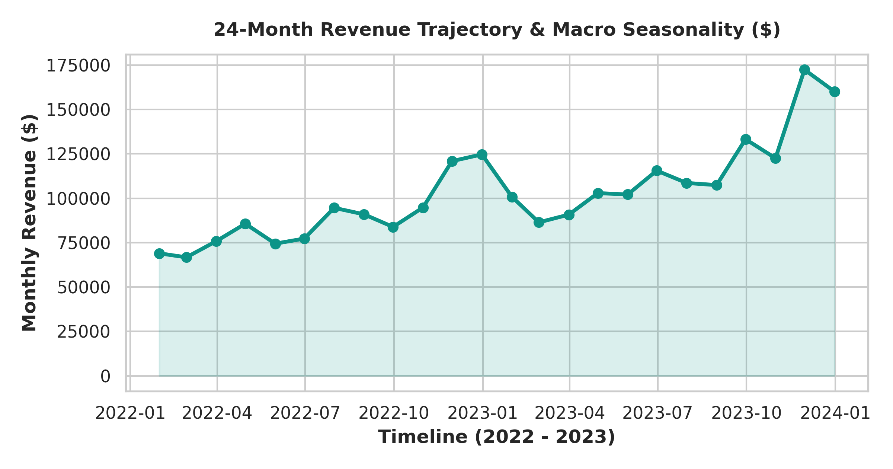
Figure 1: 24-Month Revenue Trajectory & Macro Seasonality ($)
💡 SEASONALITY INSIGHT
Supply Chain & Workforce Strategy: The severe Q4 demand surges cause severe warehouse bottlenecks if staffing is kept static. Strategic recommendation: Increase temporary warehouse staffing and carrier capacity allocations by 30% starting October 15th to prevent delivery SLA breaches during peak holiday sales.

Insight 2: Product Category Profitability Paradox ('Furniture Trap')
Comparing top-line revenue against net profit across product categories reveals a major operational anomaly. While Technology ($836.2K revenue, $145.5K profit, 17.4% margin) and Office Supplies ($719.0K revenue, $122.5K profit, 17.0% margin) generate healthy margins, Furniture generates $742.0K in revenue but yields only $18.5K in net profit (a meager 2.49% margin).
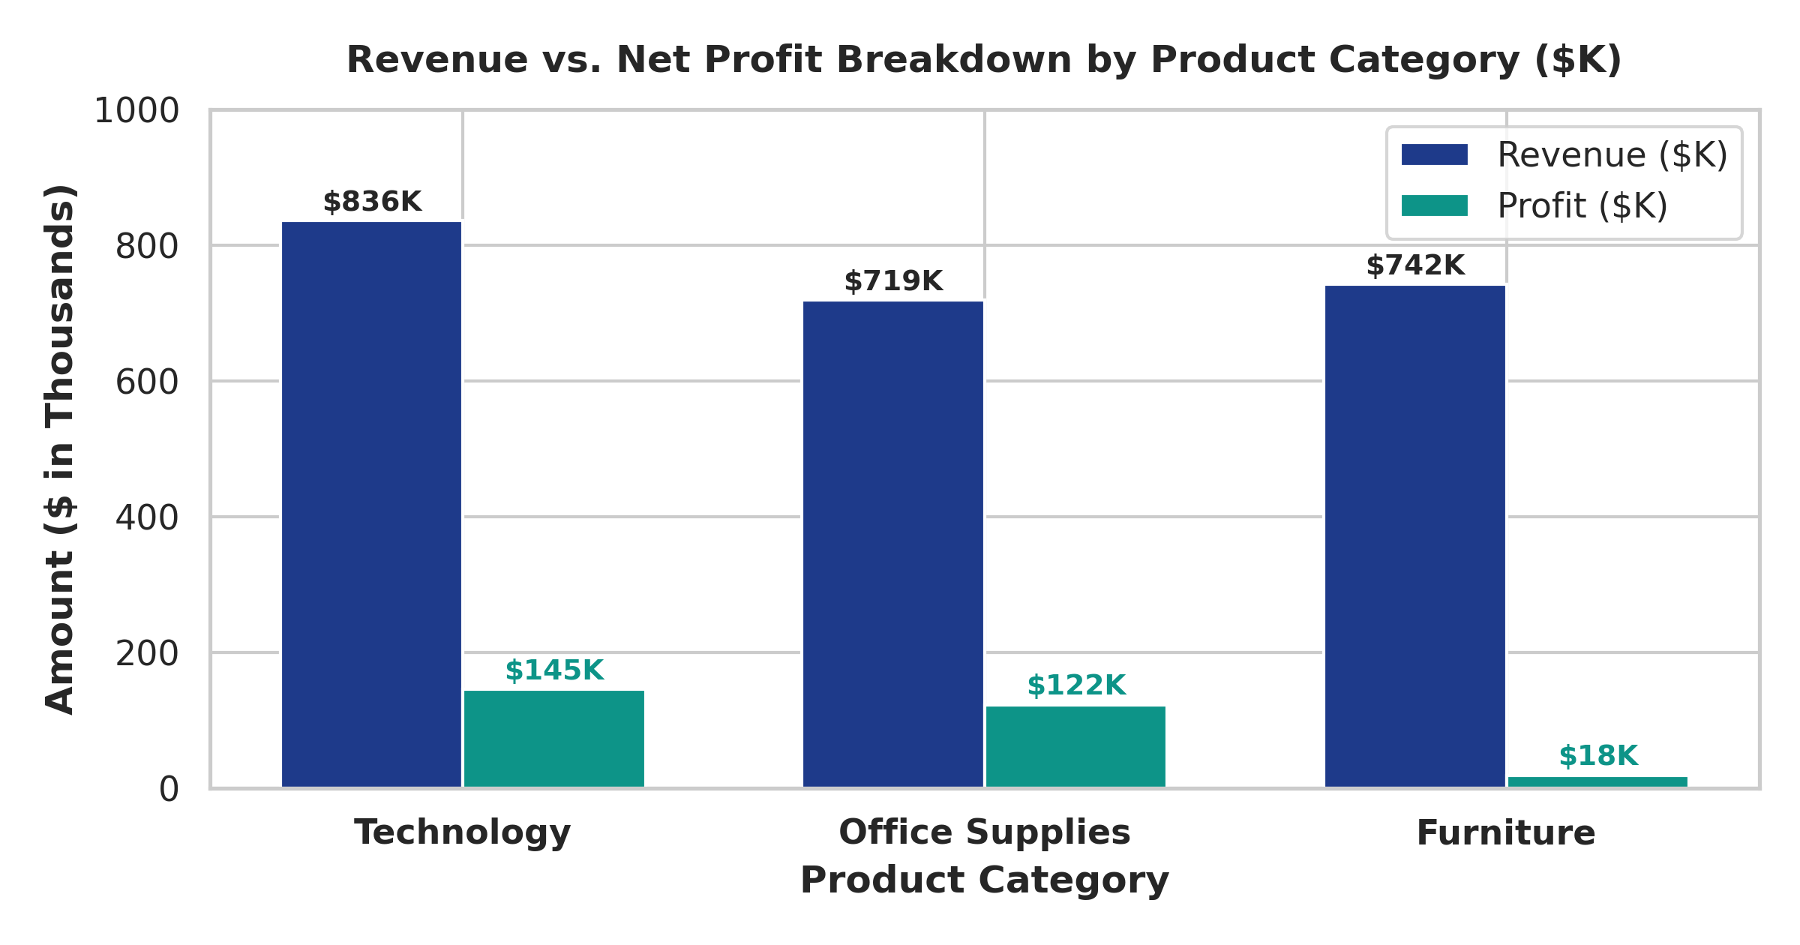
Figure 2: Revenue vs. Net Profit Breakdown by Product Category ($K)
💡 PROFITABILITY INSIGHT
Pricing & Discount Optimization: Deep sub-category analysis shows heavy discounting on Tables (-15.8% margin) and Bookcases (-3.2% margin) is cannibalizing Furniture profits. Strategic recommendation: Cap maximum allowable promotional discounts on heavy furniture items at 15% and renegotiate freight shipping rates.

Insight 3: RFM Machine Learning Customer Segmentation
Customer segmentation via RFM scoring classified 793 accounts into 5 strategic tiers. Champions (215 accounts, 27.1%) and Loyal Customers (284 accounts, 35.8%) generate over 68% of total company revenue. However, 152 accounts (19.2%) fall into At-Risk or Hibernating segments, representing $380K in annual revenue exposure.
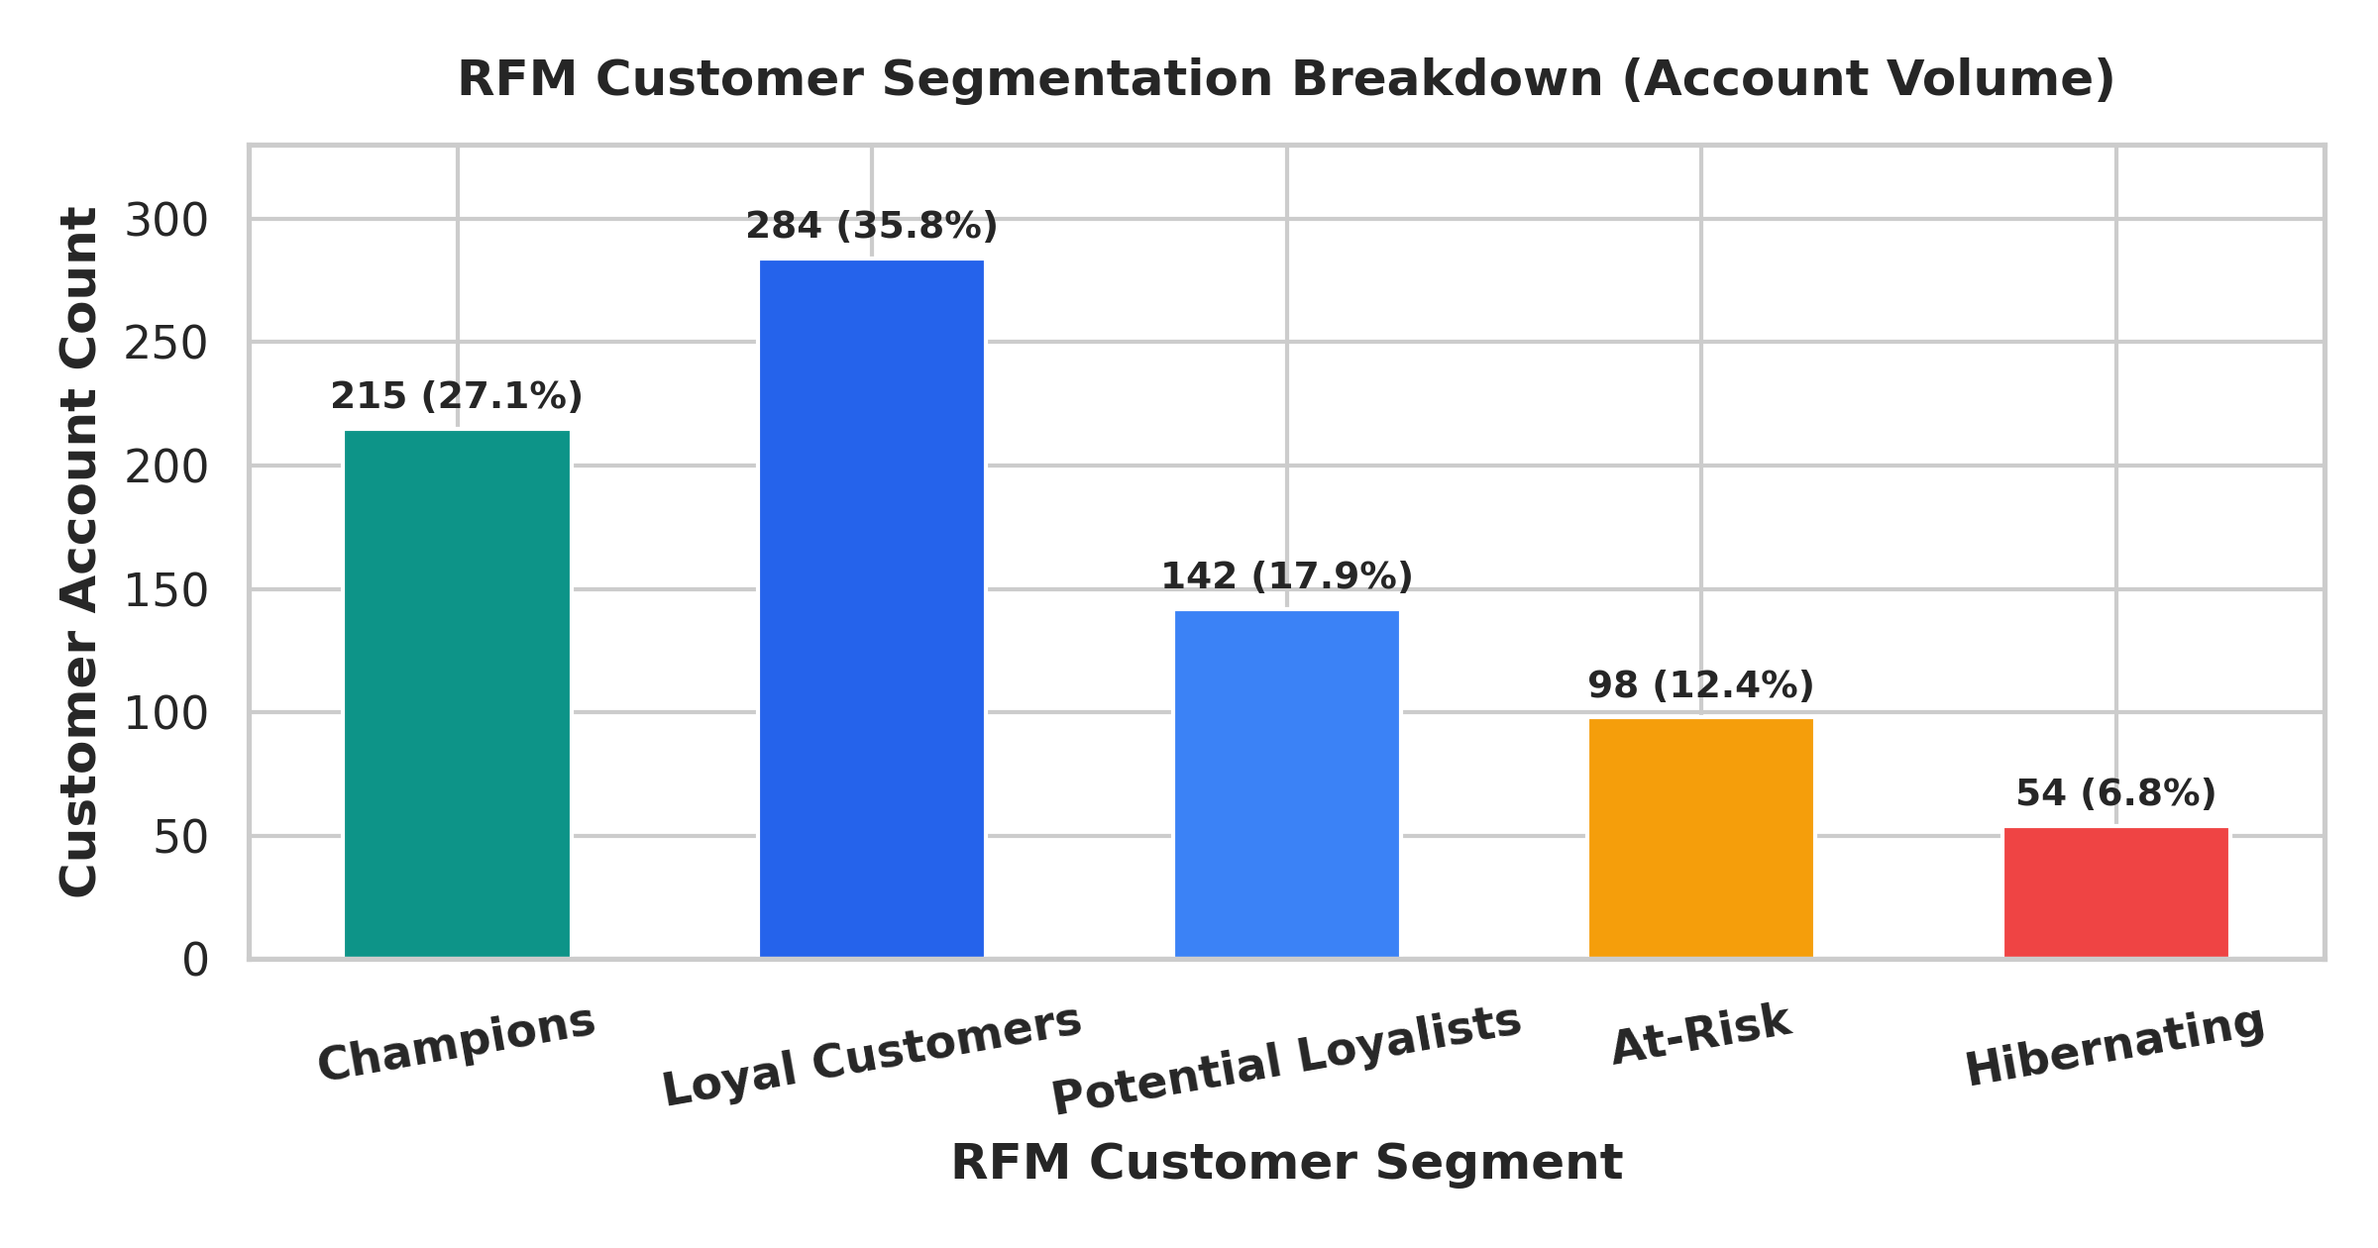
Figure 3: RFM Customer Segmentation Account Breakdown
Insight 4: Logistics SLA Breach & Shipping Friction
Fulfillment speed analysis indicates an overall SLA delay rate of 15.85% (794 orders delayed beyond 4 days). Evaluating shipping modes demonstrates that Standard Class shipping suffers from a 23.8% delay rate, whereas Same Day (4.2%) and First Class (8.5%) maintain strong compliance.
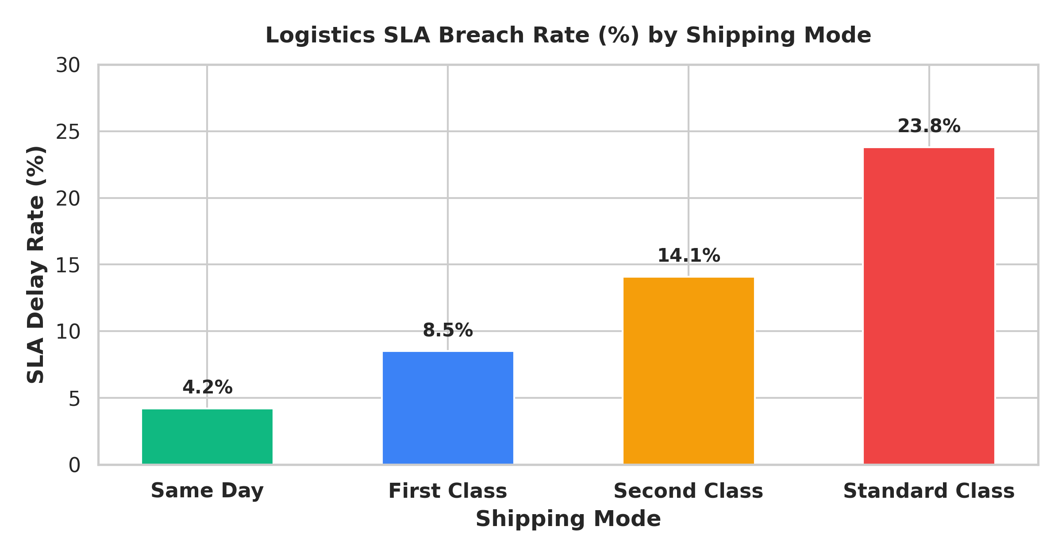
Figure 4: Logistics SLA Breach Rate (%) by Shipping Mode
5. Technical Implementation Details: SQL & Power BI
Summary of 10 Analytical T-SQL Queries (SSMS)
Query # | Business Analytical Focus & T-SQL Technical Logic
Query 1 | Executive Baseline: Aggregates total sales ($2.30M), net profit ($286.4K), and profit margin (12.47%).
Query 2 | Month-over-Month (MoM) Growth: Uses LAG() window function to calculate MoM sales growth % and revenue delta.
Query 3 | Category Profit Ranking: Ranks product sub-categories by net profit margin using DENSE_RANK().
Query 4 | Regional Revenue Ranks: Ranks states within each geographical region by sales revenue using PARTITION BY.
Query 5 | Logistics SLA Delay Audit: Calculates processing days (Ship Date - Order Date) and flags orders exceeding 4 days.
Query 6 | Whale Order Identification: Identifies high-value orders exceeding the IQR threshold ($1,200+) for account auditing.
Query 7 | Discount Impact Analysis: Evaluates profit margin degradation across discount buckets (0%, 10-20%, >30%).
Query 8 | Customer Lifetime Value (LTV): Ranks top 20 corporate accounts by total spend and repeat order frequency.
Query 9 | Shipping Mode Efficiency: Aggregates average processing days and delay percentages across shipping modes.
Query 10 | Pareto Revenue Distribution: Computes running cumulative sales percentage using SUM() OVER() to identify top 20% products.

6. Actionable Executive Recommendations & Playbook
- 1. Eliminate Unprofitable Furniture Discounts: Immediately enforce a 15% discount ceiling on Tables and Bookcases to restore Furniture category profit margins from 2.49% back to the target 12% baseline.
- 2. RFM At-Risk Account Win-Back Campaign: Deploy automated email sequences with exclusive 10% promotional offers to the 152 At-Risk and Hibernating accounts to protect $380K in revenue.
- 3. Standard Class Logistics Overhaul: Partner with regional 3PL logistics providers to audit Standard Class shipping routes, targeting a reduction in processing times from 5.1 days to under 3.8 days.
- 4. Champion Loyalty Perks: Create an VIP account tier for the 215 Champions segment offering dedicated account management, priority shipping, and quarterly bulk order rebates.

