# **Title: AcadOverflow**

# **High Level Design**

**Title: AcadOverflow** **1**

**High Level Design** **1**

Abstract 1

Use Cases 1

Web Application Architecture 9

Machine Learning Architecture 10

Team Members (Team #20) 12

## **Abstract**

In today’s world, people use the Internet to get answers to a wide range of questions. A person can ask a question being in one part of the world and get an answer from people present in other geographical locations. However, in our IIIT campus, we mostly confine our technical

discussions and knowledge sharing to a small group of friends. Questions posted on moodle

are mostly directed towards the TAs or the professor of the course.

As students we want to have a platform in the institute where technical questions can be posted/queried by any student, so that fellow peers can post responses to it or previously asked similar questions can be listed along with the answers.

## **Use Cases**

1. An account registered by a new user should be updated in the database.

**Given** that a user wants to register a new account on the web app.

**and** the user doesn’t already have an account.

**when** the user registers a new account

**then** the total number of users accounts should increase by one and appropriate entries must be made in the database.

1. An account registered by an existing user, should result in an error message.

**Given** that a user wants to register a new account on the web app.

**and** the user already has an account.

**when** the user registers a new account

**then** an error message should be displayed to the user.

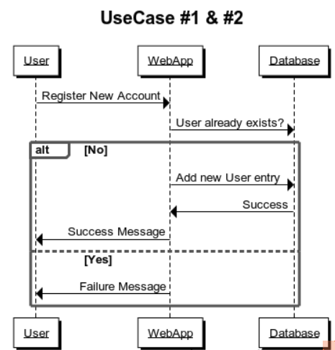

1. A logged out user should reach the login page from the base URL

**Given** that a user wants to access his/her account.

**and** the user is logged out of the account.

**when** the user enters the URL

**then** the login page should be displayed to the user.

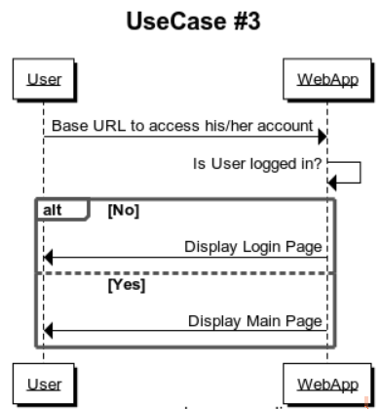

1. Unregistered username / EmaiL ID should get an error on login

**Given** that a user wants to access his/her account.

**and** the user has not registered an account.

**when** the user submits the login credentials

**then** an error message should be displayed to the user.

1. Registered username / EmaiL ID with wrong password should get an error on login

**Given** that a registered user wants to access his/her account.

**and** the user has entered a wrong password.

**when** the user submits the login credentials.

**then** an error message should be displayed to the user.

1. Successfully logged in users should be redirected to the main page.

**Given** that a registered user wants to access his/her account.

**and** the user has entered the correct password.

**when** the user submits the login credentials

**then** the user should be redirected to the main page.

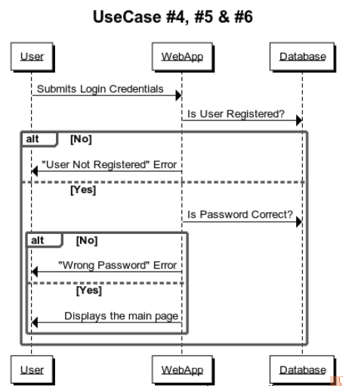

1. A logged in user should reach the main page from the base URL or Home button.

**Given** that a user is logged in

**and** there is a home button on the page

**when** the user presses the Home button

**then** the user should be redirected to the main page.

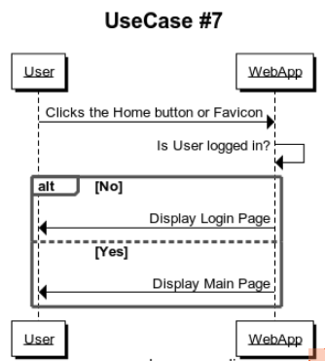

1. A clicked question should redirect to that question’s page

**Given** that the questions are listed as per the user’s query history

**and** displayed in descending order of vote count.

**when** the user clicks on a question.

**then** the user should be redirected to that question’s page.

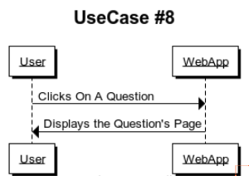

1. “Post a Question” button clicked should display the question form.

**Given** that a user wants to post a question

**and** has successfully logged in

**when** the user clicks on the “Post a Question” button.

**then** the user should be provided a question form.

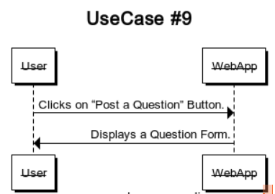

1. Question Form submitted should result in tags assigned to the question

**Given** that the user has filled the question form.

**and** the ML model has been trained

**when** the user submits the form.

**then** tags should be assigned to the new question and displayed along with it.  
The most similar questions are also displayed. Two options are given to the user, either to go to one of the similar questions if he finds one for which he is querying for, otherwise post the question.

1. User found the question he wanted to ask, so that question’s page is displayed to him.

**Given** the user found the question which he was querying for in the similar questions list

**and** he wants to go to that question’s page.

**then** the user should be redirected to that question’s page.

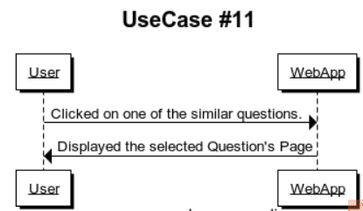

1. User not able to find the question he wanted to ask, so he actually posts the question.

**Given** the userdid not find the question which he was querying for in the similar questions list

**and** he wants to actually post the question which he mentioned in the questions’ form.

**when** the user confirmed to post the question

**then** should be redirected to that question’s page.

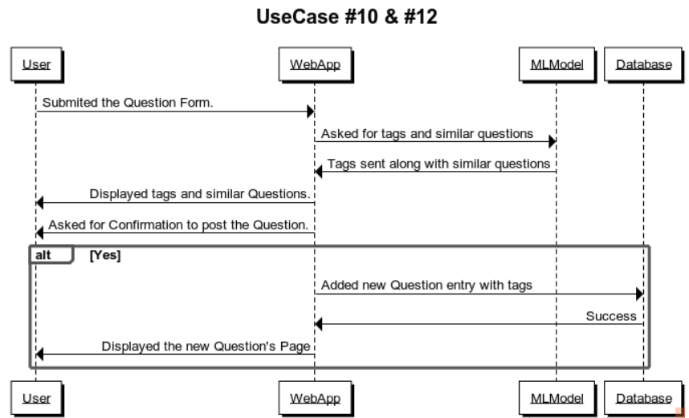

1. Search query submitted should result in similar questions being listed

**Given** that the user has successfully logged in

**and** entered the question in the search box

**when** the user clicks the search button.

**then** similar questions should be displayed.

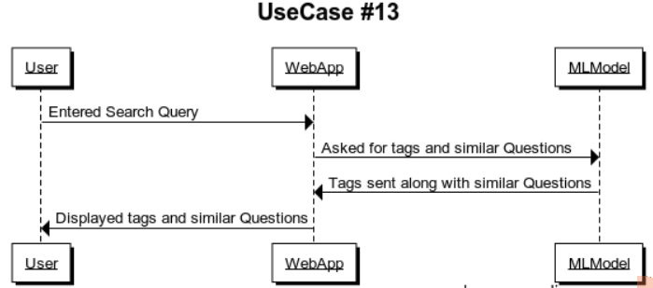

1. Upvote / Downvote buttons result in incrementing / decrementing the vote count of a particular question

**Given** that a user wants to upvote / downvote a question

**and** the vote count has been initialized with 0 in the database.

**when** the user clicks upvote / downvote button

**then** the vote count is updated accordingly on the screen and the database.

1. Similar questions should be displayed in decreasing order of vote count

**Given** the user has entered the question to be searched or posted

**and** vote count is maintained for each question in the database

**when** the user clicks the “search” or “post question” button

**then** the questions should be displayed in the decreasing order of vote count

1. Submitted answer should be displayed at the end of Answer’s List

**Given** a question

**and** an answer box on the Question’s page

**when** user submits an answer

**then** the submitted answer is displayed at the end with vote count as 0.

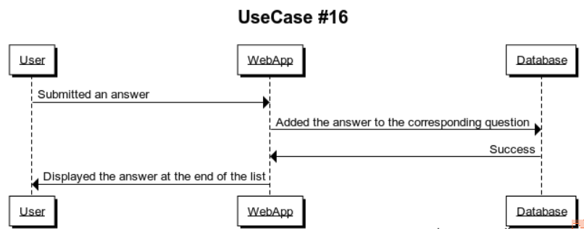

1. Clicking Upvote / Downvote buttons resulted in incrementing / decrementing the vote count of a particular answer

**Given** that a user wants to upvote / downvote an answer

**and** the vote count has been initialized with 0 in the database.

**when** the user clicked upvote / downvote button

**then** the vote count is updated accordingly on the screen and the database.

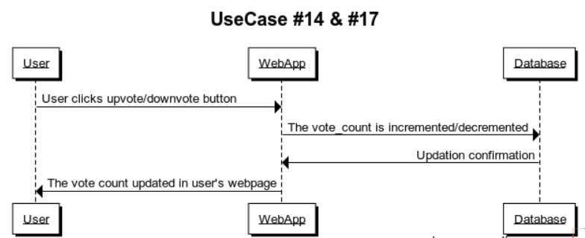

## 

## 

## 

## **Web Application Architecture**

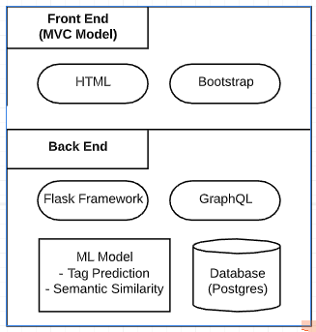

* In **Model View Controller (MVC**) architecture, the server sends HTML pages to the browser, with the relevant data inside them. The pages are created on the server using template engines.
* **Bootstrap** is an open source toolkit for developing with HTML, CSS, and JS. It comprises a responsive grid system, extensive pre-built components, and plugins built on jQuery.
* [**Flask**](http://flask.pocoo.org/) is a microframework” for Python, and is an excellent choice for building smaller applications, APIs, and web services.
* **GraphQL** allows smaller objects in the database transactions. It allows fetching different parts of different objects from the server in one call, and making calls leaner, which is better for possible smaller bandwidth that might occur if the internet is bad.
* Relational databases have tables and their schema is predefined. **PostgreSQL** is a popular choice in such cases.

## **Machine Learning Architecture**

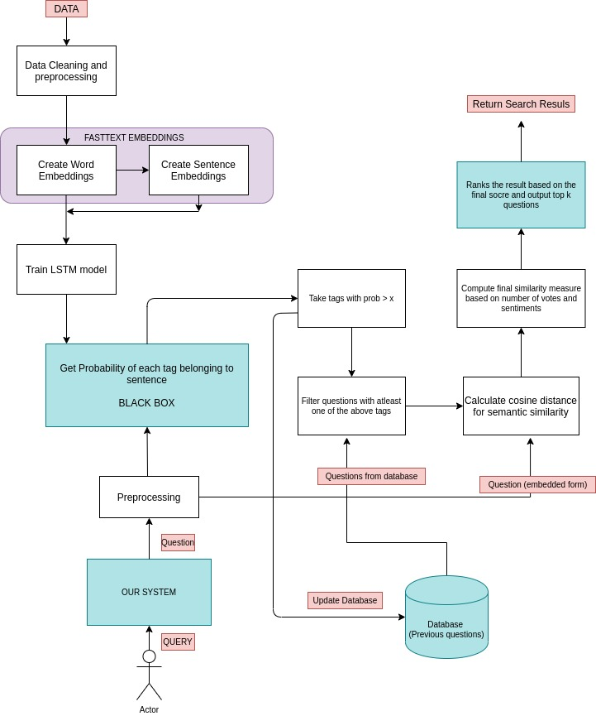

We will collect Data of questions and answers from Stack Overflow. **Google BigQuery** dataset includes an archive of Stack Overflow content, including posts, votes, tags, and badge. This data will be a tuple of **{id, title, ques, tags, answers, votes}**.

Data Preprocessing involves cleaning the text in the following ways -

* Tokenization
* Conversion to Lowercase
* Remove Stop Words and punctuation
* Dealing with HTML, URLs, abbreviations, etc.

We will use nltk library for text cleaning and preprocessing. We extract the top **500** tags based on their occurrences in the dataset. In order for our model to understand the raw text data, we need to vectorize it for that we are using **fasttext** embeddings and then will train a Tag classifier using the **LSTM model**.

***“Given the user query, we’d like to predict which tags the given query best belongs to”***

Since we are dealing with a multilabel classification problem here, we cannot train the model using a binary cross-entropy loss. This is because binary cross-entropy loss would push our model to predict one or two tags which are included in the ground truth, and won’t penalize it for missing out on the other ones. Thus **we are using log loss on each class separately** and then compute its average based on the number of classes.

After this model is ready, given any question we can predict the probabilities of each tag belonging to this question.

Finally, we will filter out top tags with probability greater than **threshold** value and hence this will reduce our set of questions which could be similar to this question.

Finally we will get the semantic similarity with the questions in this set by measuring **cosine distance** between the questions (i.e. between encodings of questions). For final similarity we are using following formula -

$Similarity(q, Qi) = Cosinedistance(q, Qi) + 0.1 * Normalized Vote Score(Qi) + 0.4 * Sentiments(Qi)$

where q = user query and Qi = existing question

Hence it consider -

* Cosine Distance as a base measure.
* Popularity of questions based on votes.
* Responses people have given to the existing question.

Finally, we will get all the related questions.

## **Team Members (Team #20)**

Bhavi Dhingra

Aditi Shrivastava

Nikita Rungta

Surbhi Sharma

Samyak Agrawal

Kajal Sanklecha