**University of Mumbai**

FITNOQUIT

Project Synopsis

Submitted in Partial fulfillment of requirements

For the degree of

BACHELOR OF TECHNOLOGY

BY

Bhavik Bhatt 1814007

Piyush Chavda 1814010

Bharat Choithani 1814011

Muskaan Nandu 1814020

Under the Guidance of

Prof. Sonali Patil

Department of Information Technology

**K. J. Somaiya College of Engineering, Mumbai-77**

##### (Autonomous College Affiliated to University of Mumbai)

2021-2022

**K. J. Somaiya College of Engineering, Mumbai-77**

(Autonomous College Affiliated to University of Mumbai)

**Approval Sheet**

Project Synopsis entitled **FitNoQuit**

Submitted by:

Bhavik Bhatt

1814007

Piyush Chavda

1814010

Bharat Choithani

1814011

Muskaan Nandu

1814020

in Partial fulfillment of the degree of B. Tech. in Information Technology is approved.

_______________________ _____________________

Guide

_____________________

Examiners

_______________________ ______________________

Head of Department Principal

Date: 10th December 2021

***Dedicated to***

*Our guide and colleagues.*

### Abstract

### {write}

### Contents

##### Introduction 1

* 1. Problem Definition 1
  2. Motivation 1
  3. Scope of Project 1
  4. Functional and Non-Functional Requirements 1
  5. Organization of the Report 3

**2 Literature Survey**……………………………………………………………... 4

1. **Software Project Management Plan** ………………………………………… 7
   1. Introduction 7
      1. Product Overview 7
      2. Project Deliverables 8
   2. Project Organization 8
      1. Software Process Models 8
      2. Roles and Responsibilities 9
      3. Tools and Techniques 9
   3. Project Management Plan 11
      1. Tasks 11
      2. Assignments 13
      3. Timetable 13

##### Software Requirement Specification 15

* 1. Introduction 15
     1. Product Overview… 15
  2. Specific Requirements 16
     1. External Interface Requirements 16
     2. Software Product Features 17
     3. Software System Attributes 18
     4. Database Requirements 19

**5 Software Design Document** ………………………………………………..… 20

* 1. Introduction 20
     1. Design Overview 20
     2. Requirements Traceability Matrix 20
  2. System Architectural Design 21
     1. Chosen System Architecture 21
     2. Discussion of Alternate Design 21
     3. System Interface Design 21
  3. Detailed Description of Components 22
  4. User Interface Design 23
     1. Description of the User Interface 23
  5. System Architecture 28
  6. Dataflow Specifications 34

##### Software Test Document 39

* 1. Introduction 39
     1. System Overview 39
     2. Test Approach 39
  2. Test Plan 40
     1. Features to be tested 40
     2. Features not to be tested 40
     3. Testing Tools and Environment 41
  3. Test Cases 41
  4. Test Results 45

##### 5 Conclusions and Learnings 46

##### References 47

**Acknowledgements** 48

1. **INTRODUCTION**
   1. **Problem Definition**

FitNoQuit aims to recommend personalized, customized and preference-based diets to its users that is sustainable and satisfies the end goal (weight loss, weight gain, maintain) of the user. The web application also aims to suggest workout to the users based on their comfort and taking into account the time duration they wish to dedicate for the workout. The system also suggests blogs to its users based on their categorical likings and preferences.

##### Motivation

The motivation for doing this project is to help people stay fit and eat healthy. FitNoQuit helps users to achieve their fitness goal and also share their experience with others through the blog community.

##### Scope of Project

FitNoQuit has 3 primary features:

* + - Diet Recommendation

The system considers user inputs such as height, weight, age, diseases, food preferences, end goal etc to generate a personalized diet using machine learning algorithm. The diet consists of meals and foods that best suits the user and will help him/her to achieve their end goal.

* + - Workout Recommendation

The system suggests workouts to user using mathematical computations and compliments with diet recommended to impact the overall calorie management of the user. The user is given options with respect to the time he/she wishes to dedicate for the workout along with workout options they prefer.

* + - Blog suggestions

FitNoQuit offers a blog section to its users wherein they can select categories of blogs they wish to read. This section aims at keeping the users abreast with the current fitness trends and updates. With the help of collaborative and/or content-based filtering, users will be recommended blogs based on their interest and likings.

##### Functional and Non-Functional Requirements

###### Functional Requirements

The requirements/features that end-users shall expect and will be incorporated in the system are:

##### Registration/Sign Up

New users will be able to access the system by registering or creating an account with “FitNoQuit”.

##### Login/Sign In

Existing users should be able to access the system using their username and password. Premium features will be available to premium registered users.

##### User Profile

Users will be able to edit and view their personal information from the User Profile section.

##### Workout Recommendation

The user will be recommended with appropriate workout and exercise based on their end goal (weight gain, weight loss maintain weight or manage a health condition)

##### Diet Recommendation

Suggest Diet Meals to the users in categories of Breakfast, Lunch and Dinner based on user’s food preferences like Veg/Non Veg/Jain/Vegan, health condition like Thyroid, PCOS, Heart Conditions, etc

##### Blog Suggestions

The users will be suggested with relevant blogs in the Community Blog section using Content-Based filtering based on the previously liked blogs.

##### Logout

The user should be able to safely log out of the system without any loss of information.

###### Non-Functional Requirements

The basic quality constraints that will be satisfied by the system is as follows:

##### Authorization:

The user data will be confidential and only authorized nutritionists will be made available with the data.

##### Speed:

The application will respond to user’s queries as soon as possible with a minimum waiting time.

##### Portability:

The system will be highly portable as it is a web-app and will work efficiently even if the user changes the device.

##### Compatibility:

Since the system is a web-app it can be accessed on any devices like laptop, tablet or mobile phones, irrespective of its Operating System.

##### Security:

Sensitive information like user passwords will be encrypted by using algorithms like SHA and then stored on the database for verification.

##### Availability:

The web-app will be available to all users with an internet-connectivity as we plan to host the website.

##### Reliability:

The recommendation system would be reliable as we would try to achieve maximum accuracy and get the recommendation model verified by a certified nutritionist.

##### Organization of the Report

###### Problem Definition

In this, we have explained the problem to be addressed in regards to diet and workout recommendations and how we have come upwith a solution with our project.

###### Background work

In this, we have explained about all the prerequisites and the background work needed before starting this project.

###### Motivation

In this, we have explained the main reason and motivation behind us taking this project.

###### Scope

In this we have explained the extent to which our project is limited. We have explained the limitations that user will face while inputting the form and up to what extend the graph simulation will work.

###### Future Scope

In this, we have explained all the things we can add in our project in the future to make our project even better.

###### Functional Requirements

In this, we have explained all the functional requirements.

###### Non Functional Requirements

In this, we have explained all the non-functional requirements.

###### Technologies Used

In this, we have explained about all the coding languages, algorithms, frameworks and data structures we have used.

1. **Literature Review**

Table 2.1 Literature Review

|  |  |  |  |
| --- | --- | --- | --- |
| **Sr. No** | **Title** | **Aim** | **Conclusion** |
| 1 | A Personalized Healthy Diet Recommender System | The main aim is to develop a method to provide every user with meals of their choice, while ensuring  that the correct proportion of nutrients are present in them. This is done  by developing a diet recommendation system  which recommends a healthy and appropriate food quantity to users. | The system presented is made up of two parts: the first part provides content based diet recommendation while the second part uses Pearson Correlation Coefficient to compare food nutrients and  recommends alternative food items, thus allowing users to make choices. The functionalities were tested by making use of data of patients collected from the OAUTHC Hospital Complex. Thus, a  system that considers an individual’s daily energy requirement in order to maintain a healthy weight and reduce the risk of chronic diseases  has been developed by considering the food preferences of the user. |
| 2 | Website on Diet Recommendation Using Machine Learning | The objective of this study is to consider various important aspects of the user's lifestyle while recommending a healthy and nutritious diet for the user and encouraging user to incorporate physical activity in their lifestyle. | The system has 3 phases: Information Collection Phase, Learning Phase and Recommendation Phase. The learning phase makes use of 2 ML Algorithms: K-Means and Random Forest to predict food items based on user inputs. The system will recommend diet in 3 categories:  Breakfast, Lunch and Dinner. The users can choose from the multiple recommendations and a comparison of calories will be shown based on which user can design a diet plan. |

|  |  |  |  |
| --- | --- | --- | --- |
| 3 | A Food Recommender System Considering Nutritional Information and User Preferences | This paper presents a general framework for daily meal plan recommendations with the simultaneous management of nutritional-aware and preference-aware information. The proposal incorporates a pre-filtering stage that uses AHPSort as multi-criteria decision analysis tool for filtering out foods which are not appropriate to the current user characteristics. Furthermore, it incorporates an optimization-based stage for generating a daily meal plan whose goal is the recommendation of food highly preferred by the user, not consumed recently, and satisfying his/her daily nutritional requirements. | The current paper has presented a food recommendation approach focused on generating daily personalized meal plans for the users, according to their nutritional necessities and previous food preferences. It presents a general architecture for food recommendation, composed by an information gathering layer, the user profile dataset, the intelligent system layer, and an end user interface. |
| 4 | Website on Diet Recommendation Using Machine Learning | A cloud based food recommendation system, called Diet-Right, for dietary recommendations based on users’ pathological reports. The model uses ant colony algorithm to generate optimal food list and recommends suitable foods according to the values of pathological reports | The experimental results show that compared to single node execution, the convergence time of parallel execution on cloud is approximately 12 times lower. Moreover, adequate accuracy is attainable by increasing the number of ants |
| 5 | e-Health Monitoring  System with Diet and  Fitness  Recommendation using  Machine Learning | Paper proposes a system that aims at improving the health of the patients  suffering from various diseases by  recommending them healthier diet and  exercise plans by analyzing and  monitoring health parameters and the  values from their latest reports related  to the disease. Authors have  considered patients suffering from  either Diabetes or Blood pressure or  Thyroid. | The paper deals with health  monitoring of disease like Diabetes,  Blood Pressure, and Thyroid based  on the patient’s latest report looking  for improvements in every follow-up  session and recommending suitable  and updated diet and exercise plan in  each follow-up session based on the  reports and other credentials like  height, weight, age, activity level,  using the Machine Learning  technique i.e. C4.5 decision tree  algorithm. |

### Whats Different in FitNoQuit?

|  |  |  |  |
| --- | --- | --- | --- |
| **Existing Systems​** | **Features of the system** | **Potential problems with existing systems.** | **How FitNoQuit solves the issue?** |
| Fittr | Fittr is a fitness community where people share, learn and discuss fitness. It provides articles, recipes and nutrition facts to users. | These articles are just facts and are not customized to the user’s needs. | FitNoQuit would provide users with customized diets and workouts to reach a certain fitness goal, along with articles on fitness and nutritional facts. |
| Cure Fit | cure.fit is a health and fitness company offering digital and offline experiences across fitness. They provide in-class and group workouts with a live trainer. | 1. Workout needs to be carried out during the working hours of the trainers so timings are less flexible.  2. No personalized diet recommendations are provided. | 1. With FitNoQuit users get customized workout plan, which they can follow at a time convenient to them.  2. FitNoQuit also provides customized diet plans which is one of the most important ingredient to healthy life, becoming a one stop destination to achieve your health goals. |
| Google Fit | Google Fit helps achieve your fitness goals through customised coaching and actionable tips based on your health and activity history | It is more of an Activity Tracker, does not give any recommendations. | FitNoQuit would provide users with customized diets and workouts to reach a certain fitness goal, along with articles on fitness and nutritional facts. |
| HealthifyMe | It is a lifestyle tracker, which allows you to track your nutrition and plan your diet. | Healthify me gives users a workout plan for their goals but doesn’t give an option to select. | FitNoQuit considers that a user might not be able to perform a certain activity thus provides various options to attain the same goal, from which the users can select. |

# FitNoQuit - SPMP

1814007, 1814010, 1814011, 1814020

September 2021

* 1. **INTRODUCTION**
     1. **Product Overview**

FitNoQuit is a health and fitness web app made for anyone who wants to enter the world of fitness. The main purpose of this product is to help and properly guide beginners. This website recommends a fully customized and personalized diet and workout plans for different individuals (based upon their inputs). This helps them to not only have an effective routine, but also helps them to enjoy thier routines as it is made according to their likings.

* + 1. **Project Deliverables**

|  |  |
| --- | --- |
| **Deliverable** | **Delivery Date** |
| Project details | 3rd Sept 2021 |
| Project Presentation | 23rd Sept 2021 |
| Scope, Technology and Tools | 24th Sept 2021 |
| SRS and SPMP | 1st Oct 2021 |
| SDD | 8th Oct 2021 |
| STD | 15th Oct 2021 |
| Presentation and Demonstration | 22nd Oct 2021 |
| Synopsis | 5th Nov 2021 |
| Data Collection | 20th Jan 2022 |
| Sign up and Login | 31th Jan 2022 |
| Handling User Inputs | 15th Feb 2022 |
| Diet Recommendation | 3rd March 2022 |
| Blog Section | 3rd March 2022 |
| Workout Recommendation | 31th March 2022 |
| UI/UX | 15th April 2022 |
| Testing and Research Paper | 29th April 2022 |

* 1. **PROJECT ORGANIZATION**
     1. **Software Process Models**

This section describes the project process model and its organizational struc- ture. The project uses an Agile development model that allows the customer to interact with and work with software that works at the end of each it- eration and provide feedback on it. This approach allows teams to easily adapt and make adjustments if needed. Agile method, software is built and more extruded in duplication. The development process is organized into a number of activities.

We have divided each module into several Iterations. All changes will be simultaneous (between two to eight weeks). At the end of each iteration, an active product will be sent. Any remaining features that cannot be brought to the first iteration will be taken to the next iteration or to the next iteration, depending on the progress. At the end of the first duplication, the team will submit active software with features that were completed during that period. The Agile approach places great value on team interaction, customer interaction, responsiveness to changes and the delivery of active software.

We can satisfy the customers because after all the Sprint operating features are delivered to them. Customers can be seen with performance that meets expectations. If customers have specific reports or changes in the item they may

be included in the current product release. In an Agile way every- day communication is needed between entrepreneurs and developers. In this way good product care is considered. Changes to needs were welcomed even in recent stages of development.

#### Roles and Responsibilities

|  |  |  |
| --- | --- | --- |
| **Roles** | **Description** | **Person** |
| Project Manager | Overall planning, risk analysis  execution planning, monitoring and closure planning | Bhavik Bhatt |
| Front-End Developer | To develop and implement a design of the  required system and ensuring that all requirements are satisfied. | Muskaan Nandu, |
| Technical Lead | Leading the development team | Bharat Choithani |
| Development Team | Implementing the functionalities  required in the application through coding. | Bhavik Bhatt  Piyush Chavda Bharat Choithani Muskaan Nandu |
| Database Management | To design and maintain the database  and to add, modify, delete, retrieve data from the database efficiently. | Bhavik Bhatt  Piyush Chavda Bharat Choithani Muskaan Nandu |
| UI/UX Designer | To prepare a prototype of the website and UI | Piyush Chavda |
| Testing team | To check whether the functionalities  work as expected and to find out bugs in the system. | Bhavik Bhatt  Piyush Chavda Bharat Choithani Muskaan Nandu |

* + 1. **Tools and Techniques**

|  |  |  |
| --- | --- | --- |
| **Activity** | **Tools required** | **Technique to be used** |
| Documentation  /User Manual | Microsoft word,  PDF converter, GanttProject, LaTeX | The procedure would  be given in steps wherever  necessary labeled images and diagrams will  be used |
| UI/UX Designing | Marvel App, Adobe XD | The prototype will be first  prepared before coding After the design  is confirmed, implementation will be done |
| Development | VS Code, Sublime text, Atom  MySQLdatabase, Github Python, Django, Sckit-learn, Keras | The development teams,  would be working on their prototype for development. |
| Meetings | Microsoft Teams, Google  Meet, ZOOM | The agenda of the meeting  along with the meeting link would be shared with all the attendees prior to meet |
| Testing | Mobile, desktop and tablet  having different browsers, testing tools | Test cases will be prepared  for the testing team to conduct the tests |

* 1. **Project Management Plan**
     1. **Tasks**

##### Requirement Analysis (Task1)

* + - * 1. **Description**: The team is required to elicit and elaborate on the requirements. All essential requirements must be noted down by asking ques- tions and taking surveys from the customer.
        2. **Deliverables and Milestones**: A list of all requirements must be submitted in a brief document along with an elaborated SRS document which clearly explains all the requirements of the software.
        3. **Resources Needed**: Surveys, Research, Feedback meetings with the mentor.
        4. **Dependencies and Constraints**: The surveys should be ap- propriate and should not have unnecessary questions that might waste the mentor’s time.
        5. **Risks and Contingencies**: If the requirements are not analysed well there is a high chance of an unhappy and unsatisfied mentor. Hence all the requirements must be clearly discussed with the mentor and constant communication should be maintained to ensure mentor satisfaction.

##### User Module (Task2)

* + - * 1. **Description**: This task contains developing the user dashboard. The User should be able to login to the system, enter different inputs like his height, weight, workout time, food preferences etc. and get an appropriate diet and workout plan. The user also gets an option to interact with the blog community that is present in out website, where he can like, comment on and get recommendations on the blogs.
        2. **Deliverables and Milestones:** At the set date of meetings the team should show a demo of the login system, user inputs and previous recommendations respectively. Along with live demo a document with images and description of each vital function must be submitted.
        3. **Resources Needed** : Documents, coding tools, packages.
        4. **Dependencies and Constraints**: The sub-functionality of each module must be completed on the specified deadline as set in the deliverable dates and gantt chart.
        5. **Risks and Contingencies:** The risk of user being unsatisfied with the work remains, hence back up plans and ideas must be provided to the user when such situations arise.

##### Machine Learning Module (Task3)

* + - * 1. **Description**: This task contains developing the ML model. Proper and appropriate ML models must be trained on rich and diverse datasets. These models must then be fine tuned according to specific needs upto the point of lowest error score.
        2. **Deliverables and Milestones:** At the set date of meetings the team should show a demo of the ML model working according to specific inputs entered by the team and the results must be accepted by the certified dietitian. Along with live demo a document with images and description of each vital function must be submitted.
        3. **Resources Needed** : Documents, coding tools, packages, schit- learn, keras, pandas, numpy, dataset.
        4. **Dependencies and Constraints**: The sub-functionality of each module must be completed on the specified deadline as set in the deliverable dates and gantt chart. The model must have an accuracy of at least 90
        5. **Risks and Contingencies:** The risk of not meeting deadlines can be very daunting. Thus, work must begin on time. If a particular deadline might not be met then the customer must be informed immediately. The risk of the ML model not predicting accurately and not satisfying the user needs can be very daunting.

##### Testing Software (Task4)

* + - * 1. **Description**: The software must be tested well before deployed for public use.
        2. **Deliverables and Milestones:** A document of all errors found while testing must be prepared and submitted. Each error must be logged and must be taken care of.
        3. **Resources Needed:** Documents, images, videos, survey forms.
        4. **Dependencies and Constraints**: The testing phase might take a little longer as all errors must be resolved and thus sufficient time must be assigned for it.
        5. **Risks and Contingencies:** If the software is not tested well there stands a risk of deploying a faulty software, Thus before making it available for public use the software must be well tested.

# **Assignments**

##### Mr. Bhavik Bhatt

The roles assigned to Bhavik are: Project Manager, Technical Lead, Database Management and Development Team. Thus, he must take care of the overall planning, risk analysis, developing and ensuring all the customer’s require- ments have been full-filled.

##### Mr. Piyush Chavda

The roles assigned to Piyush are: UI/UX Designer, Development Team, Database Management and Testing Team. Thus, he must take care of the overall designing process, contribute to the development and testing team.

**Mr. Bharat Choithani**

The roles assigned to Bharat are: Technical lead, ML Engineer, Development Team, Database Management and Testing Team. Thus, he must take care of the all the technical aspects including ML and contribute to the development and testing team.

**Ms. Muskaan Nandu**

The roles assigned to Muskaan are: Front End Engineer, database Manage- ment, Developing and Testing Team. Thus, she must take care of the design and maintenance of database, prepare a prototype for the website and test the app to check whether the functionalities are as expected without any bugs in the system.

#### Timetable

Represented using a Gantt Chart as shown below.

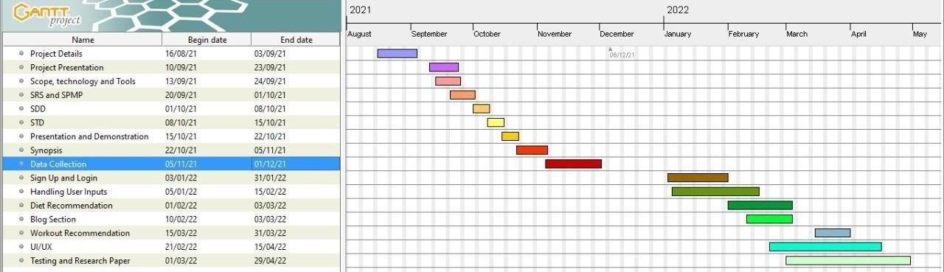

# FitNoQuit - Software Requirement Specification

1814007 - Bhavik Bhatt, 1814010 - Piyush Chavda, 1814011 - Bharat Choithani, 1814020 - Muskaan Nandu

26 September 2021

1. **INTRODUCTION**
   1. **Product Overview**

Every human being has a different body with different requirements and thus as the saying goes “one size may not fit all”, a single diet and workout routine would not serve all. To solve this issue, “FitNoQuit” aims to provide its users with personalized diet and workout recommendations. Using machine learning algorithms, we aim to provide our users with a customized diet and workout routine that best suits them. These algorithms take into context a ton of user details like height, weight, age, gender, food preference, medical conditions etc. These details enable the algorithm to formulate a plan that is accurate and easy to follow for the users. The users can also browse through the blog section where in a plethora of information with respect to current diet and workout trends, myths regarding health and so on is available. The user is recommended with related blogs using content-based filtering which aims to recommend users with blogs from a category/author that the users previously showed interest in.

To sum up, “FitNoQuit” is a knowledge-based system that aims to provide diet and workout services to its users that is personalized and most apt to the user.

1. **SPECIFIC REQUIREMENTS**

#### External Interface Requirements

##### User Interfaces

The screen formats and menu structure should be in such a way that users will find easy to use. The product must be user-friendly and inter-active. The interface must be easy to understand. The user interface includes

* + - * SCREEN FORMATS/ORGANIZATION: The introductory screen will be the user dashboard from where the user can access different modules of the web-app like diet recommendation, workout recommendation, blog section etc.
      * WINDOW FORMAT/ORGANIZATION: When the user chooses some other option, then the information pertaining to that choice will be displayed in a new window which ensures multiple windows to be visible on the screen and the users can switch between them.
      * DATA FORMAT: The data entered by the users will be alphanumeric.
      * END MESSAGES: When there are some exceptions raising error like entering invalid details, then error messages will be displayed prompting the users to re-enter the details.

##### Hardware Interfaces

Are as follows:

Source of input: Keyboard, Mouse

To accept data from user like height, weight, age, user preferences and other personal and medical information

Destination of Output: Desktop Screen

Display the personalized workout and diet recommendations along with the option of browsing through blogs via the desktop screen.

##### Software Interfaces

* Languages: Python, HTML, CSS, JavaScript, PHP
* Framework: Django, BootStrap
* Database: SQLite

##### Communication Protocols

Usage of simple electronic forms which make use of SMTP and HTTPS protocols.

* 1. **Software Product Features**

##### Functional Requirements

The requirements/features that end-users shall expect and will be incorporated in the system are:

##### Registration/Sign Up

New users will be able to access the system by registering or creating an account with “FitNoQuit”.

##### Login/Sign In

Existing users should be able to access the system using their username and password. Premium features will be available to premium registered users.

##### User Profile

Users will be able to edit and view their personal information from the User Profile section.

##### Workout Recommendation

The user will be recommended with appropriate workout and exercise based on their end goal (weight gain, weight loss maintain weight or manage a health condition)

##### Diet Recommendation

Suggest Diet Meals to the users in categories of Breakfast, Lunch and Din- ner based on user’s food preferences like Veg/Non Veg/Jain/Vegan, health condition like Thyroid, PCOS, Heart Conditions, etc

##### Blog Suggestions

The users will be suggested with relevant blogs in the Community Blog sec- tion using Content-Based filtering based on the previously liked blogs.

##### Logout

The user should be able to safely log out of the system without any loss of information.

##### Non-Functional Requirements

The basic quality constraints that will be satisfied by the system is as follows:

##### Authorization

The user data will be confidential and only authorized nutritionists will be made available with the data.

##### Speed

The application will respond to user’s queries as soon as possible with a minimum waiting time.

##### Portability

The system will be highly portable as it is a web-app and will work efficiently even if the user changes the device.

##### Compatibility

Since the system is a web-app it can be accessed on any devices like laptop, tablet or mobile phones, irrespective of its Operating System.

##### Security

Sensitive information like user passwords will be encrypted by using algo- rithms like SHA and then stored on the database for verification.

##### Availability

The web-app will be available to all users with internet-connectivity as we plan to host the website.

##### Reliability

The recommendation system would be reliable as we would try to achieve maximum accuracy and get the recommendation model verified by a certified nutritionist.

* 1. **Software System Attributes**

##### Reliability

The factors needed to establish the software expected reliability are

* + - * The user inputs should be valid and within the given range.
      * Normal execution of the system without glitches
      * Appropriate navigation and restricting access to unauthorized users

##### Availability

The factors guarantee the software’s availability includes proper termination and correct input details. Also the resources used for the project development

are Python Certified which speaks of its high quality standards.

##### Security

Are as follows:

* + - * It must be ensured that access will be provided to the authorized persons through user ID and password.
      * Passwords must be Strong.
      * No loss of data for any user must be ensured.
      * Checks can be performed at regular internals to ensure data integrity.

##### Maintainability

The software will be developed by implementing the concept of modularity which in turn reduces the complexity involved in maintaining it. The ad- ministrator should have a sound technical knowledge about maintaining the software and further enhancements will be undertaken by the developer

##### Portability

The web application is portable to any device-mobile or desktop and is adapt- able for use on different browsers with different device models and standards.

##### Performance

FitNoQuit application should be able to respond to the queries submitted by the customer without much delay.

* When a user inputs personal information in order to obtain workout and diet recommendations,the application should return the results in minimum duration.
* The user should be displayed blog recommendations that are aligned with their liking and the loading time for blogs should be less than 5 seconds.
  1. **Database Requirements**

The system requires the use of SQLite database to maintain the customer’s personal details and their medical information. An entity should be used to denote all the workout plans, diet classes (Veg, Non-Veg, Jain and Vegan) and the number of calories associated with them

FitNoQuit - Software Design Document

BHAVIK BHATT (1814007) PIYUSH CHAVDA (1814010) BHARAT CHOITHANI(1814011) MUSKAAN NANDU (1814020)

October 2021

1. **Introduction**

Daily nutrition and food, particularly for those suffering from small or serious ailments, is one of the most important aspects for a good life. According to numerous researches, improper and inadequate daily dietary intake are the primary causes of a variety of health problems and illnesses. In light of the above facts, it is important to maintain a well-balanced diet. However, due to the vast variety of food items, it is difficult for the average individual to keep track of personal food requirements. Therefore, a systematic diet recommendation system is required to recommend the appropriate food considering the user preferences.

##### Design Overview

FitNoQuit is a web app which provides users with satisfactory, personalized, customized and enjoyable workout and diet routines. Users just need to input his/her food and activity choices and will get an appropriate plan. This web app also contains a big blog community where users can share their thoughts, give feedbacks, ask questions and answer to other user queries.

##### Requirements Traceability Matrix

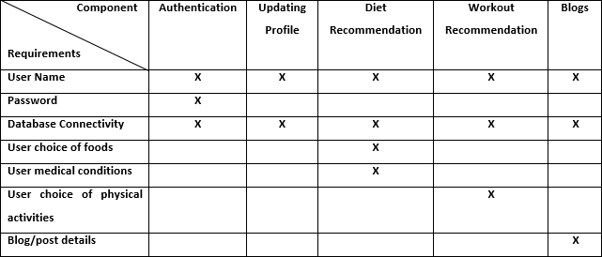

Requirement Traceability Matrix

1. **System Architectural Design**

##### Chosen System Architecture

The system is defined using an Entity Relationship diagram and a data flow diagram. The data flow diagram is attached at the end of the document.

The different entities of this system are as follows:

* + 1. User - The user entity has different attributes like username, age, height, weight, gender, email id, food preferences, health condition, weight goal, derived attribute like BMI and primary key User ID.
    2. Diet Plan - It has different attributes like Diet Plan ID which is the primary key and a composite attribute the recommended Diet Meals which is further divided into Breakfast, Lunch, Snacks and Dinner.
    3. Workout Plan - It has different attributes like Workout Plan ID which is the primary key and a composite attribute Workout plan which is further divided into three different options which the users can choose.
    4. Blogs - The users can read different blogs ehich has the primary key Blog ID and other attributes like date of publication and number of likes.
    5. Categories - The blogs are further divided into categories like healthy lifestyle, health condition management, healthy recipes, etc. Each category is identified by a primary key labelled Category ID.

##### Discussion of Alternative Design

An Alternative Design element that can be used to model the system can be an Component diagram where different components would be the Authentication, Recommendation of Diet, Recommendation of Workout and Blog Suggestions.

##### System Interface Description

The system will be able to run on Windows, Linux and Mac OS Platforms. The system will run on a web server using different graphics and an interface which makes it easy for the user to execute various functionalities of the web app.

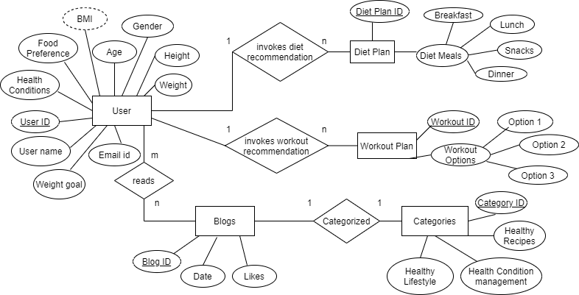

ER Diagram

1. **Detailed Description of Components**

##### Authentication

Responsibility - Bhavik Bhatt

Constraints - User must sign up or sign in to the system to be able to access the profile and obtain workout and diet recommendations.

Composition - The user must provide details like user name or Email ID and sign in with their password.

Interactions - Client server interaction using the web browser of user Resources - Database and Validation.

##### Recommendation of Diet

Responsibility - Bhavik Bhatt

Constraints - User needs to be registered and signed in

Composition - Enter personal details like height, weight, age, end goal and food preferences. Interactions - Client server interaction using the web browser of user

Resources - Database, Authentication and Machine Learning model.

##### Recommendation of Workout

Responsibility - Muskaan Nandu

Constraints - Only an authorised person can access the profile and obtain workout routine.

Composition - Enter personal details like height, weight, age, end goal and food preferences. Interactions - Client server interaction using the web browser of user.

Resources - Database, Authentication and Machine Learning model.

##### Blog Suggestions

Responsibility - Bhavik Bhatt

Constraints - The registered user must select a category from the available categories of blogs.

Composition - Enter category of interest for blog browsing. Interactions - Client server interaction using the web browser of user Resources - Database, Authentication.

#### User Interface Design

##### Description of the User Interface

* + 1. **UI Screen for Login Page**
       1. Screen Images

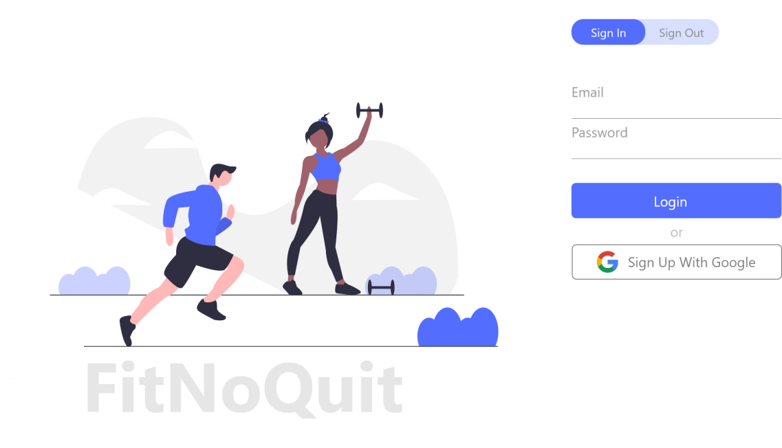

UI Screen for Login Page

* + - 1. Objects and Actions

The Different Objects on this screen are a descriptive image for fitness followed by two text fields which take the user’s email and password as input. On clicking Login the user credentials are verified and a valid user is taken to his/her account. If the user is not a registered user he/she must click on the Sign Up button

which takes the user to Sign Up page. The user can also sign in using google if he has registered using google.

* + 1. **UI Screen for Sign Up page**
       1. Screen Images

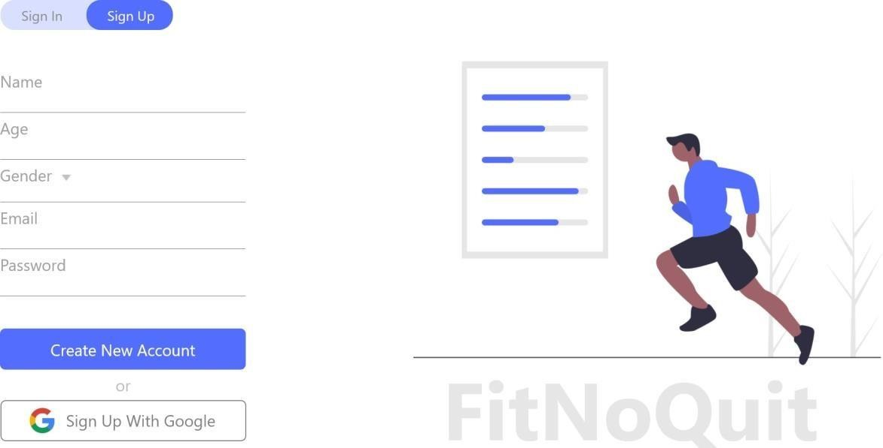

UI Screen for Sign Up screen

* + - 1. Objects and Actions

The Different Objects on this screen are a descriptive image for fitness along with five text fields which take the user’s name, age, gender, email and password as input. On clicking ”Create New Account” the user credentials are validated and a valid user account is registered. The user can also sign up using google account.

* + 1. **UI Screen for Workout Recommendation**
       1. Screen Images

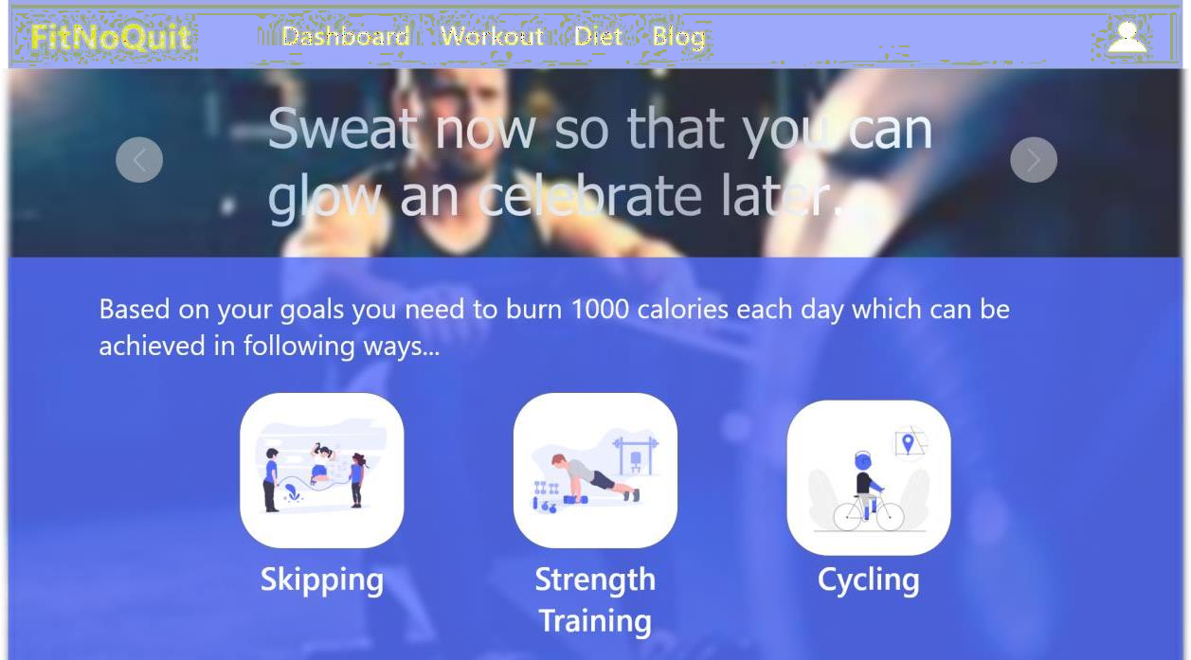

UI Screen for Workout Recommendation Page

* + - 1. Objects and Actions

The Different Objects on this screen are a descriptive image for fitness along with different workout options from which the user can select the one that he prefers.

* + 1. **UI Screen for Diet Recommendation**
       1. Screen Images

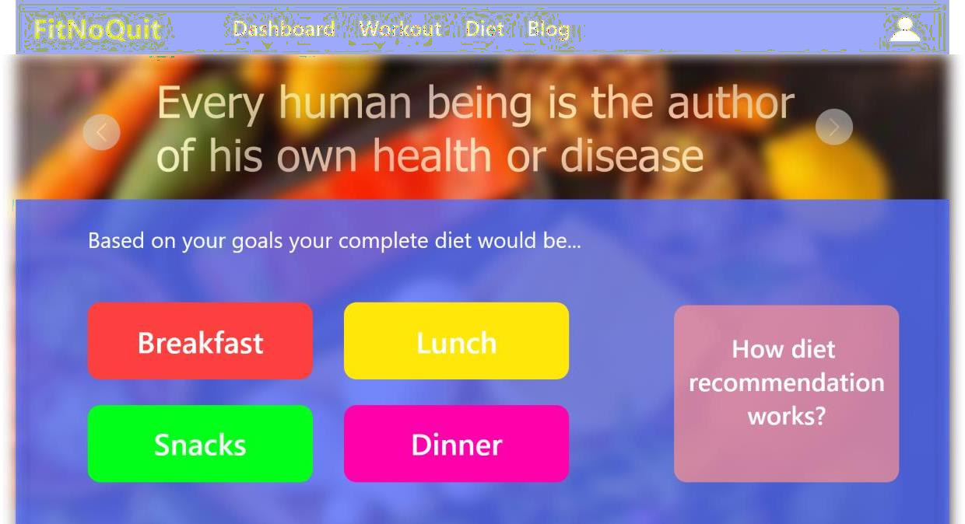

UI Screen for Diet Recommendation

* + - 1. Objects and Actions

The Different Objects on this screen are a descriptive image for healthy food along with different meals of the day from which the user can select the one that he wants to view the diet plan for.

* + 1. **UI Screen for Blog Suggestions**
       1. Screen Images

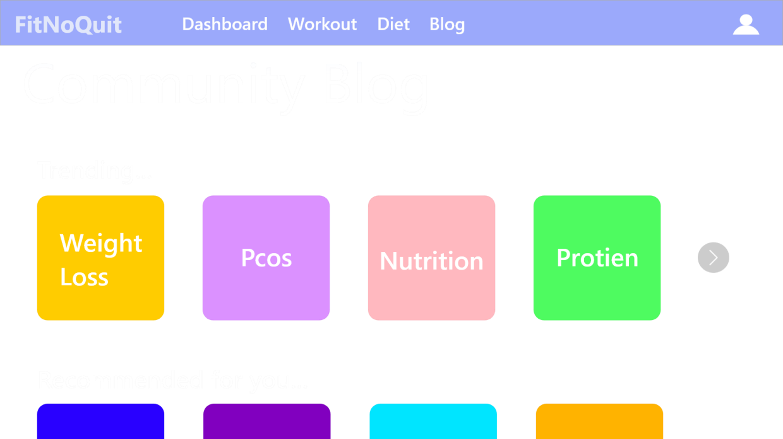

UI Screen for Blog Suggestions

* + - 1. Objects and Actions

The screen consists of different categories of blogs from which the user can click on a blog topic and browse through the information consisted in that blog.

#### System Architecture

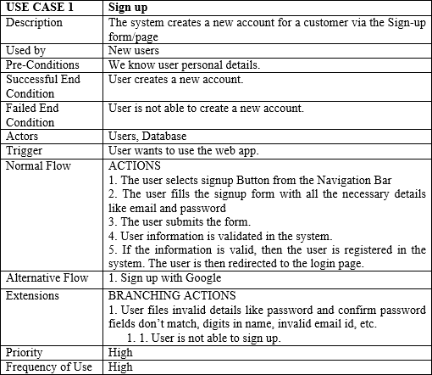

Usecase 1

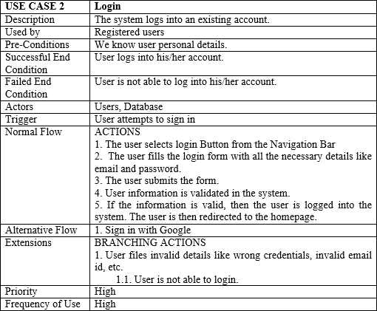

Usecase 2

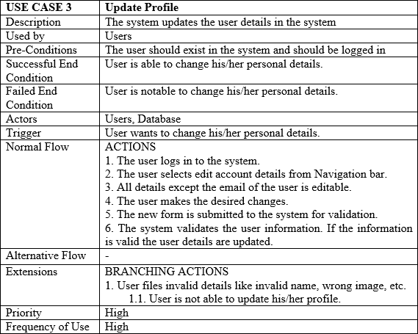

Usecase 3

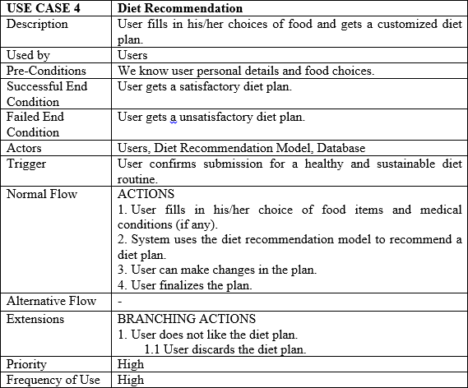

Usecase 4

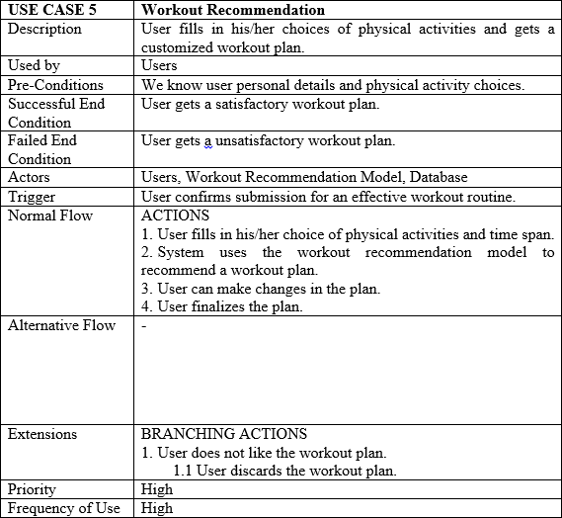

Usecase 5

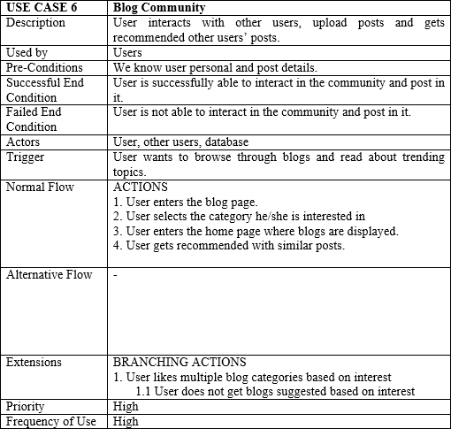

Usecase 6

#### Data flow Specifications

* 1. **Context Flow Diagram**

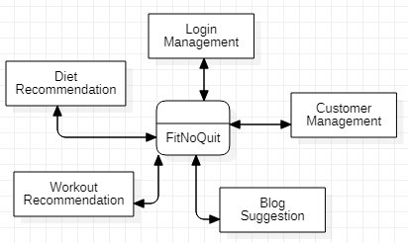

Context Flow Diagram for FitNoQuit

* 1. **Data Flow Diagram Level 0**

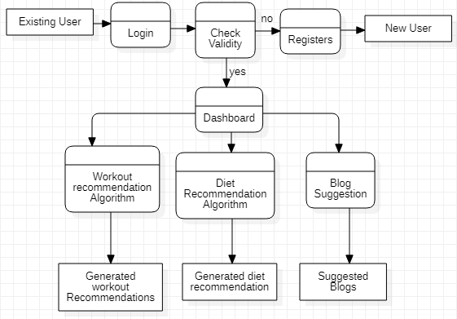

Level-0 diagram for FitNoQuit

##### Data Flow Diagram Level 1

Login Process ( Level-1 diagram for FitNoQuit )

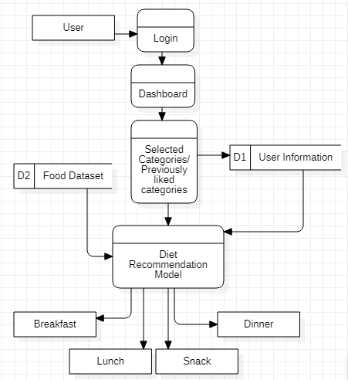

Diet recommendation ( Level-1 diagram for FitNoQuit )

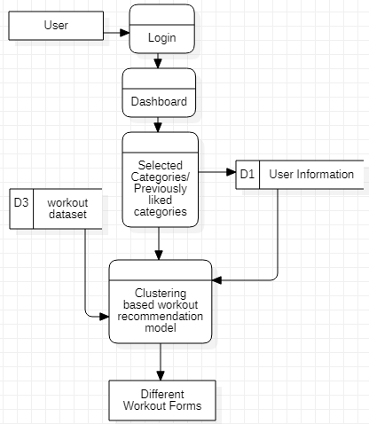

Workout Recommendation ( Level-1 diagram for FitNoQuit )

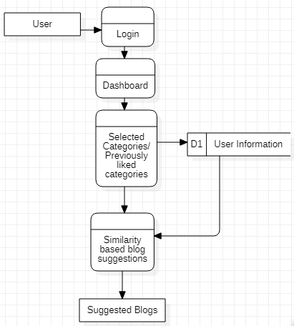

Blog Suggestion ( Level-1 diagram for FitNoQuit )

FitNoQuit - Software Test Document

BHAVIK BHATT (1814007) PIYUSH CHAVDA (1814010)

BHARAT CHOITHANI (1814011) MUSKAAN NANDU (1814020)

October 2021

1. **Introduction**

##### System Overview

Along with development, testing is also a major development cycle which is very important for to achieve the fruition of the Project. Testing helps us to identify the loop holes in the development and avoid future crisis. Testing also helps us to identify the potential failure of system and unwanted access to data. Exhaustive testing is conducted to ensure the system works with accuracy and reliability. This is done to make sure all the bugs are detected before the system is available to end user.

##### Test Approach

* + 1. **UNIT TESTING**

Unit testing is a type of software testing where individual units or components of a software are tested. The purpose is to validate that each unit of the software code performs as expected. Unit Testing is done during the development (coding phase) of an application by the developers. Unit Tests isolate a section of code and verify its correctness. A unit may be an individual function, method, procedure, module, or object. There are many benefits for this unit testing:

* The unit testing facilitates change in the code.
* It allows testing to be done in a bottom up fashion.

At the same time, unit testing has some disadvantages such as, it might not identify each and every error in the system.

* + 1. **ACCEPTANCE TESTING**

User will be involved in this phase of testing to analyse the acceptability and usability of the system. We will use black box testing to ensure the system is suitable to all user with/without technical understanding. This also helps to identify bugs that might have been missed by the previous tests.

* + 1. **SYSTEM TESTING**

System consists of all the components that makeup the system to function. This testing is done to ensure that all the components work together with each other and the system as a whole. It should work as expected.

#### Test Plan

The main scope of the test plan for the Airline Reservation System are as

follows:

* To identify the features of the system that will be tested.
* To identify and define all the activities necessary to prepare for and conduct the testing process on the Recommendation System
* To define the pass/fail criteria for each item that will be tested

To identify the deliverables of the testing phase.

* To define any suspension criteria and resumption techniques
* To discuss the testing techniques being used to test the Recommendation System.
  1. **Features to be tested**

This section of the test plan lists all the items of the Airline Reservation System project that will be tested:

1. Sign up - This feature is for users who are new to the website and have never used it before. They will have to fill in their personal details and register in the system.
2. Login - This feature is for users who want to use the functions of the website. They need enter their credentials in the website so they can use their account which contains all the information about them and their diet and workout plans.
3. Profile - Every user has a different profile that is filled up with his/her de- tails, history, plans, routines etc. Each profile is unique for every individual and should be accurately working in this web app.
4. Diet Recommendation - This feature recommends a personalized and cus- tomized diet plan for an individual and is one of the most important features of this web app.
5. Workout Recommendation - This feature recommends a personalized and customized workout plan for an individual and is one of the most important features of this web app.
6. Blog Community - This a community where users can read trending topics in food and workout industry. They can like blogs written by health experts and similar blogs will be suggested to user in the future as well.

##### Features not to be tested

This section of the test plan lists all the items of the Recommendation System that will be NOT be tested:

1. Database Connectivity - Database is one of the most important parts of a

web application. Thus, it is mandatory to check if this is working properly or not. We need to check if all the inputs from the users are properly stored in the database or not. We also need to check if the products from the database are displayed to the users or not.

1. Payment Functionality - This features allows the user to select among the dif- ferent payment methods offered to him/her and get a plan according to his/her needs.

##### Testing Tools and Environment

The time allotted for testing phase is 30 days. The testing phase will be exe- cuted by all 4 members of the team: Bhavik Bhatt, Muskaan Nandu, Piyush Chavda and Bharat Choithani. The testing process will carried out with the help of below listed tools:

* Selenium online tool
* TestingWhiz tool
* Ranorex environment

#### Test Cases

* 1. **Sign Up**
     1. **Purpose**

Registers the user in the software’s database and allows him/her to use the features provided by the software

* + 1. **Inputs**

Incorrect Input:

Wrong format entered in the input fields for the registration page

Correct Input:

The correct input would be a valid e-mail id and valid email format of the user and a valid strong format password.

* + 1. **Expected Outputs Pass/Fail criteria**

Incorrect:

An appropriate message should be generated to the user saying that he has entered the wrong format in the specific input field.

Correct:

An appropriate message should be generated to the user saying that he has en- tered the correct format in the specific input field and redirect to the software dashboard

* + 1. **Test Procedure**

The testing would be carried out on FitNoQuit while registering on the system as a new user to the system.

* 1. **Sign In**
     1. **Purpose**

Logs in the user to the software where the user can access the features provided by the software.

* + 1. **Inputs**

Incorrect Input:

Username: which is the email-id in the case of the Recommendation System FitNoQuit.

Password: with respect to the valid username. Correct Input:

The correct input would be a valid e-mail id of the user and a correct password associated with the email-id which he uses to log in.

* + 1. **Expected Outputs Pass/Fail criteria**

The user should be directed to the dashboard of the software after he/she logs into the system.

On invalid login attempts, the user should remain on the login page or can go to sign up page.

* + 1. **Test Procedure**

The testing would be carried out on the FitNoQuit while logging into the system as a customer or a normal user of the system.

##### User Profile

* + 1. **Purpose**

Every user has a different body type and requirements. The user profile takes into account all the preferences of the user and provides recommendation based on it.

* + 1. **Inputs**

Incorrect Input:

Wrong format entered in the input fields on the user profile page. Correct Input:

The correct input would be valid height, weight, food preferences, health con- ditions etc

* + 1. **Expected Outputs Pass/Fail criteria**

Incorrect:

An appropriate message should be generated to the user saying that the inputted value is invalid for the given field.

Correct:

An appropriate message should be generated to the user saying that he has entered the correct data in the fields.

* + 1. **Test Procedure**

The testing would be carried out on FitNoQuit while entering different combi- nations of data in the input fields.

* 1. **Diet Recommendation**
     1. **Purpose**

Recommends a personalized and customized diet plan for an individual based on his/her preferences and medical conditions.

* + 1. **Inputs**

Incorrect Input:

Invalid data entered on user information/profile page Correct Input: Valid data entered on user information/profile page

* + 1. **Expected Outputs Pass/Fail criteria**

Incorrect:

An appropriate message should be generated to the user saying that the entered details are invalid and no diet should be recommended.

Correct:

A personalized diet should be recommended to the user satisfying all his pref- erences and medical conditions.

* + 1. **Test Procedure**

The testing would be carried out on FitNoQuit by entering a combination of health conditions and food preferences.

##### Workout Recommendation

* + 1. **Purpose**

Recommends a personalized and customized workout plan for an individual based on his end goal and considering user’s physical disability if any.

* + 1. **Inputs**

Incorrect Input:

Invalid/Improbable end goal or extreme physical disability. Correct Input: Valid end goal and inputs entered by the user

* + 1. **Expected Outputs Pass/Fail criteria**

Incorrect:

An appropriate message should be generated to the user saying that the in- putted data is invalid.

Correct:

Different options of workouts need to be displayed to the user from which the user can follow a workout that best suits him/her.

* + 1. **Test Procedure**

The testing would be carried out on FitNoQuit entering a combination of inputs and validating the workout suggested based on it.

##### Blog Community

* + 1. **Purpose**

Users can read trending topics in food and workout industry. They can like blogs written by health experts and similar blogs will be suggested to user in the future as well.

* + 1. **Inputs**

Incorrect Input: None

Correct Input: Liking of a blog.

* + 1. **Expected Outputs Pass/Fail criteria**

Incorrect: None.

Correct:

Blogs on trending topics and topics previously liked by the user should be sug- gested.

* + 1. **Test Procedure**

The testing would be carried out on FitNoQuit by viewing different blogs.

#### Test Results

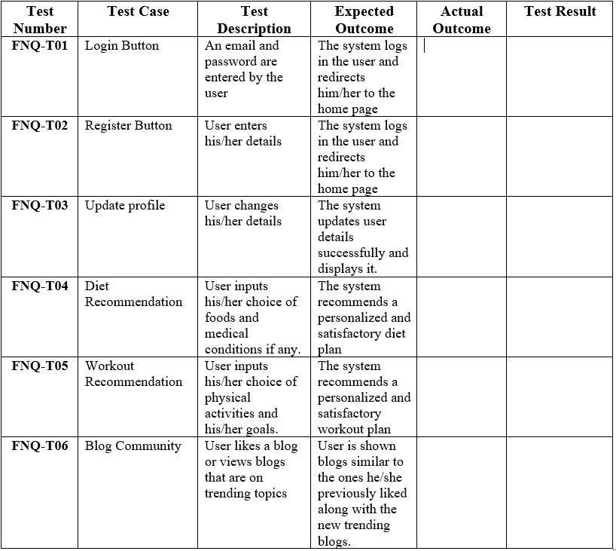

**4. CONCLUSIONS AND LEARNINGS**

##### 4.1 Conclusions

* Hence all in all, we plan to develop and implement a web application that is made for all kinds of users and helps them achieve their fitness goals by providing a personalized, sustainable and flexible workout and diet plans.
* We read different technical papers to understand how machine learning can be used for recommendation systems and how it can be applied in our project.
* We aim to incorporate features that lack in the existing systems by providing personalized diet and workout options that is completely customizable and satisfy the user’s needs.
* For the workout recommendation system, we plan to use mathematical computations and/or machine learning algorithms like K-means clustering algorithm on the exercise dataset available on Kaggle, to find 3 different exercise options to burn certain number of calories.
* We plan to create a diet recommendation system that recommends users with meals for an entire day divided in 4 categories: breakfast, lunch, snacks and dinner.
* We also plan to provide users with a blog section where users are suggested with blogs relate to the categories they show interest in.
* Hence, FitNoQuit is a one stop destination to track your health. It is an all-in-one solution that provides customized diet plans and suitable workout options to enable users to achieve their end goal.

###### References

1. F. Rehman, O. Khalid, N. u. Haq, A. u. R. Khan, K. Bilal and S. A. Madani, "Diet-Right: A Smart Food Recommendation System," KSII Transactions on Internet and Information Systems, vol. 11, no. 6, pp. 2910- 2925, 2017. DOI: 10.3837/tiis.2017.06.006.
2. Kardam, Shubham Singh, et al. "Website on Diet Recommendation Using Machine Learning." In International Research Journal of Engineering and Technology (IRJET) Volume: 08 Issue: 04, April 2021.
3. Ojokoh, B., and A. Babalola. "A Personalized Healthy Diet Recommender System." Organization for Women in Science for the Developing World (OWSD) (2016): 388-393.
4. R. Yera Toledo, A. A. Alzahrani and L. Martínez, "A Food Recommender System Considering Nutritional Information and User Preferences," in IEEE Access, vol. 7, pp. 96695-96711, 2019, doi: 10.1109/ACCESS.2019.2929413.
5. D. Mogaveera, V. Mathur and S. Waghela, "e-Health Monitoring System with Diet and Fitness Recommendation using Machine Learning," 2021 6th International Conference on Inventive Computation Technologies (ICICT), 2021, pp. 694-700, doi: 10.1109/ICICT50816.2021.9358605.

###### Acknowledgements

In this tough time, when the world is suffering from a worldwide pandemic, we would like to thank the almighty to keep us occupied with projects, like this one and help us learn and grow without many distractions. We are sure that this project will help us to explore the field of recommendation systems using machine learning along with different aspects of software development like software documentations, front- end development, dataset management, etc.

After the supreme power, we would like to thank our parents, for giving us this opportunity of learning. Next, we would like to thank each other for immense support throughout the process of the project and helping each other grow.

We would like to give our special thanks to our project guide Prof. Sonali Patil, for guiding us with this project and giving us an opportunity to learn, communicate and explore throughout the project. We would also like to thank Dt. Dhwani Parekh, a qualified nutritionist to assist our team by suggesting changes in the dataset and validate the recommendations made by our model “FitNoQuit”.

Lastly, we would like to thank the project committee of our college, K. J. Somaiya College of Engineering for providing us a chance to work on this project.