Weight: 79 kg

Exercise: Walking at brisk pace

App:

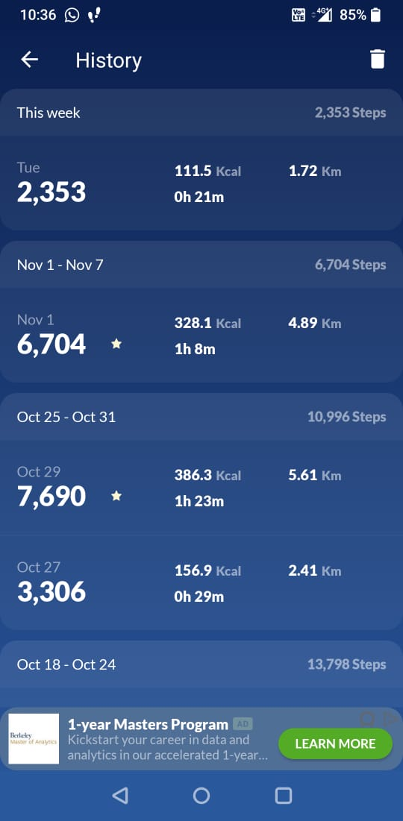

Our dataset:



Calculation: 79\*(68/60)\*3.795 = 339.8 cal

Exercise: Running at moderate speed for 8 minutes + walking slowly for 12 minutes

App:



Our dataset:





Calculation: 79\*(8/60)\*7.99 + 79\*(12/60)\*2.49 = 123.5 cal

Exercise: Swimming

Web:

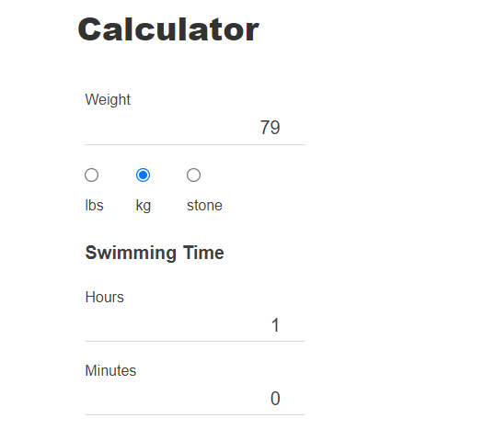



Our dataset:



Calculation: 79 \* 5.98 = 474.42 cal