# Project Report – Meet Up

**Project Members:**

Bhavik Bhatt – 1814007

Piyush Chavda – 1814010

Muskaan Nandu – 1814020

**Project guide:**

Prof. Pradnya Bhangale (Dept. Of Computer Science)

**Problem Statement:** Our Application is built to serve two types of users, Students and Teachers. It solves the most basic problem of arranging appointments for students with the teachers at a time convenient to both, the students and the teachers. This app allows the students to send a request to book an appointment with the teacher when the teacher is free, along with the purpose of the meet. The teachers can accept or reject the request based on the purpose of meet and availability of date and time. The teacher can also share the reason of rejection with the student.

Thus the app aims to save time for the teachers by allowing them to accept or reject the requests based on the purpose and also saves time of the students by preventing them to wait and look around for teachers while the teachers are busy.

**Languages used:** Dart (Flutter), Python

**Library used:** Camelot library – to read tables from pdf

**Features Of the App:**

1. Customized Login and Register

The First page allows the user to select their role as shown in Figure 1. Based on their role the student and teacher have different register and logins for their dashboard.

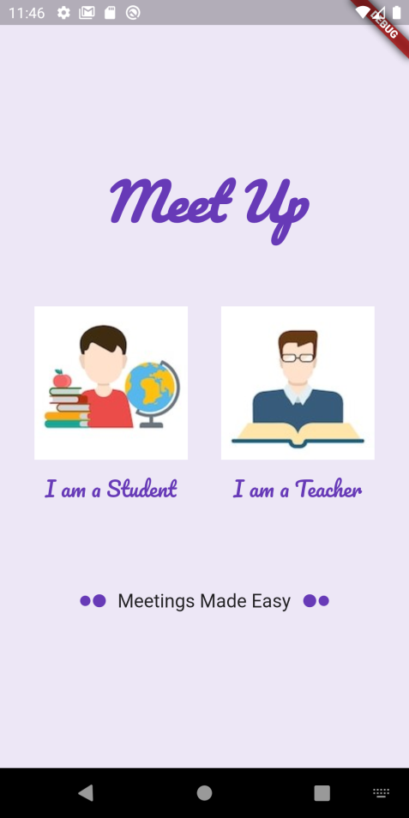

Figure Select Role

All details of the student and teacher are taken while registering.

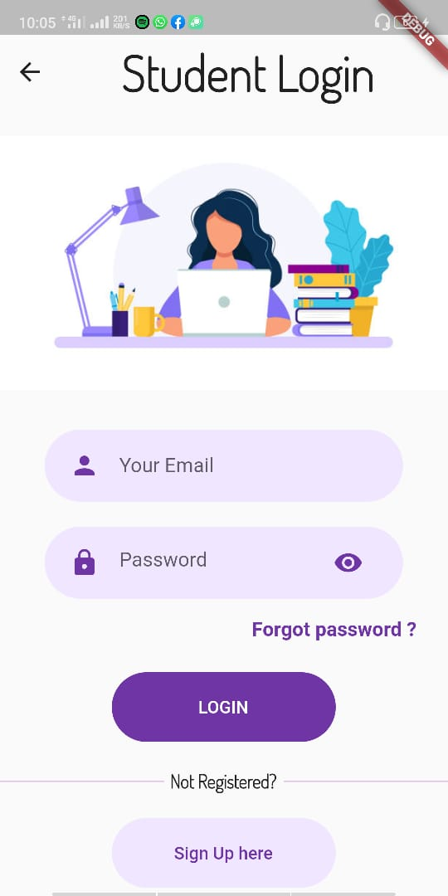 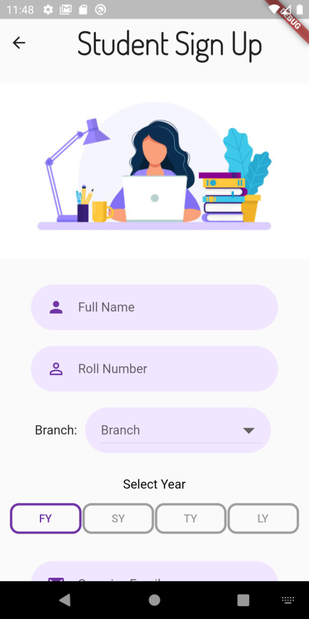 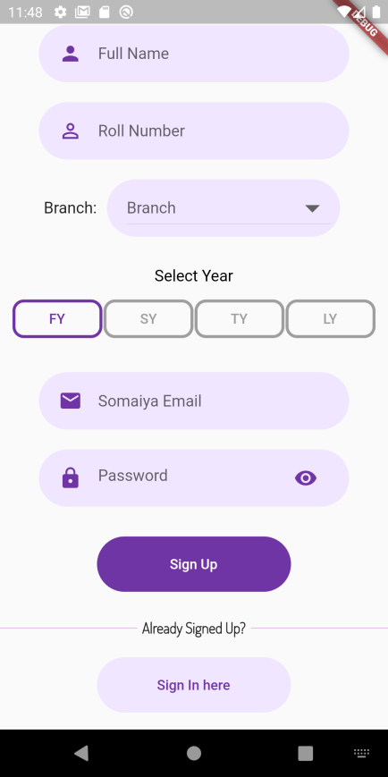

Figure Student Sign Up and Login

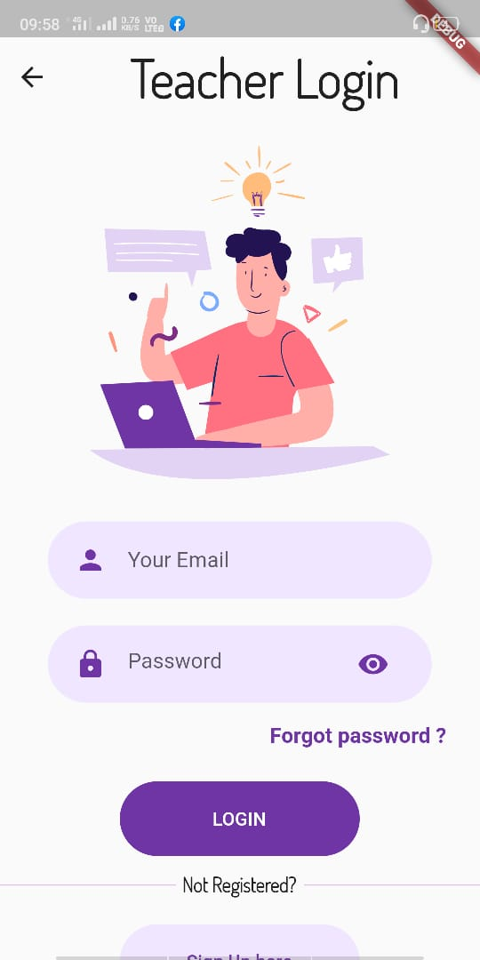 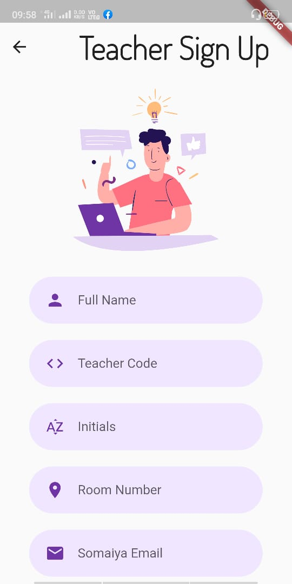

Figure Teacher Login and Sign Up

The email is verified by sending the users a verification link. Once a user is registered as a student they cannot log in as a teacher and vice versa.

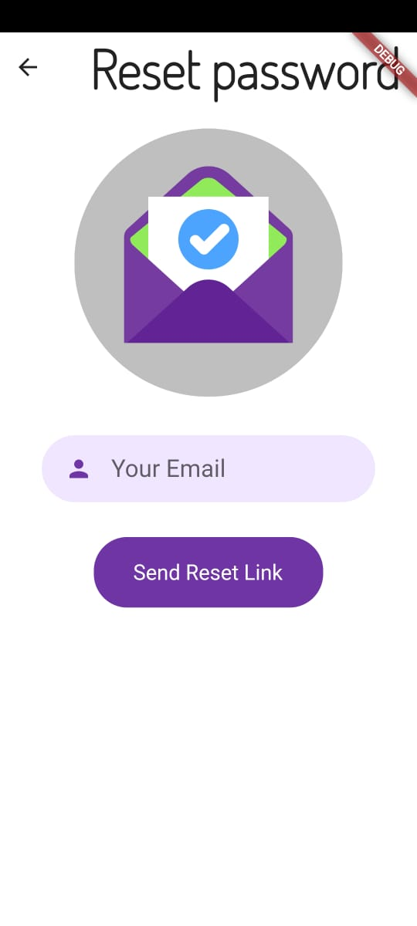 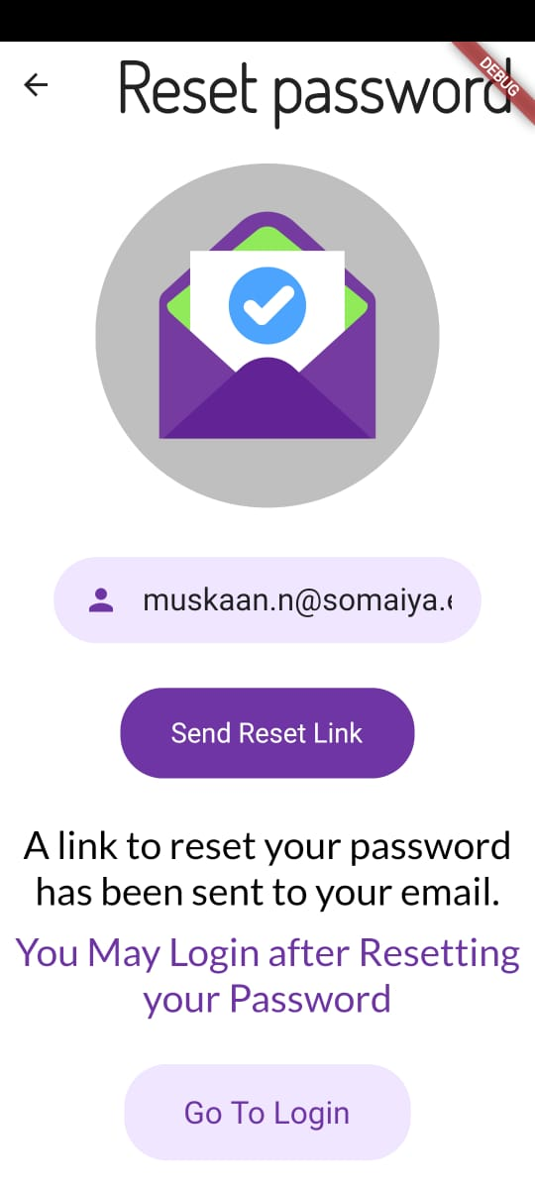 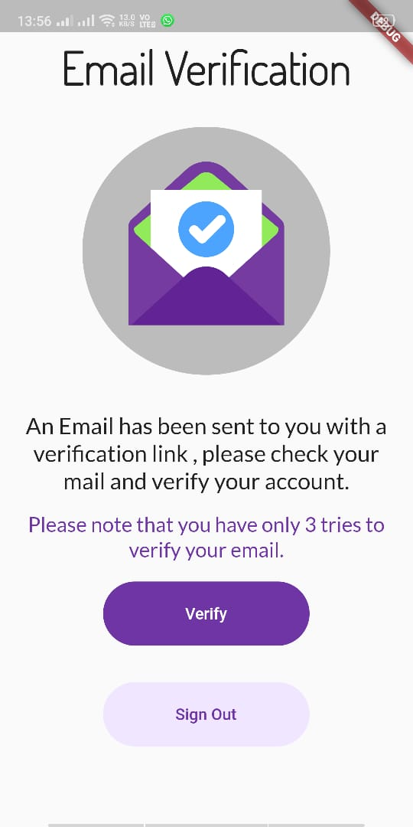

Figure Forgot Password Figure Email Verification

1. Teacher Dashboard

Once the user is logged in as a teacher, the user is taken to the teacher dashboard. Here, the teacher can manage his/her pending, accepted and rejected requests for the upcoming week.

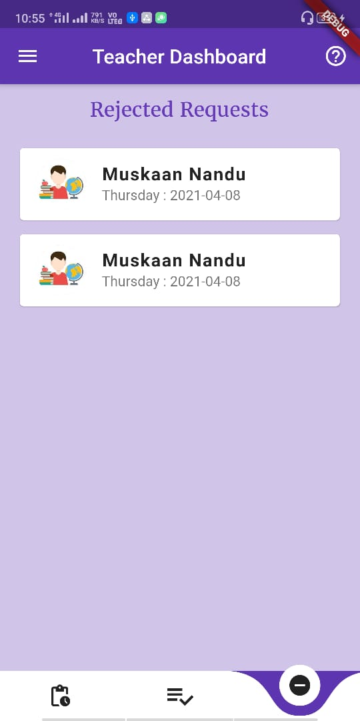 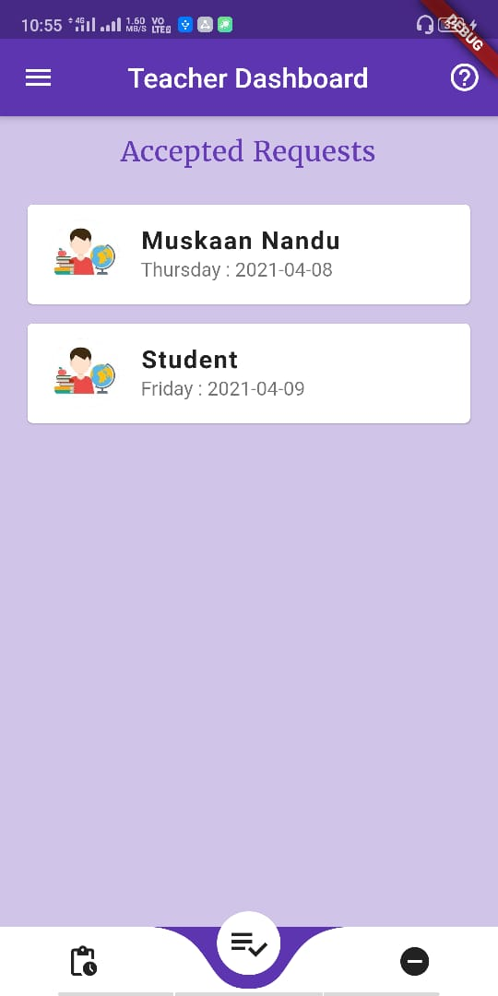 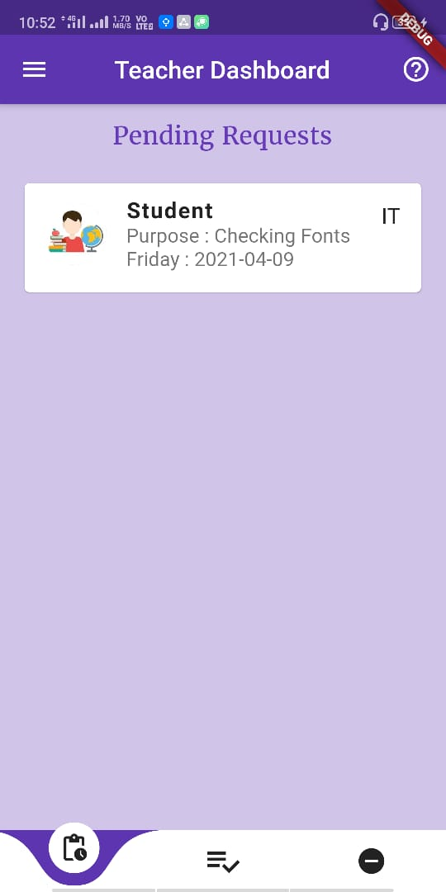

Figure Teacher Dashboard

­­

From the navigation Menu the user can go to his profile, time table, history and signout.

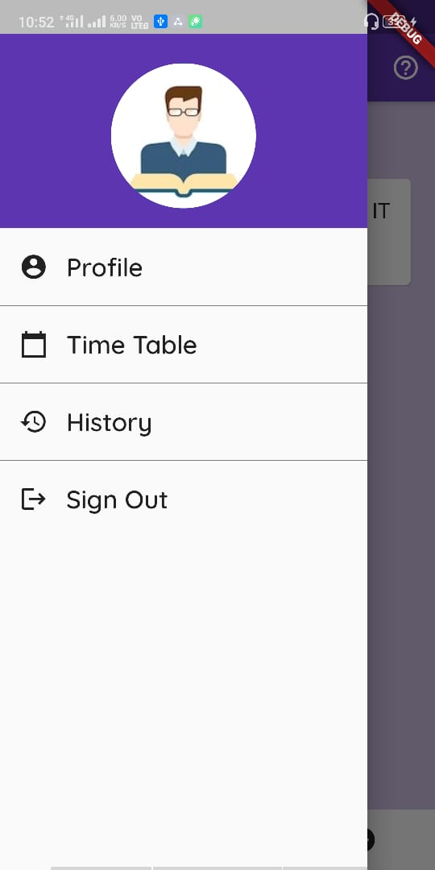 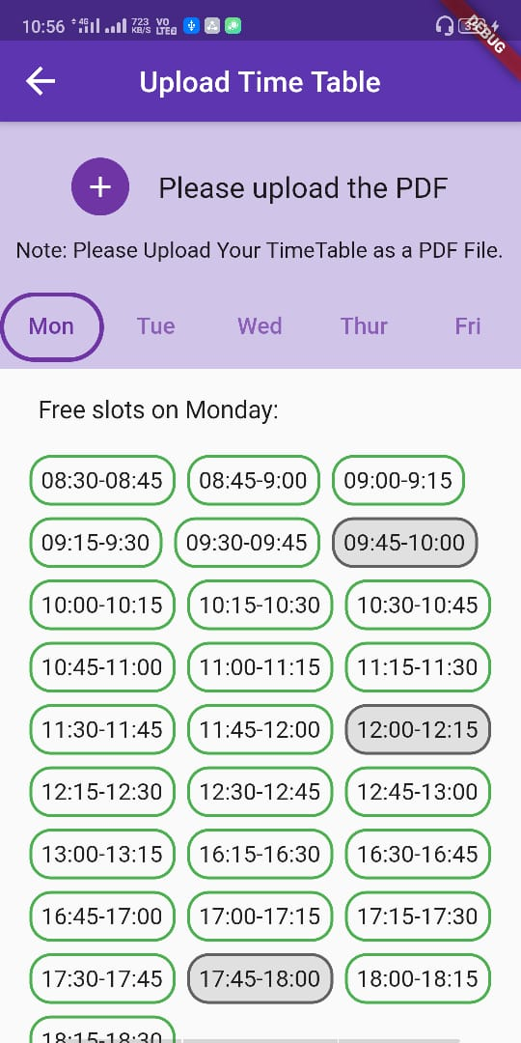 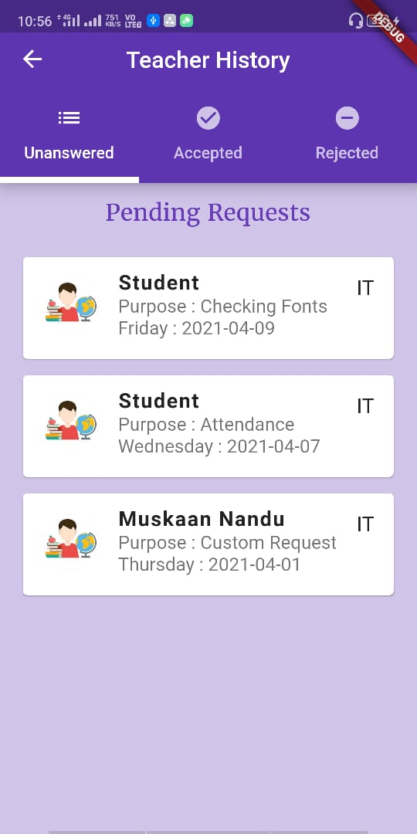

Figure Upload Time Table Figure 8 Teacher Profile Figure 9 Teacher History

The user can update his or her details from the Profile and can also upload a profile picture.

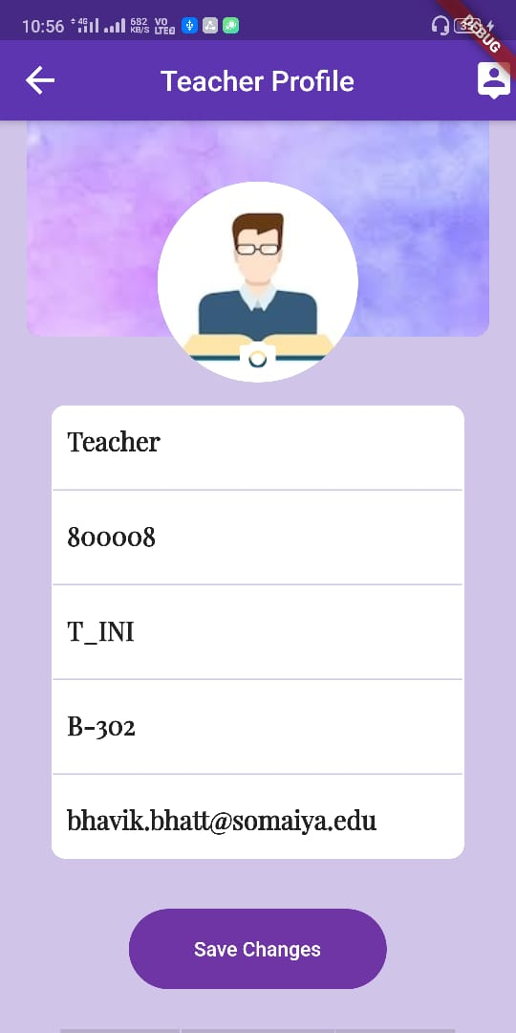

Figure Teacher Profile

­­

The user must upload his/her college time table in pdf form, from which the user’s free slots are extracted and printed day wise.

When a student books any of these slots the slots are turned to booked – in grey.

The user can access all previous requests from the history section.

1. Student Dashboard

Once the student is logged in as a student, he/she is taken to the student dashboard. Here, the student can manage his/her pending, accepted and rejected requests for the upcoming week.

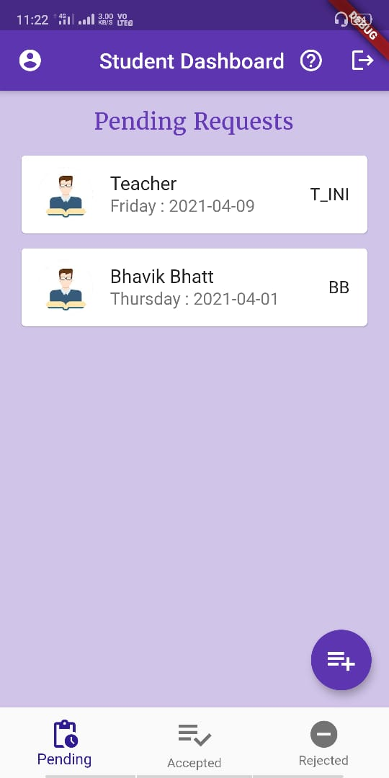 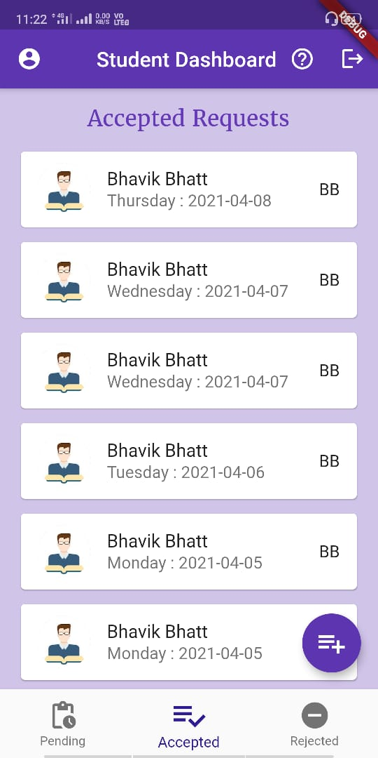 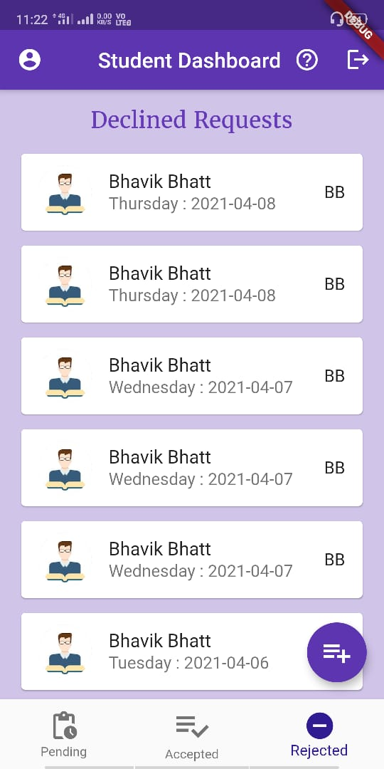

Figure Student Dashboard

The student may cancel or delete a pending or accepted request.

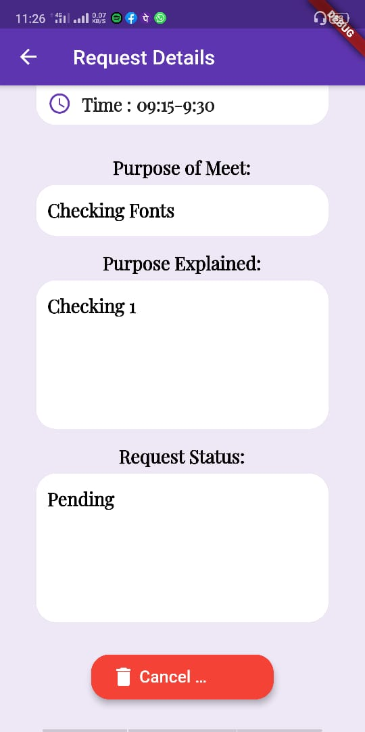

Figure Cancel Request

The student can book an appointment by clicking on + button and follow the following steps.



Figure Book Appointment

First select a teacher from the list of teachers registered in the app. Here the student can search the teacher by his/her name or employee code.

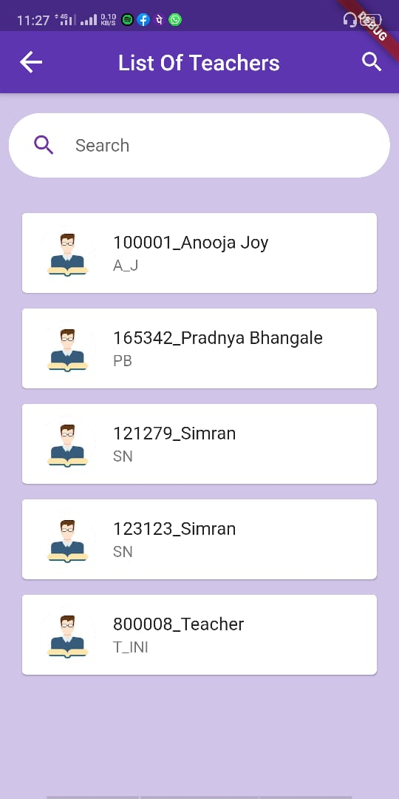

Figure Search Teacher

Then verify the details of the teacher, select a date, select from teacher’s free slots, enter the purpose of the meet. The student might also explain the purpose in detail if required. Then select confirm.

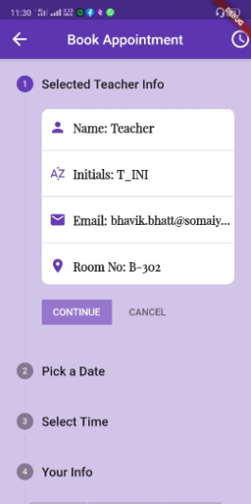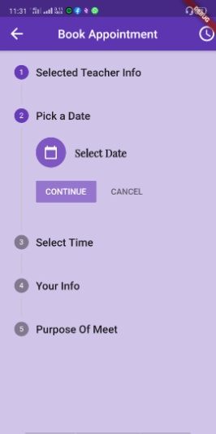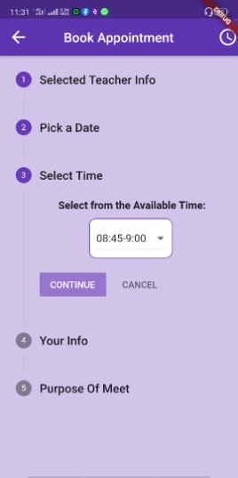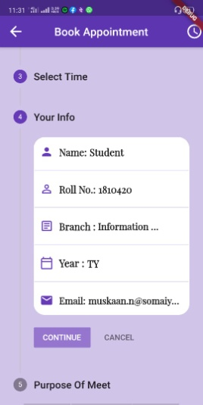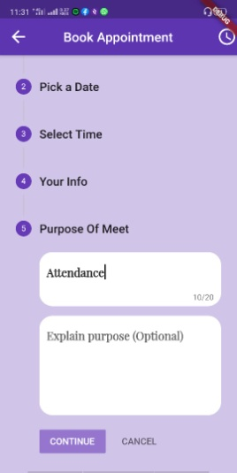

Figure Steps for booking an appointment­­­

­

The appointment is sent to the teacher and it now appears in the Pending Requests section.

1. Notifications

The app makes use of email notifications.

When a student sends a request to the teacher, the teacher is notified on her email id, with all the request details.

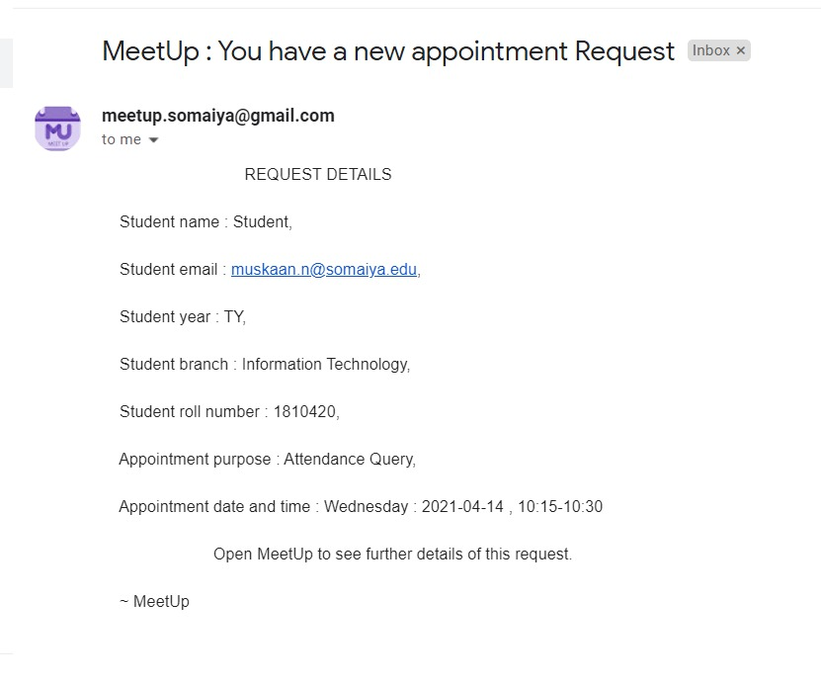

Figure 16 Teacher is notified when a new request is received.

Similarly, when the teacher responds to the request the students are notified on their email id, with the request status.

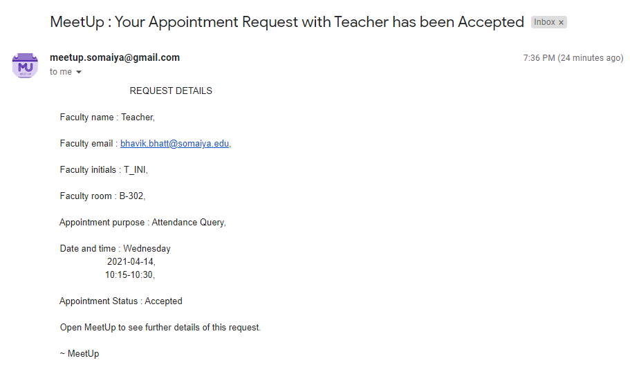

Figure 17 Student is notified when teacher accepts the request.

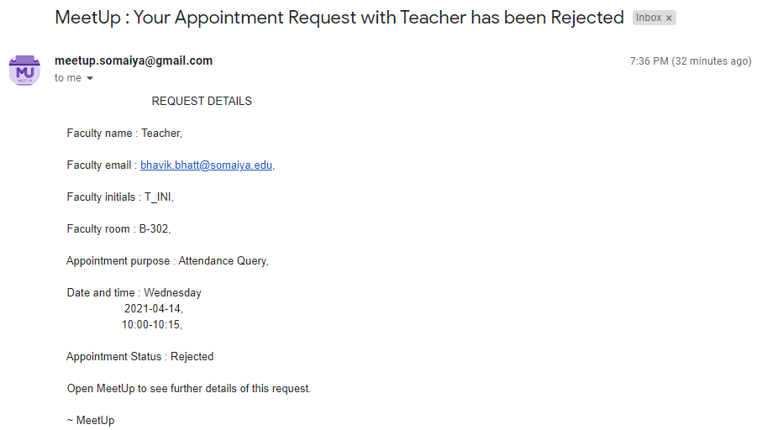

Figure 18 Student is notified when teacher rejects the request.

**Conclusion**

Hence we successfully built a Flutter Application that solves the common problem of arranging appointments of students with teachers, based on teacher’s free slots. Throughout the project we were able to learn the following things:

* how to handle problems in dart programming language
* how to connect our android app with flutter firestore
* explore Camelot library in Python language
* how to work with APIs and django
* how to work with email notifications
* we were able to integrate different UI principles while making the app keeping in mind the user experience.