Credit Score Project - Simple Summary
Predict if a customer's credit score is Good, Standard or Poor

1. What is this project?
A bank has information about customers (income, loans, late payments, debt...). We teach a computer to look at this information and guess the customer's credit score: Good, Standard or Poor. The computer method we use is a Decision Tree - it works like a game of yes/no questions (for example: "Is the credit mix good?" - yes - "Is the delay small?" ...) until it reaches an answer.

2. The data
- Source: Kaggle, file train.csv. It has 3,380 rows (customer records) and 28 columns (details about each customer).
- The thing we predict is the column Credit_Score.
- The data was messy: numbers saved as text (like '35_'), junk symbols, missing values, and impossible ages (like -500).

3. How we cleaned the data
Problem | What we did
Useless columns (ID, Customer_ID, Name, SSN) | Removed them - they don't help predict
Junk symbols like '_' and '!@9#%8' | Cleaned them / treated as missing
Impossible ages (below 18 or above 100) | Marked as missing
1 row with no Credit_Score | Removed it (3,379 rows left)
Missing values | Filled numbers with the median, text with the most common value

4. Charts and what we learned
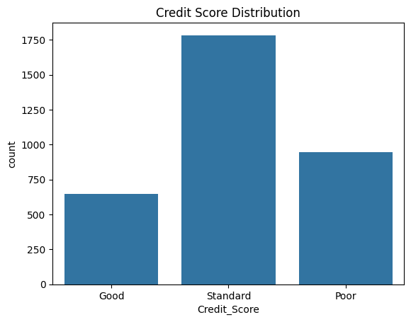 | 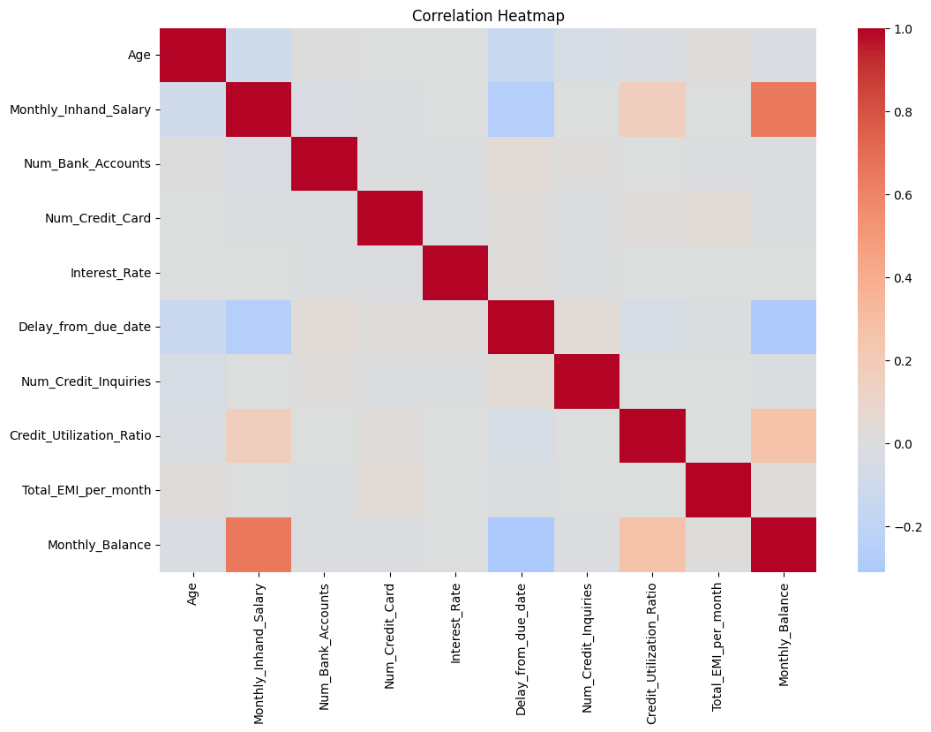
- Not balanced: Standard 53%, Poor 28%, Good 19%. So accuracy alone can fool us - we trust Macro F1 more.
- People with higher salary tend to have higher monthly balance.
- People who pay late tend to have lower salary and balance.

5. Preparing for the model
- New feature we created: Debt-to-Income = Outstanding Debt / Annual Income. It shows how big the debt is compared with income.
- Text columns were turned into 0/1 columns (one-hot encoding).
- Picked the 15 best columns (SelectKBest).
- Split data: 80% to train (2,703 rows) and 20% to test (676 rows).

6. We tried 12 different settings
We tried the default tree, gini vs entropy (two ways to choose questions), and tree depth from 2 to 10. A few results:
Setting | Test accuracy | Macro F1
entropy (BEST) | 68.05% | 0.6641
max_depth = 10 | 68.05% | 0.6597
gini / default | 68.05% | 0.6584
max_depth = 5 | 64.94% | 0.6386
max_depth = 2 (worst) | 59.91% | 0.5935

- Very shallow trees (depth 2-4) are too simple, so they do badly.
- Default tree scores 100% on training data but only 68% on test data - it memorised the training data (this is called overfitting).
- Best setting: entropy, because it has the highest Macro F1.
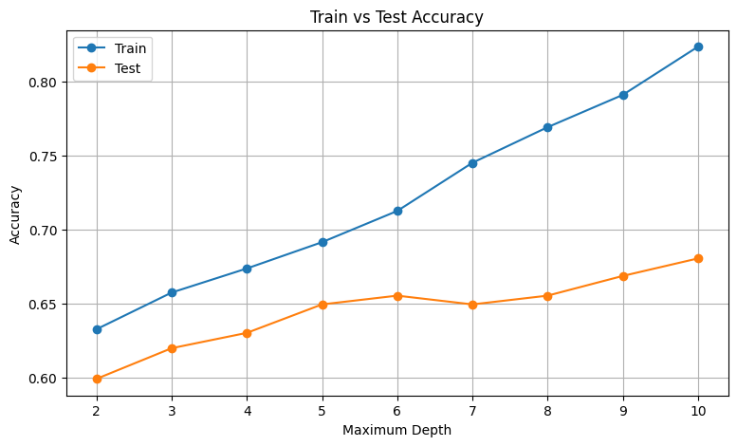

7. Final result
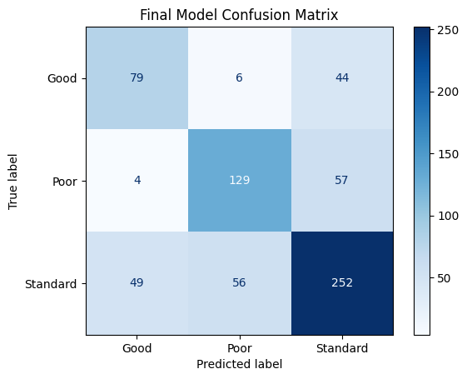 | Out of 676 test customers:  - 460 correct (79 Good + 129 Poor + 252 Standard)  - 216 wrong  Accuracy: 68%  Macro F1: 0.66  AUC: 0.74  Most mistakes are between neighbouring classes. Good-vs-Poor mix-ups are very rare (4 and 6).
Most important features: 1) Debt-to-Income ratio, 2) Monthly balance, 3) Delay from due date. The first question the tree asks is about Credit_Mix_Good.

8. Predicting 3 new customers
We took 3 customers from the test data and changed their salary by -10%, 0% and +10%. The model predicted Standard for all three. This is believable because Standard is the most common class, but it doesn't show the model separating classes - a small salary change isn't enough to change the answer.

9. Conclusion
- The model predicts the credit score correctly about 68% of the time (Macro F1 = 0.66). That is better than always guessing Standard (53%), but only moderate.
- Debt compared with income, monthly balance and late payments matter most.
- We learned: real data needs a lot of cleaning; accuracy can mislead when classes are unequal; compare train vs test results to spot overfitting.

