**Assessment**

CREATE DATABASE assessment

CREATE TABLE city(

id int PRIMARY KEY AUTO_INCREMENT NOT NULL,

city_name varchar(50),

lat varchar(50),

longg varchar(50),

country_id int(5)

);

INSERT into city(city_name,lat,longg,country_id) VALUES("Berlin",52.520008,13.404954,1),("Belgrade",44.787197,20.457273,2),("Zagreb",45.815399,15.966568,3),("New York",40.730610,-73.935242,4),("Los Angeles",34.052235,-118.243683,4),("Warsaw",52.237049,21.017532,5);

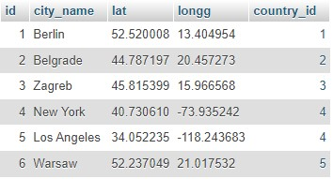

-----------------------------------------------------------------------------------------------------------------------------------------

CREATE TABLE Customer(

id int PRIMARY KEY AUTO_INCREMENT NOT NULL,

customer_name varchar(50),

city_id int,

customer_add varchar(50),

next_call_date varchar(20),

ts_inserted varchar(20),

FOREIGN KEY (city_id) REFERENCES city(id)

);

INSERT INTO customer(customer_name,city_id,customer_add,next_call_date,ts_inserted) VALUES("Jewelry Store",4,"Long Street 120","2020-01-21","2020-01-09 14:01:20.000"),("Bakery",1,"kurfurstendamm 25","2020-02-21","2020-01-09 17:52:15.000"),("Cafe",1,"Tauentzienstrabe 44","2020-01-21","2020-01-10 08:02:49.000"),("Restaurant",3,"Ulica lipa 15","2020-01-21","2020-01-10 09:20:21.000");

------------------------------------------------------------------------------------------------------------------------------------------

CREATE TABLE country(

id int PRIMARY KEY AUTO_INCREMENT NOT NULL,

country_name varchar(50),

country_name_eng varchar(50),

country_code varchar(10)

);

INSERT INTO country(country_name,country_name_eng,country_code) VALUES("Deutschland","Germany","DEU"),("Srbija","Serbia","SRB"),("Hrvatska","Croatia","HRV"),("United State of America","United State of America","USA"),("Polska","Poland","POL"),("Espana","Spain","ESP"),("Rossiya","Russia","RUS");

-----------------------------------------------------------------------------------------------------------------------------------------

**Task : 1** (join multiple tables using left join)

SELECT country.country_name_eng, city.city_name, customer.customer_name FROM country

LEFT JOIN city ON city.country_id = country.id

LEFT JOIN customer ON customer.city_id = city.id;

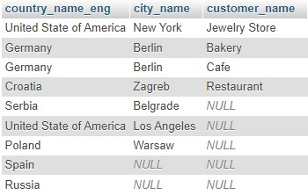

**Task : 2** (join multiple tables using both left and inner join)

SELECT country.country_name_eng, city.city_name, customer.customer_name

FROM country

INNER JOIN city ON city.country_id = country.id

LEFT JOIN customer ON customer.city_id = city.id;

