**MODULE: 1 (SDLC)**

1. **What is software? What is software engineering?**

* Software is a set of instructions, data or programs used to operate computers and execute specific tasks. It is the opposite of hardware, which describes the physical aspects of a computer. Software is a generic term used to refer to applications, scripts and programs that run on a device. It can be thought of as the variable part of a computer, while hardware is the invariable part.
* The two main categories of software are Application Software and System Software. An application is software that fulfills a specific need or performs tasks. System software is designed to run a computer's hardware and provides a platform for applications to run on top of.
* **software engineering:**
* Software engineering is defined as a process of analyzing user requirements and then designing, building, and testing software application which will satisfy those requirements.

1. **Explain types of software?**

* There are five major classifications of software:

1. Application Software
2. System Software
3. Middleware Software
4. Driver Software
5. Programming Software
   1. **Application Software**

* [Application Software](https://www.webopedia.com/TERM/A/application.html), also known as end-user programs or productivity programs are software that helps the user in completing tasks such as doing online research, jotting down notes, setting an alarm, designing graphics, keeping an account log, doing calculations or even playing games.
* All the apps that we see on our mobile phones are also examples of Application Software.
* Examples of modern application include office suites, graphics software, database and database management programs, web browsers, image editors and communication platforms.
  1. **System Software**
* A system software aids the user and the hardware to function and interact with each other. Basically, it is a software to manage computer hardware behavior so as to provide basic functionalities that are required by the user.
* In simple words, we can say that system software is an intermediator or a middle layer between the user and the hardware.
* The OS is the best example of system software; it manages all the other computer programs.
* Examples: Firmware, Windows system, Android system, etc…
  1. **Driver Software**
* Driver software communicates with hardware and control devices and peripherals attached to a computer. It does this by gathering input from the OS (operating system) and giving instructions to the hardware to perform an action or other designated task.
* Internal components like the hard drive and processor each require its own driver. If the wrong software’s installed the device won’t work correctly.
* Examples: Audio Driver, Graphic Card, Video Driver, etc…
  1. **Middleware Software**
* Middlewareis a type of computer software that provides services to software applications beyond those available from the operating system.
* the term middleware describes software that mediates between application and system software or between two different kind of application software.
* Examples: Database middleware, application server middleware, etc…
  1. **Programming Software**
* Programming software, also known as a programming tool or software development tool, is a program that assists software developers or programmers with creating, debugging and maintaining other programs and applications.
* Most code is written in English using a specific format or syntax. High-level programming languages are then converted into machine code.
* Examples of programming software include assembler, compilers, debuggers and interpreters.
* Examples: Turbo C, Eclipse, GitHub, Visual Studio Code, etc…

1. **What is SDLC? Explain each phase of SDLC?**

* **SDLC (Software Development Life Cycle): -**
* Software Development Life Cycle (SDLC) is a process used by the software industry to design, develop and test high quality software’s. The SDLC aims to produce a high-quality software that meets or exceeds customer expectations, reaches completion within times and cost estimates.
* The following figure is a graphical representation of the various stages of a typical SDLC.

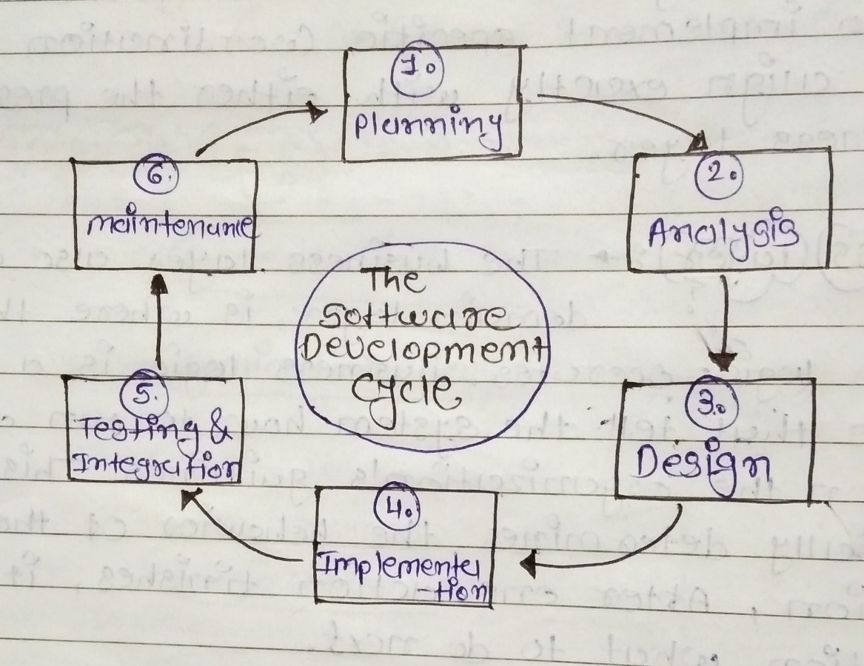

### **Stage 1: Planning**

* Planning is the most important and fundamental stage in SDLC. It is performed by the senior members of the team with inputs from the customer, the sales department, market surveys and domain experts in the industry. This information is then used to plan the basic project approach and to conduct product feasibility study in the economical, operational and technical areas.

**Stage 2: Analysis**

* The goal of analysis is to determine where the problem is. This step involves decomposing the system into pieces, analyzing project goals, breaking down what needs to be created, and engaging users to define requirements.

**Stage 3: Design**

* The design phase determines and defines the technical details of a project. For example, depending on the nature of the project, the design phase might include creating screen designs, prototypes, process diagrams, and system interfaces.
* During this phase, designers also determine the architecture, programming language, platforms, and user interface designs. This phase effectively takes the product vision and specifies

how that vision will come to life?

**Stage 4: Implementation**

* Implement the design into source code through coding.
* Combine all the modules together into training environment that detects errors and defects.
* A test report which contains errors is prepared through test plan that includes test related tasks such as test case generation, testing criteria, and resource allocation for testing.

**Stage 5: Testing**

* Testing starts once the coding is complete and the modules are released for testing. In this phase, the developed software is tested thoroughly and any defects found are assigned to developers to get them fixed.
* Retesting, regression testing is done until the point at which the software is as per the customer’s expectation. Testers refer SRS document to make sure that the software is as per the customer’s standard.

**Stage 6: Maintenance**

* Implement the changes that software might undergo over a period of time, or implement any new requirements after the software is deployed at the customer location.
* It also includes handling the residual errors and resolve any issues that may exist in the system even after the testing phase.
* Maintenance and support may be needed for a longer time for large systems and for a short time for smaller systems.

1. **What is DFD? Create a DFD diagram on Flipkart.**

* **DFD (Data Flow Diagram): -**
* A data flow diagram (DFD) maps out the flow of information for any process or system. It uses defined symbols like rectangles, circles and arrows, plus short text labels, to show data inputs, outputs, storage points and the routes between each destination.
* Data flowcharts can range from simple, even hand-drawn process overviews, to in-depth, multi-level DFDs that dig progressively deeper into how the data is handled.
* **DFD Diagram on Flipkart: -**

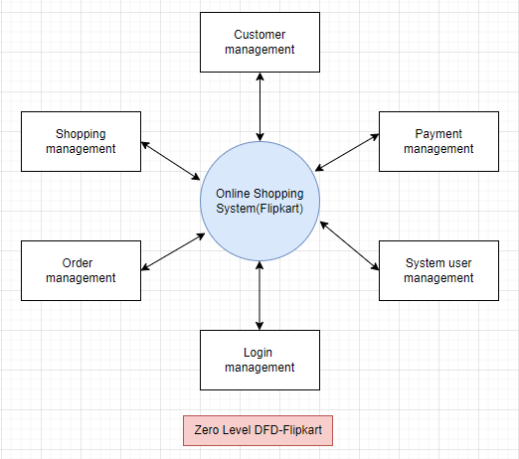

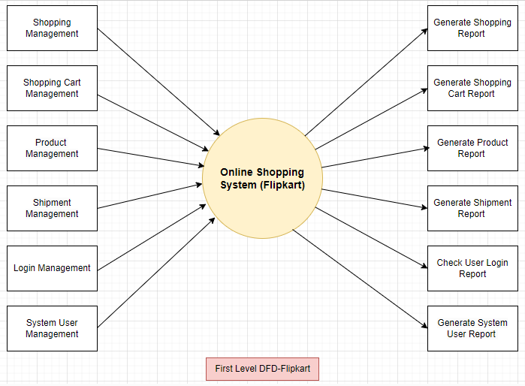

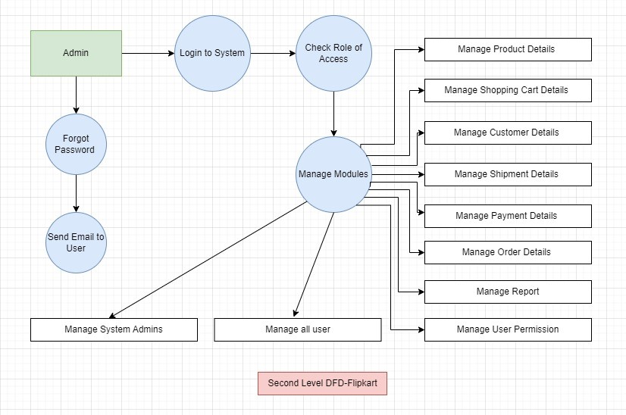

1. **What is Flow chart? Create a flowchart to make addition of two numbers?**

* **Flow Chart: -**
* A flowchart is a diagram that depicts a process, system or computer algorithm.
* They are widely used in multiple fields to document, study, plan, improve and communicate often complex processes in clear, easy-to-understand diagrams.
* Flowcharts, sometimes spelled as flow charts, use rectangles, ovals, diamonds and potentially numerous other shapes to define the type of step, along with connecting arrows to define flow and sequence.
* **Flow Chart to Addition of Two Number: -**

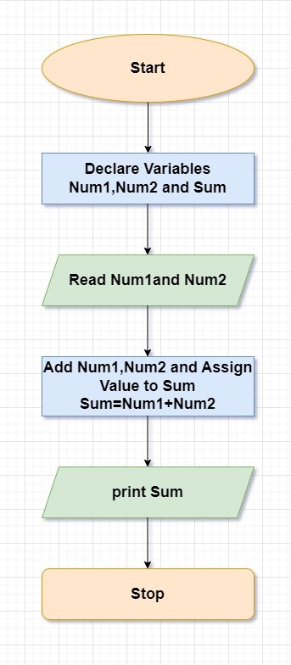

## **What is Use Case Diagram? Create a use-case on bill payment on Paytm.**

* **Use Case Diagram: -**
* use case diagram can summarize the details of your system's users and their interactions with the system.
* A use case diagram shows various use cases and different types of users the system has and will often be accompanied by other types of diagrams as well.
* The use cases are represented by either circles or ellipses.
* **Use Case Diagram of Paytm: -**

