

**Dharmsinh Desai University**

Faculty of Technology, Department of Computer Engineering

B. Tech. CE Semester – VI

Subject: System Design Practice

Project Title:

**CR Solutions**

By:

Meet Vasani CE141 (18CEUOD004)

Guided by:

Prof. Hariom A. Pandya



**Dharmsinh Desai University**

Faculty of Technology, Department of Computer Engineering

**CERTIFICATE**

This is to certify that System Design Practice Project entitled “**CR Solutions”** is the bonafide report of work carried out by:

**Meet Vasani (18CEUOD004)**

of department of Computer engineering, Semester VI, academic year 2019-2020, under our supervision and guidance.

**Guide HOD**

Prof. Hariom A. Pandya Dr. C. K. Bhensdadia

Assistant Professor Head of the department of

Department of Computer engineering Computer engineering

**Content**

# Abstract……………………………………………………… 1

# Introduction…………………………………………………. 2

# Software Requirement Specification………………………… 3

# Design………………………………………………………... 6

# Implementation Details………………………………………. 12

# Testing and Validations……………………………………… 14

# Screenshots…………………………………………………... 17

# Conclusion…………………………………………………… 20

# Limitation and Future Extensions…………………………… 21

# Bibliography………………………………………………… 22

1. **Abstract**

This project’s purpose is to help various corporations and companies to collect their annual confidential reports. This system allows remove the limitation of report layout being fixed, authorities for such companies can add various report layouts as suitable for such requirements. It does support collecting annual confidential reports from the employees’ in yearly manner, so it’s easy for the respective authorities of companies or corporations to collect reports and verify them without doing any kind of drudgery.

1. **Introduction**

**2.1 Brief Introduction**

* Purpose

This system helps collecting reports from employees and helps authorities to verify them and comment on it if necessary.

* Scope

This system scope is wide, in any corporations and companies this system is suitable to work.

* Objectives

This system aims to help authorities by providing dynamic functionalities for reports and validations for the reports, and employees would find easy to submit the reports.

**2.2 Tools / Technologies used**

* **Technology: -** MongoDB, Angular, ExpressJS and NodeJS
* **Platform: -** Cross-Platform/ Web
* **Tools:** - Visual Studio Code, NPM Library

1. **Software Requirement Specification**
   1. **Stakeholders: -**

* Authority
* Employees
  1. **Functional Requirements: -**

F.1 Authority

F.1.1 Add a company space

Description: In order to get employees reports, authority is required to have respective space for it, because there are so many different companies will be there to store their reports.

Input: Company space name.

Output: Prompt related to the action.

**Process:** Check the company space name is existed or not.

F,1,2 Add Company employees

Description: Authority shall upload the company employee list (.csv) file, with that through, company’s employee will able to login into the system.

Input: Employee list file.

Output: Prompt related to the action.

F.1.3 Add report forms for the respective year

Description: Authority shall add the report layout for the respective years, so that employee could fill those report and submit.

Input: Authority’s various selections.

Output: Prompt related to the action.

F.1.4 Load report submissions

Description: When employees done with the submission of the report form for the respective year, authority shall verify those reports and comment if required.

Input: year for which report has been submitted.

Output: Submission for the given year, if any submitted.

F1.4.1 Verify submissions

Input: Verification status and comment if any.

Output: Prompt related to the action.

F.2 Employee

F,2,1 Fill the report for the given year

Description: Employee shall fill the report form which is designed by respective authority.

Input: form field inputs.

Output: Prompt related to the action.

F.2.2 View report responses

Description: Employee would be able to see their report responses once filled and also be able to edit them if attentions is required for the employee which is given by respective authority.

Input: report response tab navigation

Output: submitted reports with verification and comments if any for the respective report.

F2.3 Download report as PDF

Description: Employee can download their submitted report response in form of the PDF.

Input: Selection of the report.

Output: PDF file.

1. **Design**
   1. **Use case Diagram**

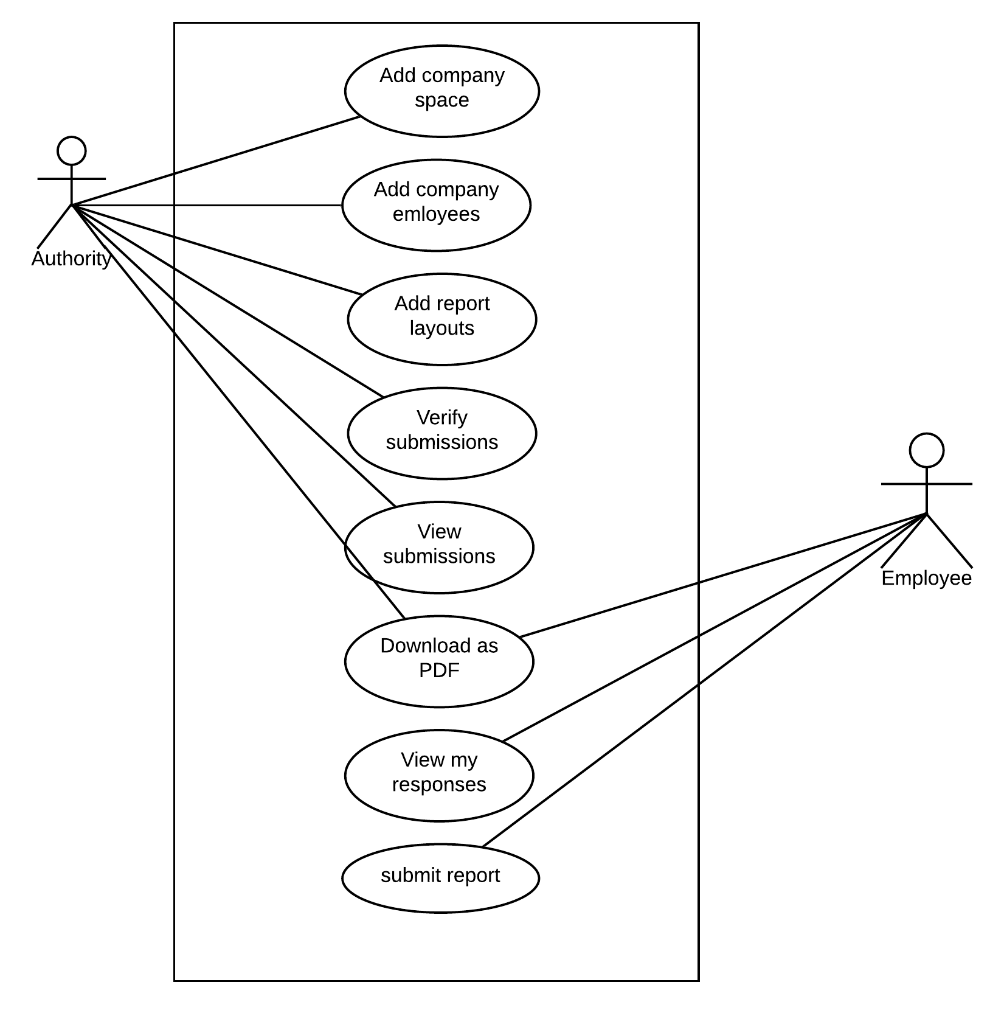

* 1. **Sequence Diagram**

1. **Authority**

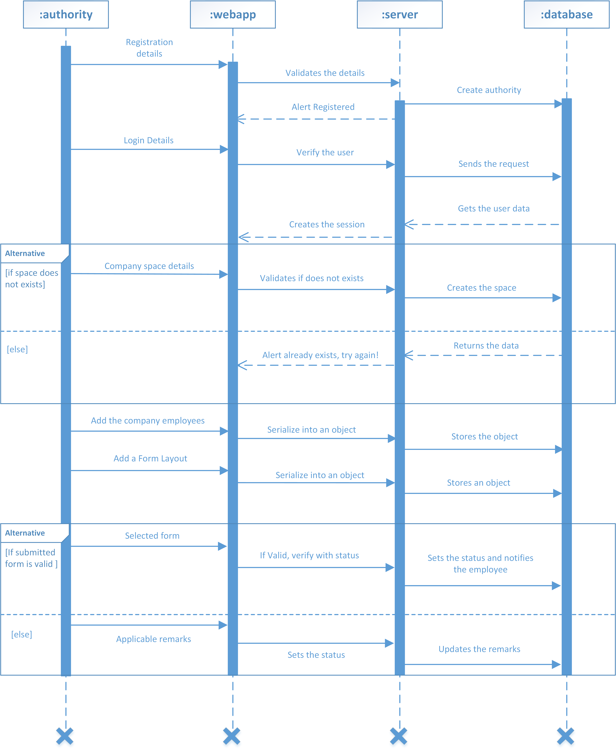

1. **Employee**

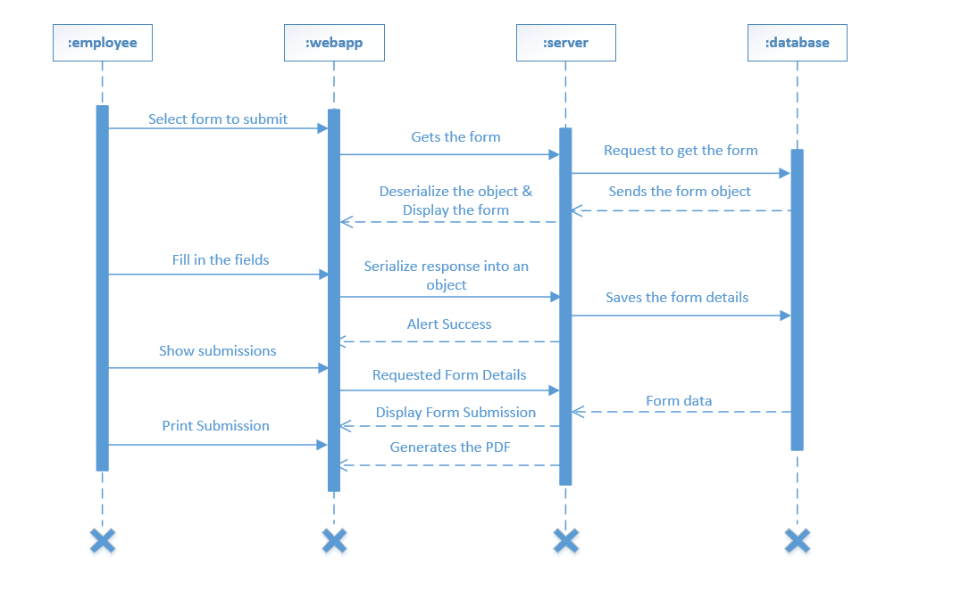

* 1. **Activity Diagram**

1. **Authority**

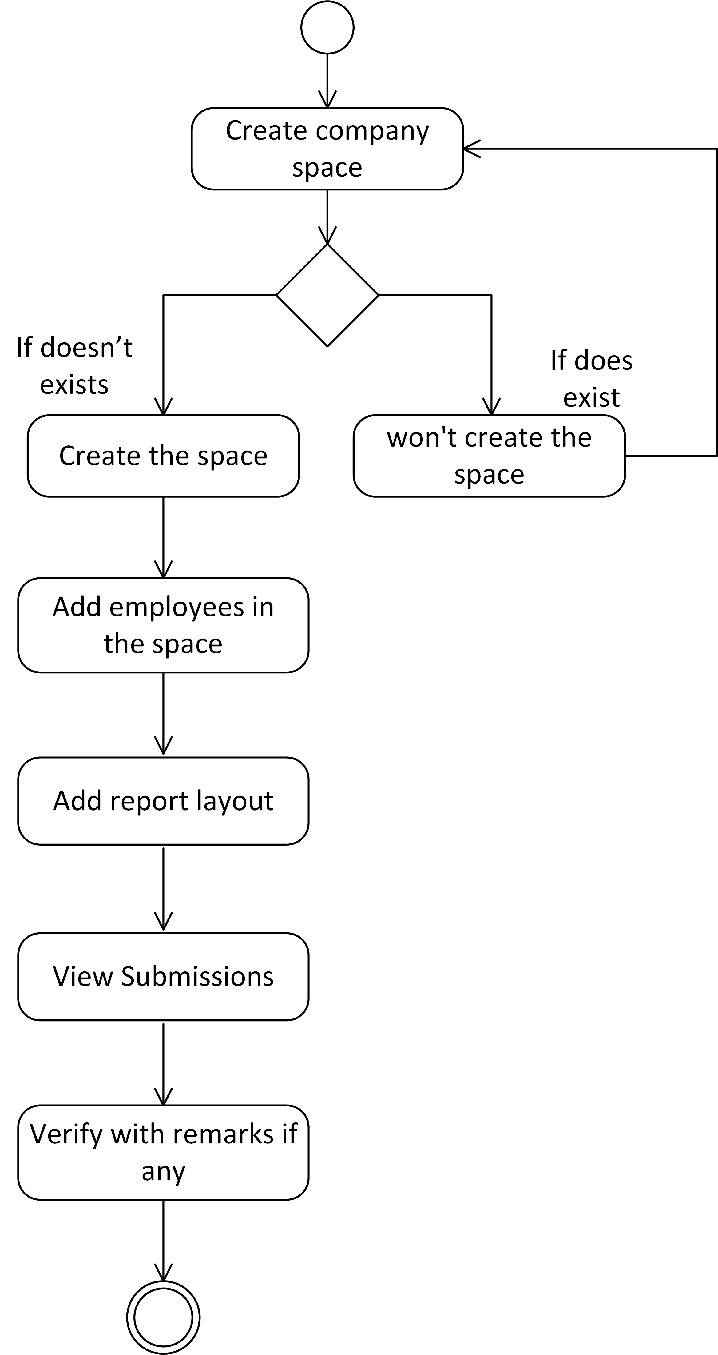

1. **Employee**

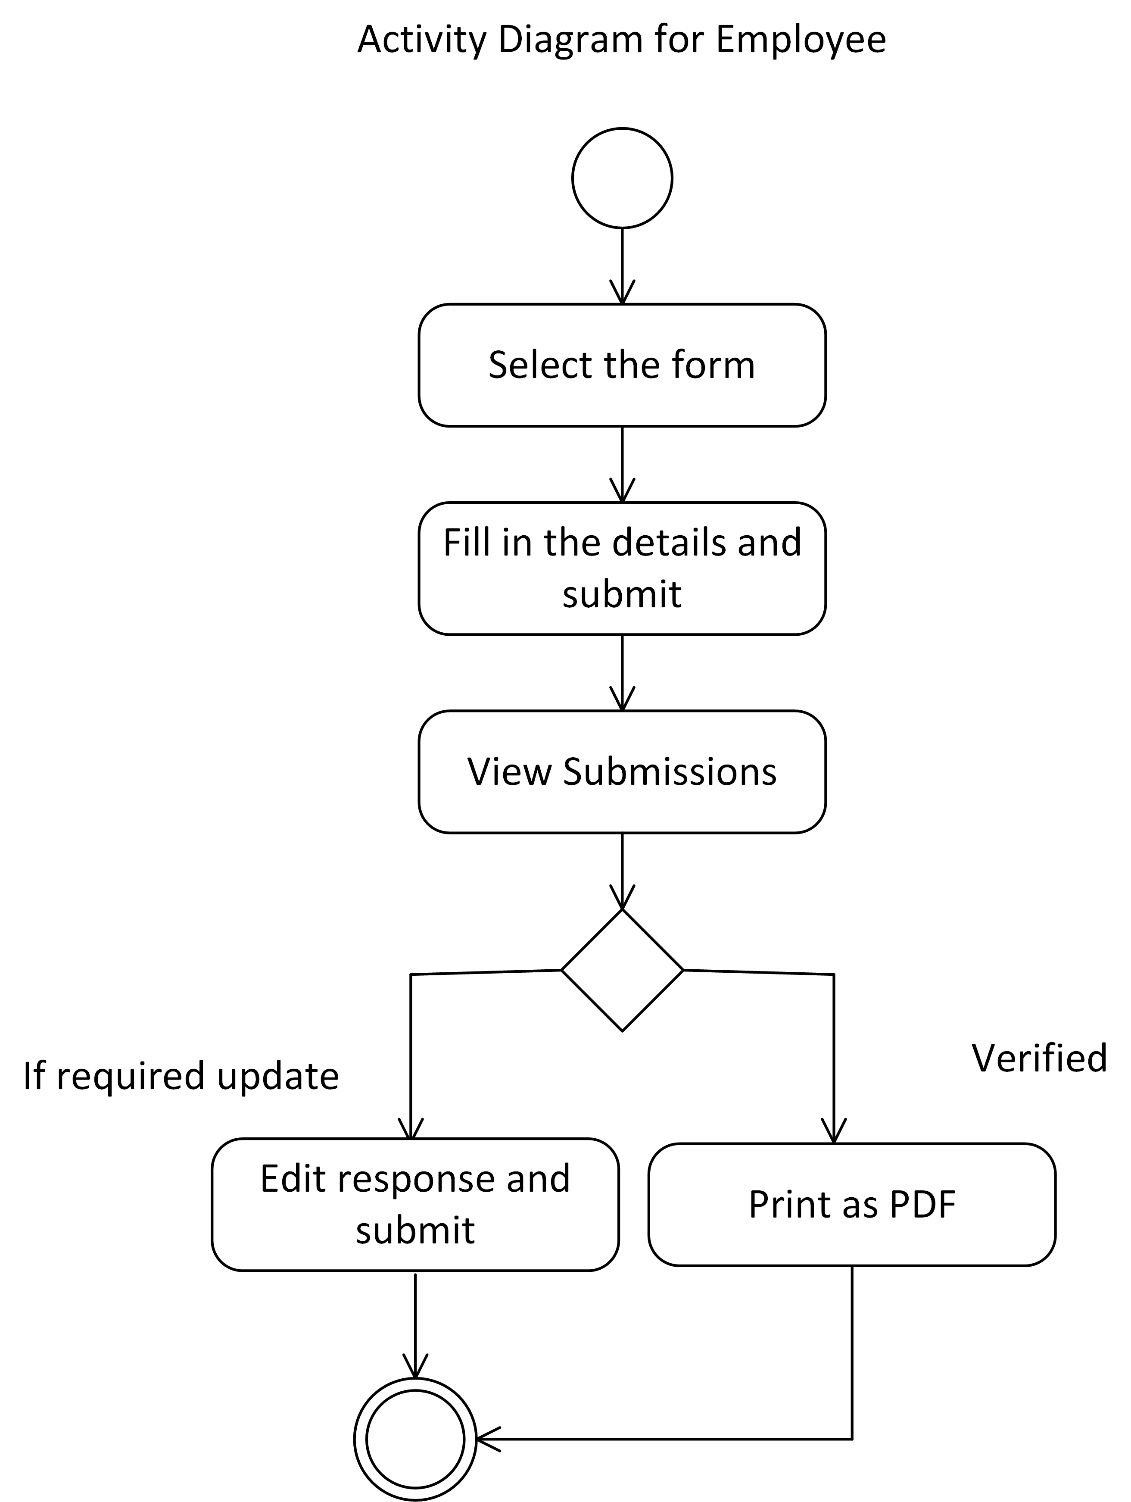

* 1. **ER Diagram (Crow’s foot database notation)**

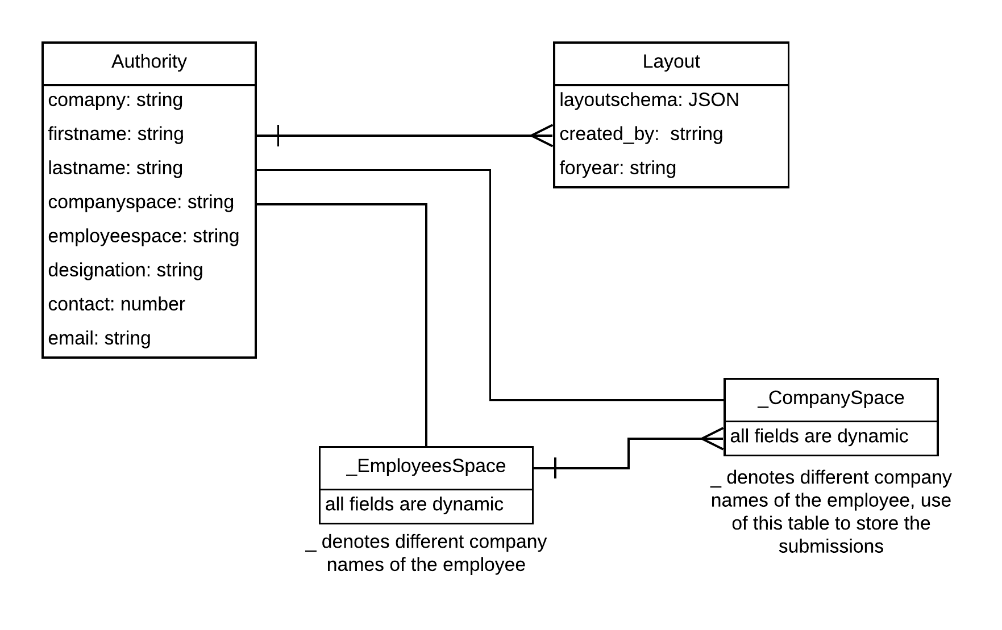

1. **Implementation Details**
   1. **Module Description**

* Login Module

This module takes credentials of various entities which are Authority and Employee. Depending on the credentials it’ll show the prompt if failed, or user will get logged in.

* Dynamic Report Generation Module

This module takes multiple inputs which are report for the year, how many fields required in the report, types of various fields etc. At the end it’ll generate report layout which was decided by the Authority.

* Submission Verification Module

This module helps the Authority to check employee report submissions by filtering with respective years. Also it helps to verify them and comment on them if any required.

* Report to PDF Module

This module takes the selected report and convert it to the PDF file. This module is usable by both entities.

* Submission Module

This module is designed for the employees, in which employees can fill the reports for the respective year which is designed by the authorities.

* Responses Module

This module is designed for the employees, in which employees can see their submitted responses with the verification status and comments if any which was reflected by the authority.

* CSV to Database Module

This module helps the Authority to upload the employee details through csv file, while converting each csv entries will be stored in the database as a record.

1. **Testing**
   1. **Test cases:**
2. Login

If the credentials are wrong, it’ll prompts the users with related message.

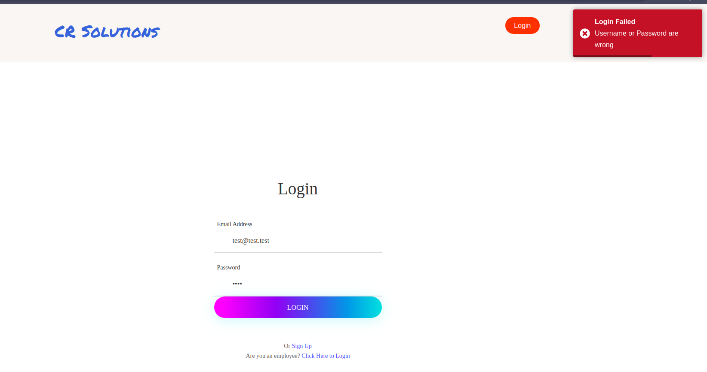

1. If the company space is already created, it’ll disable the create button.

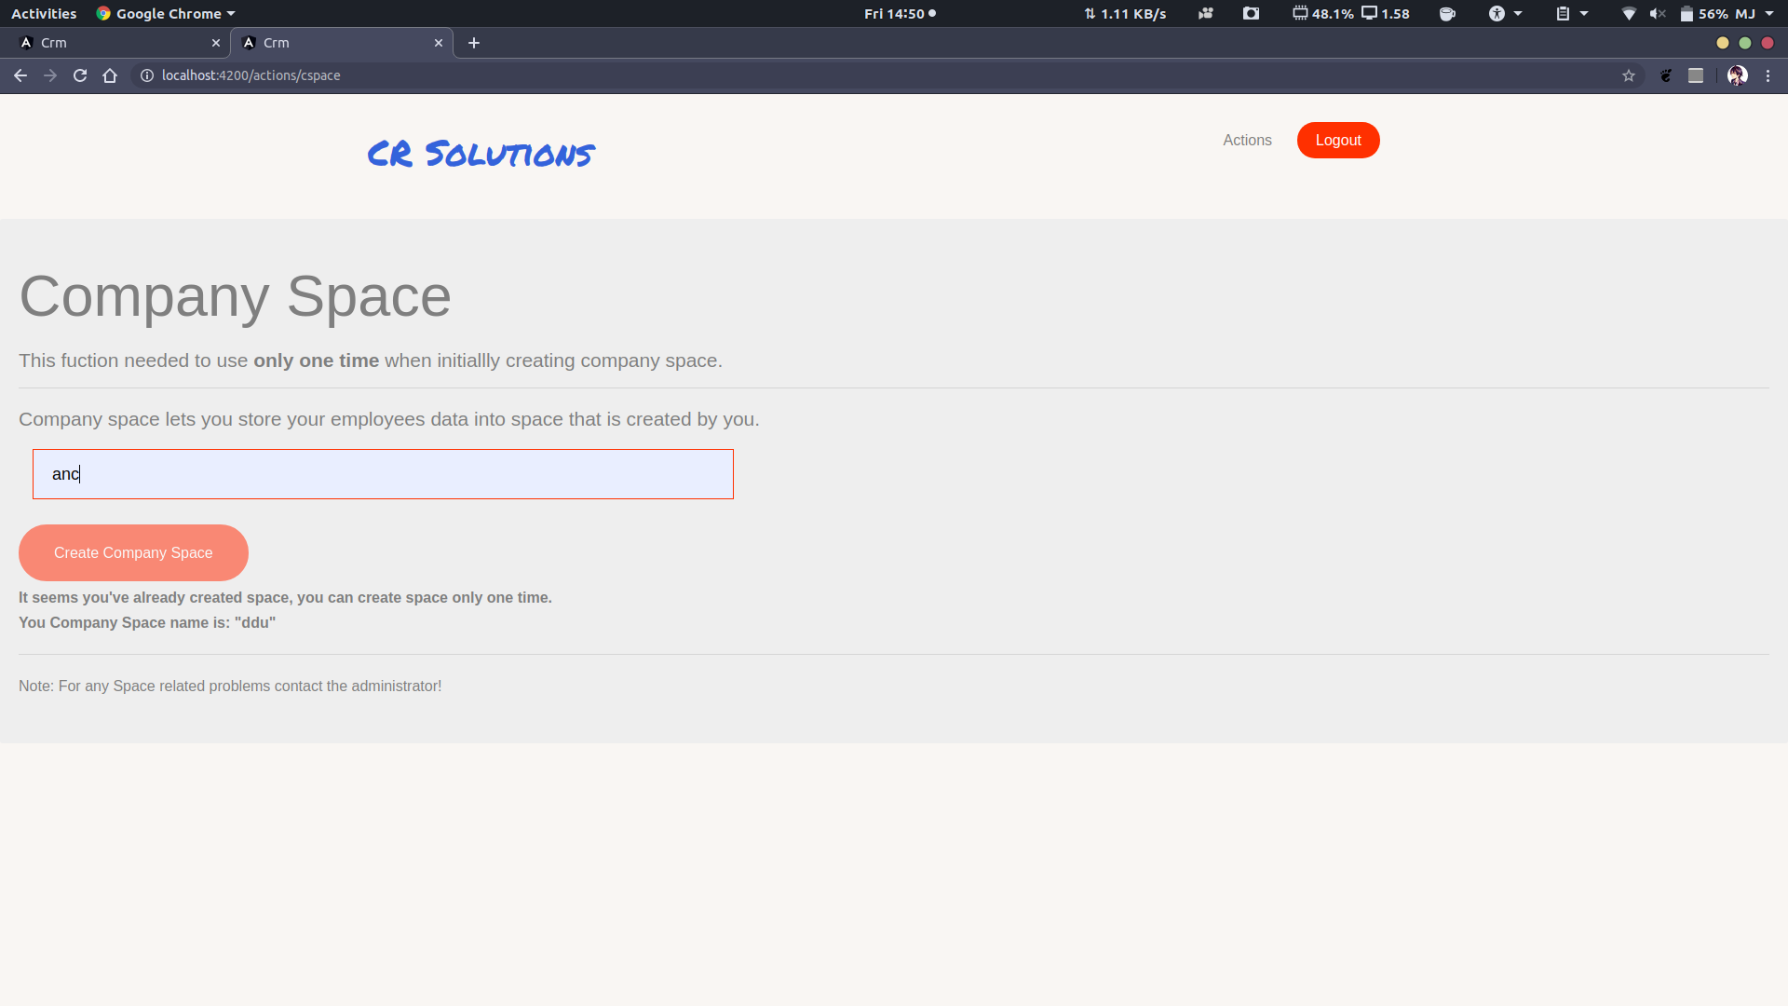

1. If the company space exists with same name, it won’t create new one with the same name.

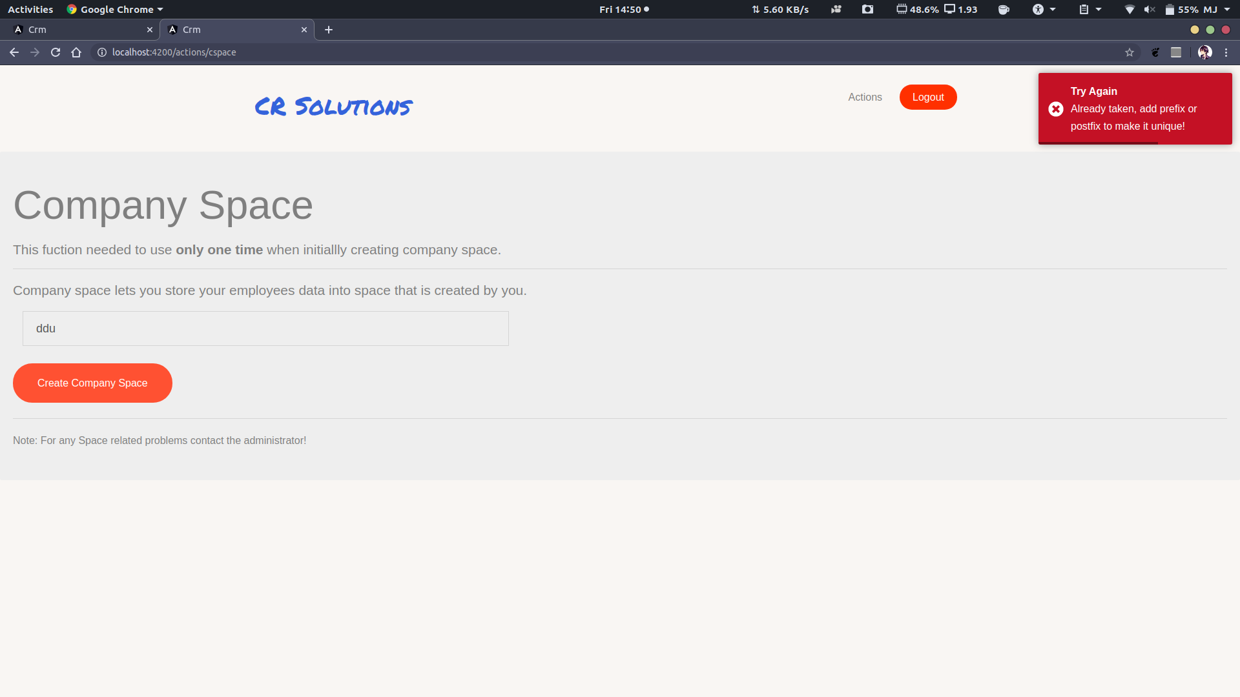

1. If user does not fill all the required fields and submits the report.

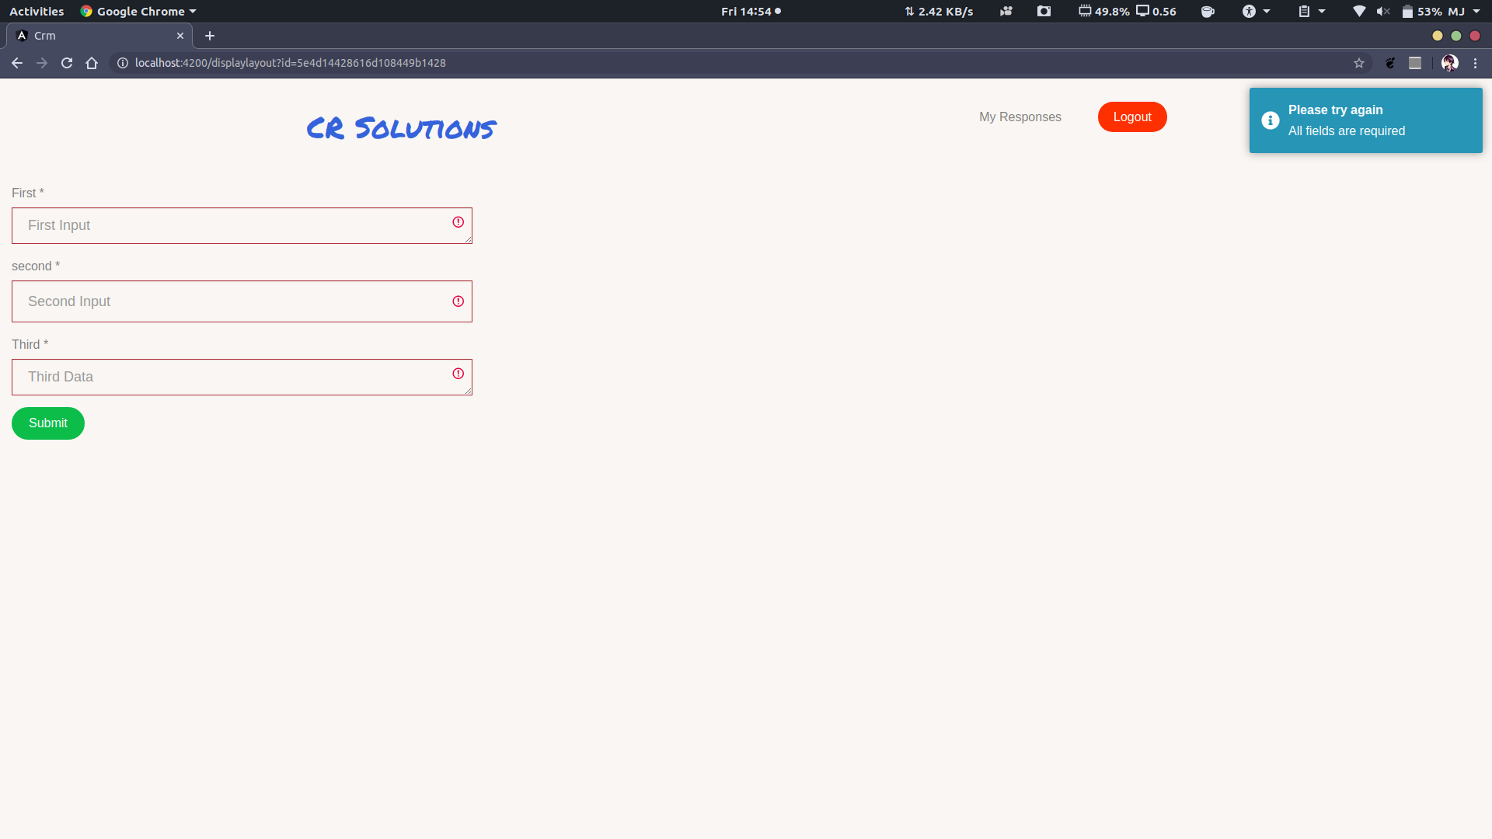

1. If user has already submitted the response, they can’t submit another response for the same report.

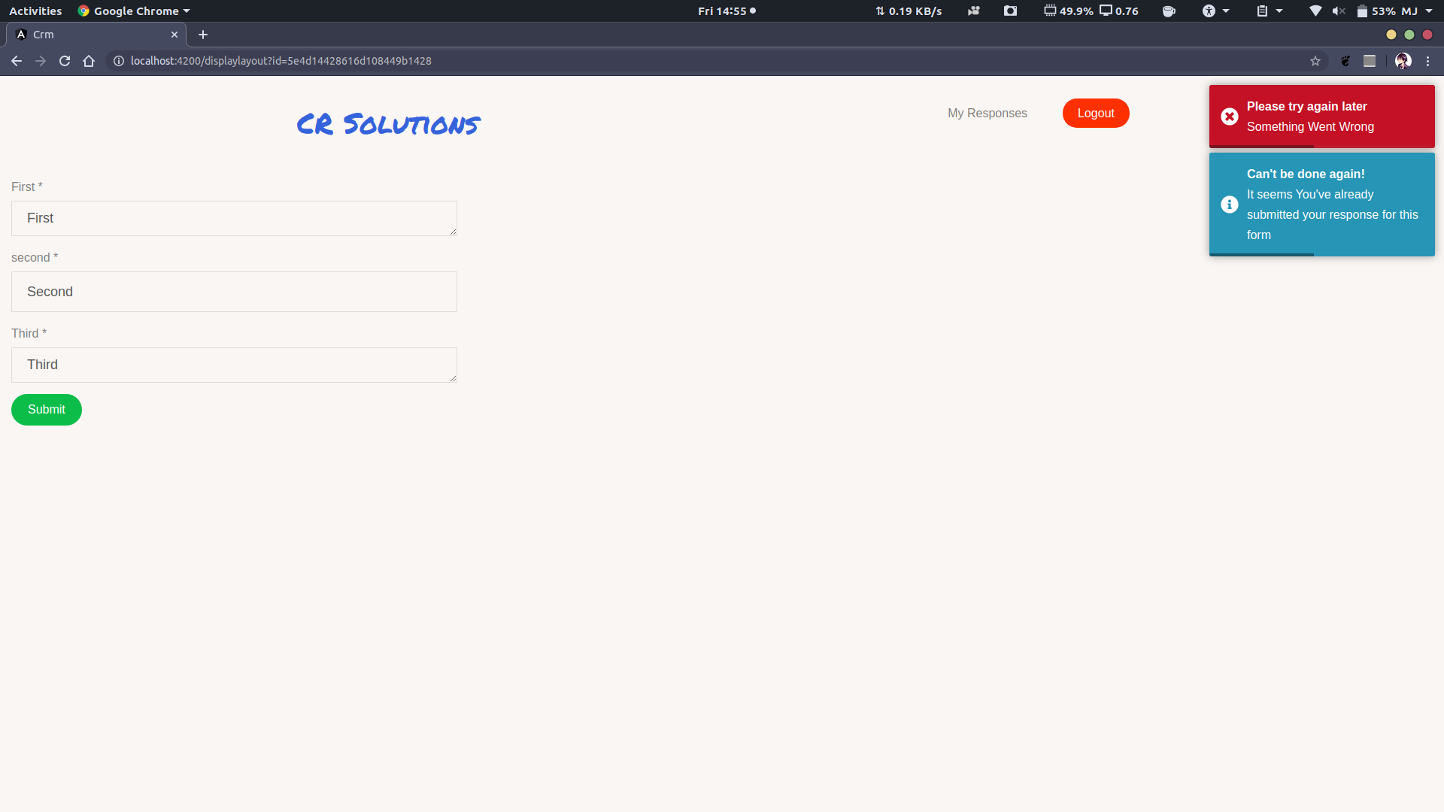

1. **Screenshots**
2. Login

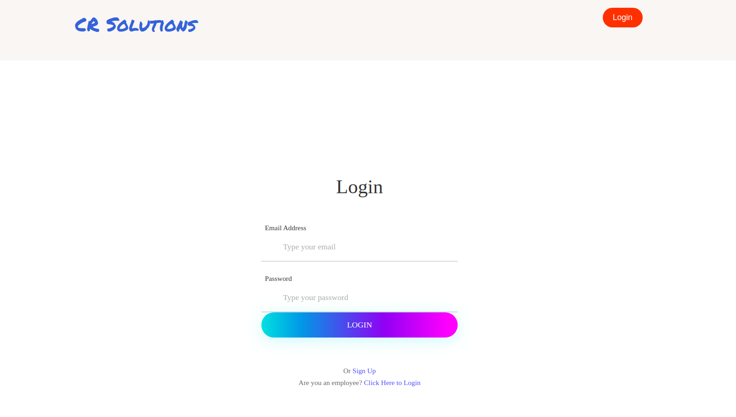

1. Register

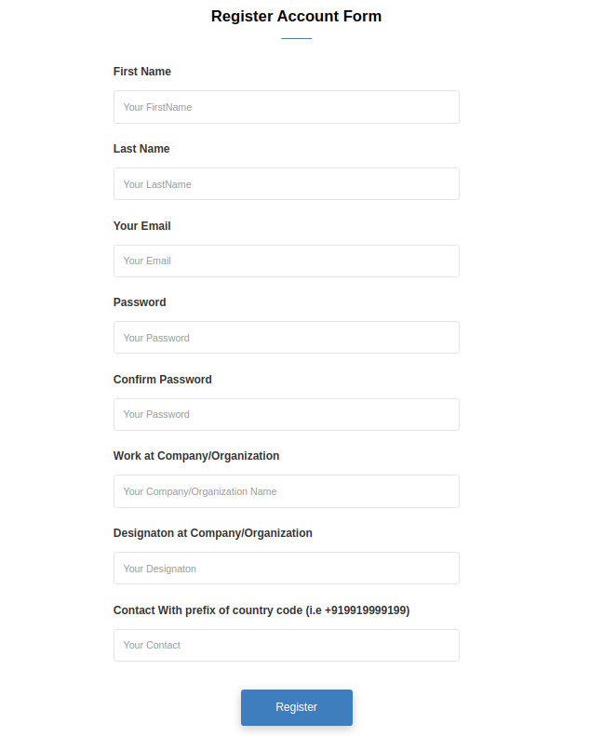

1. Actions Page

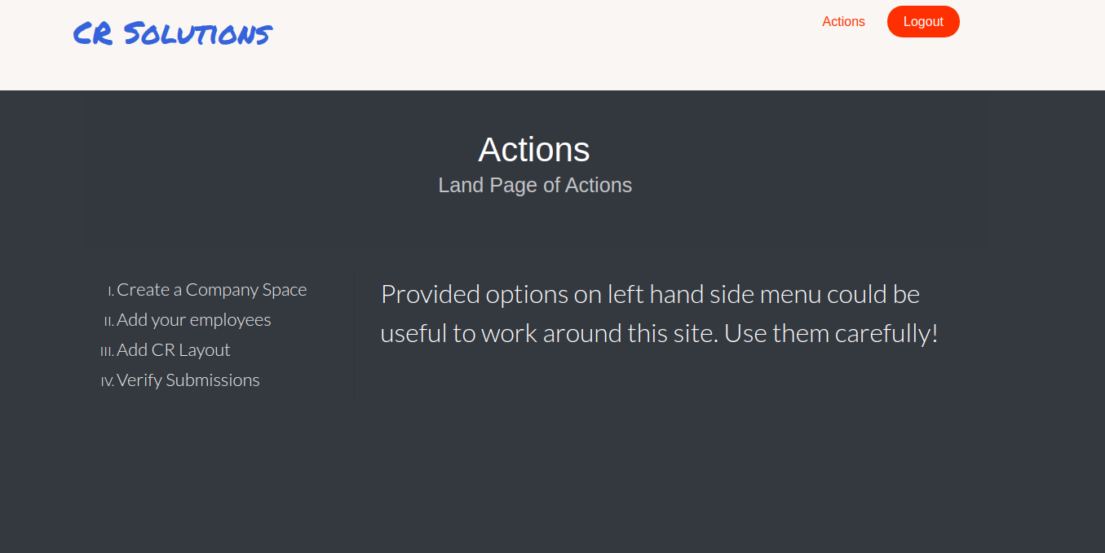

1. Adding employees

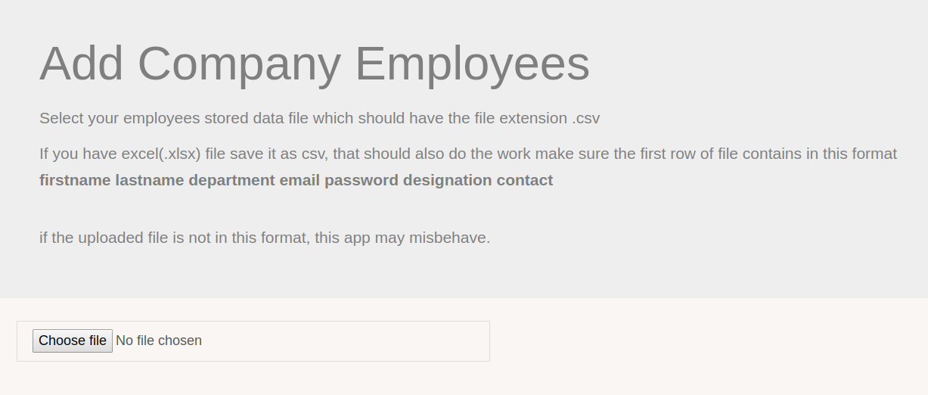

1. View Submissions

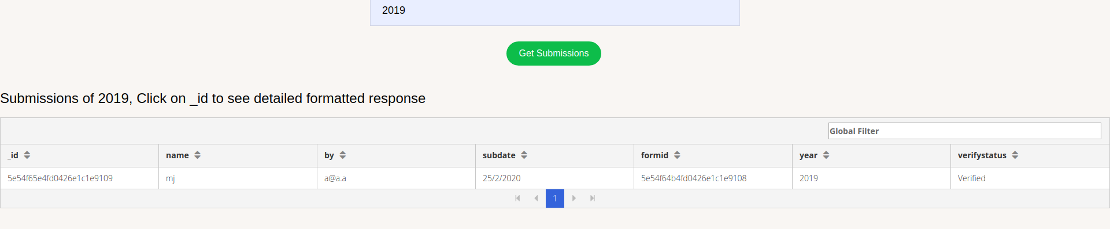

1. Detailed Submission View

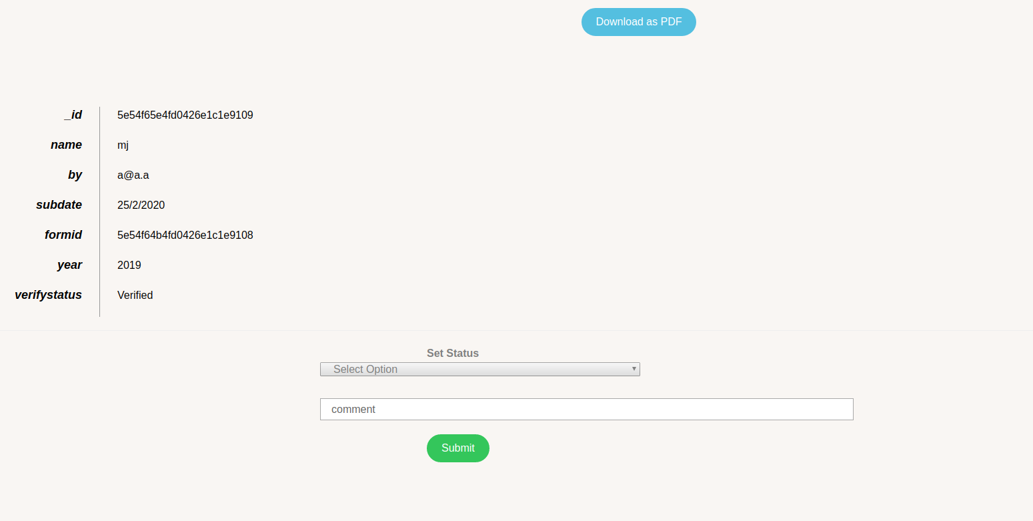

1. **Conclusion**

The functionality implemented in the system was done after understanding all the system modules according to requirements.

Functionality that is successfully implemented in the system is:

Login and Registration for all the entities

* Login and Registration functionalities for all the entities.
* Add company space.
* Add employees through .csv file.
* View employee submissions.
* Assigning verification status and comment if any for the submission.
* Downloading submission as PDF.
* Adding dynamic report form.
* Submission of yearly report form.
* Editing of yearly report form if necessary.
* View previous report submissions.

1. **Limitations and Future Enhancements**

* **Limitations:**
* While generating dynamic report layout, only two options for the fields are available which is text area and the text field.
* Only 10 fields can be added in dynamic report layout.
* **Future Extensions**
  + Adding more options for the fields of dynamic report which could be radio buttons, checkboxes and dropdown box.
  + Allowing more than 10 fields for the dynamic report layout.

**10.Bibliography**

* **Website**

<https://stackoverflow.com/>

<https://github.com/meet86/mean_crm>