Assignment-1

Name: Parmar Bhavik J.

- Create Table:

QUERY:

CREATE TABLE products (
product_id smallint NOT NULL PRIMARY KEY,
product_name character varying(40) NOT NULL,
supplier_id smallint,
category_id smallint,
quantity_per_unit character varying(20),
unit_price real,
units_in_stock smallint,
units_on_order smallint,
reorder_level smallint,
discontinued integer NOT NULL,
);

- Write a query to get a Product list (id, name, unit price) where current products cost less than $20.

QUERY:

SELECT product_id, product_name, unit_price FROM products WHERE unit_price<20;

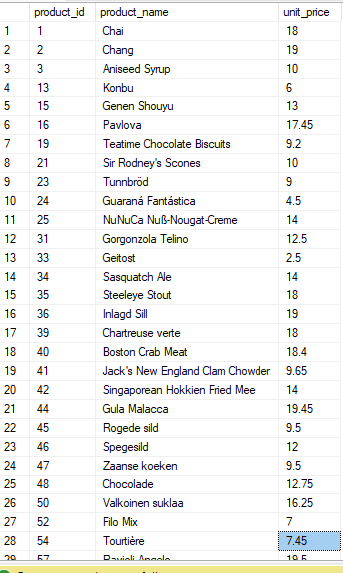

- Write a query to get Product list (id, name, unit price) where products cost between
$15 and $25.

QUERY:

SELECT product_id, product_name, unit_price FROM products WHERE unit_price BETWEEN 15 AND 25;
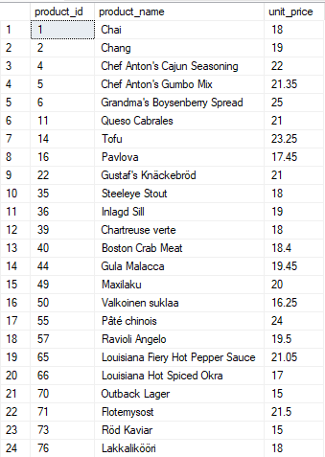

- Write a query to get Product list (name, unit price) of above average price.

QUERY:

SELECT product_id, product_name, unit_price FROM products WHERE unit_price>(SELECT AVG(unit_price) FROM products);
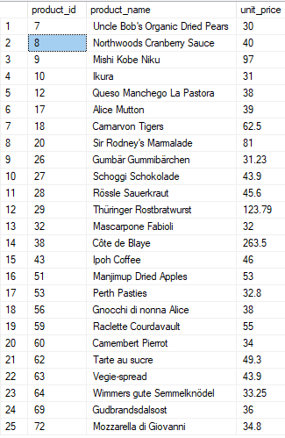

- Write a query to get Product list (name, unit price) of ten most expensive.

QUERY:

SELECT TOP 10 product_id, product_name, unit_price FROM products ORDER BY unit_price DESC;
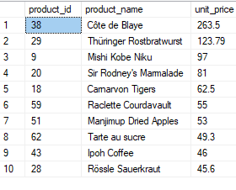

- Write a query to count current and discontinued products.

QUERY:

SELECT COUNT(product_id) from products group by discontinued;
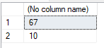

- Write a query to get Product list (name, units on order , units in stock) of stock is less than the quantity on order.

QUERY:

select product_name, units_in_stock, units_on_order from products where units_in_stock<units_on_order;
