**Assignment-1**

**Name: Parmar Bhavik J.**

* **Create Table:**

**QUERY**:

CREATE TABLE products (

product_id smallint NOT NULL PRIMARY KEY,

product_name character varying(40) NOT NULL,

supplier_id smallint,

category_id smallint,

quantity_per_unit character varying(20),

unit_price real,

units_in_stock smallint,

units_on_order smallint,

reorder_level smallint,

discontinued integer NOT NULL,

);

* **Write a query to get a Product list (id, name, unit price) where current products cost less than $20.**

**QUERY:**

SELECT product_id, product_name, unit_price FROM products WHERE unit_price<20;

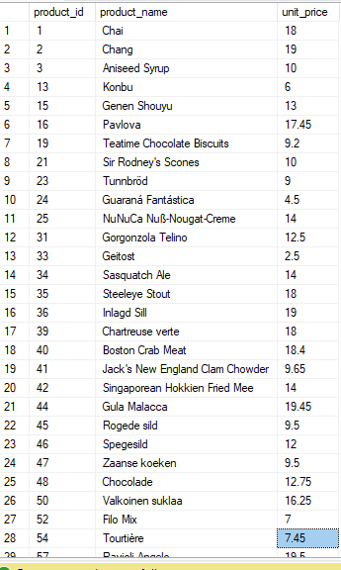

* **Write a query to get Product list (id, name, unit price) where products cost between**

**$15 and $25.**

**QUERY:**

SELECT product_id, product_name, unit_price FROM products WHERE unit_price BETWEEN 15 AND 25;

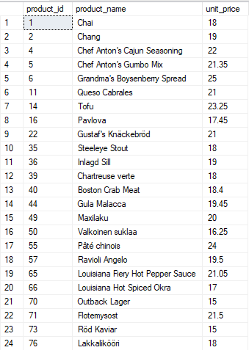

* **Write a query to get Product list (name, unit price) of above average price.**

**QUERY:**

SELECT product_id, product_name, unit_price FROM products WHERE unit_price>(SELECT AVG(unit_price) FROM products);

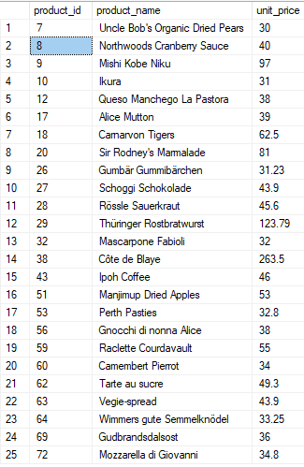

* **Write a query to get Product list (name, unit price) of ten most expensive.**

**QUERY:**

SELECT TOP 10 product_id, product_name, unit_price FROM products ORDER BY unit_price DESC;

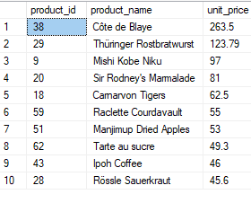

* **Write a query to count current and discontinued products.**

**QUERY:**

SELECT COUNT(product_id) from products group by discontinued;

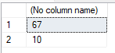

* **Write a query to get Product list (name, units on order , units in stock) of stock is less than the quantity on order.**

**QUERY:**

select product_name, units_in_stock, units_on_order from products where units_in_stock<units_on_order;

