**Assignment-2**

**Name: Parmar Bhavik J.**

* **Create Table:**

**QUERY**:

* **Salesman Table**

CREATE TABLE salesman(

salesman_id int NOT NULL PRIMARY KEY,

name nvarchar(50) NOT NULL,

city nvarchar(50),

commission int,

)

* **Customer Table**

CREATE TABLE customer(

customer_id int NOT NULL PRIMARY KEY,

cust_name nvarchar(50),

city nvarchar(50),

grade int,

salesman_id int,

);

ALTER TABLE customer

ADD FOREIGN KEY (salesman_id) REFERENCES salesman(salesman_id);

* **Order Table**

**CREATE** TABLE orders(

ord_no int NOT NULL PRIMARY KEY,

purch_amt money NOT NULL,

ord_date date NOT NULL,

customer_id int NOT NULL,

salesman_id int NOT NULL,

FOREIGN KEY (customer_id) REFERENCES customer(customer_id),

FOREIGN KEY (salesman_id) REFERENCES salesman(salesman_id),

);

* **write a SQL query to find the salesperson and customer who reside in the same city. Return Salesman, cust_name and city.**

**QUERY:**

SELECT s.name, c.cust_name, s.city

**FROM salesman s inner join customer c on s.city=c.city;**

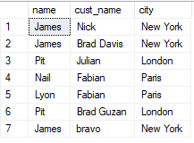

* **write a SQL query to find those orders where the order amount exists between 500 and 2000. Return ord_no, purch_amt, cust_name, city.**

**QUERY:**

SELECT o.ord_no, o.purch_amt ,c.cust_name, c.city

FROM customer c inner join orders o on c.customer_id=o.customer_id

WHERE o.purch_amt BETWEEN 500 AND 2000;

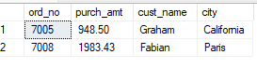

* **write a SQL query to find the salesperson(s) and the customer(s) he represents.Return Customer Name, city, Salesman, commission**

**QUERY:**

SELECT s.name, c.cust_name AS "Costomer Name", s.city , s.name,s.commission

**FROM salesman s inner join customer c on s.salesman_id=c.salesman_id;**

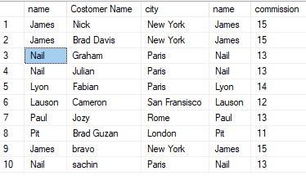

* **write a SQL query to find salespeople who received commissions of more than 12 percent from the company. Return Customer Name, customer city, Salesman,commission.**

**QUERY:**

**SELECT s.name, c.cust_name AS "Costomer Name", s.city , s.name,s.commission FROM salesman s inner join customer c on s.salesman_id=c.salesman_id WHERE s.commission>12;**

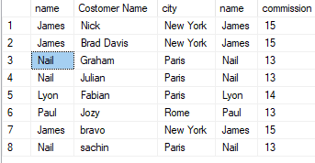

* **write a SQL query to locate those salespeople who do not live in the same city where their customers live and have received a commission of more than 12% from the company. Return Customer Name, customer city, Salesman, salesman city,commission.**

**QUERY:**

**SELECT s.name, c.cust_name AS "Costomer Name", c.city as "customer city" , s.name, s.city as "salesman city",s.commission** FROM salesman s inner join customer c on s.salesman_id=c.salesman_id **WHERE S.commission>12 AND s.city ! = c.city;**

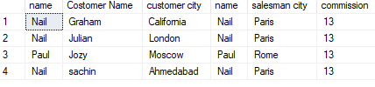

* **write a SQL query to find the details of an order. Return ord_no, ord_date, purch_amt, Customer Name, grade, Salesman, commission.**

**QUERY:**

**SELECT o.ord_no, o.ord_date , o.purch_amt , c.cust_name as "Customer Name" , c.grade , s.name as "Salesman Name", s.commission** FROM orders o inner join customer c on o.customer_id = c.customer_id inner join salesman s on o.salesman_id = s.salesman_id;

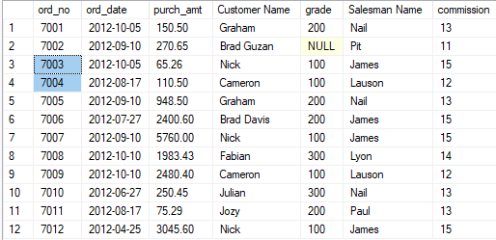

* **Write a SQL statement to join the tables salesman, customer and orders so that the same column of each table appears once and only the relational rows are returned.**

**QUERY:**

**SELECT** o.* , c.cust_name as "customer name" , c.city as "customer city" , c.grade , s.name as "salesman name" , s.city as "salesman city" , s.commission FROM orders o inner join customer c on o.customer_id = c.customer_id inner join salesman s on o.salesman_id = s.salesman_id;

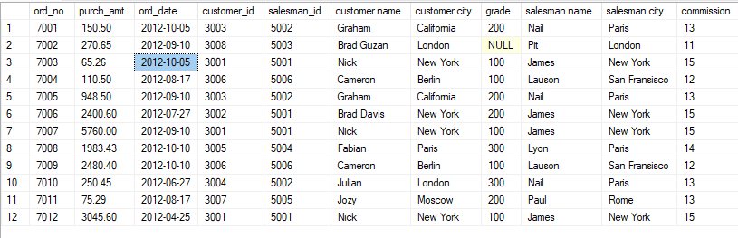

* **write a SQL query to display the customer name, customer city, grade, salesman, salesman city. The results should be sorted by ascending customer_id.**

**QUERY:**

SELECT c.cust_name as "cutomer name", c.city as "customer city" , c.grade , s.name as "salesman name" , s.city as "salesman city" FROM salesman s inner join customer c on s.salesman_id=c.salesman_id **order by c.customer_id asc;**

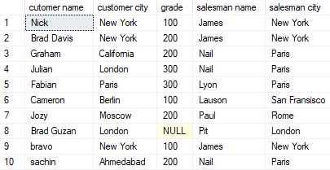

* **write a SQL query to find those customers with a grade less than 300. Return**

**cust_name, customer city, grade, Salesman, salesmancity. The result should be**

**ordered by ascending customer_id.**

**QUERY:**

**SELECT** c.cust_name as "cutomer name", c.city as "customer city" , c.grade , s.name as "salesman name" , s.city as "salesman city"

FROM salesman s inner join customer c on s.salesman_id=c.salesman_id

WHERE c.grade<300

order by c.customer_id asc;

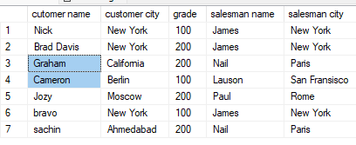

* **Write a SQL statement to make a report with customer name, city, order number, order date, and order amount in ascending order according to the order date to determine whether any of the existing customers have placed an order or not**

**QUERY:**

**SELECT** c.cust_name as "customer name" , c.city as "customer city" , o.ord_no , o.ord_date , o.purch_amt as "Order Amount"

FROM customer c left outer join orders o on c.customer_id=o.customer_id

order by o.ord_date;

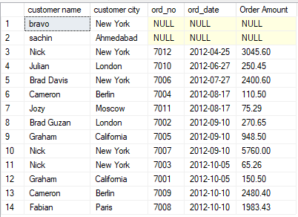

* **Write a SQL statement to generate a report with customer name, city, order number, order date, order amount, salesperson name, and commission to determine if any of the existing customers have not placed orders or if they have placed orders through their salesman or by themselves**

**QUERY:**

**SELECT** c.cust_name as "customer name" , c.city as "customer city" , o.ord_no , o.ord_date , o.purch_amt as "Order Amount" , s.name as "salesman name" , s.commission FROM customer c left outer join orders o on c.customer_id=o.customer_id left outer join salesman s on o.salesman_id = s.salesman_id;

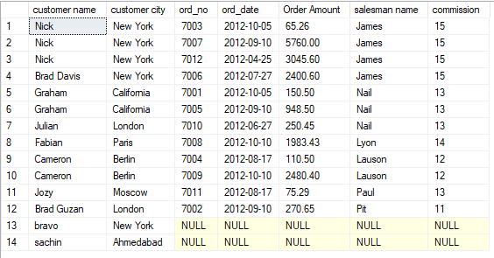

* **Write a SQL statement to generate a list in ascending order of salespersons who**

**work either for one or more customers or have not yet joined any of the customers**

**QUERY:**

**SELECT** s.*,c.cust_name as "customer name" FROM salesman s left outer join customer c on s.salesman_id=c.salesman_id **order by s.salesman_id asc;**

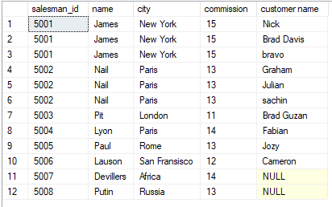

* **write a SQL query to list all salespersons along with customer name, city, grade,**

**order number, date, and amount.**

**QUERY:**

**Select** s.*, c.cust_name as 'Customer Name', c.city as 'Customer City', c.grade, o.ord_no, o.ord_date, o.purch_amt from salesman s

Inner Join customer c On s.salesman_id = c.salesman_id

**Inner Join orders o On s.salesman_id = o.salesman_id;**

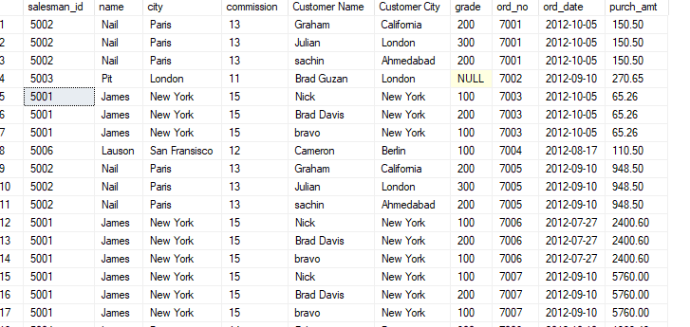

* **Write a SQL statement to make a list for the salesmen who either work for one or more customers or yet to join any of the customers. The customer may have placed, either one or more orders on or above order amount 2000 and must have a grade, or he may not have placed any order to the associated supplier.**

**QUERY:**

**Select** s.*, c.cust_name as 'Customer Name', c.city as 'Customer City', c.grade, o.ord_no, o.ord_date, o.purch_amt from salesman s

right outer Join customer c On s.salesman_id = c.salesman_id

**left outer Join orders o On c.customer_id = o.customer_id**

**where o.purch_amt > 2000 And c.grade Is Not NULL;**

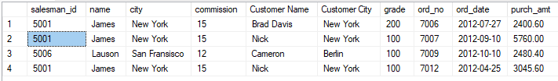

* **Write a SQL statement to generate a list of all the salesmen who either work for one or more customers or have yet to join any of them. The customer may have placed one or more orders at or above order amount 2000, and must have a grade, or he may not have placed any orders to the associated supplier.**

**QUERY:**

**Select** s.*, c.cust_name as 'Customer Name', c.city as 'Customer City', c.grade, o.ord_no, o.ord_date, o.purch_amt from salesman s

right outer Join customer c On s.salesman_id = c.salesman_id

**left outer Join orders o On c.customer_id = o.customer_id**

**where o.purch_amt > 2000 And c.grade Is Not NULL;**



* **Write a SQL statement to generate a report with the customer name, city, order no. order date, purchase amount for only those customers on the list who must have a grade and placed one or more orders or which order(s) have been placed by the customer who neither is on the list nor has a grade.**

**QUERY:**

**SELECT** c.cust_name,c.city, o.ord_no, o.ord_date,o.purch_amt AS "Order Amount"

FROM customer c FULL OUTER JOIN orders o ON c.customer_id=o.customer_id

WHERE c.grade IS NOT NULL;

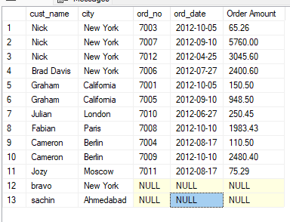

* **Write a SQL query to combine each row of the salesman table with each row of the customer table.**

**QUERY:**

select * from salesman s cross join customer c;

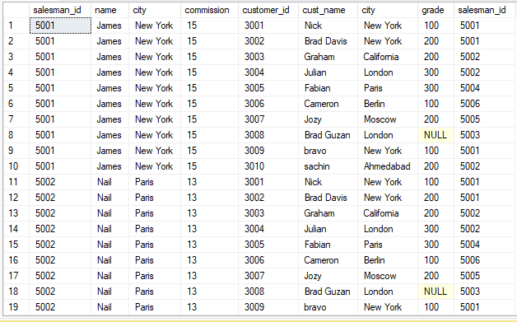

* **Write a SQL statement to create a Cartesian product between salesperson and**

**customer, i.e. each salesperson will appear for all customers and vice versa for that**

**salesperson who belongs to that city**

**QUERY:**

**select** * from salesman s cross join customer c

where s.city = c.city;

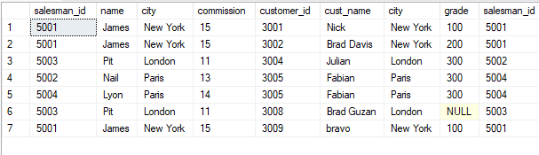

* **Write a SQL statement to create a Cartesian product between salesperson and**

**customer, i.e. each salesperson will appear for every customer and vice versa for**

**those salesmen who belong to a city and customers who require a grade**

**QUERY:**

**select** * from salesman s cross join customer c

where s.city = c.city and c.grade is not null;

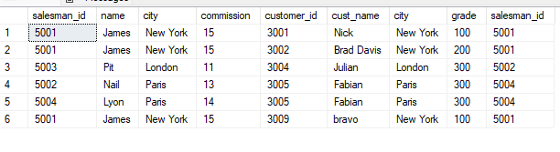

* **Write a SQL statement to make a Cartesian product between salesman and**

**customer i.e. each salesman will appear for all customers and vice versa for those**

**salesmen who must belong to a city which is not the same as his customer and the**

**customers should have their own grade**

**QUERY:**

**select** * from salesman s cross join customer c

where s.city != c.city and c.grade is not null;

