# Network Topology:

The arrangement of a network which comprises of nodes and connecting lines via sender and receiver is referred as network topology. The various network topologies are:

# Mesh Topology:

➔ A mesh topology, every device has a **dedicated point-to-point** link to every other device.

➔ The term dedicated means that the link carries traffic only between the two devices it connects.

➔ If suppose, N number of devices are connected with each other in mesh topology, then total number of ports that is required by each device is N-

* 1. In the Figure , there are 5 devices connected to each other, hence total number of ports required is 4.

➔ If suppose, N number of devices are connected with each other in mesh topology, then total number of dedicated links required to connect them is NC2 i.e. N(N-1)/2. In the Figure , there are 5 devices connected to each other, hence total number of links required is 5*4/2 = 10.

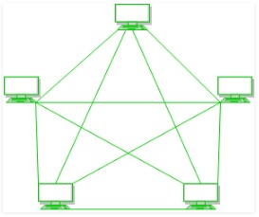

# Every device is connected with another via dedicated channels. These channels are known as links.

**Advantages:**

* No traffic problem as there are dedicated links.
* Robust as failure of one link does not affect the entire system.
* Security as data travels along a dedication easy
* Point to point links mark fault identification easy
* Provides security and privacy.

# Disadvantages:

* There is mesh of wiring which can be difficult to manage
* Installation and configuration is difficult.
* Cost of cables is high as bulk wiring is required, hence suitable for less number of devices.
* Cost of maintenance is high.

# Bus Topology:

➔ Physical Bus Network Topology is the simplest and most widely used of the network designs.

➔ It consists of one continuous length of cable (trunk) and a terminating resistor (terminator) at each end.

➔ Data communication message travels along the bus in both directions until it is picked up by a workstation or server NIC.

➔ If the message is missed or not recognized, it reaches the end of the cabling and dispelled at the terminator.

➔ Bus Network Topology requires a multipoint connection.

➔ All nodes on the bus topology have equal access to the trunk

➔ This is accomplished using short drop cables or direct T-connectors.

➔ The number of devices and the length of the trunk can be easily expanded.

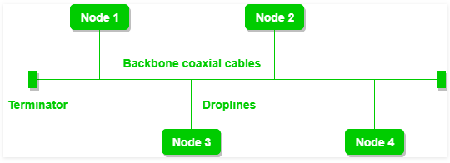

# A bus topology with shared backbone cable. The nodes are connected to the channel via drop lines

**Advantages:**

* It uses established standards and it is relatively easy to install.
* It requires a less media than other topologies.
* Cost of the cable is less as compared to other topology, but it is used to built small networks (LAN).
* Does not require any special networking device

# Disadvantages:

* The bus networks are difficult to reconfigure, especially when the acceptable number of connections or maximum distance have been reached.
* If the common cable fails, then the whole system will crash down.
* If the network traffic is heavy, it increases collisions in the network.

# Star Topology:

➔ Physical star Network Topology is the most widely used of the network designs.

➔ It uses a central controlling hub / switch with dedicated pointing in all directions like points of a star.

➔ Each network device has a dedicated point-to-point link t the central hub.

➔ This strategy prevents troublesome collisions and keeps the lines of communications open and free of traffic This Network Topology, obviously, require a great deal cabling.

➔ This design provides an excellent platform for reconfiguration and trouble- shooting.

➔ Changes to the network are as simple as plugging another segment into the hub and a break in the LAN is easy to isolate and doesn’t affect the rest of the network.

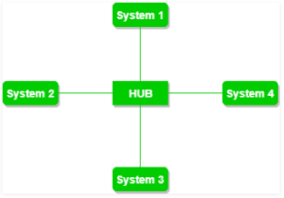

# A star topology having four systems connected to single point of connection i.e. hub

**Advantages:**

* Relatively easy to configure. If N devices are connected to each other in star topology, then the number of cables required to connect them is N. So, it is easy to set up.
* Easy to troubleshoot
* Media faults are automatically isolated to the fail segment.
* Each device requires only 1 port i.e. to connect to the hub.
* Used in big network
* Easily add and remove devices

# Disadvantages

* If the concentrator (hub) on which the whole topology relies fails, the whole system will crash down.
* Cost of installation is high.
* Performance is based on the single concentrator i.e. hub.

# Ring Topology:

➔ The physical ring Network Topology is a circular loop of point-to-point links.

➔ In this topology, it forms a ring connecting a devices with its exactly two neighbouring devices.

➔ Each device connects directly to the ring or indirectly through an interface device or drop cable.

➔ Message travel around the ring from node to node in a very organized manner.

➔ Each workstation checks the message for a matching destination address.

➔ If the address doesn't match the node simply regenerates the message and sends it on its way.

➔ If the address matches, the node accepts the message and sends a reply to the originating sender.

➔ The following operations takes place in ring topology are :

➔ One station is known as **monitor** station which takes all the responsibility to perform the operations.

➔ To transmit the data, station has to hold the token. After the transmission is done, the token is to be released for other stations to use.

➔ When no station is transmitting the data, then the token will circulate in the ring.

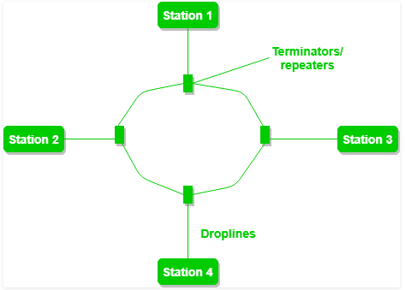

# A ring topology comprises of 4 stations connected with each forming a ring

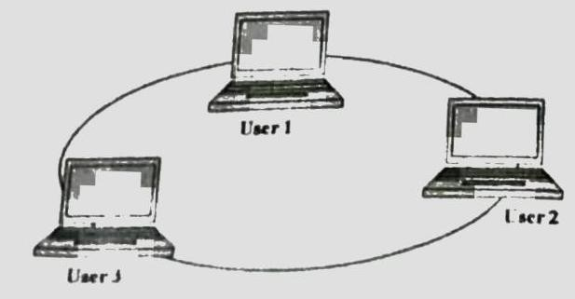

**Advantages:**

* They are very easy to troubleshoot because each device incorporates a repeater.
* A special internal feature called beaconing allows troubled workstations to identify themselves quickly.The possibility of collision is minimum in this type of topology.

# Disadvantages:

* It is considerably difficult to install and reconfigure ring Network Topology
* Media failure on unidirectional or single loop causes complete network failure.
* Addition of stations in between or removal of stations can disturb the whole topology.

# Tree Topology:

➔ Tree Topology integrates the characteristics of Star and [Bus Topology](http://www.ianswer4u.com/2011/05/bus-topology-advantages-and.html).

➔ In Tree Topology, the number of Star networks is connected using Bus.

➔ This main cable seems like a main stem of a tree, and other star networks as the branches.

➔ It is also called **Expanded Star Topology**.

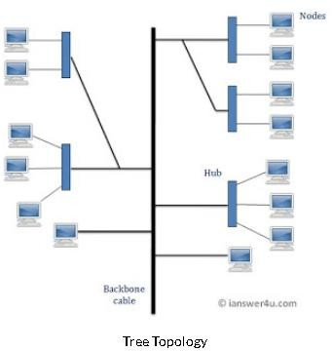

# Advantages

* It is an extension of Star and bus Topologies, so in networks where these topologies can't be implemented individually for reasons related to scalability, tree topology is the best alternative.
* Expansion of Network is possible and easy.
* Here, we divide the whole network into segments (star networks), which can be easily managed and maintained.
* Error detection and correction is easy.
* Each segment is provided with dedicated point-to-point wiring to the central hub.
* If one segment is damaged, other segments are not affected.

# Disadvantages

* Because of its basic structure, tree topology, relies heavily on the main bus cable, if it breaks whole network is crippled.
* As more and more nodes and segments are added, the maintenance becomes difficult.

# Hybrid Topology:

➔ The hybrid Network topology is a type of network that is composed of one or more interconnection of two or more networks that are based upon different physical topologies.

➔ This topology is a collection of two or more topologies which are described above. This is a scalable topology which can be expanded easily. It is reliable one but at the same it is a costly topology.

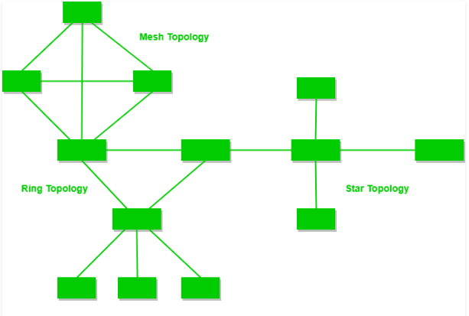

# A hybrid topology which is a combination of ring and star topology.