**What is IIS - Internet Information Server**

**Internet Information Server**

Internet Information Server (IIS) is one of the most popular web servers from Microsoft that is used to host and provide Internet-based services to ASP.NET and ASP Web applications. A web server is responsible for providing a response to requests that come from users. When a request comes from client to server IIS takes that request from users and process it and send response back to users.

Internet Information Server (IIS) has it's own ASP.NET Process Engine to handle the ASP.NET request. The way you configure an ASP.NET application depends on what version of IIS the application is running on.



Internet Information Server (IIS) includes a set of programs for building and administering Web applications, search engines, and support for writing Web-based applications that access databases such as SQL Server. With IIS, you can make your computer to work as a Web server and provides the functionality to develop and deploy ASP.NET Web applications on the server. You can also set security for a particular Website for specific Users and Computer in order to protect it from unauthorized access.

**What is Virtual Directory**

**Virtual Directory**

A virtual directory is a directory name that you specify in IIS and map to physical directory on a local server's hard drive or a directory on another server (remote server). You can use Internet Information Services Manager to create a virtual directory for an ASP.NET Web application that is hosted in IIS.

The virtual directory name becomes part of the application's URL. It is a friendly name, or alias because an alias is usually shorter than the real path of the physical directory and it is more convenient for users to type. A virtual directory receives queries and directs them to the appropriate backend identity repositories. It integrates identity data from multiple heterogeneous data stores and presents it as though it were coming from one source.

How to create a virtual directory by using IIS Manager

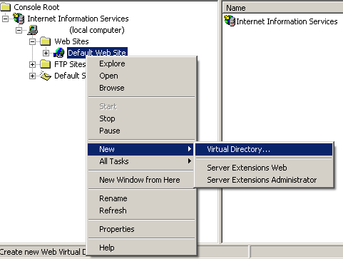

1. In IIS Manager, expand the local computer and the Web site to which you want to add a virtual directory.

2. Right-click the site or folder in which you want to create the virtual directory, click New, and then click Virtual Directory.

3. In the Add Virtual Directory dialog box, at a minimum enter information in the Alias and Physical path and then click OK.

By default, Internet Information Server uses configuration from Web.config files in the physical directory to which the virtual directory is mapped, as well as in any child directories in that physical directory