The web.config File
The web.config file uses a predefined XML format. The entire content of the file is nested in a root <configuration> element. This element contains a <system.web> element, which is used for ASP.NET settings. Inside the <system.web> element are separate elements for each aspect of configuration.
Here’s the basic skeletal structure of the web.config file:
<?xml version="1.0" encoding="utf-8" ?>
<configuration>
<system.web>
<!-- Configuration sections go here. -->
</system.web>
</configuration>
This example adds a comment in the place where you’d normally find additional
settings. XML comments are bracketed with the <!-- and --> character sequences, as
shown here:
<!-- This is the format for an XML comment. -->
You can include as few or as many configuration sections as you want. For example,
if you need to specify special error settings, you could add just the <customErrors> group.
Note that the web.config file is case-sensitive, like all XML documents, and starts every setting with a lowercase letter. This means you cannot write <CustomErrors> instead of <customErrors>.

If you want an at-a-glance look at all the available settings, head to C:\WINDOWS\Microsoft.NET\Framework\[Version]\CONFIG directory, and look at the web.config.comments file. This file consists of XML comments that show the available options for every possible setting.

The entire contents of a configuration file, whether it is machine.config or web.config,
is nested in a <configuration> element.
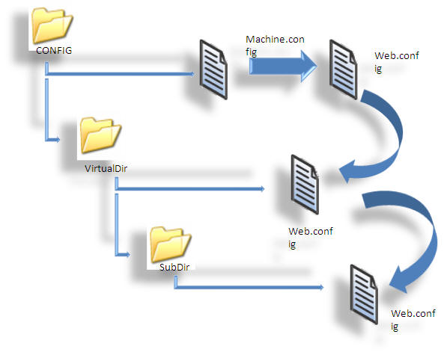
In the web.config, under the <configuration> element, there is another element <system.web>, which is used for ASP.NET settings and contains separate elements for each aspect of the configuration.

Important Configuration Tags

<authentication>
This element is used to verify the client's identity when the client requests a page from the server. This is set at the application level. We have four types of authentication modes: “None”, “Windows”, “Forms”, and “Passport”.
If we don't need any authentication, this is the setting we use:
<authentication mode="None"/>

<compilation>
In this section, we can configure the settings of the compiler. Here, we can have lots of attributes, but the most common ones are debug and defaultLanguage. Setting debug to true means we want the debugging information in the browser, but it has a performance tradeoff, so normally, it is set as false. And, defaultLanguage tells ASP.NET which language compiler to use: VB or C#.

<customErrors>
This tags includes the error settings for the application, and is used to give custom error pages (user-friendly error pages) to end users. In the case that an error occurs, the website is redirected to the default URL. For enabling and disabling custom errors, we need to specify the mode attribute.
<customErrors defaultRedirect="url" mode="Off">
<error statusCode="403" redirect="/accesdenied.html" />
<error statusCode="404" redirect="/pagenotfound.html" />
</customErrors>
- "On" means this settings is on, and if there is any error, the website is redirected to the default URL.
- "Off" means the custom errors are disabled.
- "RemoteOnly" shows that custom errors will be shown to remote clients only.

<trace>
As the name suggest, it is used for tracing the execution of an application. We have here two levels of tracing: page level and application level. Application level enables the trace log of the execution of every page available in the application. If pageOutput="true", trace information will be displayed at the bottom of each page. Else, we can view the trace log in the application root folder, under the name trace.axd.
<trace enabled="false" requestLimit="10" pageOutput="false"
traceMode="SortByTime" localOnly="true" />

<appSettings>
This section is used to store custom application configuration like database connection strings, file paths etc. This also can be used for custom application-wide constants to store information over multiple pages. It is based on the requirements of the application.
<appSettings>
<add key="Emailto" value="me@microsoft.com" />
<add key="cssFile" value="CSS/text.css" />
</appSettings>
It can be accessed from code like:
ConfigurationSettings.AppSettings("Emailto")

