# JavaScript Functions

**JavaScript functions** are used to perform operations. We can call JavaScript function many times to reuse the code.

#### **Advantage of JavaScript function**

There are mainly two advantages of JavaScript functions.

1. **Code reusability**: We can call a function several times so it save coding.
2. **Less coding**: It makes our program compact. We don’t need to write many lines of code each time to perform a common task.

## JavaScript Function Syntax

The syntax of declaring function is given below.

function functionName([arg1, arg2, ...argN]){

 //code to be executed

}

JavaScript Functions can have 0 or more arguments.

## JavaScript Function Example

Let’s see the simple example of function in JavaScript that does not has arguments.

**<script>**

function msg(){

alert("hello! this is message");

}

**</script>**

**<input** type="button" onclick="msg()" value="call function"**/>**

#### **Output of the above example**

## 

## JavaScript Function Arguments

We can call function by passing arguments. Let’s see the example of function that has one argument.

**<script>**

function getcube(number){

alert(number*number*number);

}

**</script>**

**<form>**

**<input** type="button" value="click" onclick="getcube(4)"**/>**

**</form>**

#### **Output of the above example**

Bottom of Form



## Function with Return Value

We can call function that returns a value and use it in our program. Let’s see the example of function that returns value.

**<script>**

function getInfo(){

return "hello javatpoint! How r u?";

}

**</script>**

**<script>**

document.write(getInfo());

**</script>**

#### **Output of the above example**

hello javatpoint! How r u?

Dialog boxes

There are three types of dialog boxes supported in [JavaScript](https://www.javatpoint.com/javascript-tutorial) that are **alert, confirm,** and **prompt**. These dialog boxes can be used to perform specific tasks such as raise an alert, to get confirmation of an event or an input, and to get input from the user.

Let's discuss each dialog box.

Alert Dialog box

It is used to provide a warning message to users. It is one of the most widely used dialog box in JavaScript. It has only one **'OK'** button to continue and select the next task.

We can understand it by an example like suppose a textfield is mandatory to be filled out, but the user has not given any input value to that text field, then we can display a warning message by using the **alert box**.

5

**Syntax**

alert(message);

**Example**

Let us see the demonstration of an alert dialog box by using the following example.

<html>

<head>

    <script type="text/javascript">

        function show() {

            alert("It is an Alert dialog box");

        }

    </script>

</head>

<body>

    <center>

        <h1>Hello World :) :)</h1>

        <h2>Welcome to javaTpoint</h2>

        <p>Click the following button </p>

        <input type="button" value="Click Me" onclick="show();" />

    </center>

</body>

</html>

**Output**

After the successful execution of the above code, you will get the following output.

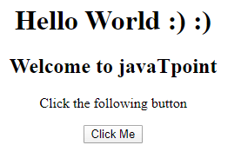

After clicking on the **Click Me** button, you will get the following output:

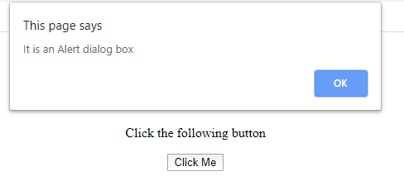

Confirmation Dialog box

It is widely used for taking the opinion from the user on the specific option. It includes two buttons, which are **OK** and **Cancel**. As an example, suppose a user is required to delete some data, then the page can confirm it by using the confirmation box that whether he/she wants to delete it or not.

If a user clicks on the **OK** button, then the method **confirm()** returns **true**. But if the user clicks on the **cancel** button, then the **confirm() method** returns false.

**Syntax**

confirm(message);

**Example**

Let us understand the demonstration of this dialog box by using the following example.

<html>

<head>

    <script type="text/javascript">

        function show() {

            var con = confirm ("It is a Confirm dialog box");

**if**(con == **true**) {

                document.write ("User Want to continue");

            }

**else** {

                document.write ("User does not want to continue");

            }

        }

    </script>

</head>

<body>

    <center>

        <h1>Hello World :) :)</h1>

        <h2>Welcome to javaTpoint</h2>

        <p>Click the following button </p>

        <input type="button" value="Click Me" onclick="show();" />

    </center>

</body>

</html>

**Output**

After the successful execution of the above code, you will get the following output.

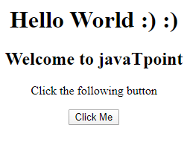

When you click on the given button, then you will get the following output:

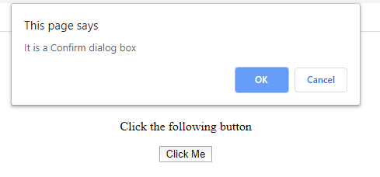

After clicking the **OK** button, you will get:

ES6 Dialog boxes

On clicking the **Cancel** button, you will get:

ES6 Dialog boxes

Prompt Dialog box

The prompt dialog box is used when it is required to pop-up a text box for getting the user input. Thus, it enables interaction with the user.

The prompt dialog box also has two buttons, which are **OK** and **Cancel**. The user needs to provide input in the textbox and then click OK. When a user clicks on the OK button, then the dialog box reads that value and returns it to the user. But on clicking the **Cancel** button, **prompt()** method returns **null**.

**Syntax**

prompt(message, default_string);

Let us understand the prompt dialog box by using the following illustration.

**Example**

<html>

<head>

    <script type="text/javascript">

        function show() {

            var value = prompt("Enter your Name : ", "Enter your name");

            document.write("Your Name is : " + value);

        }

    </script>

</head>

<body>

    <center>

        <h1>Hello World :) :)</h1>

        <h2>Welcome to javaTpoint</h2>

        <p>Click the following button </p>

        <input type="button" value="Click Me" onclick="show();" />

    </center>

</body>

</html>

**Output**

After executing the above code successfully, you will get the following output.

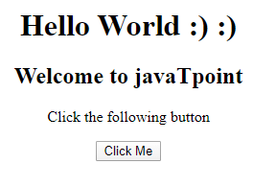

When you click on the **Click Me** button, you will get the following output:

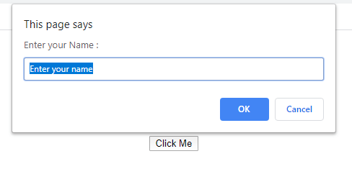

Enter your name and click OK button, you will get:

ES6 Dialog boxes