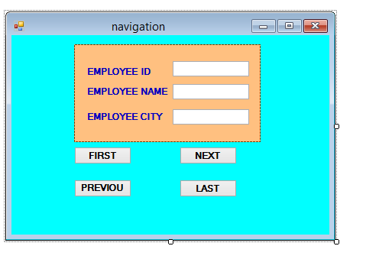

Imports System.Data

Imports System.Data.OleDb

Public Class navigation

Dim cn As New OleDbConnection("Provider=Microsoft.Jet.OLEDB.4.0;Data Source=C:\Users\JIG\Desktop\db_arti.mdb")

Dim adp As New OleDbDataAdapter("select * from employee", cn)

Dim ds As New DataSet

Dim cnt As Integer

Dim cmd As New OleDbCommandBuilder(adp)

Private Sub navigation_Load(ByVal sender As System.Object, ByVal e As System.EventArgs) Handles MyBase.Load

cn.Open()

MsgBox("connected")

adp.Fill(ds)

cnt = 0

showdata()

End Sub

Private Sub showdata()

Dim row As DataRow

row = ds.Tables(0).Rows(cnt)

TextBox1.Text = row("ID")

TextBox2.Text = row("ename")

TextBox3.Text = row("ecity")

End Sub

Private Sub Button1_Click(ByVal sender As System.Object, ByVal e As System.EventArgs) Handles Button1.Click

cnt = 0

showdata()

End Sub

Private Sub Button2_Click(ByVal sender As System.Object, ByVal e As System.EventArgs) Handles Button2.Click

If cnt >= ds.Tables(0).Rows.Count - 1 Then

MsgBox("last record")

Else

cnt += 1

showdata()

End If

End Sub

Private Sub Button3_Click(ByVal sender As System.Object, ByVal e As System.EventArgs) Handles Button3.Click

If cnt = 0 Then

MsgBox("first record")

Else

cnt -= 1

showdata()

End If

End Sub

Private Sub Button4_Click(ByVal sender As System.Object, ByVal e As System.EventArgs) Handles Button4.Click

cnt = ds.Tables(0).Rows.Count - 1

showdata()

End Sub

End Class