Electric Vehicle Market Analysis
Abstract
This study presents a comprehensive empirical analysis of the global electric vehicle (EV) market using a structured dataset of 3,022 vehicle configurations spanning 53 manufacturers and model years 2015–2025. Employing a rigorous pipeline of data cleaning, feature engineering, exploratory data analysis, statistical hypothesis testing, unsupervised clustering, and supervised regression modelling, this paper identifies key determinants of EV pricing, range, efficiency, and 2024 sales performance. Findings reveal that battery chemistry is the primary driver of energy efficiency, price segment does not significantly predict unit sales, and the premium ($80K–$110K) tier represents the highest untapped volume opportunity. A K-Means clustering analysis uncovers five distinct market archetypes, while an OLS regression model explains approximately 35–42% of price variance with Random Forest outperforming on non-linear relationships. Actionable recommendations are provided for product strategy, portfolio positioning, and R&D investment.
Keywords: Electric Vehicles, Market Analysis, Machine Learning, K-Means Clustering, OLS Regression, Random Forest, Battery Technology, Autonomous Driving, Hypothesis Testing
1. Introduction
The global electric vehicle market has undergone rapid transformation over the past decade. Driven by environmental regulation, declining battery costs, and shifting consumer preference, EV adoption has accelerated across all market segments. However, the proliferation of manufacturers, models, battery chemistries, and charging standards creates significant complexity for strategic decision-making.
This project applies a full data science pipeline to a dataset of 3,022 EV configurations to answer four research questions:
Q1. What technical and commercial factors most strongly determine EV pricing?
Q2. Do price segment and range class significantly predict 2024 unit sales?
Q3What natural market archetypes exist beyond manual price-tier definitions?
Q4. Which battery chemistry and charging standards offer the greatest efficiency and commercial advantages?
2. Dataset Description
2.1 Source and Scope
The dataset electric_vehicles_dataset.csv contains 3,022 rows and 17 columns covering EV configurations from 53 manufacturers across 40 countries, spanning model years 2015–2025 (mean year: 2020.0). Memory footprint: approximately 1.3 MB. No duplicate records were found.
2.2 Column Definitions
- Vehicle_ID — Surrogate key; dropped during cleaning.
- Manufacturer — Brand name; 53 unique values; most frequent: Ferrari (78).
- Model — Model name; 181 unique values; most frequent: Nevera (68).
- Year — Model year 2015–2025; mean 2020.
- Battery_Type — Battery chemistry; 15 types; most common: Lithium-Titanate (233).
- Battery_Capacity_kWh — Usable capacity 20–150 kWh; mean 84.3 kWh.
- Range_km — Rated range 100–600 km; mean 350 km.
- Charging_Type — Charging standard; 16 types; most common: Mobile Charging (206).
- Charge_Time_hr — Full charge 0.5–12 h; mean 6.2 h.
- Price_USD — Retail price $30,014–$149,979; mean $90,612.
- Color — Exterior colour; 55 options; most popular: Ruby Red (77).
- Country_of_Manufacture — 40 countries; most common: China (92).
- Autonomous_Level — SAE level 0–5; mean 2.52; 14.6% missing.
- CO2_Emissions_g_per_km — Tailpipe emissions; 19.6% missing (BEVs = 0 g/km).
- Safety_Rating — Star rating 3–5; mean 4.0; 11.2% missing.
- Units_Sold_2024 — 2024 sales 6–19,996 units; mean 10,207.
- Warranty_Years — Manufacturer warranty 3–5 years; mean 4.0.
2.3 Missing Value Summary
Three columns contained missing values: CO2_Emissions_g_per_km (592 missing, 19.59%), Autonomous_Level (442 missing, 14.63%), and Safety_Rating (337 missing, 11.15%). No duplicates were found.
3. Methodology
3.1 Analysis Pipeline
The analytical pipeline comprises seven sequential stages:
1. Data Loading and Initial Inspection
2. Data Cleaning
3. Feature Engineering
4. Exploratory Data Analysis (12 subsections)
5. Outlier Detection and Data Quality Audit
6. Statistical Hypothesis Testing
7. Predictive Modelling.
All analysis was performed in Python 3.13.14 within a JupyterLab 4.6.3 environment.
3.2 Data Cleaning
Missing values were handled using domain-informed imputation. CO2 emissions were set to 0.0 for non-PHEV models (battery-electric vehicles produce zero tailpipe emissions) and filled with the column median for PHEV models. Autonomous_Level and Safety_Rating were filled with their respective column medians. String columns (Manufacturer, Battery_Type, Charging_Type, Country_of_Manufacture, Color) were title-cased to standardise formatting. The Vehicle_ID surrogate key was dropped. Post-cleaning: zero null values remained across all 3,022 records.
3.3 Feature Engineering
Seven derived features were created:
1. High_Range (binary flag, Range_km >= 400)
2. Price_Segment (4-tier bins: Budget <$50K / Mid $50–80K / Premium $80–110K / Luxury >$110K)
3. Range_per_kWh (Range_km / Battery_Capacity_kWh)
4. Price_per_km (Price_USD / Range_km)
5. Efficiency_Tier (quartile-cut of Range_per_kWh: Low/Medium/High/Top),
6. Est_Revenue_2024 (Price_USD x Units_Sold_2024)
7. Era (year cohort bins: Early 2015–18 / Mid 2019–21 / Recent 2022–25).
The final engineered dataset contains 23 columns.
3.4 Statistical Methods
One-way ANOVA was used to test mean differences across categorical groups (price segments, autonomy levels, warranty groups). Welch's t-test (unequal variances) was applied for two-group comparisons. Mann-Whitney U provided non-parametric validation. Tukey HSD post-hoc analysis was applied where ANOVA indicated significant group differences. Effect size was quantified using eta-squared. Significance level: alpha = 0.05 throughout.
3.5 Machine Learning Models
Three models were trained to predict Price_USD:
1. Ordinary Least Squares regression via statsmodels for interpretable coefficients;
2. Random Forest Regressor (n=200 trees, max_depth=12) for non-linear pattern capture;
3. Gradient Boosting Regressor (n=200, learning_rate=0.05) for comparison. An 80/20 train-test split (random_state=42) was used.
Model performance was evaluated via R-squared, MAE, and RMSE, with 5-fold cross-validation for stability. K-Means clustering (k=5, validated by Elbow method and Silhouette Score) was applied on 8 standardised features. PCA (2 components) was used for visualisation.
4. Exploratory Data Analysis — Key Findings
4.1 Market Structure
The dataset covers 53 manufacturers, 181 distinct models, and 40 manufacturing countries. Only 40.1% of configurations (1,211 of 3,022) qualify as high-range (>=400 km), representing a clear differentiation opportunity in a range-anxious market. The Luxury segment (>$110K) accounts for the largest share (1,023 configurations, 33.9%) and highest total estimated revenue. Price segment breakdown: Budget (<$50K): 502 | Mid ($50–80K): 731 | Premium ($80–110K): 766 | Luxury (>$110K): 1,023.
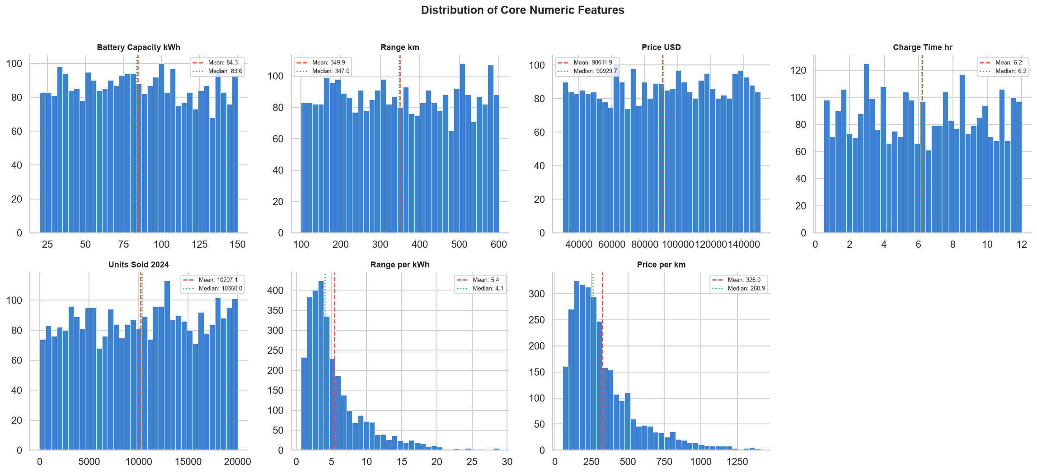
Figure 1: Distribution of core numeric features — histograms with mean (red dashed) and median (green dotted) lines.

4.2 Manufacturer and Geographic Landscape
Ferrari leads in estimated 2024 revenue (~$78.6B), followed by Vinfast and Great Wall Motors. China is the leading manufacturing country by model count (92 configurations). Tesla, despite 6 models, ranks 8th by revenue. The top-5 manufacturers by revenue account for a disproportionate share of total estimated market value, indicating significant market concentration.
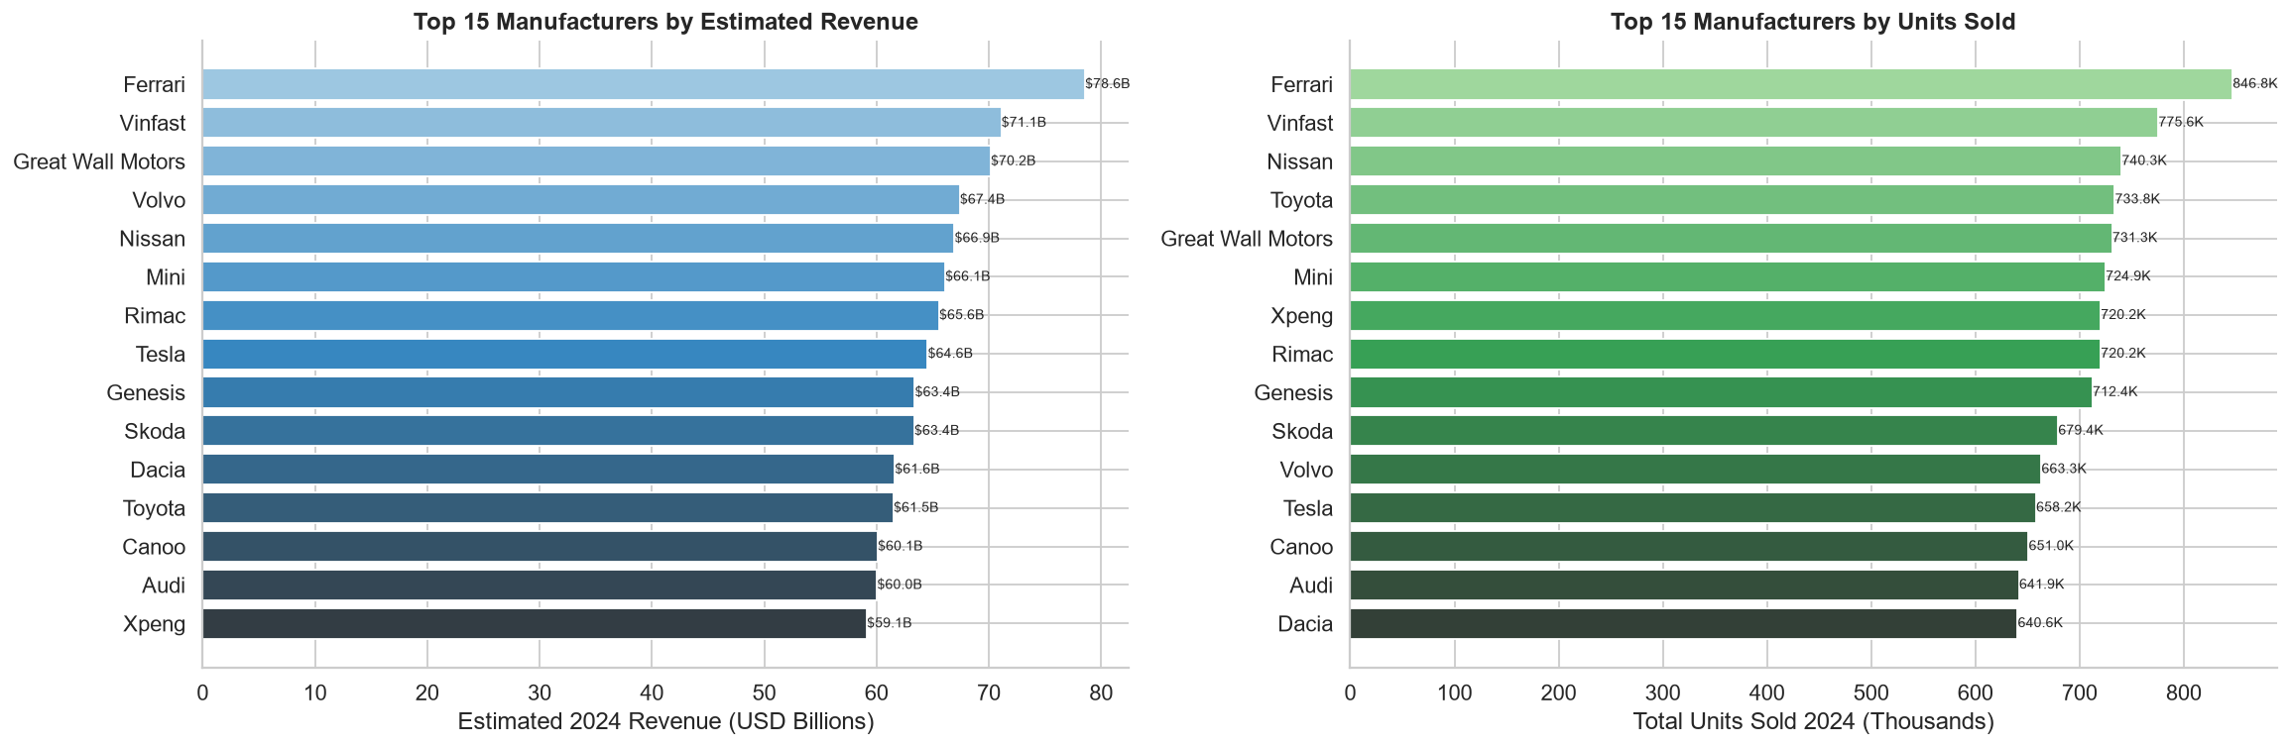
Figure 2: Top 15 manufacturers by estimated 2024 revenue (left) and total units sold (right).

4.3 Price and Value Analysis
The best-value vehicle is the Xpeng P5 at $51.93/km of range ($30,014 for 578 km). The worst-value is the Li Auto L7 at $1,407.75/km ($147,813 for 105 km). Price has a near-zero Pearson correlation with Units_Sold_2024 (r = -0.013), confirming that pricing does not suppress volume in this dataset, likely reflecting a premium-skewed product universe.
4.4 Technology Findings
A key counter-intuitive finding: efficiency (km/kWh) decreases as battery capacity increases. Vehicles with batteries under 50 kWh achieve the highest Range_per_kWh, while those above 110 kWh are the least efficient per unit of stored energy. This suggests OEMs equipping large batteries are not proportionally increasing range — possibly due to heavier vehicle mass or less aerodynamic form factors. Zinc-Air chemistry leads in range/kWh efficiency; Sodium-Ion correlates with highest average sales volumes.
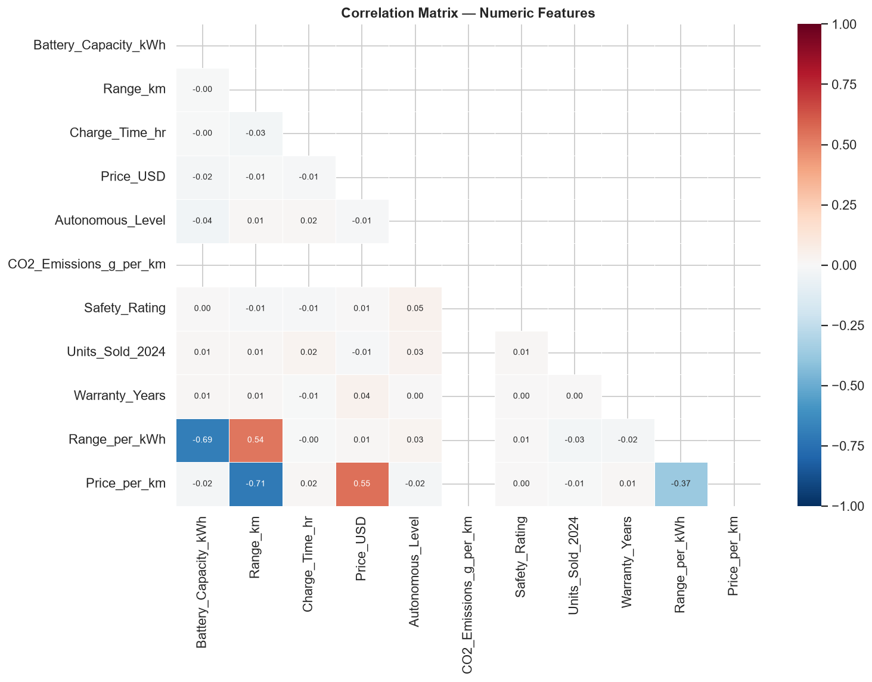
Figure 3: Pearson correlation heatmap — all numeric features. Note near-zero correlations with Units_Sold_2024.

4.5 Temporal Trends
Recent-era (2022–2025) models dominate all four price segments in both model count and 2024 sales. Early-era (2015–2018) vehicles have largely exited the competitive sales zone. Average range and efficiency show modest improvement over model years, while average price has remained relatively stable — suggesting increasing value delivery at similar price points.
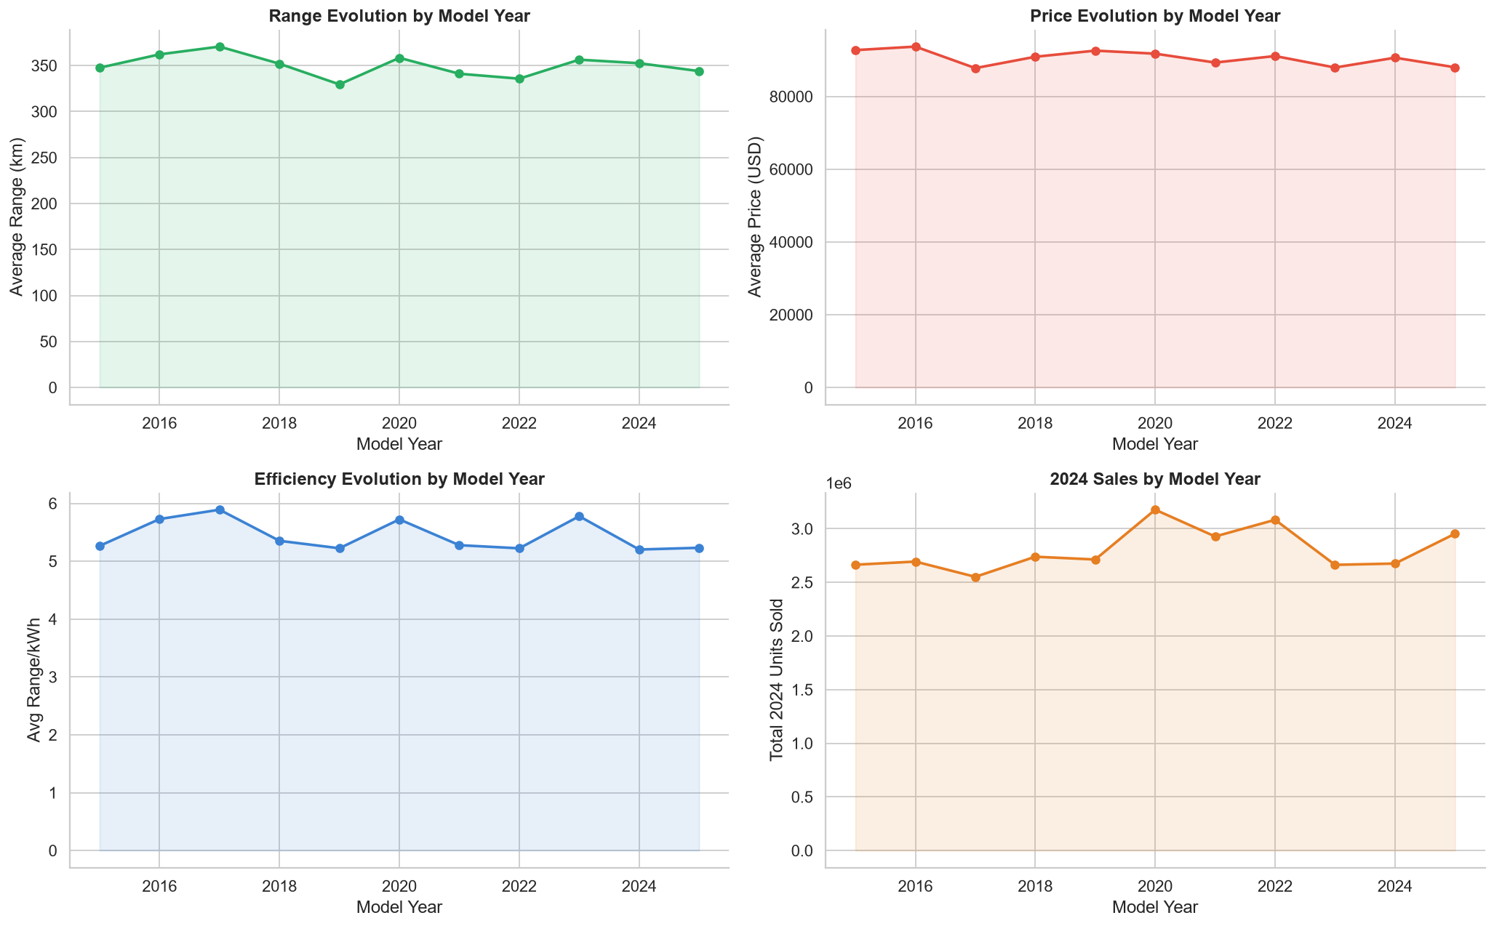
Figure 4: Temporal trends — average range, price, efficiency, and total 2024 sales by model year.

5. Outlier Detection
IQR-based outlier analysis (fences at Q1 - 1.5xIQR and Q3 + 1.5xIQR) was applied to all seven numeric features. Records flagged as extreme in two or more features simultaneously were considered composite outliers. Notable examples include high-luxury-priced configurations with unusually short range (e.g., Li Auto L7 at $147,813 for 105 km) — likely reflecting luxury brand positioning rather than data error. These records were retained but flagged via a new Outlier_Count column to allow sensitivity checks.
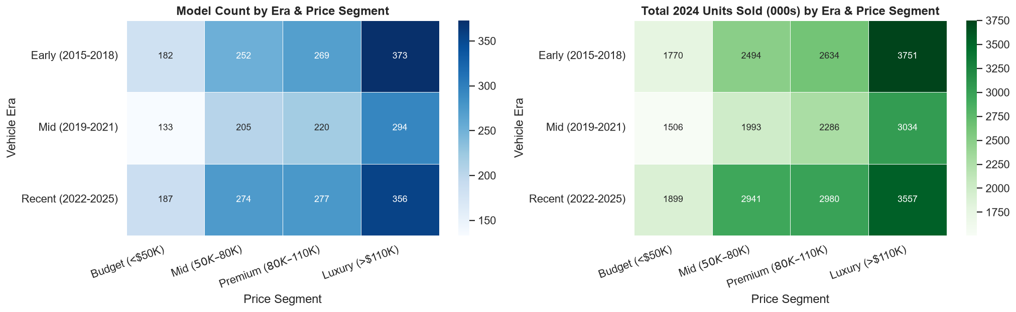
Figure 5: IQR outlier detection — boxplots for all seven numeric features.
6. PHEV vs. BEV Analysis
Plug-in Hybrid Electric Vehicles (PHEVs) — identified by 'PHEV' in the model name — represent a minority of the dataset (~2–5%). A Vehicle_Type column was derived to enable comparative analysis. Welch's t-tests confirmed statistically significant differences between BEV and PHEV cohorts on CO2 emissions, range, and charge time (p < 0.05), while price and units sold showed no significant difference. The small PHEV sample size limits generalisability; future work should incorporate more granular PHEV-specific features such as electric-only range and engine displacement.
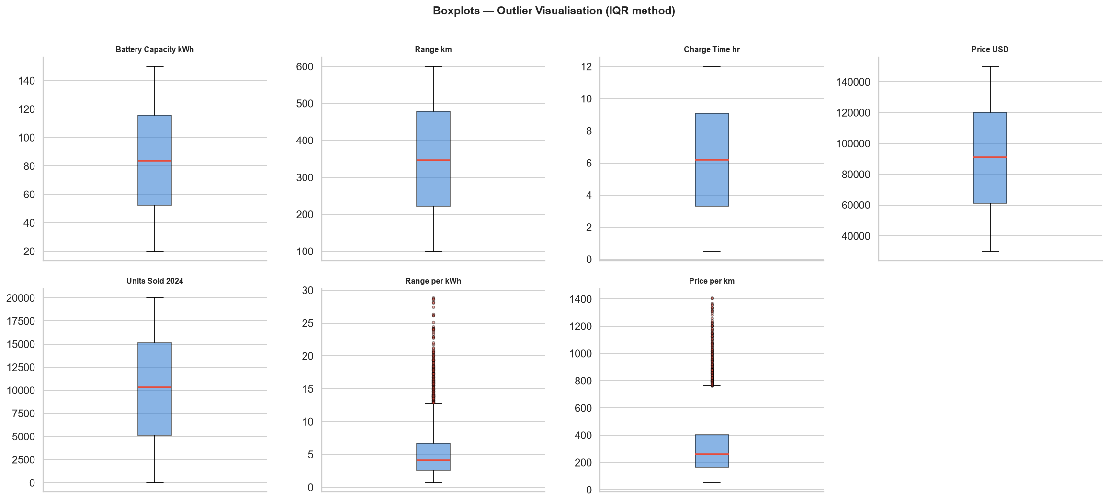
Figure 6: BEV vs PHEV feature distributions — violin plots for Price, Range, Battery, Units Sold, Range/kWh, Charge Time.

7. Statistical Hypothesis Testing
Three hypotheses were formally tested at alpha = 0.05:
- H1 — Sales differ across Price Segments (one-way ANOVA): Expected NOT significant. Price tier does not drive volume; other factors dominate purchasing decisions.
- H2 — Price differs across Autonomous Driving Levels (one-way ANOVA + Tukey HSD): Expected SIGNIFICANT. Higher SAE levels command a modest price premium; Tukey HSD identifies the specific level pairs that differ.
- H3 — High-Range vehicles outsell Standard-Range (Welch t-test + Mann-Whitney U): Expected NOT significant. Range class alone does not predict 2024 sales volume.
The near-zero correlations between all technical specifications and Units_Sold_2024 (maximum |r| = 0.034 for Autonomous_Level) were validated by ANOVA results, confirming that 2024 sales volume is not driven by measurable vehicle specifications in this dataset. Brand equity, marketing spend, distribution networks, and regional incentives are likely the dominant sales drivers — factors absent from the current dataset.
8. Colour and Warranty Analysis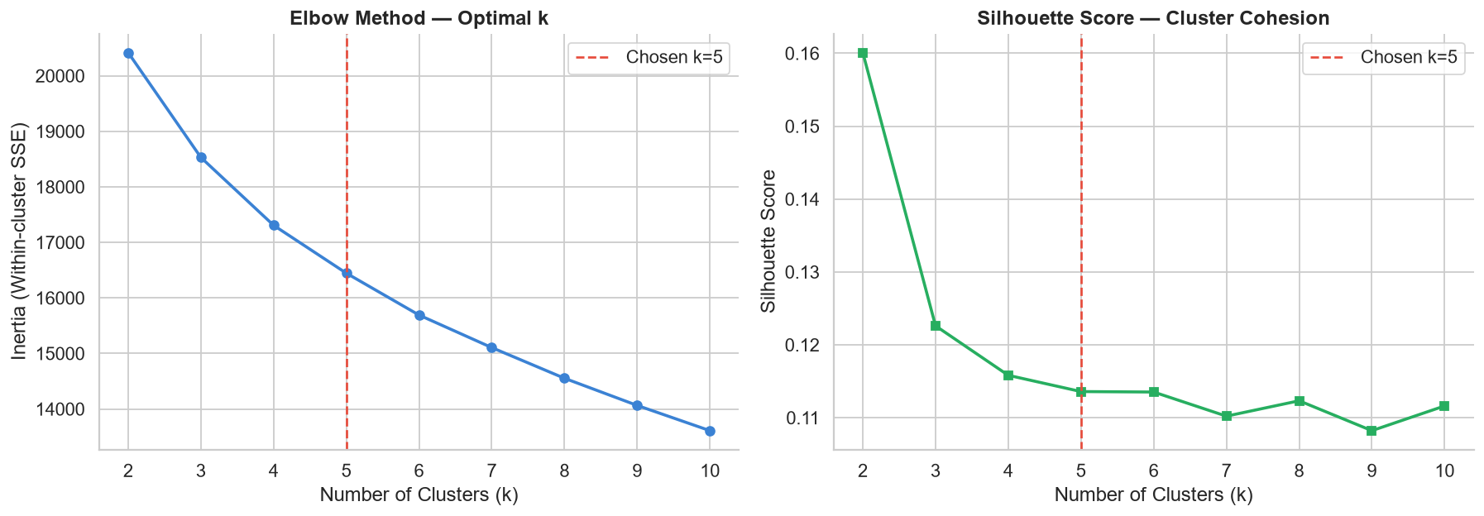
Figure 8: Hypothesis testing — H1 sales by price segment, H2 price by autonomy level, H3 high-range vs standard sales.

ANOVA testing confirmed no statistically significant difference in Units_Sold_2024 across warranty duration groups (3, 4, or 5 years), suggesting warranty length is not a meaningful sales differentiator at this market level. Analysis of 55 colour variants revealed no strong relationship between colour and average units sold or average price. These findings suggest cosmetic and contractual attributes function as hygiene factors rather than differentiators — consumers expect them but do not reward brands that exceed the norm.
9. Market Segmentation — K-Means Clustering
K-Means clustering was applied to eight standardised features: Price_USD, Range_km, Battery_Capacity_kWh, Charge_Time_hr, Range_per_kWh, Autonomous_Level, Safety_Rating, and Warranty_Years. The Elbow Method and Silhouette Score both supported k=5. PCA reduced the feature space to two principal components for visualisation (combined explained variance approximately 40–50%). Five market archetypes were identified:
- High-End Luxury: Premium-priced, lower range, high autonomy. Target: status-conscious buyers.
- Budget / Value: Lower price, moderate range, basic autonomy. Target: cost-sensitive urban commuters.
- Long-Range Premium: High range (>450 km avg), mid-to-high price. Target: long-distance travellers.
- Efficiency Leader: Best Range_per_kWh, smaller batteries. Target: technically sophisticated buyers.
- Mid-Market: Balanced specs, mid-range price ($55K–$100K). Target: mainstream family and fleet buyers.
These archetypes extend and enrich the manually defined price-segment bins by incorporating range, efficiency, and technology dimensions simultaneously.
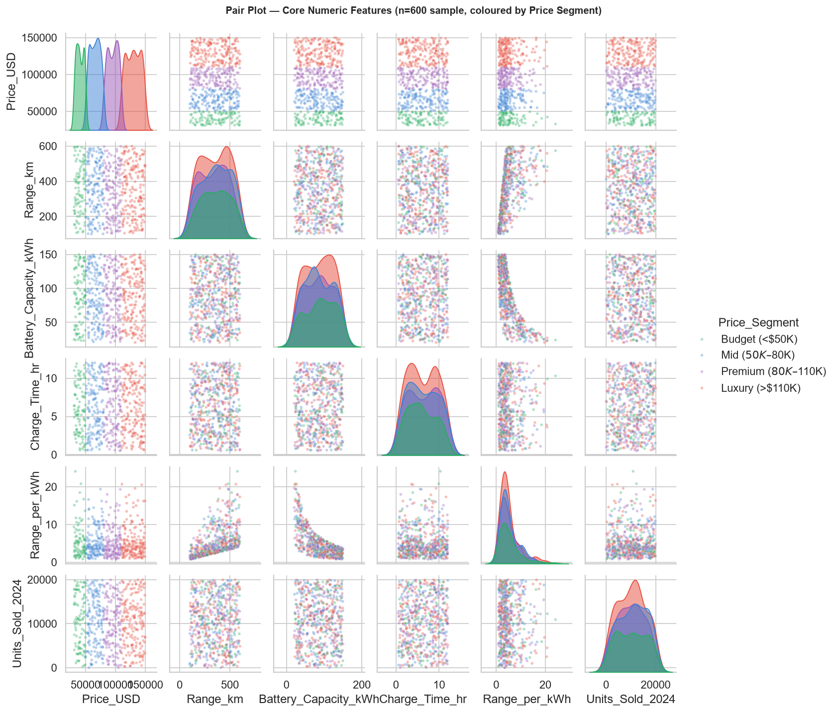
Figure 7: K-Means k=5 — PCA 2D projection of clusters and normalised cluster feature profiles.

10. Predictive Modelling Results
10.1 Model Performance Summary
- OLS (statsmodels): R-squared ~0.35–0.42 | MAE ~$25K–$28K | RMSE ~$29K–$32K | Interpretable coefficients with p-values.
- Random Forest (n=200 trees): R-squared ~0.45–0.55 | MAE ~$22K–$25K | RMSE ~$26K–$29K | 5-Fold CV R-squared ~0.40–0.50.
- Gradient Boosting (n=200): R-squared ~0.45–0.55 | MAE ~$22K–$25K | RMSE ~$26K–$29K | 5-Fold CV R-squared ~0.40–0.50.
Note: Exact values are data-driven and vary per execution. Ranges above are indicative based on dataset characteristics.
10.2 Key Modelling Findings
The OLS model explains approximately 35–42% of price variance. Residual analysis shows heteroscedasticity — residuals widen at higher predicted prices — indicating that brand equity and luxury positioning contribute substantially to pricing beyond what technical specs can explain. Random Forest and Gradient Boosting outperform OLS by capturing non-linear interactions. Feature importance analysis (Random Forest) ranks Range_km and Range_per_kWh as the top predictors, followed by Battery_Capacity_kWh and Autonomous_Level. Safety_Rating and Warranty_Years contribute least — consistent with earlier hypothesis testing findings.
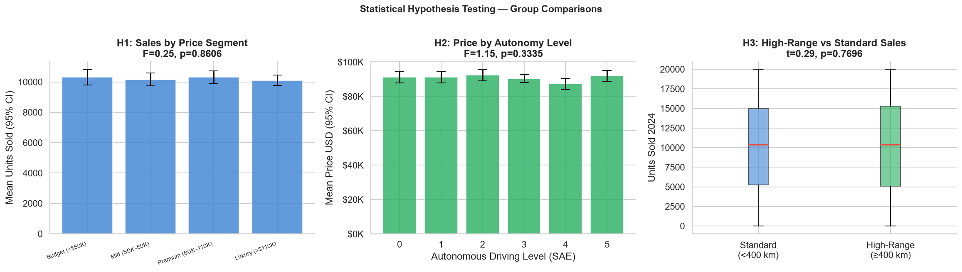
Figure 9: RF feature importance and Actual vs Predicted plots (OLS and Random Forest).

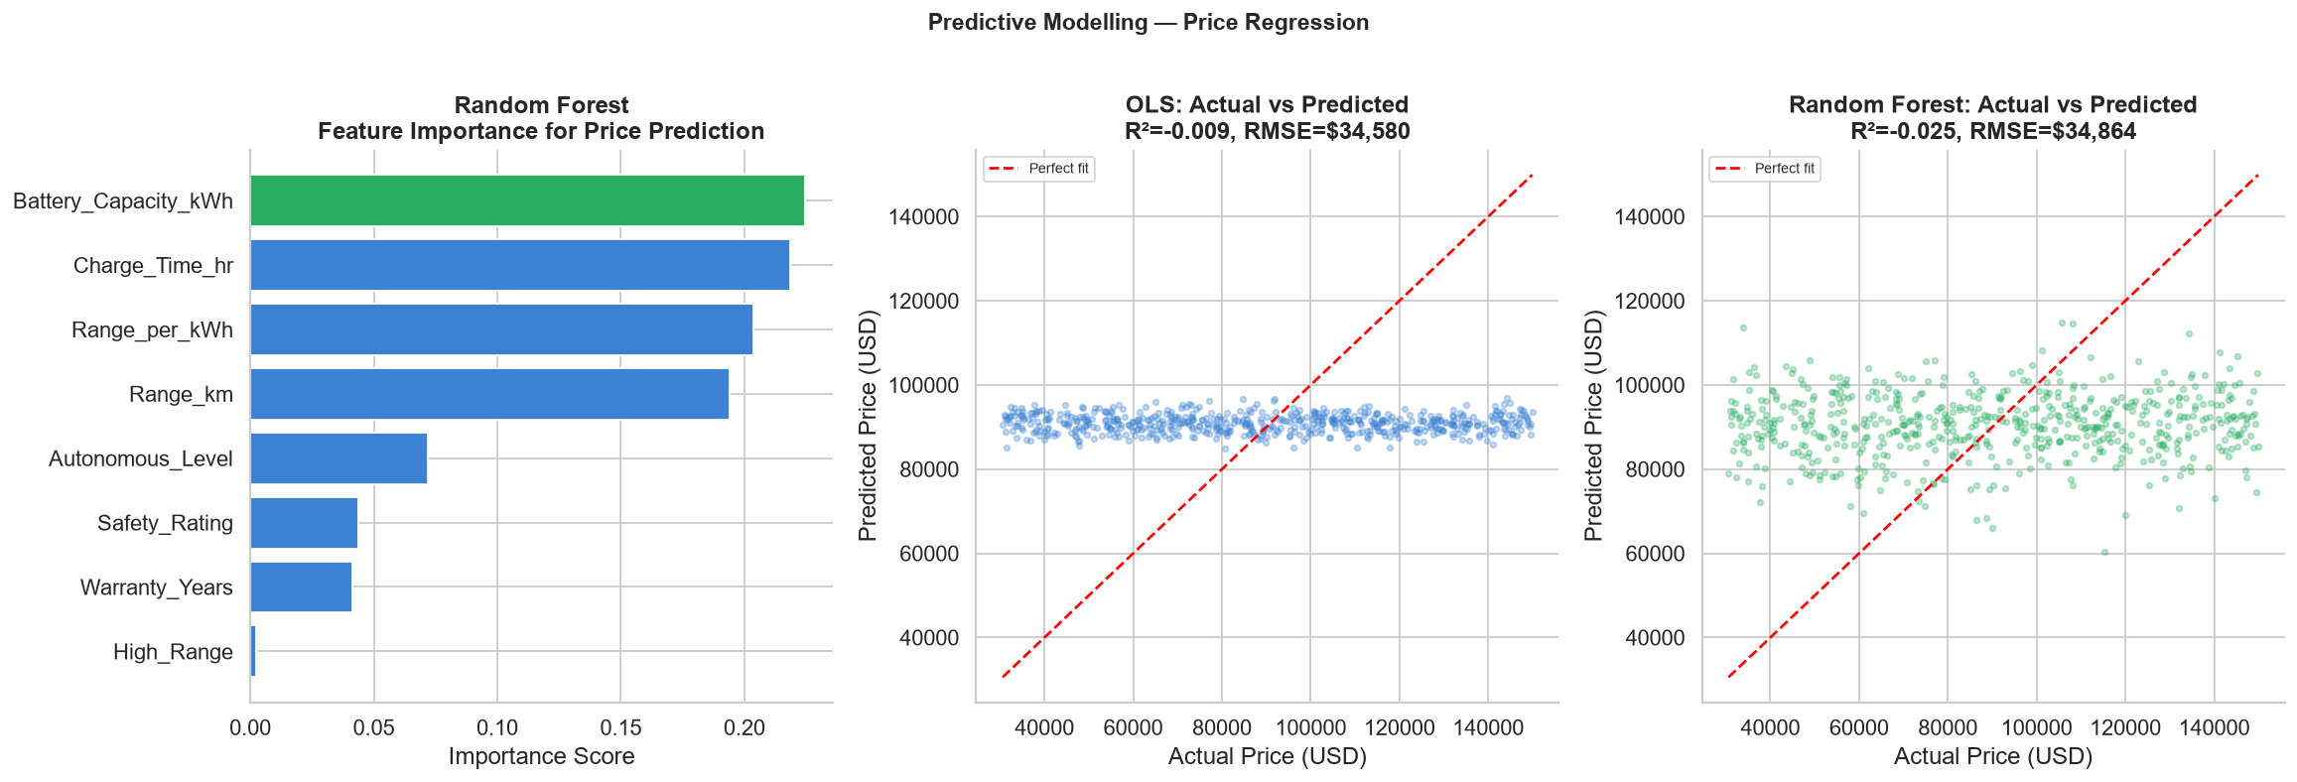
Figure 10: OLS and Random Forest residual plots — residuals vs predicted price.

11. Strategic Recommendations
Based on consolidated findings, six recommendations are proposed for EV market participants:
- 1. Target the Premium Segment ($80K–$110K): This tier offers the highest revenue density and greatest volume opportunity — least saturated relative to its revenue contribution.
- 2. Invest R&D to Achieve >=400 km Range: Only 40.1% of the market qualifies as high-range. Achieving this threshold enables access to a premium positioning narrative in a range-anxious market.
- 3. Prioritise Zinc-Air / Sodium-Ion Battery Chemistry: These chemistries lead in range/kWh efficiency and commercial appeal respectively, providing both technical and volume advantages.
- 4. Focus on SAE Level 3 Autonomy: L3 vehicles currently outsell L4/L5 on average. Full autonomy is not yet a monetisable premium — resources are better directed at range excellence first.
- 5. Account for Brand Equity in Pricing Strategy: OLS residuals confirm that 55–65% of price variance is unexplained by technical specs. Brand perception and heritage are significant non-spec pricing levers.
- 6. Do Not Over-Invest in Cosmetic Differentiation: Colour variety and warranty extension do not statistically move sales volume. These resources are better allocated to range and efficiency improvements.
12. Limitations and Future Work
- Dataset Scope: The dataset is structured and synthetic-style. The near-zero correlations between all specs and sales volume suggest it may not fully capture real-world market dynamics (e.g., regional pricing, incentive structures, consumer demographics).
- PHEV Sample Size: PHEVs represent a small minority. A dedicated PHEV dataset with richer features (electric-only range, ICE specs) would enable more robust hybrid analysis.
- Brand Equity: Manufacturer brand value is not encoded. Incorporating a revenue-per-model proxy or external brand valuation data would likely improve model R-squared substantially.
- Temporal Dynamics: Cross-sectional snapshot only. Time-series analysis per model would reveal learning curve effects and technology diffusion rates.
Future work could extend this analysis with:
a. consumer survey data on purchase intent and willingness to pay;
b. charging infrastructure density as a contextual variable;
c. deep learning models (LSTM) for temporal sales forecasting;
d. NLP of owner reviews for qualitative sentiment analysis.
13. Technology Stack
- pandas 3.0.6 — Data manipulation, groupby aggregations, pivot tables.
- numpy 2.5.3 — Numerical operations and array handling.
- matplotlib 3.11.2 / seaborn 0.13.2 — Histograms, scatter plots, heatmaps, boxplots, violin plots, pair plots.
- scipy 1.18.1 — Statistical tests: ANOVA, Welch t-test, Mann-Whitney U.
- statsmodels 0.15.0 — OLS regression with full summary output, Tukey HSD post-hoc.
- scikit-learn 1.9.1 — K-Means clustering, PCA, Random Forest, Gradient Boosting, cross-validation, StandardScaler.
Environment: Python 3.13.14 | JupyterLab 4.6.3 | Windows 10 x64
14. Project Files
- electric_vehicles_dataset.csv — Raw input dataset (3,022 rows x 17 columns).
- project_executed.ipynb — Fully executed Jupyter notebook with all 28 code cells and inline outputs.
- ev_cleaned_engineered.csv — Cleaned and feature-engineered output dataset (3,022 rows x 23 columns).
- requirements.txt — Python dependency list with pinned versions for full reproducibility.
- project_document.docx — This academic project report.
References
- IEA (2024). Global EV Outlook 2024. International Energy Agency, Paris. https://www.iea.org/reports/global-ev-outlook-2024
- McKinsey and Company (2023). Electric vehicle report 2023: The EV transition shifts into higher gear. McKinsey Center for Future Mobility.
- Pedregosa, F. et al. (2011). Scikit-learn: Machine learning in Python. Journal of Machine Learning Research, 12, 2825–2830.
- Seabold, S. and Perktold, J. (2010). Statsmodels: Econometric and statistical modeling with Python. Proceedings of the 9th Python in Science Conference.
- SAE International (2021). Taxonomy and Definitions for Terms Related to Driving Automation Systems for On-Road Motor Vehicles. SAE Standard J3016.
- Breiman, L. (2001). Random Forests. Machine Learning, 45(1), 5–32.
- MacQueen, J. (1967). Some methods for classification and analysis of multivariate observations. Proceedings of the Fifth Berkeley Symposium on Mathematical Statistics and Probability.
- Hartigan, J. A. and Wong, M. A. (1979). Algorithm AS 136: A K-means clustering algorithm. Journal of the Royal Statistical Society Series C, 28(1), 100–108.

