**Assignment**

1. Define the terms: Website, Webpage, Web browser, Web server, HTML,CSS

Website:

A website is a collection of web pages that are related to each other and typically served from a single domain. It can include a variety of content such as text, images, videos, and interactive elements.

Webpage:

A webpage is a single document that is part of a website. It is typically written in HTML and can include multimedia elements, styling (CSS), and interactivity (JavaScript). Webpages are what users view and interact with in their web browsers.

Web Browser:

A web browser is a software application that allows users to access and navigate the World Wide Web. Examples of web browsers include Chrome, Firefox, Safari, and Edge. Browsers interpret HTML, CSS, and JavaScript to render webpages for users.

Web Server:

A web server is a software application or hardware device that stores, processes, and delivers web content to users. It responds to requests from web browsers and serves the requested web pages. Popular web server software includes Apache, Nginx, and Microsoft Internet Information Services (IIS).

HTML (Hypertext Markup Language):

HTML is the standard markup language used to create the structure of web pages. It consists of a series of elements (tags) that define the content and layout of a webpage. HTML is essential for creating the basic structure of a webpage, such as headings, paragraphs, images, links, and more.

CSS (Cascading Style Sheets):

CSS is a stylesheet language used for describing the presentation and formatting of a document written in HTML. It allows web developers to control the appearance of HTML elements by defining styles like colors, fonts, spacing, and layout. CSS helps separate the structure (HTML) from the presentation (CSS) in web development.

2. Create a webpage to show “This is my first HTML page?

Certainly! Below is a simple HTML code that you can use to create a webpage displaying the text "This is my first HTML page". You can save this code in a file with a .html extension and open it in a web browser to view the webpage.

Html ex: 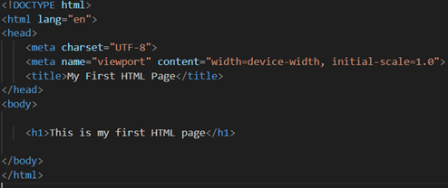

3. 3. Display top 10 IT companies list in html webpage?

<!DOCTYPE html>

<html lang="en">

<head>

   <meta charset="UTF-8">

   <meta name="viewport" content="width=device-width, initial-scale=1.0">

   <title>Document</title>

</head>

<body>

   <ol>

      <li>

         CodeAroma Technologies - Motera, Ahmedabad

     </li>

     <li>

      Sapphire Software Solutions - Sarkhej, Ahmedabad

     </li>

     <li>

      iCoderz Solutions - Gota, Ahmedabad

    </li>

    <li>

    Concept Infoway - Sarkhej, Ahmedabad

   </li>

   <li>

      ConvergeSol - Bopal, Ahmedabad

   </li>

   <li>

      Vrinsoft Technology - Sarkhej, Ahmedabad

   </li>

   <li>

      NCode Technologies - Navrangpura, Ahmedabad

   </li>

   <li>

      SolGuruz LLP - Usmanpura, Ahmedabad

   </li>

   <li>

      Agile Infoways - Jhanshi ki Rani, Ahmedabad

   </li>

   <li>

      Techcronus - Nehru Nagar, Ahmedabad

   </li>

   </ol>

</body>

</html>

4.. Create a dropdown list

the HTML page using the **<select>** and **<option>** elements.

dropdown list EX: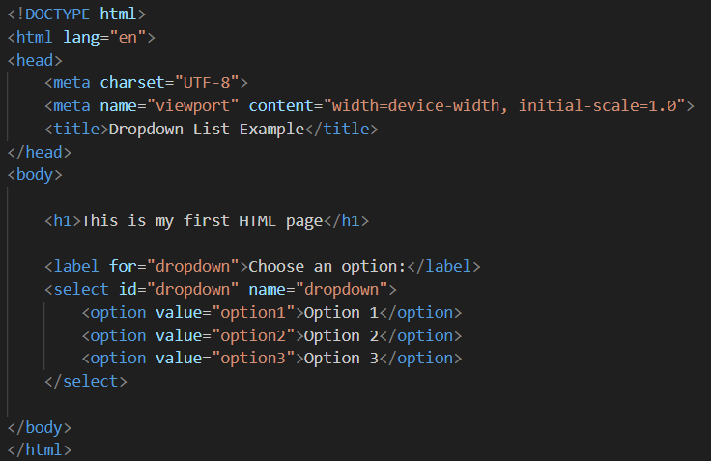

5. Create a Table Of college Management system using row span & colspan

<!DOCTYPE html>

<html lang="en">

<head>

    <meta charset="UTF-8">

    <meta name="viewport" content="width=device-width, initial-scale=1.0">

    <title>College Management System</title>

    <style>

        table {

            width: 100%;

            border-collapse: collapse;

            margin-top: 20px;

        }

        th, td {

            border: 1px solid #ddd;

            padding: 8px; text-align: left;

        }

        th {

            background-color: #f2f2f2;

        }

    </style>

</head>

<body>

    <h1>College Management System</h1>

    <table>

        <thead>

            <tr>

                <th rowspan="2">Student ID</th>

                <th rowspan="2">Name</th>

                <th rowspan="2">Gender</th>

                <th colspan="3">Class Schedule</th>

            </tr>

            <tr>

                <th>Monday</th>

                <th>Wednesday</th>

                <th>Friday</th>

            </tr>

        </thead>

        <tbody>

            <tr>

                <td>001</td>

                <td>John Doe</td>

                <td>Male</td>

                <td>Math</td>

                <td>Physics</td>

                <td>Computer Science</td>

            </tr>

            <tr>

                <td>002</td>

                <td>Jane Smith</td>

                <td>Female</td>

                <td>History</td>

                <td>Chemistry</td>

                <td>Biology</td>

            </tr>

            <!-- Add more rows as needed -->

        </tbody>

    </table>

</body>

</html>

6. Create below table using HTML table tags

**Table 1:-**

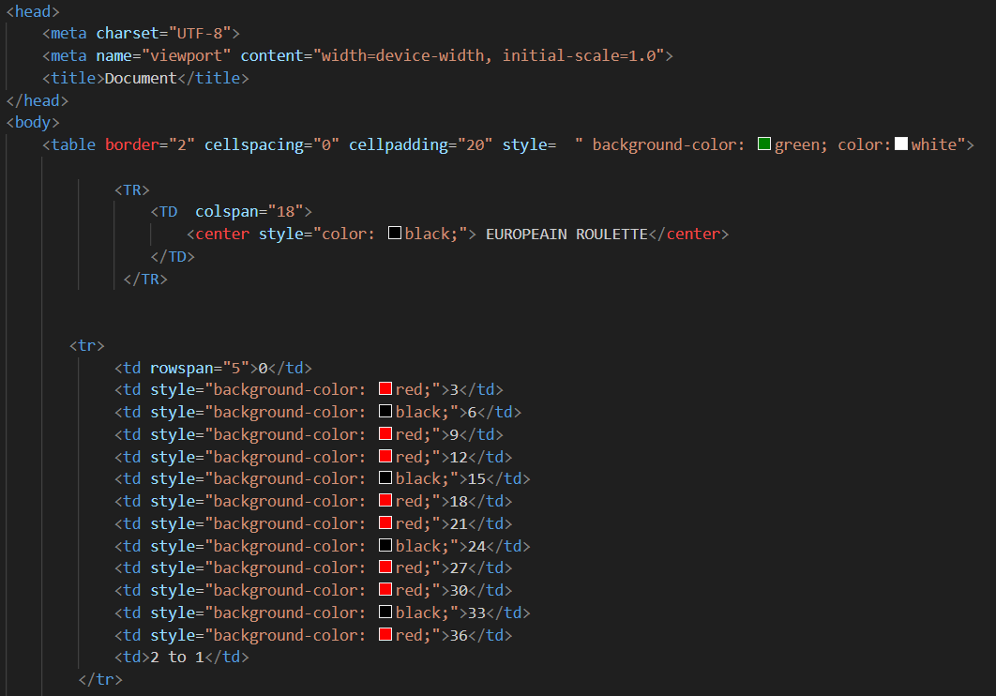

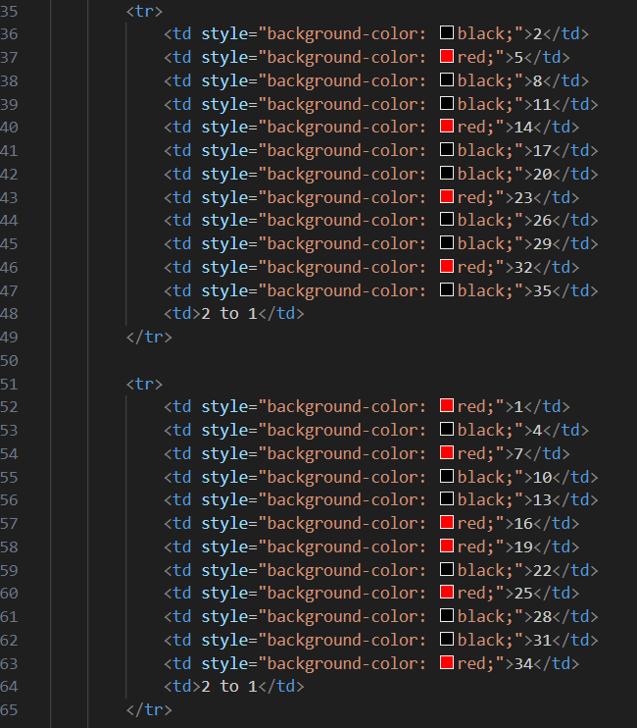

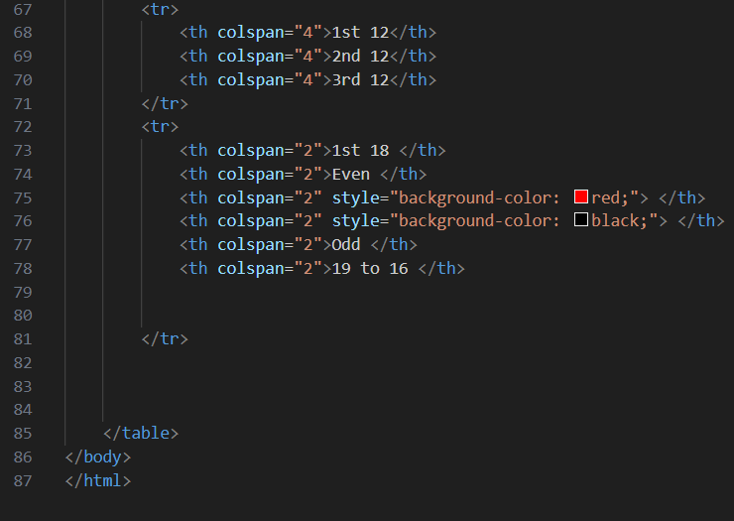

**Table 2:-**

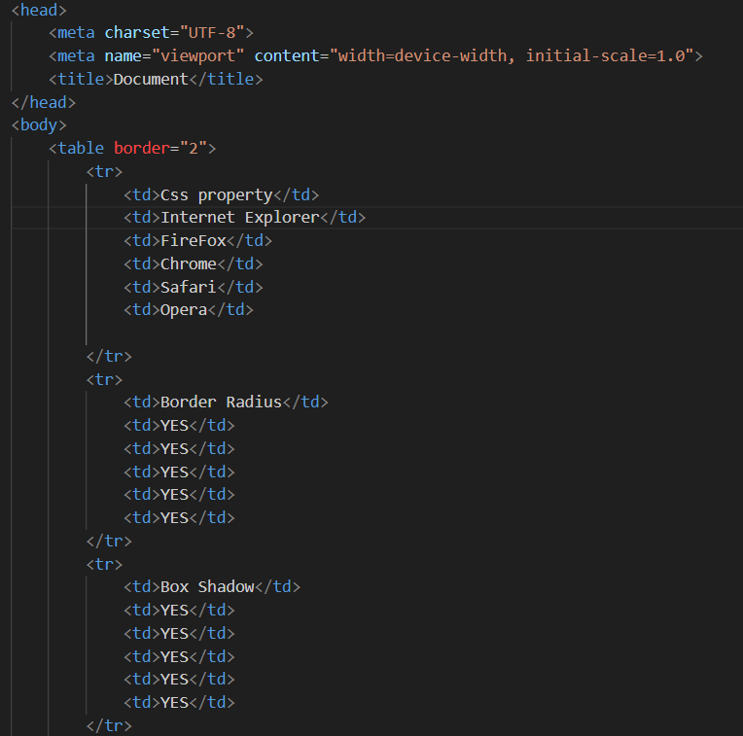

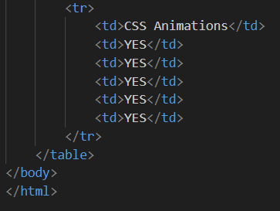

**Output:-**

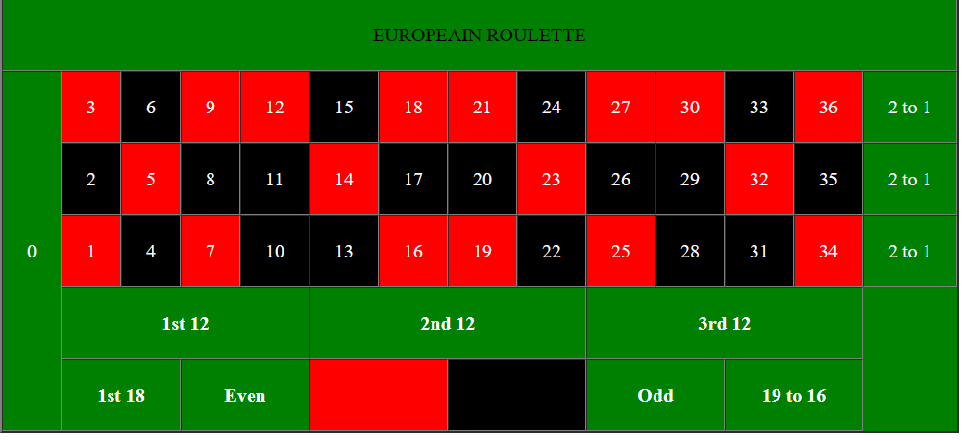

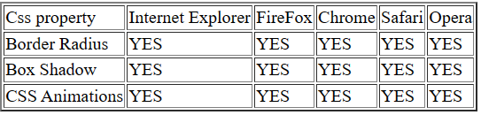

7. Create Registration form using HTML, CSS

<!DOCTYPE html>

<html lang="en">

<head>

    <meta charset="UTF-8">

    <meta name="viewport" content="width=device-width, initial-scale=1.0">

    <title>Registration Form</title>

    <style>

        body {

            font-family: Arial, sans-serif;

            background-color: #f4f4f4;

            margin: 0;

            padding: 0;

            display: flex;

            align-items: center;

            justify-content: center;

            height: 100vh;

        }

        form {

            background-color: #fff;

            padding: 20px;

            border-radius: 8px;

            box-shadow: 0 0 10px rgba(0, 0, 0, 0.1);

            width: 300px;

        }

        label {

            display: block;

            margin-bottom: 8px;

        }

        input {

            width: 100%;

            padding: 8px;

            margin-bottom: 12px;

            box-sizing: border-box;

            border: 1px solid #ccc;

            border-radius: 4px;

        }

        button {

            background-color: #4caf50;

            color: #fff;

            padding: 10px;

            border: none;

            border-radius: 4px;

            cursor: pointer;

        button:hover {

            background-color: #45a049;

        }

    </style>

</head>

<body>

    <form>

        <h2>Registration Form</h2>

        <label for="username">Username:</label>

        <input type="text" id="username" name="username" required>

        <label for="email">Email:</label>

        <input type="email" id="email" name="email" required>

        <label for="password">Password:</label>

        <input type="password" id="password" name="password" required>

        <label for="confirmPassword">Confirm Password:</label>

        <input type="password" id="confirmPassword" name="confirmPassword" required>

        <button type="submit">Register</button>

    </form>

</body>

</html>

8. In how many ways can a CSS be integrated as a web page?

Cascading Style Sheets (CSS) can be integrated into a web page in several ways. The most common methods include:

1.Inline CSS:

Inline CSS is applied directly within the HTML element using the "style" attribute.

EX:



2. Internal/Embedded CSS:

0Internal CSS is placed within the <style> tags in the head section of the HTML document.

EX:

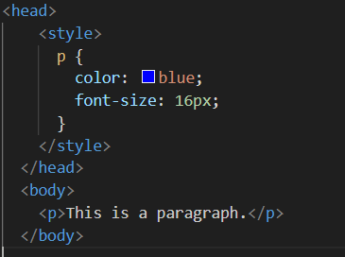

3.External CSS:

Create a separate CSS file with the styles and link it to the HTML document using the <link> tag.

Ex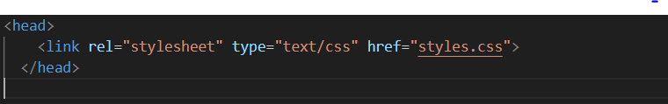

In the style.css

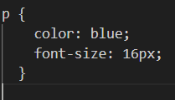

4. Import CSS:

Use the @import rule to include an external CSS file within another CSS file.

EX:

  
5. CSS in the Head:

CSS in the Head

Combine external CSS and internal CSS in the <head> section of the HTML document.

EX: 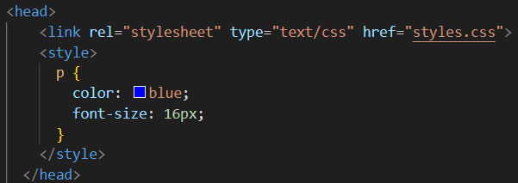

9. Certainly! Here are examples of three HTML pages using External CSS, Internal CSS, and Inline CSS.

External CSS (styles.css):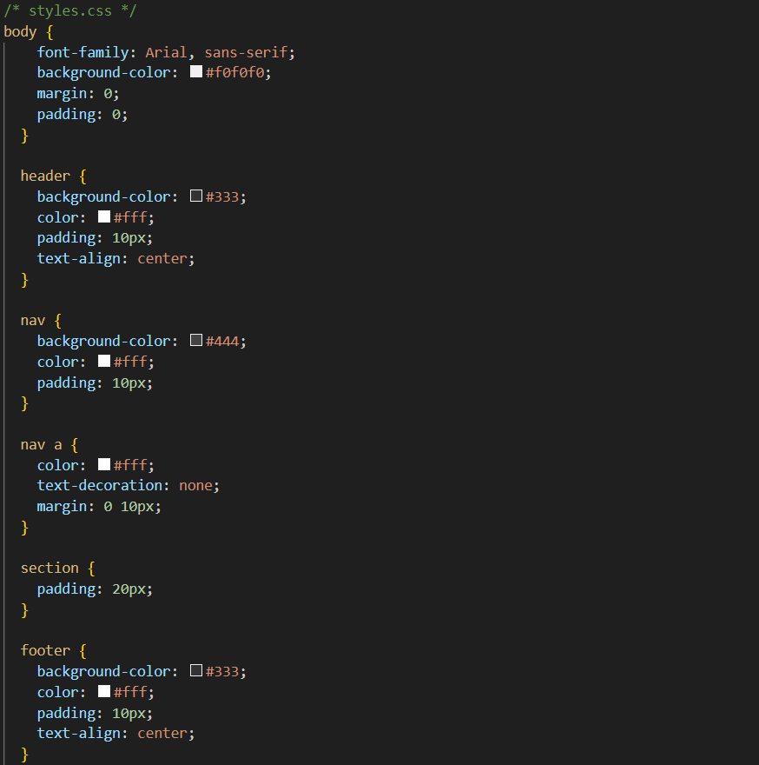

HTML with External CSS (index_external.html):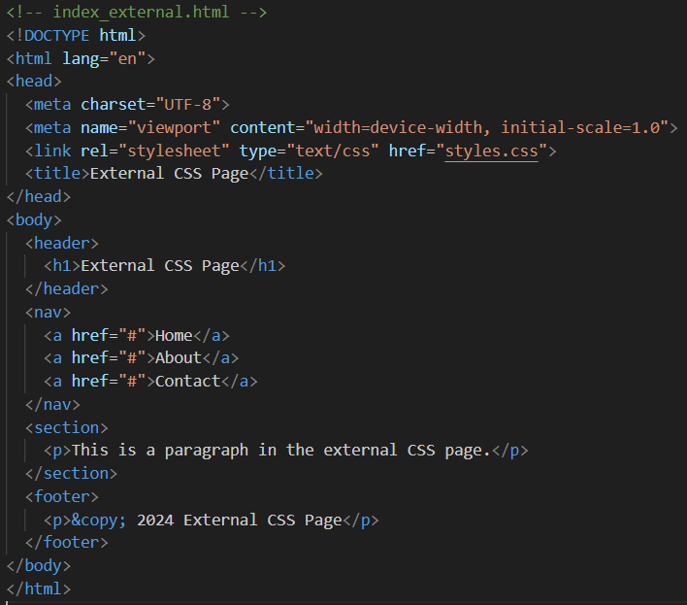

Internal CSS (index_internal.html)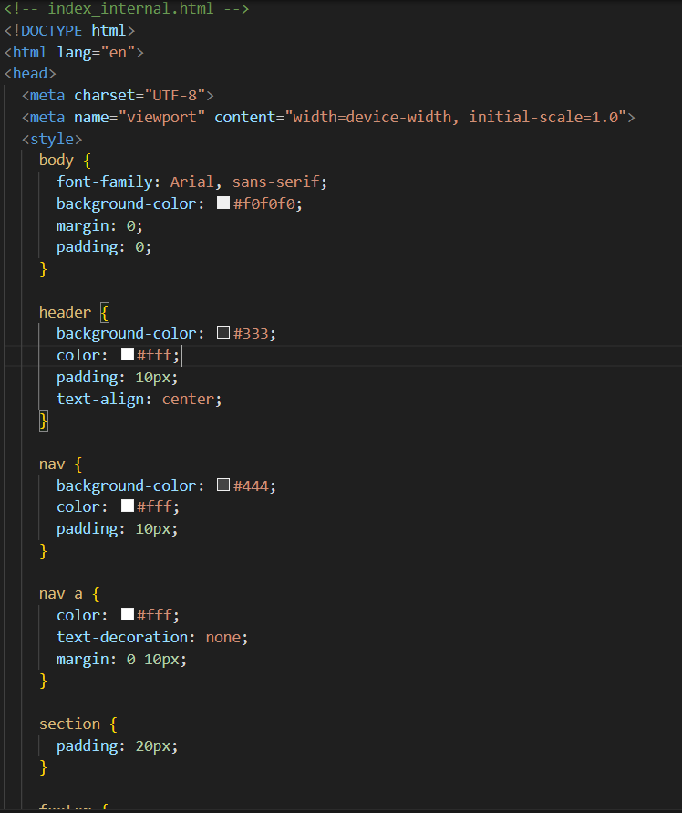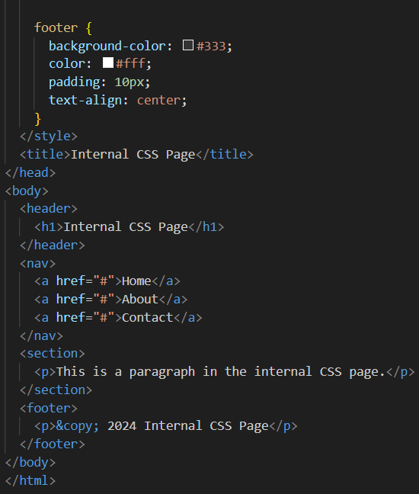

These examples illustrate how to apply External, Internal, and Inline CSS to create simple web pages with different styling approaches.

10.Create below page using HTML CSS

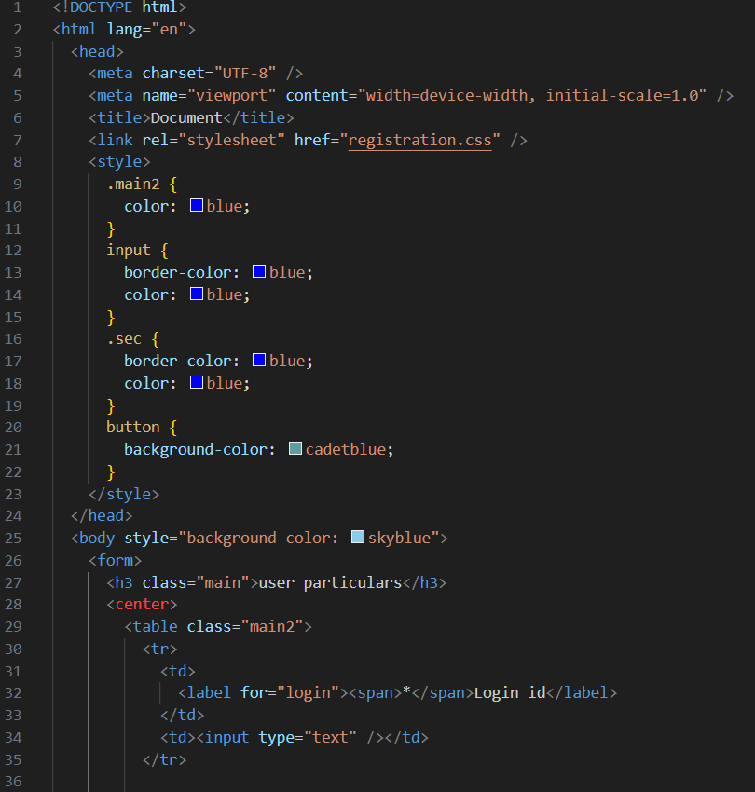

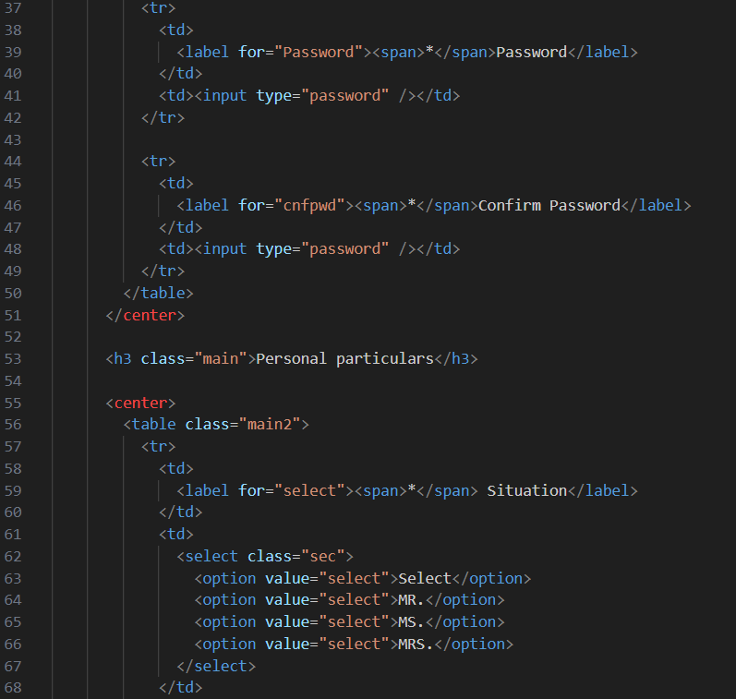

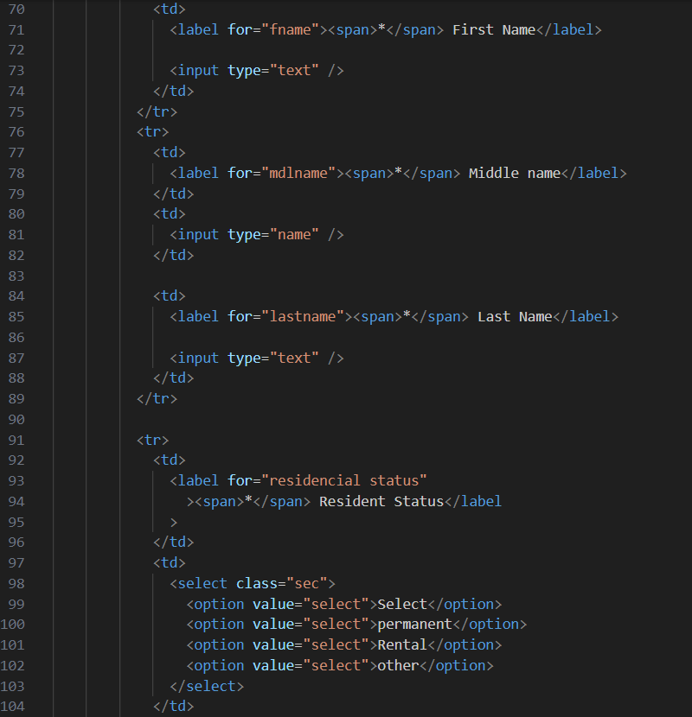

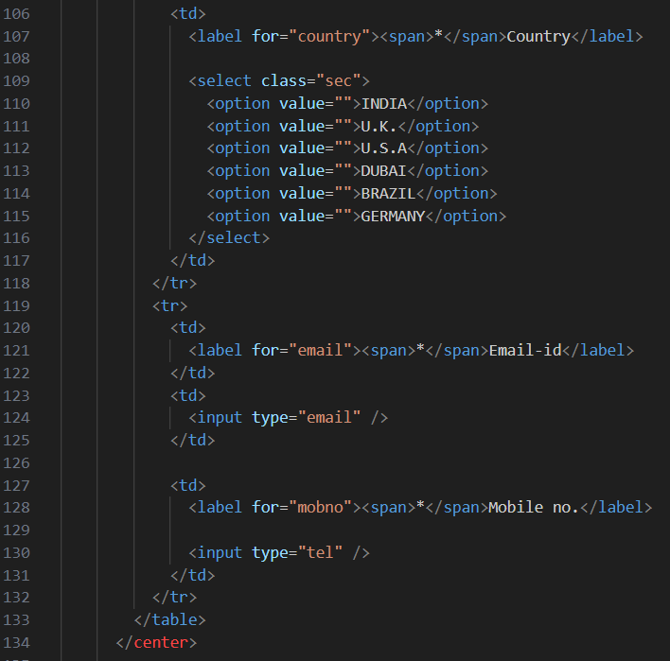

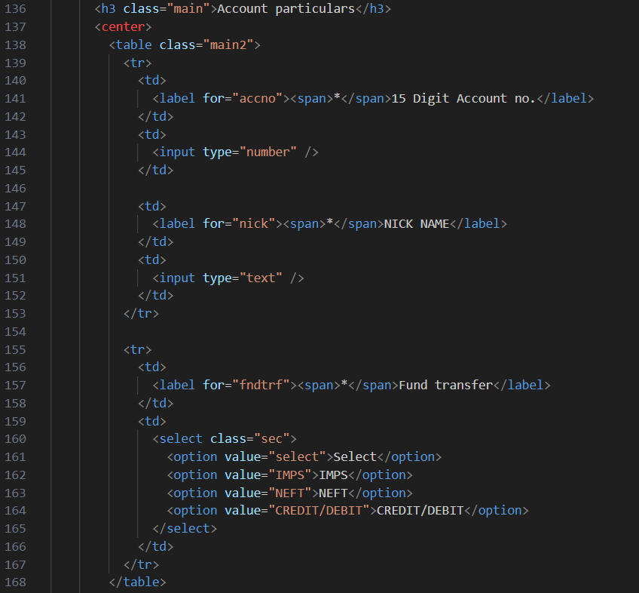

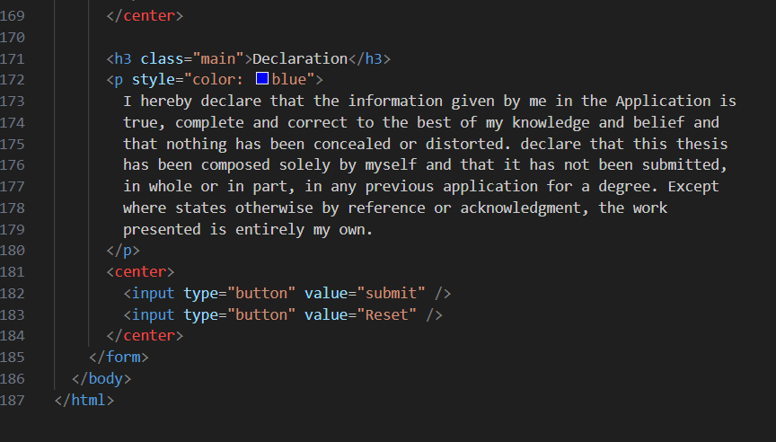

**OutPut :**

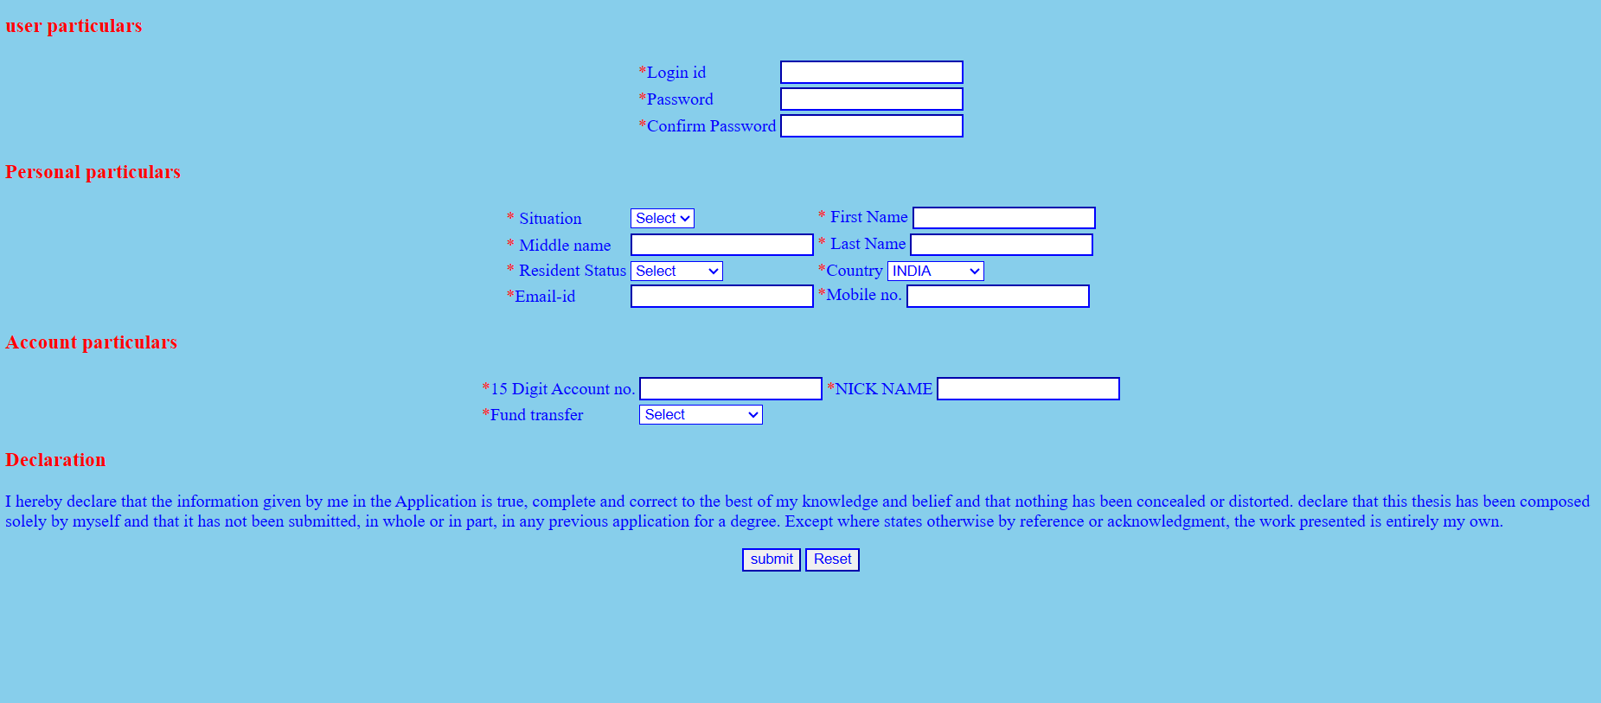

11. Create link-pseudo classes using external css, to format links on the pages.

link CSS pseudo-class represents an element that has not yet been visited. It matches every unvisited <a> or <area> element that has an href attribute.

Create a CSS file (e.g., styles.css):

Ex: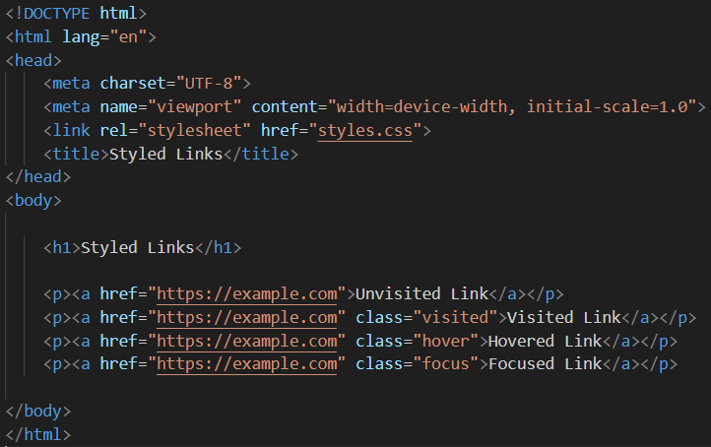

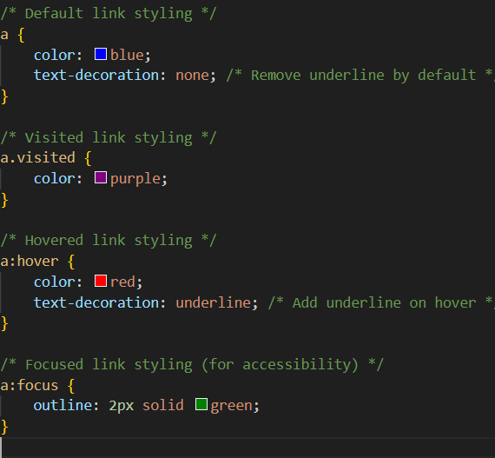

12. Create a dynamic pseudo class using HTML, CSS

Dynamic pseudo-classes in CSS are used to style elements based on user interaction or certain conditions. One commonly used dynamic pseudo-class is **:hover**, which styles an element when the user hovers over it. Here's an example of using the **:hover** pseudo-class:html

Ex:

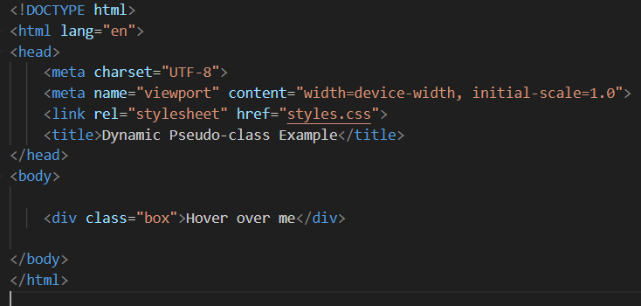

Now, create a CSS file (e.g., styles.css):

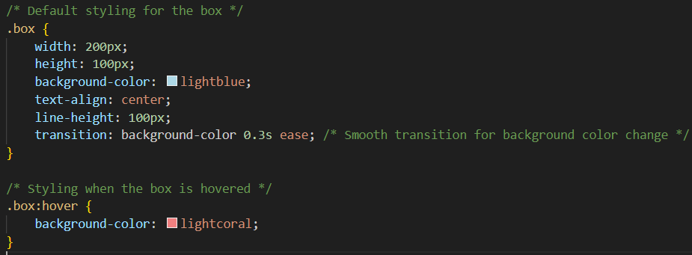

In this example, when you hover over the box element, the background color changes from lightblue to lightcoral. You can customize the styles and add other dynamic pseudo-classes based on your requirements.

Dynamic pseudo-classes include :hover, :active, :focus, and more. They allow you to create interactive and engaging user interfaces by styling elements based on user actions.