1. **What is software? What is software engineering?**

**Ans**: Software is nothing but set of instructions or set of programs are known as. software is that part of a complier which cannot be touched.

Software engineering is a technique through which we can developed or created software for computer system and any other electronic devices.

In software engineering the development of software using well decline scientific principal method and procedures. Software engineers build these software and applications by using designing and programming languages.

Software encompasses programs, data, and instructions that enable computers to perform tasks. Software engineering applies engineering principles to develop, test, and maintain software systems effectively. It involves systematic processes like requirement analysis, design, coding, testing, deployment, and maintenance to ensure high-quality, reliable, and scalable software solutions.

1. **Explain types of software?**

**Ans**: 1. System software

2.Application software

3.utility software

1.System software: - System software is a software designed to provide a platform to other software.

Ex: -Operating System (windows, android, Linux)

2.Application software: - The software that you help you to do a specific type of works is called application software.

Ex: - Ms word, Excel etc.

3.utility software: - utility software helps to manage, maintain and control computer resources.

Ex:- Anti-virus software, backup software, disk tools etc…

1. **What is SDLC? Explain each phase of SDLC?**

**Ans**: SDLC Stand for software development life cycle model. It describes the sequence of phases or staps to develop any software.in simple word entire life of software from beginning to ending.

1.Requirements Gathering: - This phase involves gathering and documenting the requirements of the software from stakeholders. It includes identifying user needs, functional requirements, and system constraints.

2.Analysis: - In this phase, the gathered requirements are analysed to understand their feasibility and impact on the software project. It involves studying the requirements in detail to identify potential risks and constraints.

3.Design:- The design phase focuses on creating a blueprint for the software solution based on the analyzed requirements. It includes architectural design, database design, and detailed design of individual components.

4. Implementation:- Also known as the coding phase, implementation involves translating the design into actual code. Developers write, compile, and integrate the code to build the software according to the design specifications.

5. Testing:- In this phase, the software is tested to ensure it meets the specified requirements and quality standards. Different types of testing, such as unit testing, integration testing, and system testing, are performed to identify and fix defects.

6. Deployment:- Once the software has been tested and approved, it is deployed to the production environment. This involves installing the software on the target systems and configuring it for end-user use.

7.Maintenance:-The maintenance phase involves monitoring and supporting the software in the production environment. It includes addressing user feedback, fixing bugs, making enhancements, and ensuring the software's long-term reliability and performance.

1. **What is DFD? Create a DFD diagram on Flipkart.**

DFD typically stands for "Data Flow Diagram." It's a graphical representation of the flow of data through a system, illustrating how data enters and exits the system, where it's stored, and how it's processed.

**Ans:**

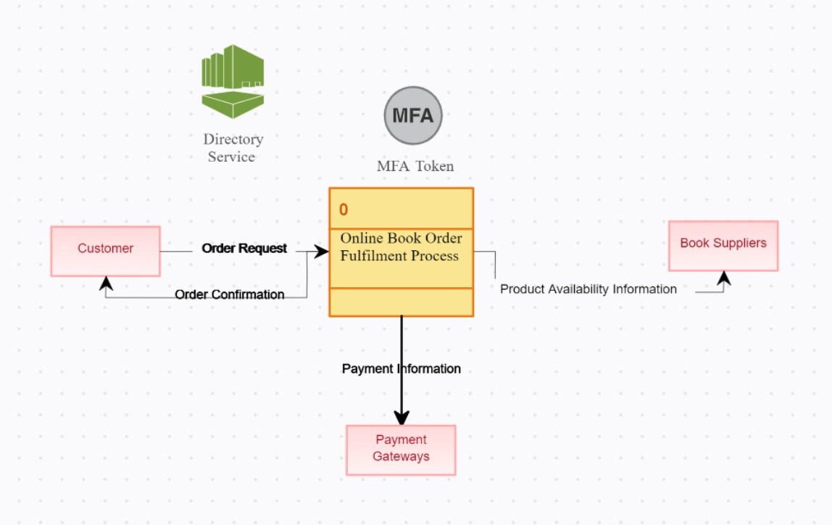

5. What is Flow chart? Create a flowchart to make addition of two numbers

**Ans:** A flowchart is a picture of the separate steps of a process in sequential order.

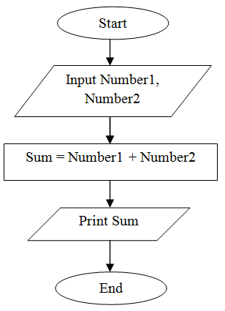

6.What is Use case Diagram? Create a use-case on bill payment on Paytm.

**Ans:** Use-case diagrams describe the high-level functions and scope of a system. These diagrams also identify the interactions between the system and its actors.

