Experiment 3

Student Name: Bhavik Pahuja UID: 24BAI70522
Branch: CSE - AIML Section/Group: 24AIT_KRG G1
Semester: 4 Date of Performance: 28/1/26
Subject Name: DBMS Subject Code: 24CSH-298

Aim
To understand the basic structure of a PL/SQL program by creating and executing a simple PL/SQL block that includes declaration and execution sections, and to display output using built-in procedures.

Software Requirements
- Database Management System:
  - PostgreSQL
- Database Administration Tool:
  - pgAdmin

Objectives
- To create a simple PL/SQL program demonstrating Declaration Section and Execution Section.

Problem Statement
The program is structured to handle the following operations:
- Memory Allocation: Initialize variables for Employee ID, Name, and Salary.
- Arithmetic Processing: Compute the House Rent Allowance (HRA) as 40% of the base salary:
HRA = Salary \ 0.40
- Conditional Evaluation: Determine tax liability based on a salary threshold of 60,000.
- Data Output: Stream results to the console using the DBMS_OUTPUT package.

Practical/Experiment Steps
- Environment Setup: Connected to the database and enabled SERVEROUTPUT to ensure console visibility.
- Variable Definition: Used the DECLARE section to allocate memory for numerical and character data types.
- Data Mapping: Assigned static values (e.g., Name: 'THOMAS', Salary: 25,000) to simulate a single-record environment.
- Logic Execution: * Initiated the BEGIN block for procedural processing.
- Applied arithmetic formulas for allowance calculations.
- Implemented an IF-ELSE structure to provide boolean-based tax status.
- Finalization: Closed the block with the END; keyword and triggered the PL/SQL engine for execution.

Procedure
- Established a connection to the database environment.
- Initiated the DECLARE section to reserve memory for numerical and character data types.
- Mapped real-world data to the defined variables, such as setting the Employee Name to ‘THOMAS’ and Salary to 25,000.
- Constructed the BEGIN block to initiate the procedural execution of the code.
- Coded a series of output commands to display the primary employee details and the computed HRA value.
- Applied a conditional logic check to compare the employee's salary against the 60,000 threshold.
- Defined the alternative output paths to inform the user of their tax status based on the boolean result of the salary check.
- Concluded the block with the END; keyword and executed the script to trigger the PL/SQL engine.
- Verified the console output against the manual calculations to ensure the logic and variables were handled correctly.

Input/Output Analysis
SQL Input Queries
DECLARE
EMP_ID NUMBER:=101;
EMP_NAME VARCHAR(20):='THOMAS';
EMP_SALARY NUMBER:=25000;

BEGIN
DBMS_OUTPUT.PUT_LINE('EMPLOYEE ID: '||EMP_ID);
DBMS_OUTPUT.PUT_LINE('EMPLOYEE NAME: '||EMP_NAME);
DBMS_OUTPUT.PUT_LINE('SALARY: RS. '||EMP_SALARY);
DBMS_OUTPUT.PUT_LINE('HOUSE RENT ALLOWANCE: RS. '||(0.40*EMP_SALARY));
IF EMP_SALARY > 60000 THEN
DBMS_OUTPUT.PUT_LINE('YOU NEED TO PAY TAX');
ELSE
DBMS_OUTPUT.PUT_LINE('YOU DO NOT HAVE TO PAY TAX');
END IF;
END;

Output
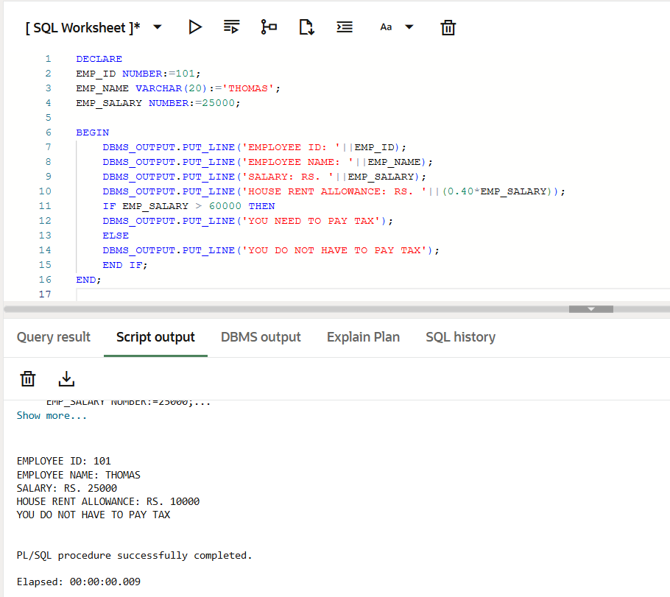

Learning Outcomes
- Understanding the fundamental organisation of PL/SQL declaration and execution sections.
- Learnt to declare, initialise, and use different data types within a procedural block.
- Implementing conditional branching and basic arithmetic operations to process data dynamically.
- Utilising built-in procedures to format and display calculated results to the user.

