Name: Bhavik Pahuja
UID: 24BAI70522
Course: BE-CSE (AI&ML)
Subject: Database Management Systems

Experiment: Library Management System Implementation
1. Aim of the Session
The aim of this practical is to design and implement a relational database schema for a Library Management System. This involves defining tables with specific constraints, establishing relationships between entities, and managing database security through role-based access control.
2. Objective of the Session
Upon completing this session, the following objectives were achieved:
- Developed table structures using Primary Keys, Foreign Keys, and Check Constraints for data validation.
- Gained proficiency in DML (Data Manipulation Language) operations, specifically INSERT, SELECT, UPDATE, and DELETE.
- Implemented DCL (Data Control Language) to manage user roles and granular permissions.
- Maintained referential integrity across multiple related tables (books, library_visitors, and book_issue).
3. Practical / Experiment Steps
The implementation was carried out through the following tasks:
- Schema Definition: Created the base tables for books and library_visitors with specific constraints such as NOT NULL, UNIQUE, and CHECK (e.g., ensuring visitor age is 18+).
- Relational Setup: Created the book_issue table to act as a transaction bridge, linking books and visitors via Foreign Keys.
- Data Population: Populated the tables with initial records to test the schema's validity.
- Operational Testing: Performed updates on user information and attempted deletion of records to observe constraint behavior.
- Security Administration: Created a librarian role with login credentials and configured its access levels using GRANT and REVOKE commands.
4. Procedure of the Practical
The following steps were followed during the execution:
- System Initialization: Logged into the database environment and established a connection to the server.
- Database Creation: Initialized a new database to house the library management system.
- Executing Table Scripts: Ran the CREATE TABLE commands in a specific sequence (creating parent tables before dependent transaction tables).
- Data Entry: Executed INSERT statements to add sample books and visitor profiles.
- Query Verification: Used SELECT queries to verify that the data was correctly stored and consistent across tables.
- Data Modification: Tested the UPDATE and DELETE commands to ensure the system handles changes as intended.
- Role Configuration: Defined the librarian role and assigned specific table privileges.
- Security Verification: Tested and then revoked permissions to confirm the effectiveness of the security policy.
- Record Maintenance: Saved the SQL script and took screenshots of the execution results.
5. I/O Analysis (Input / Output Analysis)
Input Queries
SQL
-- Table Creation
CREATE TABLE books(
id INT PRIMARY KEY,
name VARCHAR(50) NOT NULL,
author_name VARCHAR(50) NOT NULL,
count INT CHECK(count>0)
);

CREATE TABLE library_visitors(
user_id INT PRIMARY KEY,
user_name VARCHAR(20) NOT NULL,
age INT CHECK(age>=18) NOT NULL,
email VARCHAR(40) UNIQUE NOT NULL
);

CREATE TABLE book_issue(
book_issue_id INT PRIMARY KEY,
book_id INT NOT NULL,
user_id INT NOT NULL,
FOREIGN KEY (book_id) REFERENCES books(id),
FOREIGN KEY (user_id) REFERENCES library_visitors(user_id),
book_issue_date DATE NOT NULL
);

-- Data Manipulation
INSERT INTO books VALUES(1, 'Hairy Popter', 'R. Snap', 1);
INSERT INTO library_visitors VALUES(101, 'Robert', 20, 'abc@il.com');
UPDATE library_visitors SET email='Robel.com' WHERE user_id = 101;

-- Role Management
CREATE ROLE librarian WITH LOGIN PASSWORD 'WHIPWHIP';
GRANT SELECT, INSERT, DELETE, UPDATE ON books TO librarian;
Output Details
- Schema Success: All tables were created successfully. The system correctly enforced the CHECK(age>=18) constraint, rejecting invalid entries.
- DML Results: The UPDATE query correctly modified the email field for user 101, and SELECT queries displayed the current state of all tables accurately.
- DCL Verification: The librarian role was successfully created and assigned the necessary privileges for library management tasks.
- Validation: Testing confirmed that after the REVOKE command, the librarian could no longer perform operations on the books table, ensuring the security policy is functional.
- We also confirmed the permissions of the role “librarian” by checking the table privileges.
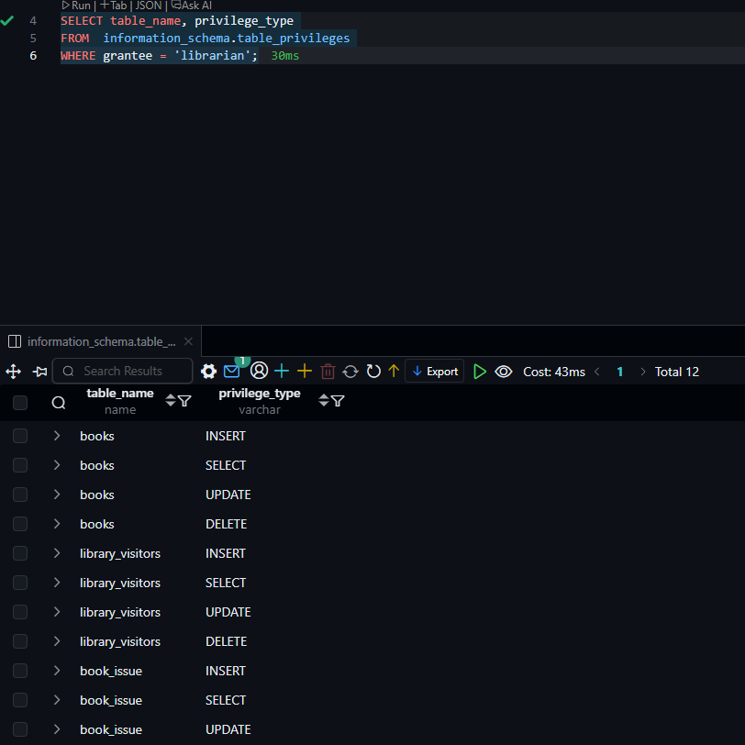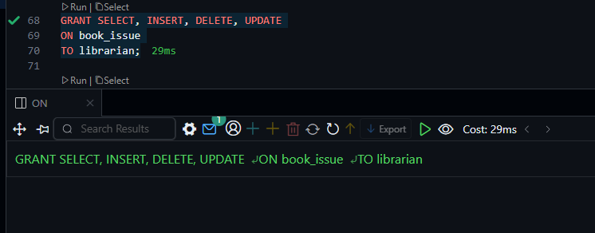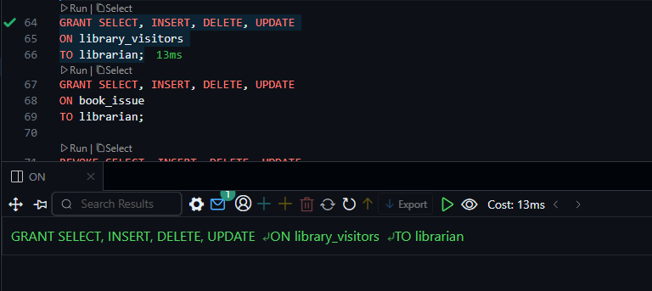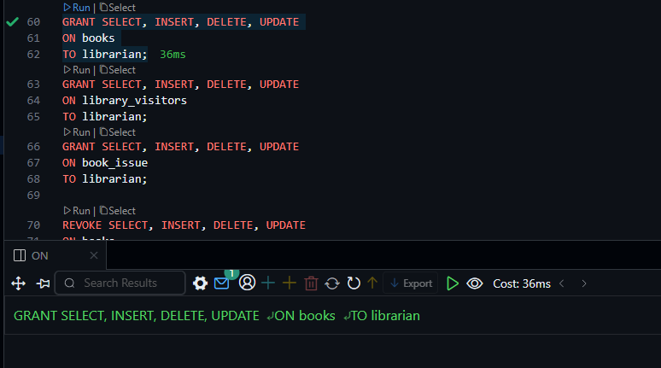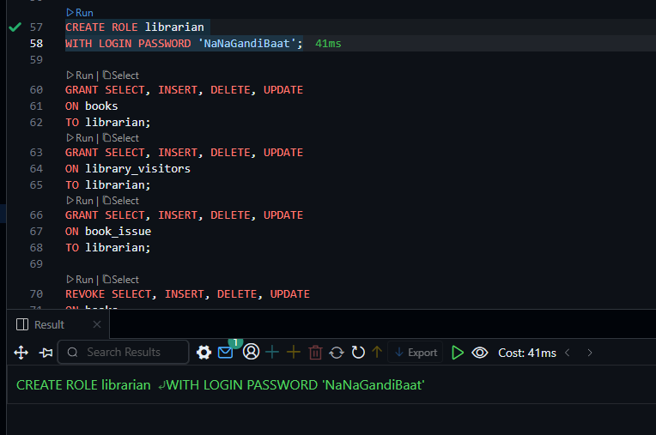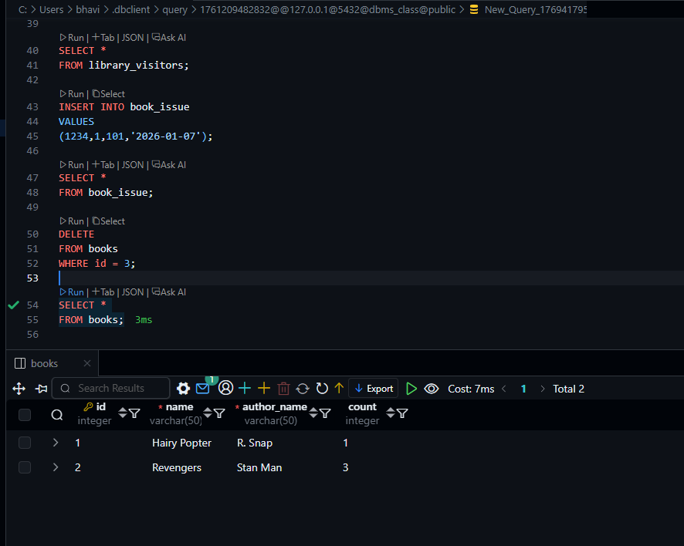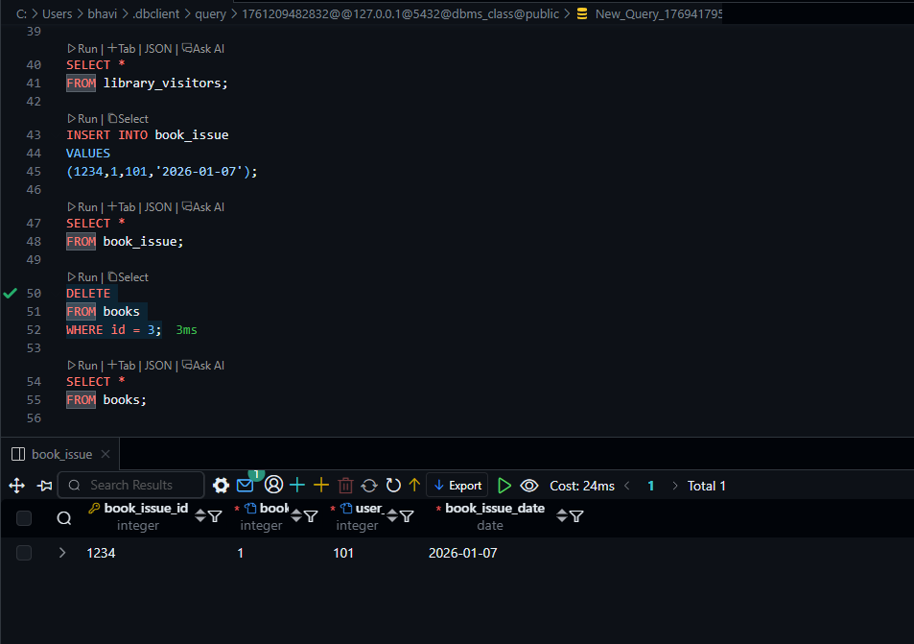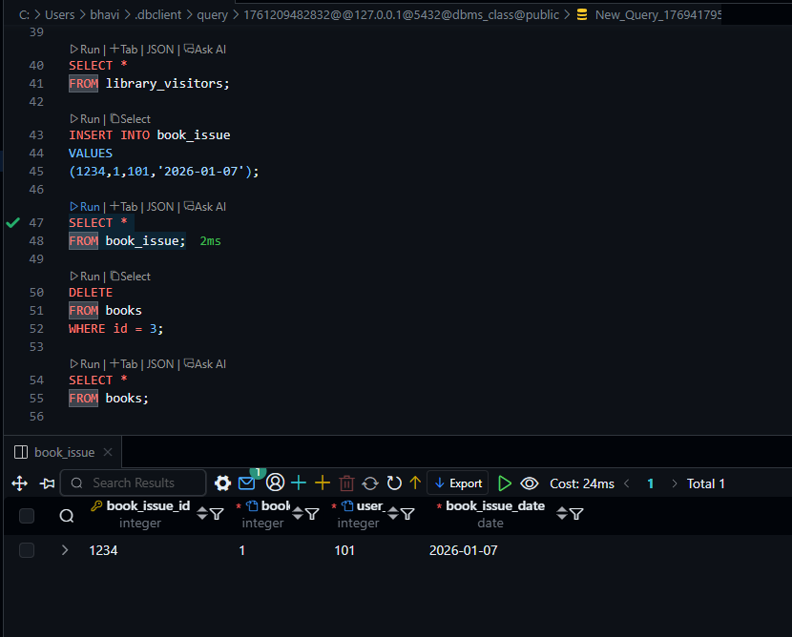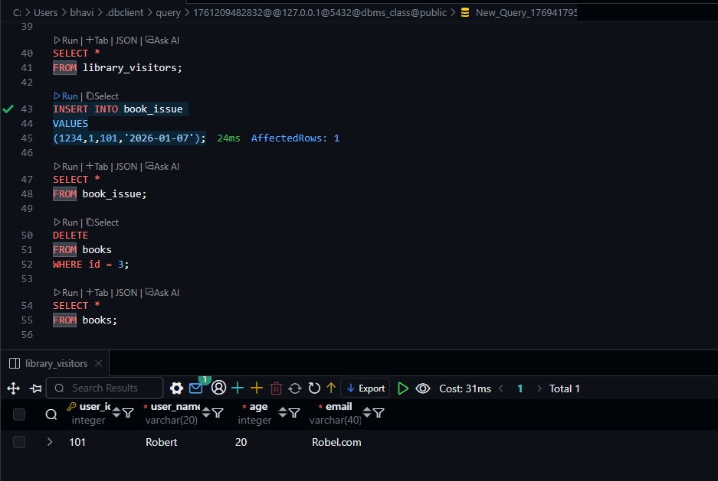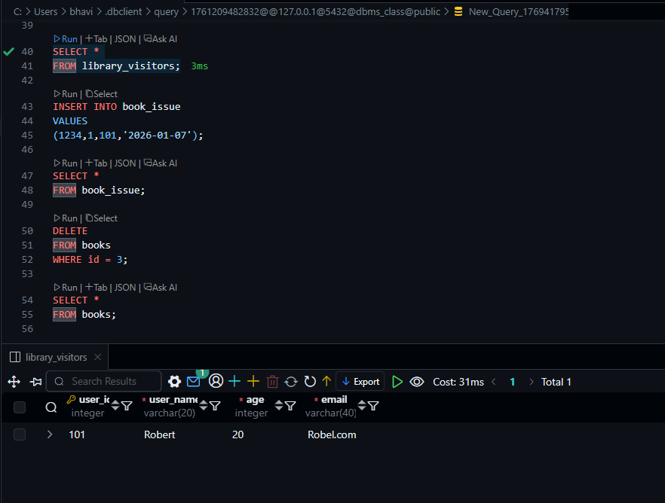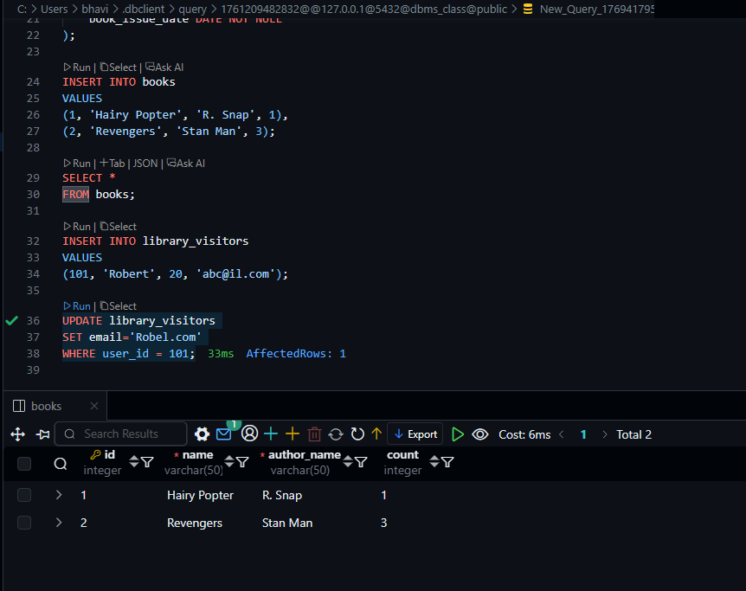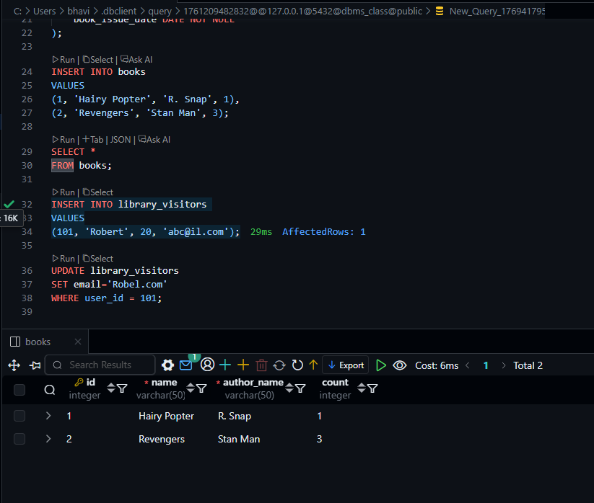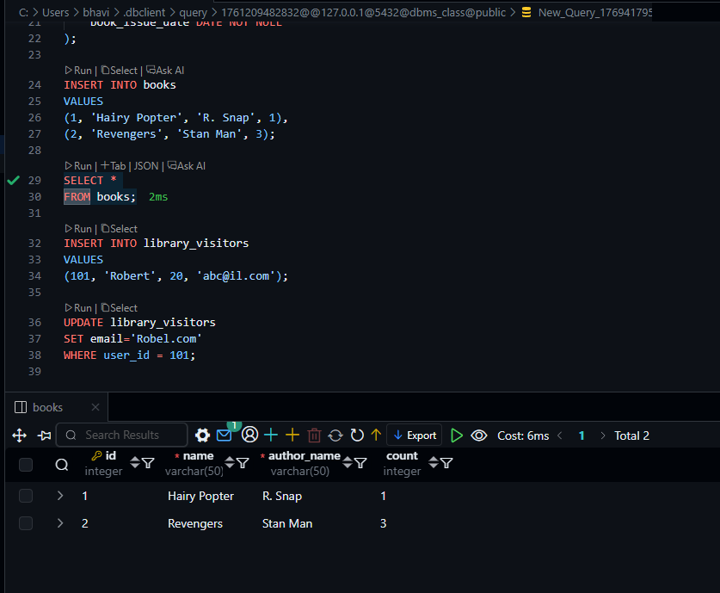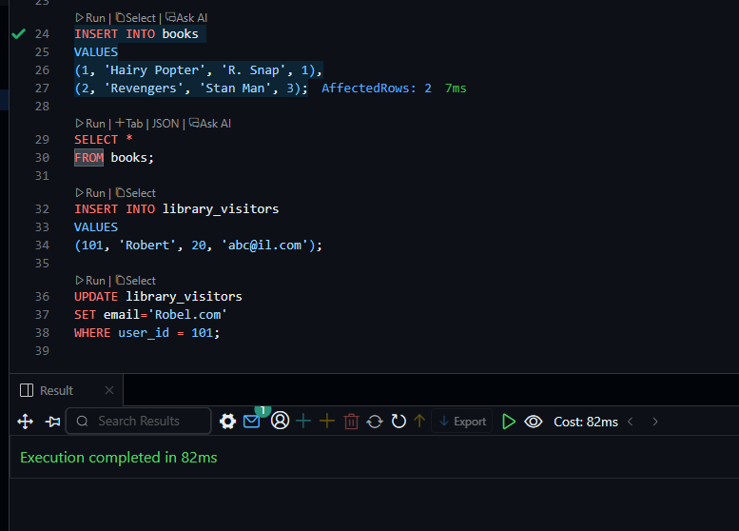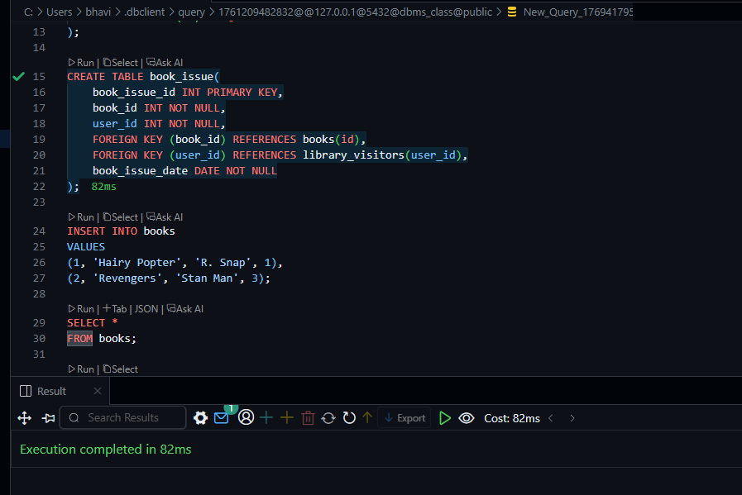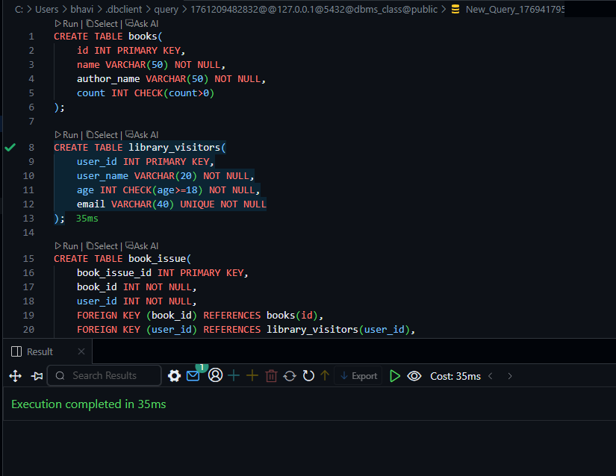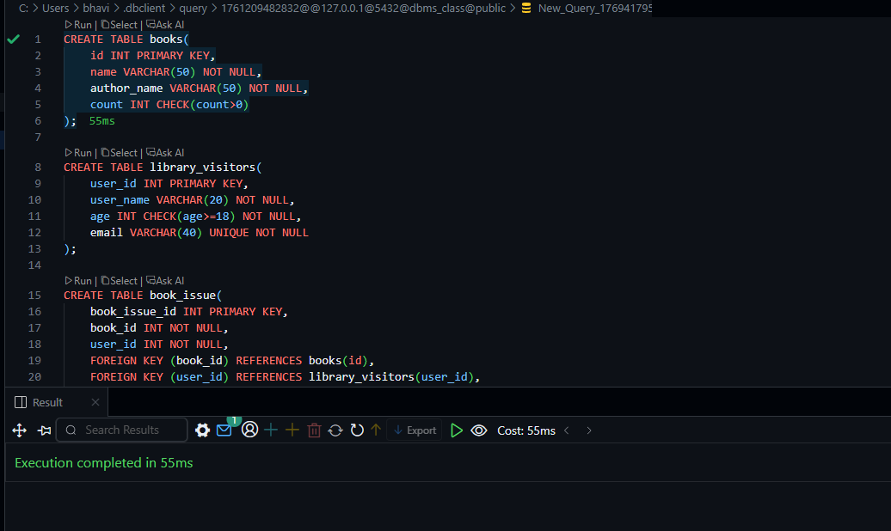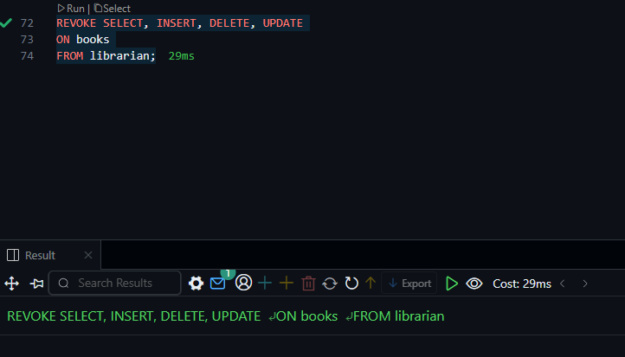

6. Learning Outcome
This practical session provided significant insights into:
- Structural Logic: Understanding how Foreign Keys and Check Constraints maintain high data quality and prevent logical errors.
- Security Implementation: Learning to manage database security through roles rather than individual user permissions.
- Practical Application: Applying SQL fundamentals to a real-world scenario (Library Management), demonstrating how relational databases handle complex interactions between entities.

