OUTPUTS FOR ASSIGNMENT - 1, 2 & 3

Assignment: 1

1. MPI_SEND_RECV

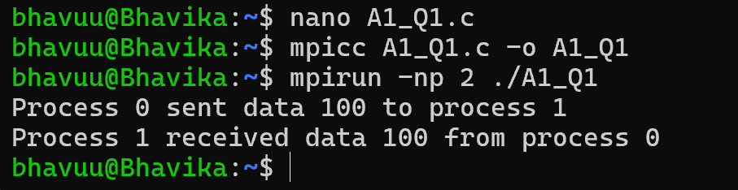

1. MPI_PROBE_STATUS

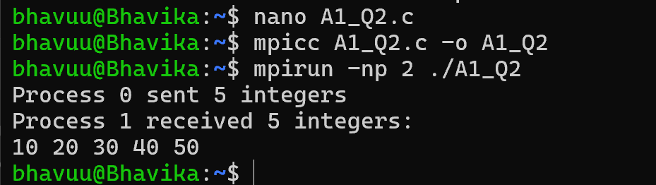

1. MPI_RANDOM_WALK

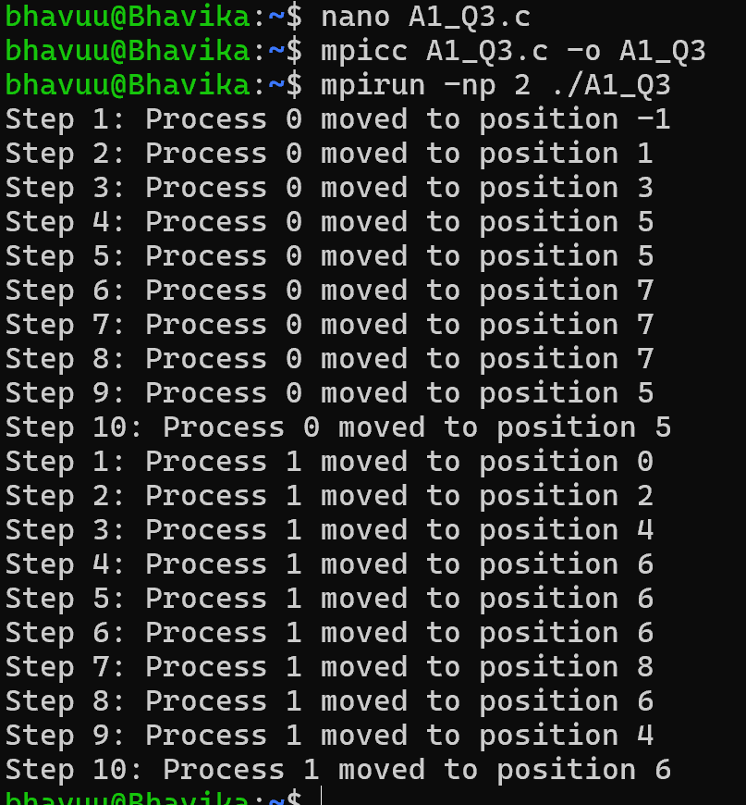

Assignment: 2

1. MPI_PI_ESTIMATION

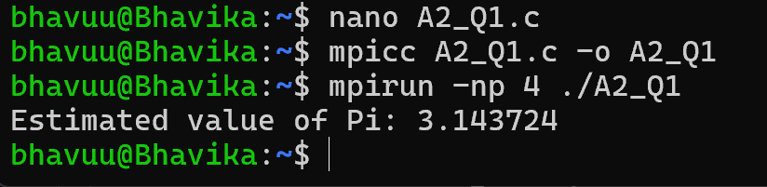

1. MPI_MATRIX_MULTIPLICATION

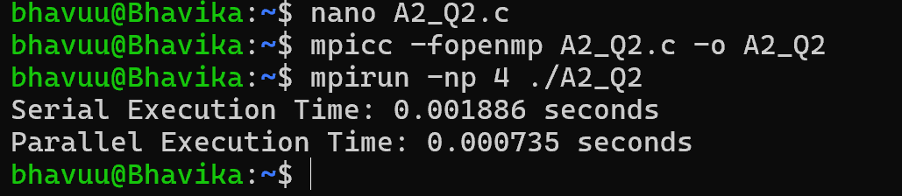

1. MPI_ODD_EVEN_SORT

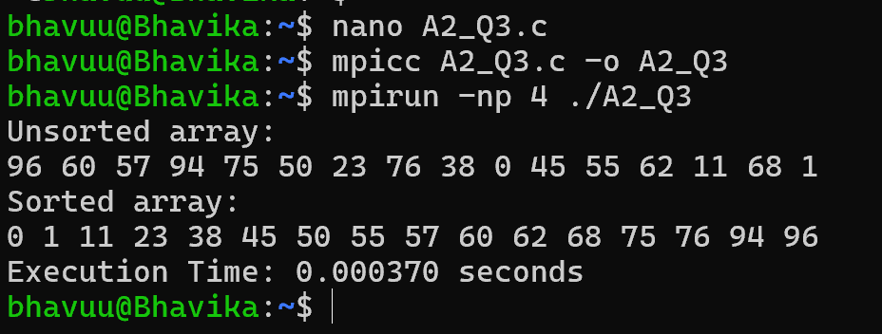

1. MPI_HEAT_SIMULATION

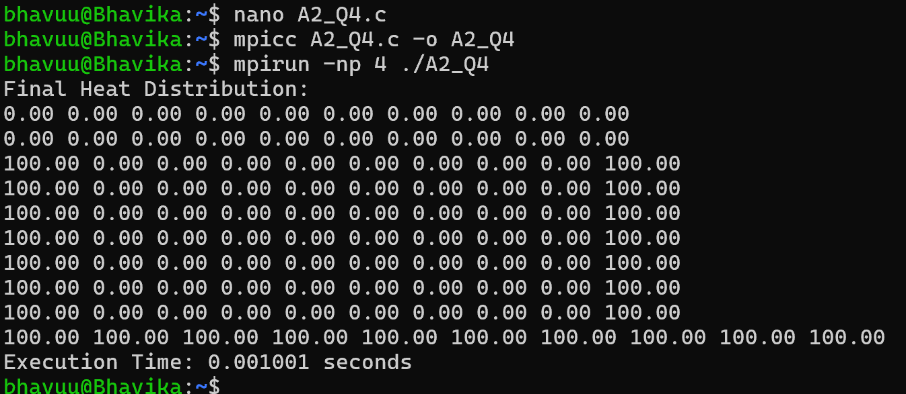

1. MPI_REDUCTION

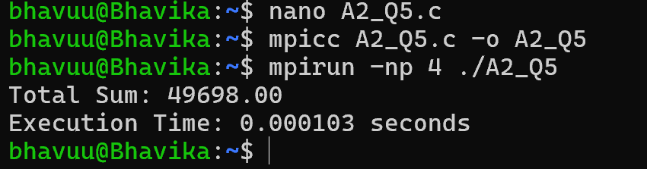

1. MPI_DOT_PRODUCT

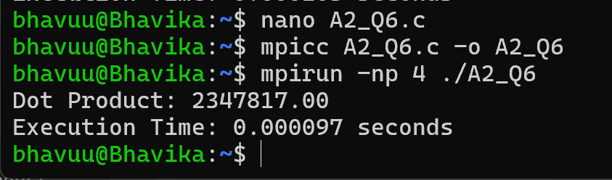

1. MPI_PREFIX_SUM

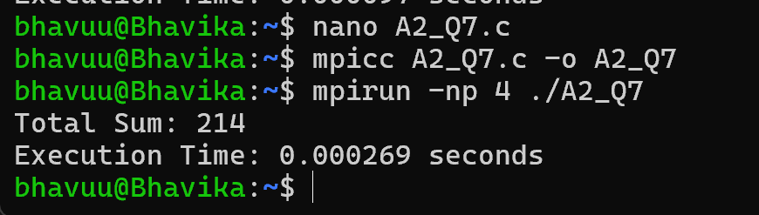

1. MPI_MATRIX_TRANSPOSE

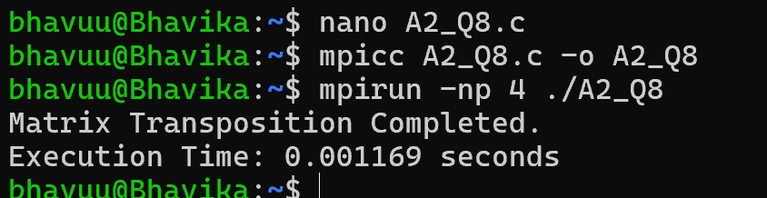

Assignment: 3

1. MPI_DAXPY

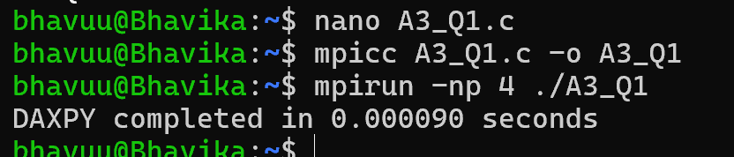

1. MPI_PI_CALCULATION

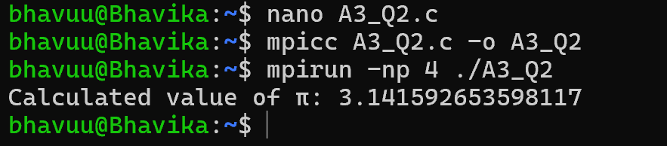

1. MPI_PRIME_FINDER

