SANYUKT ORGANISATION
Spreading Love Since 2020
INTERNSHIP RECRUITMENT PACKAGE
Marketing Intern & Content Writer Intern
Prepared By
Bhavika Santosh Bhoir
Human Resources Department
www.sanyuktorg.com

MARKETING INTERN
Job Title: Marketing Intern
Duration: 30 Days
Mode: Remote
Internship Type: As per Organisation Policy

About the Internship
Sanyukt Organisation is looking for a motivated Marketing Intern to support its outreach and awareness initiatives. This internship offers hands-on exposure to digital marketing in a non-profit setting, giving interns the opportunity to contribute directly to campaigns that drive real social impact.

Key Responsibilities
- Assist in planning and executing digital marketing campaigns.
- Create engaging content ideas for social media platforms.
- Promote events, initiatives and awareness campaigns.
- Increase audience engagement and community interaction.
- Collaborate with design and content teams for campaigns.
- Monitor campaign performance and prepare simple reports.
- Research marketing trends and competitor activities.
- Support partnerships and outreach initiatives.
- Promote volunteer and internship opportunities.
- Suggest creative ideas to improve online presence.

Required Skills & Qualifications
- Pursuing or completed degree in Marketing, Business, Mass Communication or a related field.
- Good written and verbal communication skills.
- Basic understanding of digital marketing and social media.
- Familiar with Instagram, LinkedIn and Facebook.
- Basic knowledge of Canva or similar tools.
- Creative thinking and problem-solving ability.
- Good organisational and time-management skills.
- Ability to work independently in a remote setup.
- Willingness to learn and adapt.
- Interest in social impact and community work.

Preferred Skills
- Prior exposure to campaign planning or brand promotion.
- Familiarity with basic analytics or reporting tools.
- Experience creating content for social causes.

Benefits & Perks
- Internship Completion Certificate.
- Letter of Recommendation for outstanding performers.
- Flexible remote working hours.
- Practical marketing experience in an NGO.
- Work on real social impact campaigns.
- Mentorship from experienced professionals.
- Skill development and portfolio building.
- Networking with changemakers.

Learning Opportunities
- Understand digital marketing strategies for social causes.
- Learn campaign planning and execution.
- Improve communication, creativity and analytical skills.
- Gain hands-on experience with real projects.

Certificate Information
A digital Internship Completion Certificate will be provided to all interns who successfully complete 30 days and fulfil their responsibilities.

Letter of Recommendation
Top performers will be eligible for a Letter of Recommendation from Sanyukt Organisation.

Who Can Apply
- Students or fresh graduates from any stream.
- Individuals interested in marketing, communication and social impact.
- Anyone eager to learn, create and contribute to meaningful work.

Application Method
Interested candidates can send their updated resume to the official email address, or apply through the LinkedIn application link, with the subject line "Marketing Intern – Application".

Professional Closing Statement
Sanyukt Organisation welcomes individuals who are passionate about marketing and eager to use their skills for a meaningful purpose. Join us in creating lasting impact through creativity and collaboration.

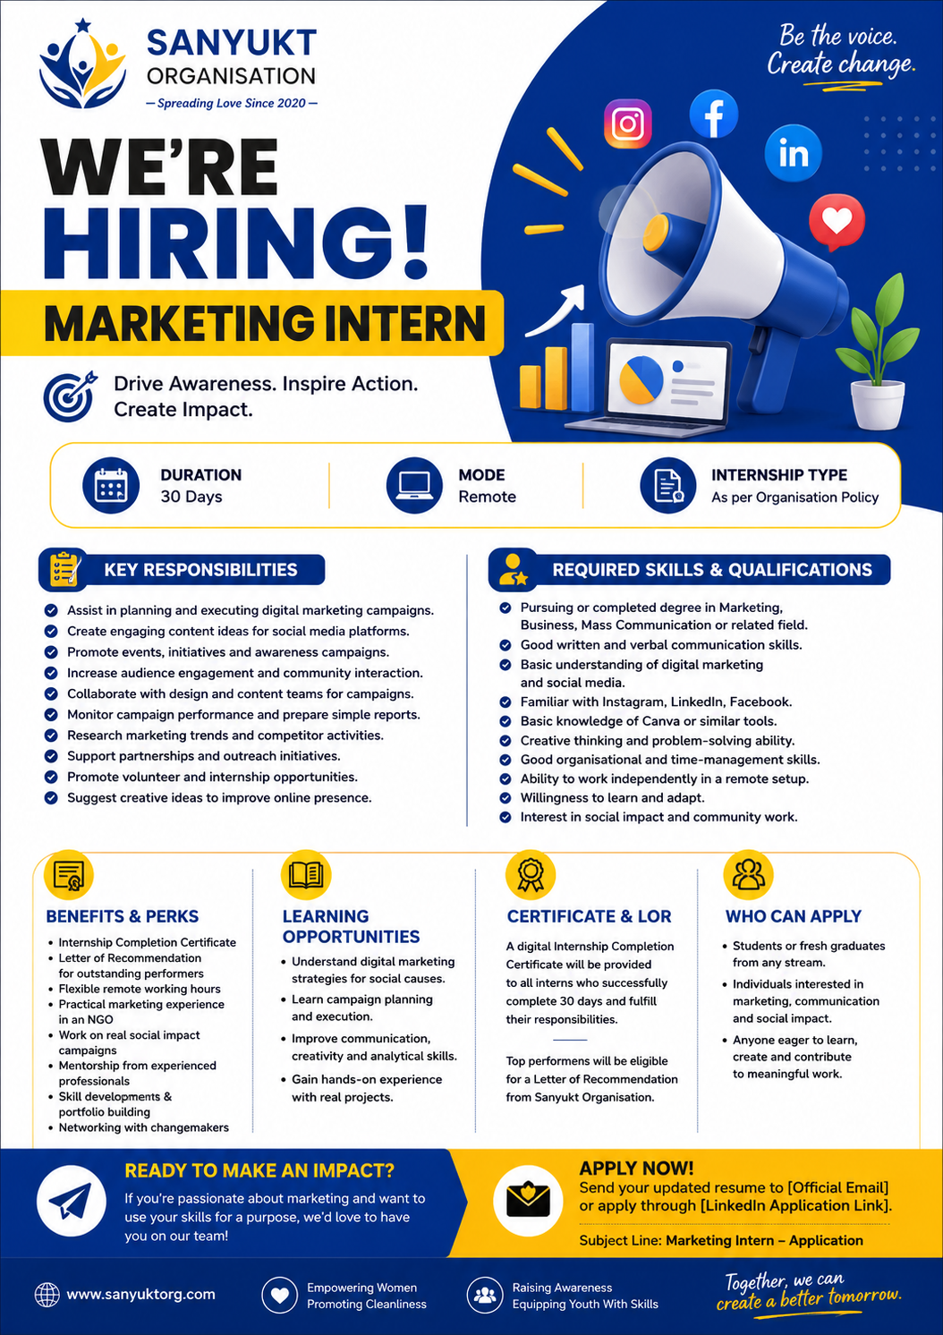

CONTENT WRITER INTERN
Job Title: Content Writer Intern
Duration: 30 Days
Mode: Remote
Internship Type: As per Organisation Policy

About the Internship
Sanyukt Organisation is seeking a dedicated Content Writer Intern to help craft meaningful stories and awareness content. This internship provides an opportunity to build strong writing and storytelling skills while contributing to campaigns that inform, inspire and create lasting change.

Key Responsibilities
- Research and write engaging content for social media, blogs and campaigns.
- Create captions, articles and awareness posts that align with the mission.
- Develop storytelling content that connects with diverse audiences.
- Edit and proofread content for clarity, grammar and impact.
- Collaborate with the design and marketing teams to bring ideas to life.
- Cover and document NGO events and initiatives through written content.
- Help maintain a consistent brand voice across platforms.
- Suggest content ideas and topics to increase engagement.
- Support in writing newsletters and email communications.
- Stay updated on trends and best practices in content writing.

Required Skills & Qualifications
- Currently pursuing or recently completed a degree in English, Journalism, Mass Communication or a related field.
- Excellent written and verbal communication skills.
- Strong command over grammar, punctuation and vocabulary.
- Ability to write creative, engaging and error-free content.
- Basic knowledge of SEO and content optimisation is a plus.
- Familiarity with social media platforms and trends.
- Ability to manage time and meet deadlines.
- Good research skills and attention to detail.
- Comfortable working independently in a remote setup.
- Passion for social impact and storytelling.

Preferred Skills
- Prior experience writing for digital or social platforms.
- Basic understanding of SEO principles.
- Portfolio of previous writing samples, if available.

Benefits & Perks
- Internship Completion Certificate.
- Letter of Recommendation for outstanding performers.
- Flexible remote working hours.
- Real-world NGO experience.
- Portfolio building opportunities.
- Skill development in writing, editing and communication.
- Networking with changemakers.

Learning Opportunities
- Learn content strategy and storytelling for social causes.
- Gain hands-on experience in writing for digital platforms.
- Understand audience engagement and communication.
- Improve research, editing and creative thinking skills.

Certificate Information
A digital Internship Completion Certificate will be provided to all interns who successfully complete 30 days and fulfil their responsibilities.

Letter of Recommendation
Top performers will be eligible for a Letter of Recommendation from Sanyukt Organisation.

Who Can Apply
- Students or fresh graduates from any stream.
- Individuals passionate about writing and social impact.
- Anyone eager to learn, create and contribute to meaningful work.

Application Method
Interested candidates can send their updated resume to the official email address, or apply through the LinkedIn application link, with the subject line "Content Writer Intern – Application".

Professional Closing Statement
Sanyukt Organisation welcomes individuals who are passionate about writing and storytelling for social good. Join us in spreading awareness and creating impact, one word at a time.

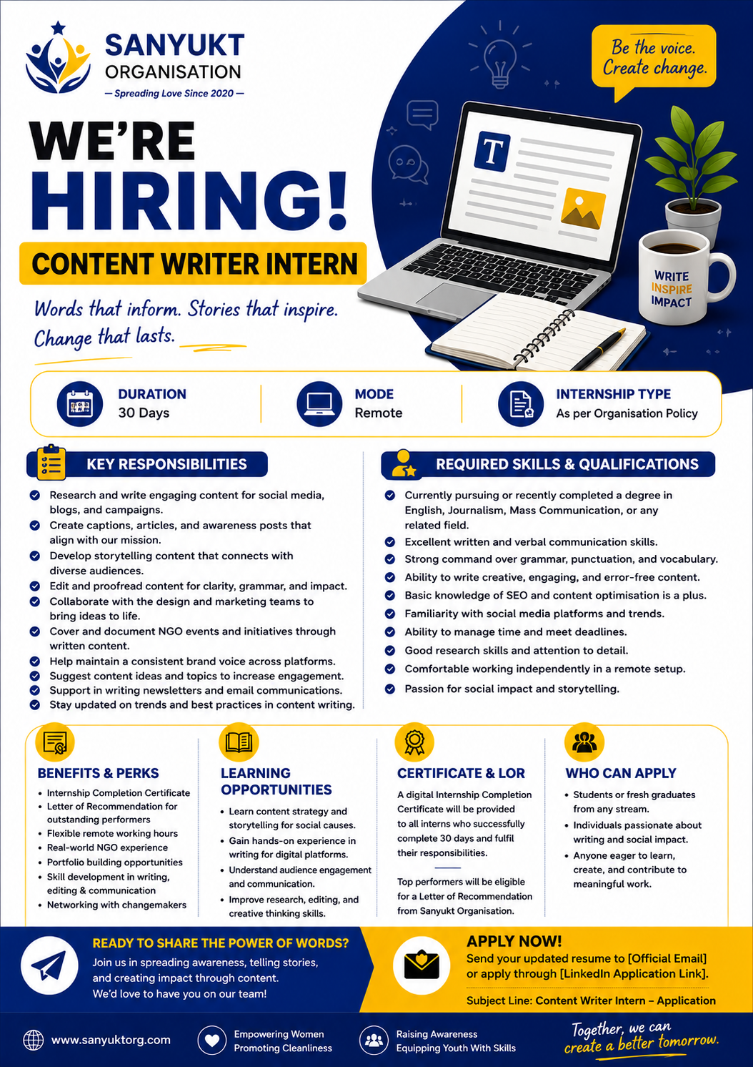

LINKEDIN HIRING POST

Marketing Intern
We're looking for a creative and driven Marketing Intern to join the Sanyukt Organisation team!
If you're passionate about digital marketing and want your ideas to support real social causes, this 30-day remote internship is for you. You'll assist with campaign planning, social media promotion and community outreach, while learning directly from experienced professionals in the non-profit space.
What you'll gain: hands-on marketing experience, a Certificate of Completion, a Letter of Recommendation for outstanding performers, flexible remote hours, and the chance to build a portfolio while working on meaningful projects.
Ready to make an impact? Send your updated resume to our official email or apply through the LinkedIn application link, with the subject line "Marketing Intern – Application".
#Hiring #MarketingInternship #RemoteInternship #NGOJobs #DigitalMarketing #SanyuktOrganisation #InternshipOpportunity #SocialImpact

LINKEDIN HIRING POST

Content Writer Intern
Sanyukt Organisation is hiring a Content Writer Intern who loves turning ideas into words that matter.
This 30-day remote internship is perfect for students and fresh graduates who want to sharpen their writing skills while contributing to campaigns that raise awareness and inspire change. You'll write blogs, social captions and newsletters, and collaborate closely with our design and marketing teams.
In return, you'll receive an Internship Completion Certificate, a Letter of Recommendation for top performers, flexible working hours, and valuable real-world experience in NGO communications.
If storytelling is your strength and social impact is your passion, we'd love to hear from you. Send your resume to our official email or apply via the LinkedIn application link, with the subject line "Content Writer Intern – Application".
#Hiring #ContentWriting #RemoteInternship #NGOJobs #Storytelling #SanyuktOrganisation #InternshipOpportunity #SocialImpact

