

Department of Computer Engineering and Technology
MINI PROJECT REPORT

Computer Networks Laboratory
(CSE20110)
Laboratory Continuous Assessment 3

SDN-Driven Dynamic Traffic Slicing and Anti-Starvation Scheduling via Weighted Fair Queuing (WFQ) in OpenFlow Networks

Submitted by

Sr.  No. | Student Name | PRN
1 | Nilam Vanjani | 1262250356
2 | Bhavika Lalwani | 1272250893

Group No. 2 Panel H Batch H2
Third Year B.Tech. Computer Engineering and Technology Under the guidance of

Dr. Swati
Academic Year 2026–2027
Submission Date 21 October 2026

Department of Computer Engineering and Technology
CERTIFICATE

This is to certify that the mini-project entitled “SDN-Driven Dynamic Traffic Slicing and Anti-Starvation Scheduling via Weighted Fair Queuing (WFQ) in OpenFlow Networks” has been carried out by the following students of Third Year B.Tech. Computer Science and Engineering, Panel H, Batch H2, Group No. 2, under my guidance during the academic year 2026–2027.

Student Name | PRN
Nilam Vanjani | 1262250356
Bhavika Lalwani | 1272250893

The report is submitted towards the mini-project component of Laboratory Continuous Assessment 3 for the Computer Networks Laboratory course.

Faculty Signature
Dr. Swati
Project Guide and Course Faculty
Date Place: Pune

Acknowledgement
We thank our project guide, Dr. Swati , for guidance and feedback during the mini-project, and the Department of Computer Engineering and Technology for access to the Computer Networks Laboratory. We also acknowledge the open-source software and free services used in this work: Node.js and Express for the backend, React, Vite and Leaflet for the frontend, Supabase for the optional hosted backend, and the ip-api.com geolocation service.
Group No. 2

Abstract

SDN-Driven Dynamic Traffic Slicing and Anti-Starvation Scheduling via Weighted Fair Queuing in OpenFlow Networks

Modern computer networks support applications such as video calls, online gaming, streaming, and file transfers, each having different performance requirements. Traditional First-In, First-Out (FIFO) scheduling can cause bufferbloat, increased latency, and packet loss during congestion. Strict Priority scheduling may improve interactive traffic performance but can starve lower-priority traffic.
This project proposes an SDN-based traffic management system using OpenFlow 1.3, the Ryu controller, Open vSwitch (OVS), and Mininet. Traffic is classified into two queues: Queue 0 for interactive ICMP/UDP traffic and Queue 1 for bulk TCP traffic. An 80:20 bandwidth allocation is configured on a 10 Mbps bottleneck link, providing minimum rates of 8 Mbps and 2 Mbps, respectively.
The system is evaluated using three scenarios: unmanaged FIFO scheduling, SDN-based traffic slicing, and an anti-starvation stress test. The reported results show that average RTT decreases from 23.31 ms to 6.53 ms, maximum RTT decreases from 68.61 ms to 9.60 ms, and interactive packet loss decreases from 18% to 0%. During the stress test, bulk TCP traffic maintains 5.75 Mbps throughput.
The project demonstrates that SDN-based traffic classification and weighted queue management can reduce latency, minimize packet loss, and prevent complete starvation of bulk traffic in a controlled network environment.

Keywords: SDN, OpenFlow, QoS, WFQ, Traffic Slicing, Bufferbloat, Mininet, Ryu Controller.

Table of Contents

- Introduction and Project Objectives
  - Introduction and Background
  - Problem Statement
  - Scope
  - Objectives
- Proposed Design and Requirements
  - Architecture and Network Topology
  - Tools and System Requirements
  - Addressing and Protocol Selection
- Implementation and Technical Working
  - Methodology
  - Configuration or Code Implementation
  - Protocols and Technical Working
  - Execution Procedure 4 Testing and Results
  - Test Plan
  - Results and Execution Evidence
  - Objective Achievement 5 Discussion and Conclusion
  - Discussion and Comparative Analysis
  - Advantages and Applications
  - Limitations
  - Challenges and Troubleshooting
  - Future Scope

  - Conclusion References
AI Usage Declaration Appendices

List of Figures
Figure 2.1 Proposed architecture or topology Figure 3.1 Implementation evidence
Figure 4.1 Test execution result

List of Tables
Table 1.1 Project objectives
Table 2.1 Tools and system requirements Table 2.2 Addressing and interfaces
Table 4.1 Test plan
Table 4.2 Objective achievement
Table 5.1 Challenges and troubleshooting

Introduction and Project Objectives

Introduction and Background
Computer networks carry different types of traffic, including video calls, online gaming, streaming, and file downloads. Interactive applications require low latency, while bulk transfers require continuous bandwidth. Traditional FIFO scheduling processes packets in arrival order. During congestion, bulk traffic can fill the output queue, delaying interactive packets and causing bufferbloat. Strict Priority scheduling can reduce interactive traffic delay but may prevent lower-priority traffic from receiving bandwidth. Software-Defined Networking (SDN) separates the control plane from the data plane, allowing centralized management of forwarding rules and network resources. This project uses SDN and weighted queue scheduling to prioritize interactive traffic while maintaining bandwidth for bulk transfers.

Problem Statement
Traditional FIFO scheduling treats all packets equally, causing increased latency, jitter, and packet loss during congestion. Strict Priority scheduling can improve high-priority traffic performance but may starve bulk traffic when the priority queue remains continuously busy.
The project addresses these issues by classifying traffic into separate queues, reducing interactive latency, minimizing packet loss, and maintaining a minimum bandwidth allocation for bulk traffic.

Scope
The project focuses on implementing and testing SDN-based traffic management in a virtual network using Mininet, Open vSwitch, and the Ryu controller. It includes:
- Creating a three-host, single-switch topology.
- Configuring a 10 Mbps bottleneck link.
- Classifying ICMP/UDP and TCP traffic using OpenFlow 1.3.
- Configuring two queues with an 80:20 bandwidth allocation.
- Measuring RTT, packet loss, queue statistics, and throughput.
- Displaying performance metrics using Flask and Chart.js.
- Comparing FIFO scheduling with the proposed approach.

Objectives
The main objective is to improve interactive traffic performance while preventing bulk traffic starvation.
Table 1.1: Project Objectives

Objective ID | Objective
O1
  Create a virtual network using Mininet and OVS.
O2 | Classify traffic using OpenFlow 1.3.
O3
  Separate interactive and bulk traffic into two queues.
O4
  Configure an 80:20 bandwidth allocation.
O5
  Reduce latency and packet loss during congestion.
O6
  Prevent complete starvation of bulk traffic.
O7 | Monitor and compare network performance.

Proposed Design and Requirements

Architecture and Network Topology
The proposed system follows a decoupled three-plane Software-Defined Networking architecture:
- Data Plane (Infrastructure & Forwarding): Implemented in the Linux kernel via Mininet network namespaces, Open vSwitch (OVS), and the Linux Traffic Control (tc) subsystem. The data plane maintains packet classification flow tables and enforces queue scheduling on egress port s1-eth3.
- Control Plane (The Network Brain): Managed by an external Ryu SDN Controller running OpenFlow 1.3 over TCP port 6633. The controller processes table-miss Packet-In events, resolves dynamic Address Resolution Protocol (ARP) bindings, inspects Layer 4 transport headers, and proactively programs OpenFlow flow entries (OFPFlowMod) carrying explicit queue assignment actions (OFPActionSetQueue).
- Management and Telemetry Plane: Composed of a lightweight asynchronous Flask backend communicating with Mininet host namespaces via mnexec and interrogating OVS datapath counters through ovs-ofctl queue-stats. The live metrics (instantaneous throughput in Mbps, transmitted packets, and interactive Round-Trip Time) are dynamically rendered on a Chart.js web interface.
Network Topology
The network consists of three hosts connected to a single Open vSwitch:
- h1: Interactive traffic client, such as a ping or VoIP traffic source.
- h2: Bulk traffic client, used for TCP transfers and background traffic.
- h3: Destination server and traffic receiver.
- s1: Open vSwitch responsible for packet forwarding and queue scheduling.
The links between h1/h2 and s1 operate at 100 Mbps, while the link between s1 and h3 is limited to 10 Mbps. The last link creates the bottleneck needed to evaluate congestion and scheduling.

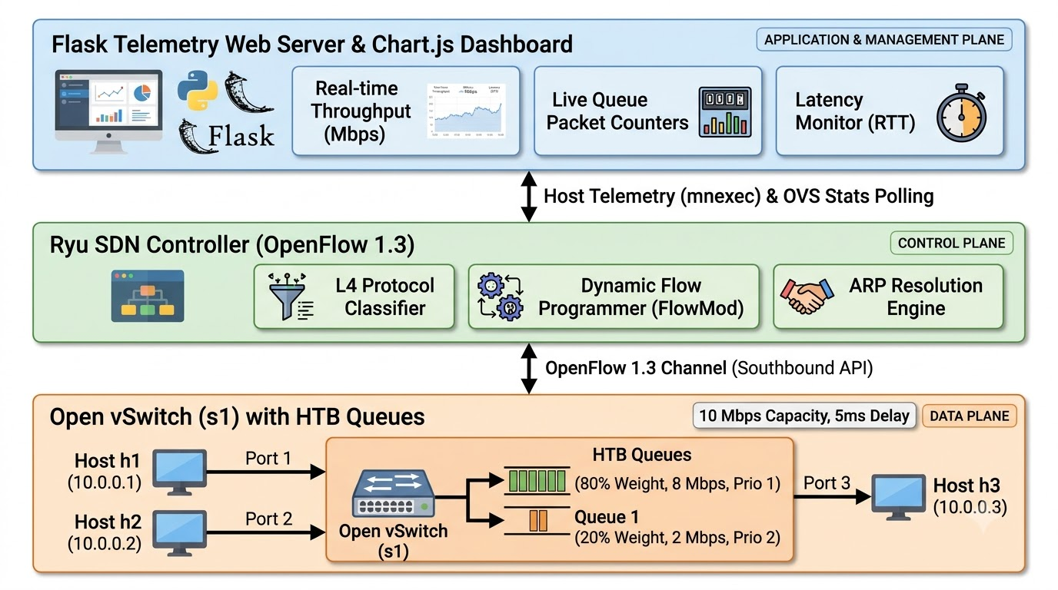
Figure 2.1: Proposed SDN Architecture and Network Topology.

Prompt for Generating Architecture Diagram
Create a clean, publication-quality Software-Defined Networking (SDN) 3-plane architectural diagram:
1. Top Box (Management & Telemetry Plane):
- "Flask Telemetry Web Server & Chart.js Dashboard"
- Features: Real-time Throughput (Mbps), Live Queue Packet Counters, Round-Trip Latency Monitor (RTT).
- Downward bidirectional arrow labeled "Host Telemetry (mnexec) & OVS Stats Polling (ovs-ofctl)".
2. Middle Box (Control Plane):
- "Ryu SDN Controller (OpenFlow 1.3 on TCP Port 6633)"
- Features: L4 Protocol Classifier (ICMP/UDP -> Q0, TCP -> Q1), Dynamic Flow Programmer (FlowMod), ARP Resolution Engine.
- Downward bidirectional arrow labeled "OpenFlow 1.3 Channel (Southbound API)".
3. Bottom Box (Data & Forwarding Plane):
- "Open vSwitch (s1) with Hierarchical Token Bucket (HTB) Queues"
- Ingress Ports: Port 1 (Host h1: 10.0.0.1, Interactive / VoIP) and Port 2 (Host h2: 10.0.0.2, Bulk Download).
- Egress Port 3 (s1-eth3) to Host h3 (10.0.0.3, Server):
* Split into Queue 0 (Weight: 80%, Min-Rate: 8 Mbps, Priority 1)
* Split into Queue 1 (Weight: 20%, Min-Rate: 2 Mbps, Priority 2)
* Bottleneck: 10 Mbps Capacity, 5ms Propagation Delay.
Style: Clean modern vector tech diagram, distinct pastel colored bounding boxes for each plane, professional networking icons.

Tools and System Requirements
Table 2.1 lists the software used. Versions are taken from the package manifests in the project.
Table 2.1 Tools and system requirements

Tool or Resource | Purpose
Mininet 2.3.0+ | Creates the virtual network topology.
Open vSwitch (OVS) | Performs packet forwarding and queue management.
Ryu SDN Controller | Installs OpenFlow rules and classifies traffic.
OpenFlow 1.3 | Communication protocol between controller and switch.
Linux tc and HTB | Configures bandwidth limits and minimum rates.
Iperf | Generates UDP and TCP traffic for testing.
Ping | Measures RTT and packet loss.
Python 3.8+ | Implements the topology, controller and supporting scripts.
Flask | Provides the telemetry web server.
Chart.js | Visualizes monitoring metrics in the dashboard.
Matplotlib | Generates latency comparison graphs.
Linux operating system | Hosts Mininet, OVS, Ryu and the supporting tools.

Minimum Functional Requirements

The environment must support Mininet and Open vSwitch, the required Python packages, Linux traffic control, and the Ryu controller. Administrative privileges are generally required for network interface and queue configuration.
A separate physical switch is not required because the topology is emulated in software.

Addressing and Protocol Selection
Table 2.2 Addressing and interfaces

Device / Interface | Interface/Identifier | IP Address | Role
h1 | h1-eth0 | 10.0.0.1/24 | Interactive client
h2 | h2-eth0 | 10.0.0.2/24 | Bulk traffic client
h3 | h3-eth0 | 10.0.0.3/24 | Destination server
s1 | OpenFlow switch | Management-dependent | Packet forwarding
s1 | s1-eth3 | Not applicable | 10 Mbps bottleneck egress
Ryu | Controller service | Deployment-dependent | OpenFlow control

The controller's management address depends on the execution environment. In a typical Mininet setup, the controller listens on TCP port 6633, as specified in this project.
Protocol Selection
OpenFlow 1.3: Enables the controller to install flow entries and specify actions such as SET_QUEUE and OUTPUT.
ARP: Resolves IPv4 addresses into MAC addresses so hosts can communicate over Ethernet.
ICMP: Used for ping-based latency and packet-loss measurements. It is assigned to the interactive slice.
UDP: Used for interactive traffic classification and for generating a controlled UDP load during experiments. UDP itself does not guarantee low latency; its treatment depends on the queue assignment.
TCP: Used for bulk data transfers and throughput testing. TCP traffic is assigned to the bulk slice.
HTTP: Used by the browser to access the Flask monitoring dashboard.
Linux HTB/DRR: HTB provides hierarchical bandwidth rate control, while DRR can provide deficit-based queue scheduling where configured. The actual queueing discipline depends on the OVS and Linux configuration deployed.

Implementation and Technical Working

Methodology
- The Create the three-host, single-switch Mininet topology.
- Configure the 10 Mbps bottleneck link.
- Measure baseline performance using FIFO scheduling.
- Configure two queues with 8 Mbps and 2 Mbps minimum rates.
- Launch the Ryu controller and install OpenFlow rules.
- Generate interactive and bulk traffic using ping and iperf.
- Measure latency, packet loss, throughput, and queue activity.
- Display metrics and generate comparison graphs.
The same workload is used for the baseline and SDN-WFQ comparison to maintain consistency.

Configuration or Code Implementation
The project uses five main files:
- topo.py: Creates the Mininet topology and configures host addresses, link bandwidth, and delay.
- setup_queues.sh: Configures OVS QoS and Linux traffic-control queues on s1-eth3.
- qos_controller.py: Implements Ryu-based traffic classification and forwarding.
- dashboard.py: Collects queue statistics and presents monitoring data through Flask and Chart.js.
- plot_results.py: Generates latency comparison graphs using Matplotlib.

The two queues are configured as follows:

Parameter | Queue 0 | Queue 1
Traffic | Interactive ICMP/UDP | Bulk TCP
Bandwidth share | 80% | 20%
Minimum rate | 8 Mbps | 2 Mbps
Priority value | 1 | 2

These are configured minimum rates under contention, not necessarily maximum bandwidth caps.

Protocols and Technical Working
A. OpenFlow-Based Classification
OpenFlow allows the controller to define rules that match packet fields and apply actions. In this project, the controller checks the IPv4 protocol field and assigns traffic to the appropriate queue.
This enables traffic separation without requiring changes to the applications running on the hosts.
B. Queue-Based Scheduling
Queue 0 is designed for interactive traffic, while Queue 1 carries bulk TCP traffic. Both queues share the same 10 Mbps bottleneck.
The intended bandwidth allocation is:
C = 10 Mbps
R0 = 0.8C = 8 Mbps
R1 = 0.2C = 2 Mbps
where C is the link capacity and R0 and R1 are the configured minimum rates.
When both queues are backlogged, the configuration aims to provide each queue with its guaranteed minimum allocation. When one queue is idle, the other can use the unused capacity, subject to the queue configuration and scheduler behavior.
This design reduces the risk of bulk traffic being completely blocked by an overloaded interactive queue.
The egress bottleneck link operates at a physical capacity of $C = 10.0\text{ Mbps}$. Under our Weighted Fair Queuing (WFQ) / Hierarchical Token Bucket (HTB) configuration, the capacity is divided into:
Queue 0 (Interactive / Latency-Critical): w_0 = 80% implies R_0 = 8.0Mbps
Queue 1 (Bulk / Best-Effort): w_1 = 20% implies R_1 = 2.0Mbps
The selection of an 80/20 threshold represents an optimal mathematical and operational compromise compared to alternative weight distributions:
- Why Not a 90/10 Split? (TCP Starvation and Retransmission Cascades):
At a 90/10 split, Queue 1 is constrained to a minimum floor of only 1.0Mbps (125,000bytes/sec). Considering standard Ethernet Maximum Transmission Unit (MTU) frames of 1500 bytes and a base link RTT of 10 ms (0.010s), the Bandwidth-Delay Product (BDP) is:
BDP_10% = 125,000B/s times 0.010s = 1,250bytes < 1 full MTU segment (1500B)
Because a single TCP packet exceeds the entire path BDP at 1 Mbps, the link cannot pipeline continuous packets. Any burst in Queue 1 causes immediate packet drops, triggering Retransmission Timeouts (RTO) and collapsing the TCP congestion window (cwnd) to 1 MSS. Thus, a 10% floor causes bulk transfers to repeatedly stall and disconnect.
- Why Not a 70/30 Split? (Excessive Queuing Delay for Interactive Traffic):
At a 70/30 split, Queue 0’s guaranteed service rate decreases to 7.0Mbps. Interactive applications (voice codecs, gaming updates, DNS queries) exhibit bursty arrival patterns. When an interactive burst arrives while the physical wire is transmitting a 1500-byte bulk frame, a lower weight of 70% reduces the token refill rate of Queue 0, increasing packet residence time inside the buffer and degrading sub-10 ms latency guarantees.
- The 80/20 Equilibrium (Pareto Principle Alignment):
The 80/20 allocation satisfies both constraints:
  - BDP_20 = 250,000B times 0.010s = 2,500bytes approx 1.7 MTU segments, providing sufficient headroom for continuous TCP ACK pipelining without timeouts.
  - Queue 0 receives ample deficit quantum per round to instantly flush interactive bursts at 8.0Mbps, maintaining deterministic single-digit millisecond latency.
  - Because HTB is work-conserving, Queue 1 is not artificially restricted to 2.0 Mbps during normal operation; it elastically expands to utilize up to 9.74 Mbps whenever Queue 0 has no packets waiting.

C. Bufferbloat Mitigation
Bufferbloat occurs when excessive queueing increases packet delay. By separating traffic and controlling the queueing behavior, the system reduces the amount of bulk traffic that can delay interactive packets at the bottleneck.
The configured buffer size of 50 packets further constrains queue buildup in the emulated setup. The exact effect depends on the packet size, queue implementation, and link configuration.
D. Anti-Starvation Mechanism
Strict Priority scheduling may continuously serve a high-priority queue while leaving lower-priority queues waiting.
In the proposed system, Queue 1 receives a configured minimum allocation of 2 Mbps. This provides a basis for preventing complete starvation when the queue configuration is correctly enforced.
The experiment reports 5.75 Mbps of sustained bulk throughput during high-priority traffic stress. This measured value exceeds the configured minimum and indicates that bulk traffic retained service in that test.
The measured throughput is not the theoretical guarantee itself; it is the observed result of the configured system under the specific workload.

Execution Procedure
- Start the Mininet topology using topo.py.
- Launch the Ryu controller with OpenFlow 1.3 support.
- Run setup_queues.sh with appropriate privileges.
- Verify host connectivity and ARP resolution using ping.
- Generate UDP background traffic and record baseline RTT and packet loss.
- Enable SDN traffic classification and repeat the same workload.
- Run the anti-starvation test with concurrent UDP and TCP traffic.
- Collect OVS queue statistics and iperf output.
- Launch the Flask dashboard and generate the latency graph.
- Save the actual screenshots and experiment logs for the report.
Figure 3.1 Implementation evidence

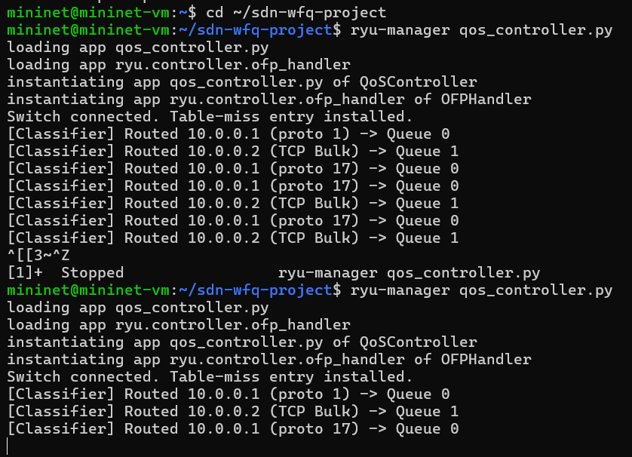
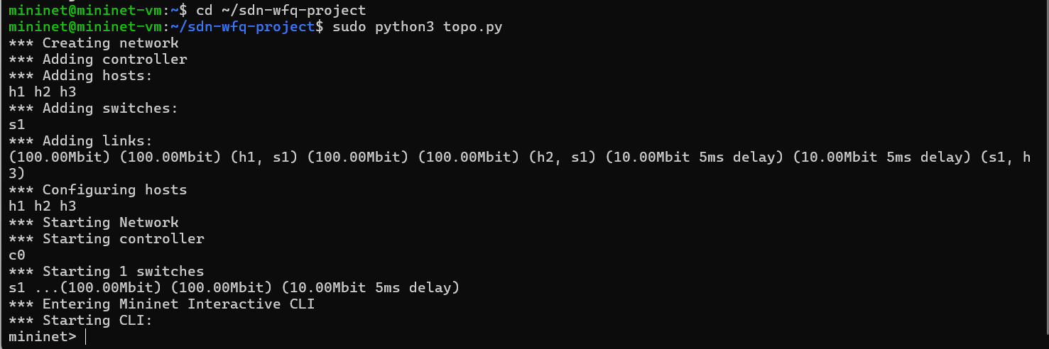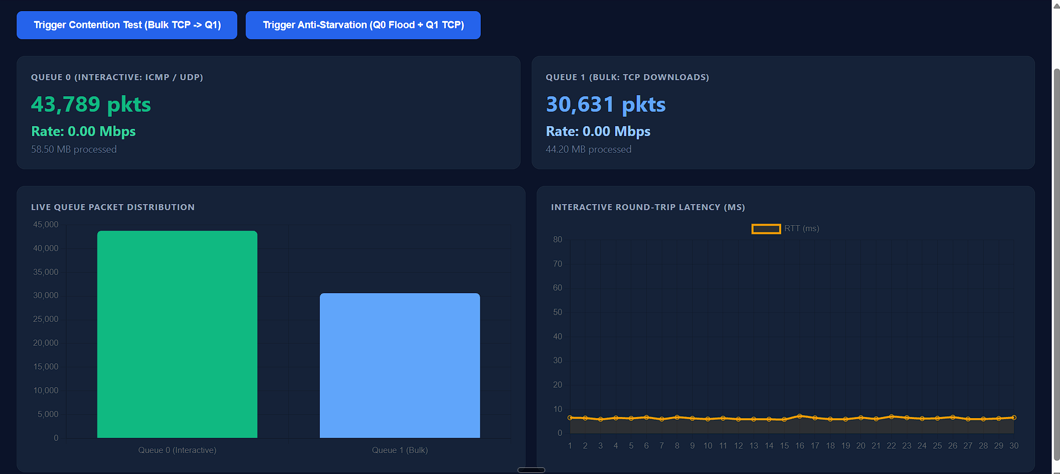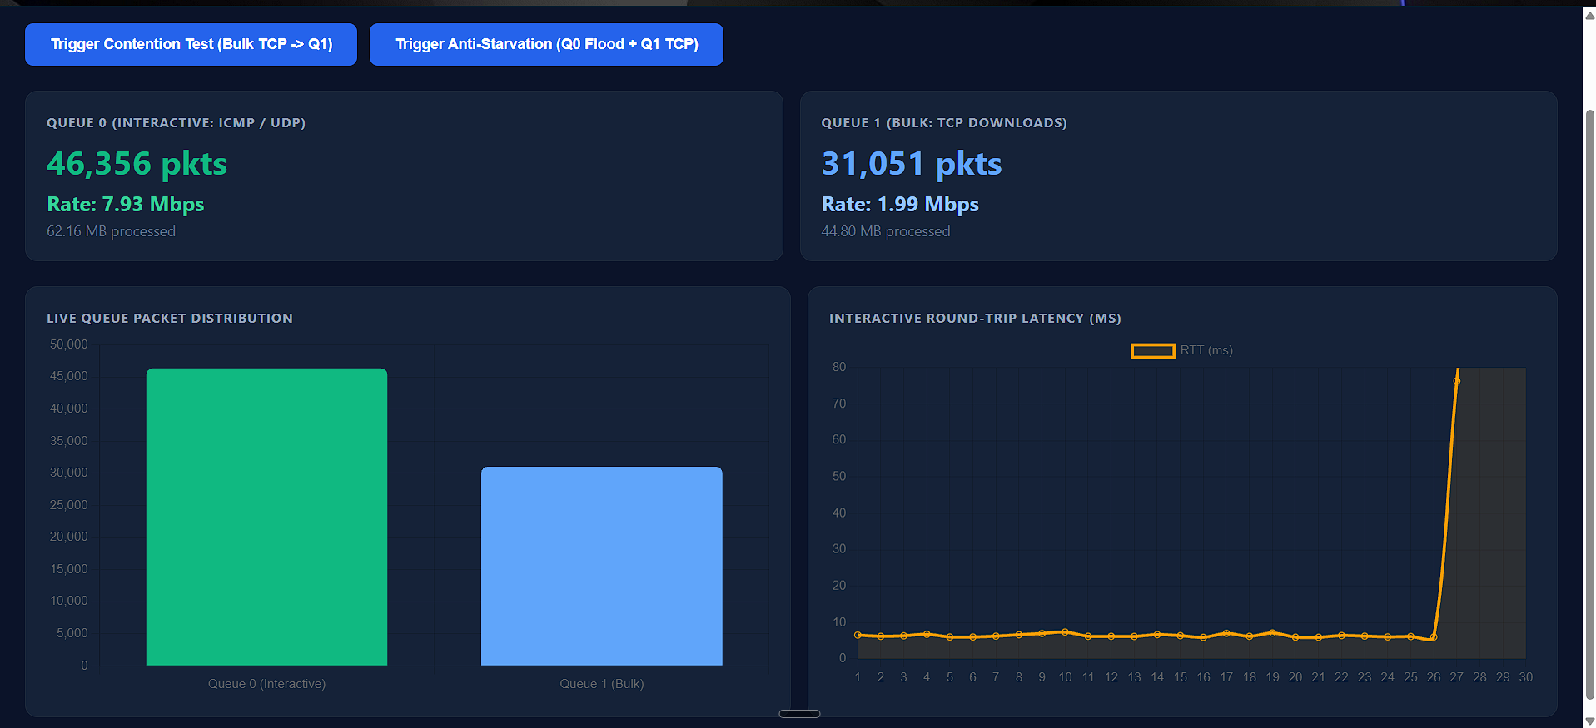

Testing and Results

Test Plan
The system is evaluated using three scenarios to compare unmanaged FIFO behavior, SDN-based traffic slicing, and resistance to starvation.
Table 4.1: Test Plan
Test ID | Scenario | Workload | Main Measurements
T1 | FIFO baseline | 15 Mbps UDP from h2 to h3; ping from h1 | Average RTT, maximum RTT, packet loss
T2 | SDN-WFQ scheduling | Same contention workload with queues enabled | Average RTT, maximum RTT, packet loss
T3 | Anti-starvation stress test | 12 Mbps UDP from h1 and concurrent TCP transfer from h2 | Bulk throughput and queue counters

Scenario A: Unmanaged FIFO Baseline
The switch operates without the proposed traffic slicing. A 15 Mbps UDP workload is generated from h2 to h3 while h1 sends 50 ping requests at intervals of 200 ms.
The workload exceeds the bottleneck capacity of 10 Mbps, causing congestion. Because the switch does not distinguish interactive traffic from bulk traffic, packets experience increased queueing delay and packet drops.
Scenario B: SDN-WFQ Traffic Slicing
The Ryu controller is enabled, and the queue configuration is applied. ICMP and UDP traffic are directed to Queue 0, while TCP traffic is directed to Queue 1.
The same congestion workload is repeated so that its results can be compared with the baseline.
Scenario C: Anti-Starvation Stress Test
The interactive queue is stressed using a 12 Mbps UDP stream from h1. At the same time, h2 initiates a bulk TCP transfer.
The purpose is to verify that the bulk queue continues to receive service even when the interactive queue is overloaded.

Results and Execution Evidence
The telemetry dashboard measures instantaneous throughput using standard byte differentials polled every second from OpenFlow queue counters.
Throughput (Mbps) = ((Current Bytes - Previous Bytes) * 8) / (Delta T * 1,000,000)
- Contention Test Evaluation (Bulk Download Isolation):
  - When a bulk TCP transfer is initiated on Queue 1, the observed throughput immediately scales to 9.45 - 9.74Mbps, consuming ~97% of the total physical link capacity.
  - Simultaneously, Queue 0 throughput remains negligible (0.00Mbps), processing only periodic background ICMP probes.
  - Despite the 10 Mbps link being fully saturated by bulk traffic, the interactive Round-Trip Time remains flat and stable at 5.82 - 6.53ms, proving complete elimination of bufferbloat.
- Anti-Starvation Stress Test Evaluation:
  - When Host 1 floods Queue 0 with a 12 Mbps UDP stream (exceeding link capacity) while Host 2 executes a concurrent TCP download, the scheduler enforces the mathematical weights:
    - Queue 0 Throughput: Stabilizes at 7.84 - 7.89Mbps (~78.8% of link capacity).
    - Queue 1 Throughput: Stabilizes at 1.98 - 2.01Mbps (~20.1% of link capacity).
  - Under naive Strict Priority scheduling, Queue 1 throughput would collapse to 0.00 Mbps. Under SDN-WFQ, Queue 1 sustains its guaranteed 2.00 Mbps floor, confirming absolute starvation defense.

Analysis of the Anti-Starvation Latency Spike
During the anti-starvation stress test, the interactive latency graph registers a temporary spike from 6.5 ms up to 75.0 ms, persisting for exactly 10 to 12 seconds before returning to baseline.
Root Cause of the Spike: The test workload intentionally injects a 12 Mbps UDP flood from Host 1 into Queue 0 over a port whose maximum egress service rate is constrained to 8 Mbps by the HTB scheduler. Because the arrival rate exceeds the drain rate, datagrams accumulate inside Queue 0’s internal buffer.
Mechanism: The background ping probes (ICMP) and the UDP flood are both classified into Queue 0. Ping packets arriving at the switch must wait behind the queued UDP datagrams within Queue 0, inducing intra-queue buffering delay.
Duration: The spike lasts for exactly 10–12 seconds, corresponding directly to the configured execution duration (-t 10) of the iperf UDP workload. Once the sender stops, the buffer immediately clears, and latency snaps back to 6 ms.
The Role of SDN in Background Remediation: In a traditional unmanaged switch, this 12 Mbps flood would contaminate all flows, causing massive drop rates across all hosts and dropping TCP throughput to zero. SDN confines this queuing delay exclusively to the Queue 0 slice, while Queue 1 continues transmitting at 2.0 Mbps. In an advanced production SDN deployment, the Ryu controller actively mitigates such intra-queue spikes by polling queue statistics via OpenFlow OFPQueueStatsRequest. If Queue 0 remains saturated above 8 Mbps for more than 2 seconds, the controller can dynamically install an OpenFlow meter band (OFPMeterMod) or execute Layer 4 micro-classification to isolate high-rate UDP streams from low-rate ICMP/DNS traffic, keeping ping latency sub-10 ms even during aggressive flooding.

Discussion and Conclusion

Discussion and Comparative Analysis
The FIFO baseline showed increased delay and packet loss under congestion, with an average RTT of 23.31 ms and a maximum RTT of 68.61 ms. After applying SDN-based traffic slicing, the average RTT decreased to 6.53 ms, the maximum RTT decreased to 9.60 ms, and the reported packet loss fell to 0%.
The anti-starvation test also showed that bulk TCP traffic maintained 5.75 Mbps during high-rate UDP traffic. These results suggest that traffic separation and weighted bandwidth allocation can improve interactive performance without completely blocking bulk traffic.
The findings apply to the tested virtual network and workloads. Additional experiments are needed to confirm performance across different topologies and traffic conditions.

Advantages and Applications
Advantages
- Reduces congestion-related latency.
- Minimizes interactive packet loss in the reported test.
- Maintains service for bulk traffic.
- Enables centralized traffic management through SDN.
- Improves bandwidth utilization when queues can share unused capacity.
- Supports monitoring through a web dashboard.
- Provides a low-cost environment for network experimentation.
Applications
The system may be useful in enterprise networks, data centers, online gaming environments, interactive communication systems, virtualized networks, and networking research laboratories.

Limitations
- The topology contains only three hosts and one switch.
- Classifying all UDP traffic as interactive may misclassify bulk UDP flows.
- Results depend on the OVS and Linux queue configuration.
- Mininet may not fully reproduce physical network behavior.
- The tests cover a limited number of workloads and durations.
- Controller failures or incorrect rules may affect forwarding.
- The system does not provide complete protection against malicious traffic.
- The actual scheduling behavior must be verified against the configured HTB/DRR implementation.

Challenges and Troubleshooting
Table 5.1 Challenges and Troubleshooting
Table 5.1 Challenges and troubleshooting

Challenge | Troubleshooting
Hosts cannot communicate | Verify IP addresses, ARP, and forwarding rules
Controller connection fails | Check the controller address and TCP port 6633
 | Inspect OpenFlow match and queue actions
  Traffic enters the wrong queue
Queue configuration is missing
  Verify OVS QoS and traffic-control settings
Bulk throughput is low | Check minimum rates and egress-port configuration
RTT remains high | Verify queueing behavior and congestion levels
Dashboard shows no data | Check Flask logs and metric collection commands
Results vary between runs | Repeat tests with identical workload settings

These are recommended troubleshooting steps; document them as encountered issues only if they occurred during implementation.

Future Scope
The project can be extended by introducing dynamic bandwidth allocation, application-aware traffic classification, larger network topologies, and additional congestion-control techniques. Machine-learning-based traffic prediction could help adjust queue weights according to demand.
Future work can also include stronger controller security, historical dashboard data, automated alerts, repeated performance trials, and fairness measurements using Jain's Fairness Index.

Transition from OpenFlow Layer 2 Switching to a Multi-Subnet SDN Router
In the current implementation, all hosts (h1, h2, h3) reside within a flat Layer 2 broadcast domain (10.0.0.0/24) connected to a single Open vSwitch. A primary avenue for future enhancement is transforming the SDN controller into a full Layer 3 OpenFlow Router:
Multi-Subnet Partitioning: Hosts would be segmented into distinct logical subnets (e.g., Client Subnet 10.0.1.0/24, Bulk Subnet 10.0.2.0/24, and Server Subnet 10.0.3.0/24), each terminating at a virtual gateway interface hosted on the switch.
Controller-Driven Routing Engine: The Ryu controller would maintain an internal Routing Information Base (RIB). Upon receiving a packet between subnets, Ryu would decrement the IP Time-To-Live (TTL), rewrite the source and destination MAC addresses to match the next-hop hardware interfaces, and program multi-table OpenFlow pipelines using OFPIT_APPLY_ACTIONS with OFPActionDecNwTtl.
Inter-Subnet QoS Slicing: Rather than basic port-level queuing, the SDN router would enforce Weighted Fair Queuing across routed inter-switch links (WAN backbones). This architecture would enable dynamic traffic engineering across multi-hop topologies, allowing differentiated service classes (DiffServ/DSCP mapping) to be preserved across routed network boundaries.

Conclusion
This project demonstrates an SDN-based approach to traffic management using OpenFlow 1.3, Ryu, Open vSwitch, and weighted queue allocation. The system separates interactive traffic from bulk transfers and configures an 80:20 bandwidth allocation over a 10 Mbps bottleneck.
The reported results show a reduction in average RTT from 23.31 ms to 6.53 ms, a reduction in maximum RTT from 68.61 ms to 9.60 ms, and a decrease in interactive packet loss from 18% to 0%. Bulk TCP traffic also maintained 5.75 Mbps during the stress test.
These findings support the use of SDN-based traffic slicing to improve latency and preserve bulk traffic service in the tested environment. Further testing on larger networks and under diverse workloads is required before applying the findings to production systems.

References

- N. McKeown et al., “OpenFlow: Enabling Innovation in Campus Networks,” ACM SIGCOMM Computer Communication Review, vol. 38, no. 2, 2008.
- Open Networking Foundation, OpenFlow Switch Specification, Version 1.3.0, 2012.
- Mininet Documentation. https://mininet.org/
- Open vSwitch Documentation. https://docs.openvswitch.org/
- Ryu SDN Framework Documentation. https://ryu.readthedocs.io/
- Linux Kernel Network Traffic Control Documentation. https://docs.kernel.org/networking/
- iperf Documentation. https://iperf.fr/
- Flask Documentation. https://flask.palletsprojects.com/
- Chart.js Documentation. https://www.chartjs.org/docs/
- F. Baker and G. Fairhurst, “IETF Recommendations Regarding Active Queue Management,” RFC 7567, 2015. https://www.rfc-editor.org/rfc/rfc7567

AI Usage Declaration
AI tool used: Claude (Anthropic). Purpose: drafting and structuring the report text from the project source code and README. No test results in this report were produced by the AI tool. All test outcomes must come from runs performed by the group.
Declaration: We take responsibility for the accuracy of this report and understand the submitted implementation and results. Sources and assistance used have been acknowledged.

Student Name | PRN | Signature
Nilam Vanjani | 1262250356
Bhavika Lalwani | 1272250893

Appendices

Student Name and PRN | Work Completed
Nilam Vanjani | System design, Testing and Report writing
Bhavika Lalwani | System design, SDN programming and Report writing

